0522-3D打印无人机GPS减震支架生产记录
Drone GPS Shock Absorbing Mount
🖨️ SLA光固化
🖥️ 打印机: Stratasys
📦 材料: SLA
生活再难，也别停下脚步。就像接下这个无人机GPS减震支架的单子，提醒我们在技术中寻找可能性，继续前行。
No matter how difficult life gets, don't stop moving forward. Just like taking on this order for a drone GPS shock-absorbing bracket, it reminds us to seek possibilities in technology and keep moving ahead.
________________________________________________________________________________
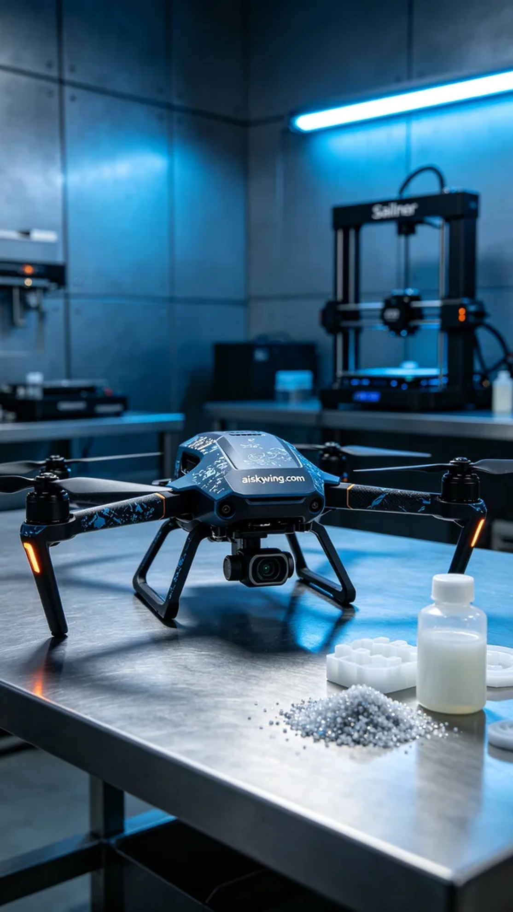
Recently, someone approached us with a design challenge — to manufacture a highly efficient drone GPS shock-absorbing bracket. What they needed was a precise and aesthetically pleasing product that could effectively reduce vibrations during flight, providing better stability for their drones.
To achieve this, we chose SLA resin as the raw material due to its excellent photopolymerization properties, allowing for extreme clarity and detailed surface finishes in the printed bracket. Using a Stratasys printer, we set the parameters to a layer thickness of 0.1mm, a printing temperature of 25 degrees Celsius, a curing power of 1000mW, and a print speed of 40mm/s. These meticulous settings helped ensure that every detail would be perfectly represented.
During the printing process, the Stratasys printer performed exceptionally well, operating smoothly throughout. We constantly monitored the progress, ensuring there were no issues with light leakage or material shortages. Ultimately, the entire bracket was completed in 3 hours, with satisfying texture and detail.
After printing, we proceeded with post-processing. First, we placed the bracket in a cleaning tank, using isopropyl alcohol to remove excess resin from the surface. Then, we sanded it down with fine-grit sandpaper to achieve a smoother finish. Next, we cured it under UV light to ensure the resin's properties were fully activated. Finally, each bracket underwent rigorous inspection to meet our quality standards.
With a series of meticulous operations completed, the final drone GPS shock-absorbing bracket not only showcased its strong technical foundation but also featured personalized decorations that made every detail memorable. This production experience reaffirmed that patience and attention to detail are key to realizing our dreams.
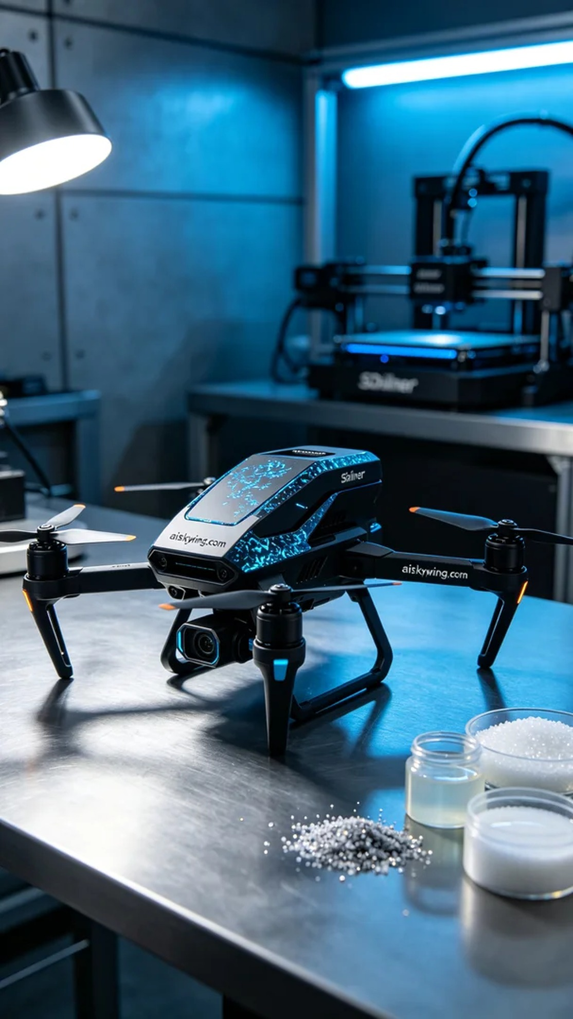
最近，有人找到我们，希望能够解决一个设计上的挑战——制造一款高效的无人机GPS减震支架。他们需要的就是这个精准而美观的产品，能够有效减少飞行过程中的震动，为无人机提供更好的稳定性。
为了实现这一目标，我们选择了SLA树脂作为原材料，其优良的光固化特性使得打印出的支架可以达到极致的清晰度和细致的表面效果。使用Stratasys打印机进行生产时，我们设置的参数为0.1mm的层厚，打印温度为25摄氏度，照射功率为1000mW，打印速度控制在40mm/s。这些细致的参数帮助我们确保每个细节都能完美呈现。
在打印过程中，Stratasys打印机的表现十分稳定，设备运行顺畅。我们时刻监控打印进程，确保没有出现漏光或材料短缺等问题。最后，整个支架在3小时内完成打印，质感和细节都让人满意。
完成打印后，我们进行了后处理。首先将支架放入清洗槽中，使用异丙醇去除表面的多余树脂，随后用细砂纸进行打磨，使表面更加光滑。接着，我们使用UV灯进行固化处理，确保树脂的特性完全发挥。最后，对每个支架进行严格检验，以确保符合我们的质量标准。
经过一系列的精细操作，最终完成的无人机GPS减震支架不仅展现出其雄厚的技术底蕴，还具备了个性化装饰，让每一个细节都难忘。这次生产经历再次证明，耐心与细致是实现梦想的关键。
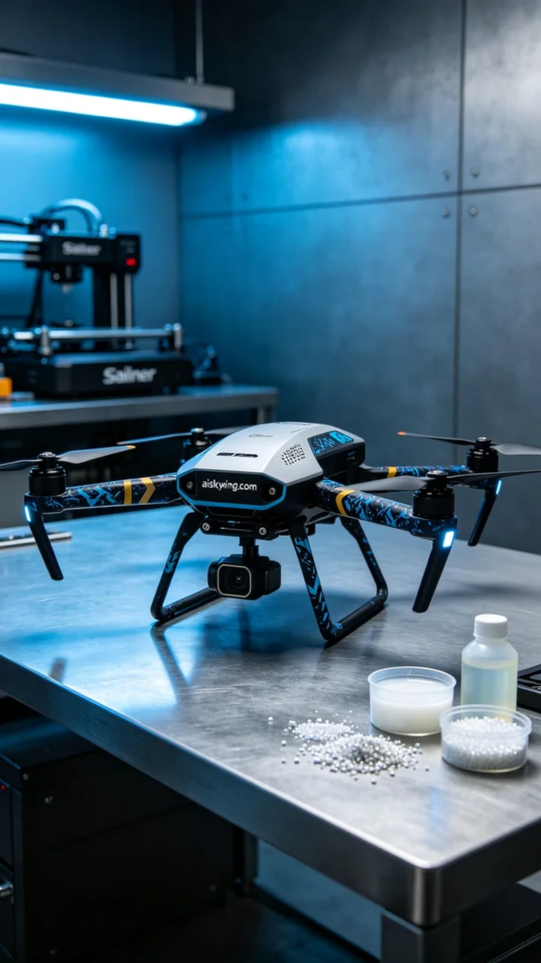
Aiskywing Industrial 3D Printing
Drone GPS Shock Absorbing Mount


