0523-无人机云台减震球生产记录
Drone Gimbal Shock Absorber Ball
🖨️ SLM金属打印
🖥️ 打印机: Carbon
📦 材料: 摆放着未成型的液态光敏
生活就像一场3D打印的旅程，任何目标都需要一步一个脚印。今天，我们要为无人机云台减震球置于画面正中央展开工作。
Life is like a journey of 3D printing, where every goal requires taking one step at a time. Today, we will focus on placing the drone gimbal shock-absorbing ball right in the center of the frame.
________________________________________________________________________________
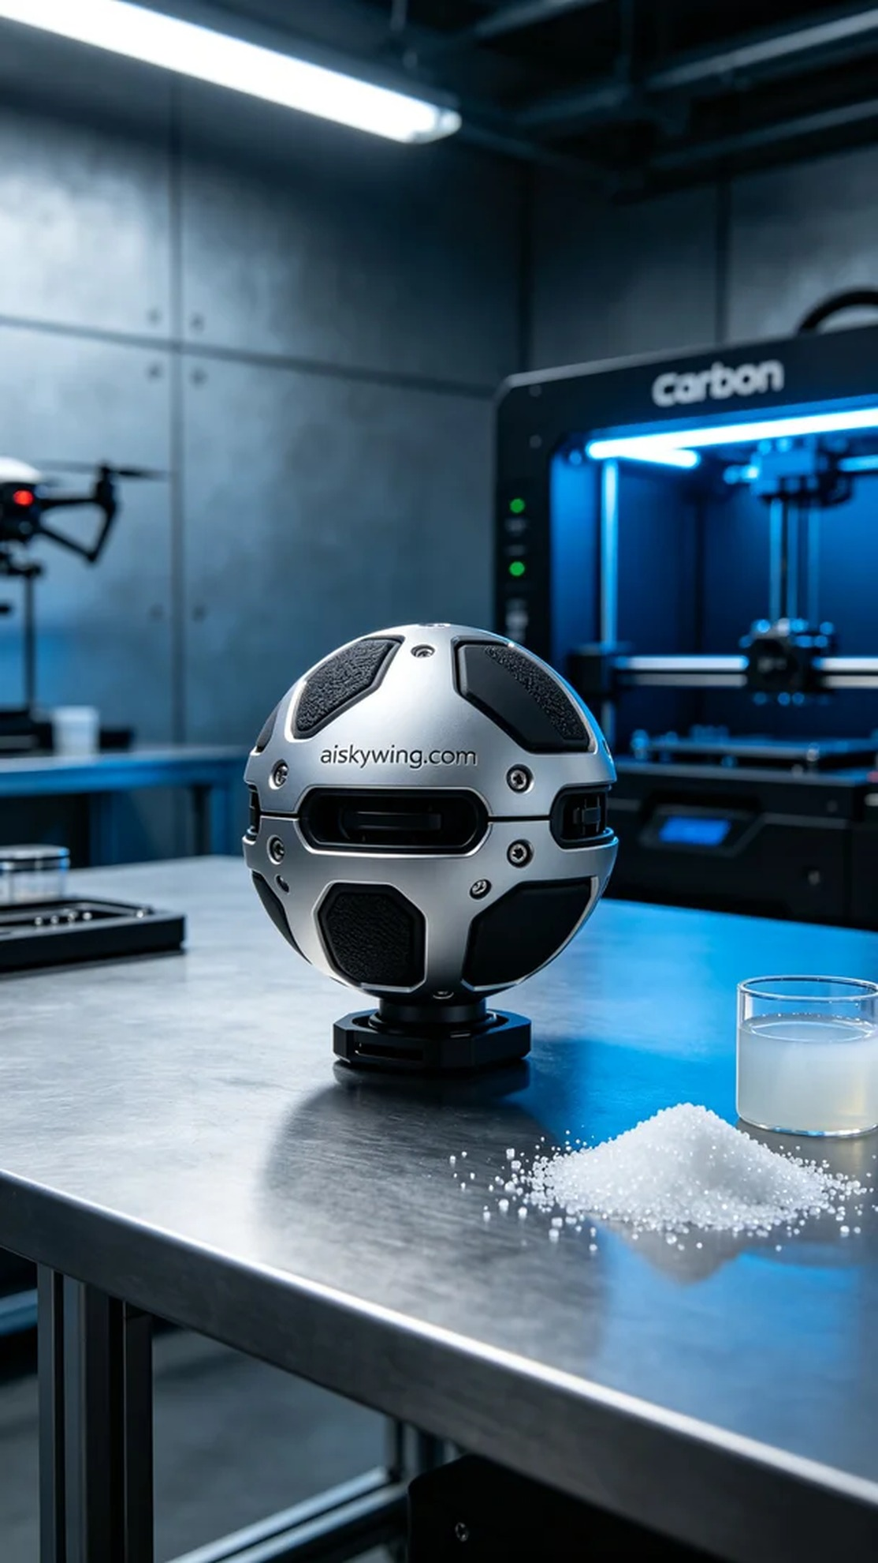
Life is like a journey of 3D printing, every goal requires step-by-step progress. Today, we are set to work on the drone gimbal shock-absorbing ball placed at the center of the frame.
On Instagram, someone reached out to us for a shooting requirement, wanting to create a drone gimbal shock-absorbing ball. This product demands extreme clarity while showcasing outstanding performance and aesthetics in an industrial environment.
We selected unformed liquid photosensitive resin as the material. This material cures quickly under light exposure, ensuring that the printed parts have high precision. We used a Carbon 3D printer, with a layer thickness set at 0.1mm, printing temperature kept at 20°C, power adjusted to 80%, printing speed at 50mm per hour, and the entire print process is expected to take about 4 hours.
As the printing process began, the machine ran steadily, and the liquid resin cured layer by layer under precise lighting. Under the printer's monitoring, we ensured that the quality and details of each layer met expectations. As printing progressed, the shock-absorbing ball's shape gradually emerged, with clear details, including the engraved "aiskywing.com" text becoming increasingly visible.
Once printing was completed, we moved to the post-processing phase. First, the shaped parts were placed in a cleaning tank to remove uncured resin from the surface using a specialized cleaning solution. After cleaning, we gently sanded the edges with fine sandpaper to smooth the surface. Finally, the finished product was placed in a curing box to accelerate the curing process, ensuring durability and strength. After strict quality inspections, each detail was confirmed to meet the standards, leading to a successful delivery.
After this meticulous work, the drone gimbal shock-absorbing ball was perfectly presented, both practical and beautiful, marking another success in our 3D printing technology journey.
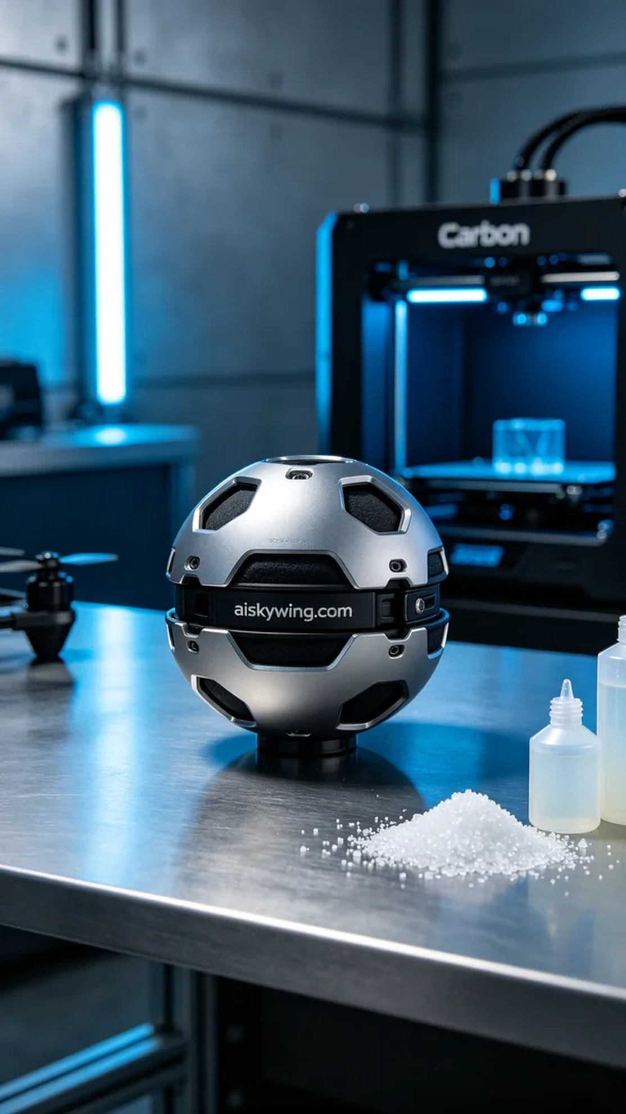
在Instagram上，有人因为拍摄需求找到了我们，希望制作一个无人机云台减震球。这个产品不仅需要极致的清晰度，还要在工业环境中展现出卓越的性能与美感。
我们选择了未成型的液态光敏树脂作为原材料。这种材料在光照下能迅速固化，保证打印出的部件具有极高的精细度。我们使用的Carbon 3D打印机，设置了层厚0.1毫米，打印温度保持在20°C，功率调整为80%，打印速度为每小时50毫米，预计整个打印过程需要大约4小时。
打印过程开始后，机器稳定运行，液态树脂通过精准的光照照射逐层固化。在打印机的监控下，我们始终确保每一层的质量和细节都达到预期标准。随着打印的继续，减震球的形状逐渐显现，细节清晰，表面雕刻的“aiskywing.com”字样也愈加清晰。
打印完成后，我们进入后处理阶段。首先，将成型件放入清洗槽，用专用清洗液去除表面未固化的树脂。清洗完成后，再用细砂纸轻轻打磨，去掉边缘的毛刺，使得产品表面光滑。最后，将成品放入固化箱中，加速固化过程，确保其耐用性和强度。经过严格的检验，确保每个细节都符合质量标准，最终成功交付。
经过这一系列精细的工作，无人机云台减震球完美呈现，既实用又美观，标志着我们在3D打印技术上的又一次成功。
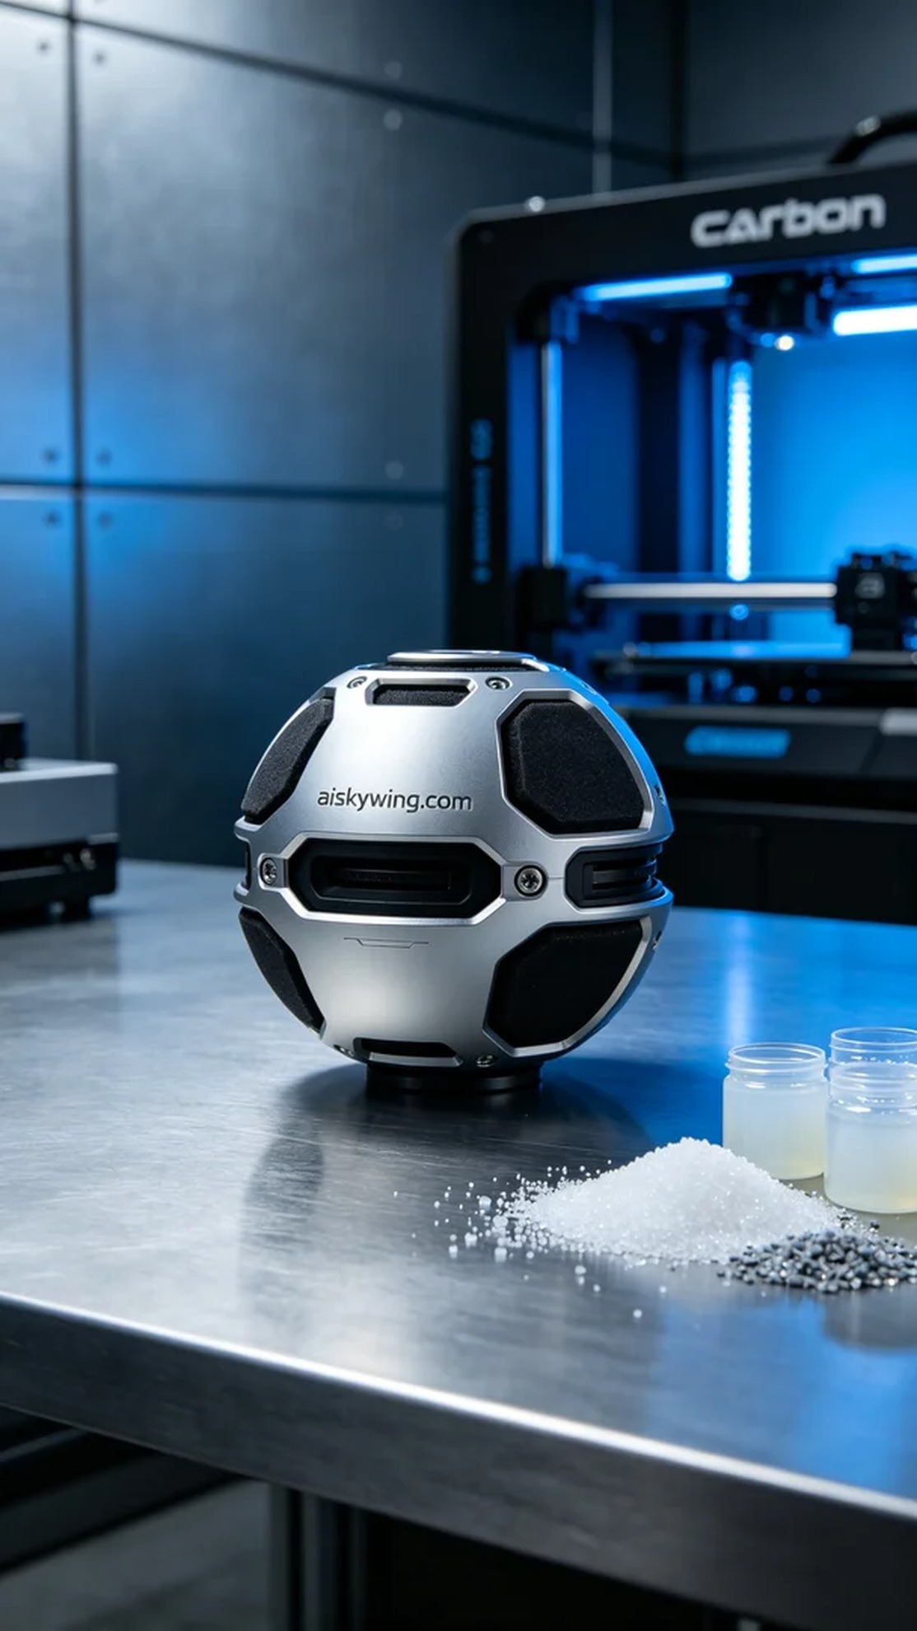
Aiskywing Industrial 3D Printing
Drone Gimbal Shock Absorber Ball


