0524-无人机减震支柱3D打印生产记录
Drone shock absorber pillar
🖨️ SLA光固化
🖥️ 打印机: Stratasys
📦 材料: SLA
在Instagram上，有人因为无人机减震支柱的强度与稳定性问题找到了我们。生活总要不断创新，才能领跑未来。
On Instagram, someone reached out to us regarding the strength and stability issues of drone shock-absorbing pillars. Life requires constant innovation to stay ahead of the future.
________________________________________________________________________________
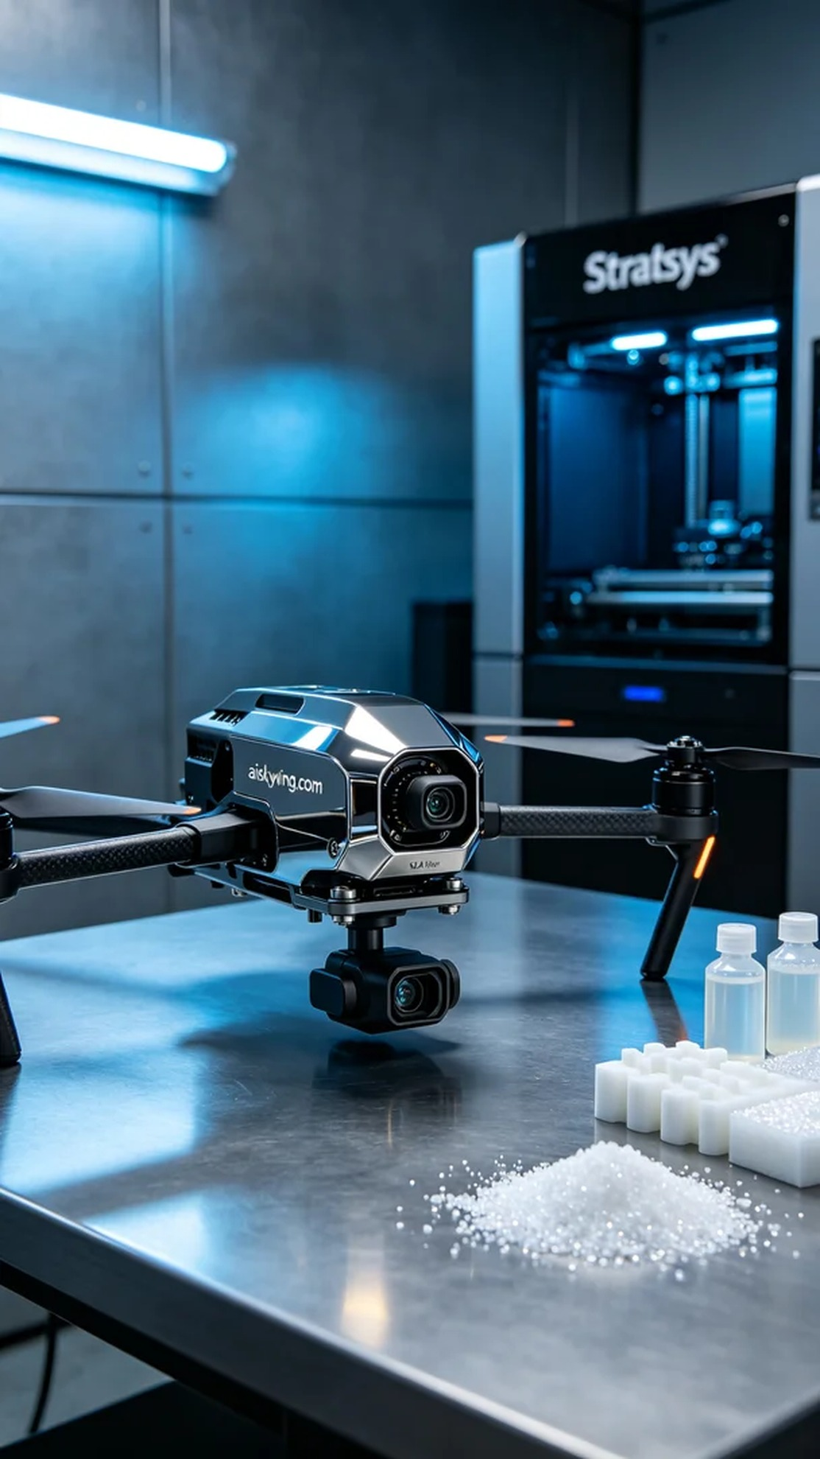
Recently, we received an order for a drone vibration damping pillar. Someone faced issues with the stability and strength of the drone during flight, and they turned to us to leverage 3D printing technology for a better damping solution.
For this project, we chose high-quality SLA resin as our material. This material not only offers good strength and toughness but also presents a high-gloss surface finish after curing, enhancing the product's technological appeal. We employed a Stratasys printer, setting the layer thickness to 0.1 mm, maintaining a printing temperature of 25 degrees Celsius, with a power of 50% and a printing speed of 30 mm per second. The estimated printing time was around 4 hours.
During the printing process, the Stratasys printer operated steadily, with the liquid resin curing layer by layer under the exposure to light. We closely monitored the print quality to ensure that each layer adhered perfectly, avoiding any bubbles or defects. As the printing progressed, the damping pillar gradually took shape, revealing its precise details.
After printing, we carried out a series of post-processing steps. First, we placed the formed pillar into a cleaning solution to thoroughly remove any uncured resin from the surface. Next, we gently polished it with sandpaper to ensure a smooth, flawless finish. Finally, it underwent a curing process to further enhance its mechanical properties. After rigorous inspection, we ensured that each pillar met the required standards.
In the end, the drone vibration damping pillar was successfully completed, achieving the desired outcome through meticulous work and processing. Our efforts made the product not only visually appealing but also highly functional.
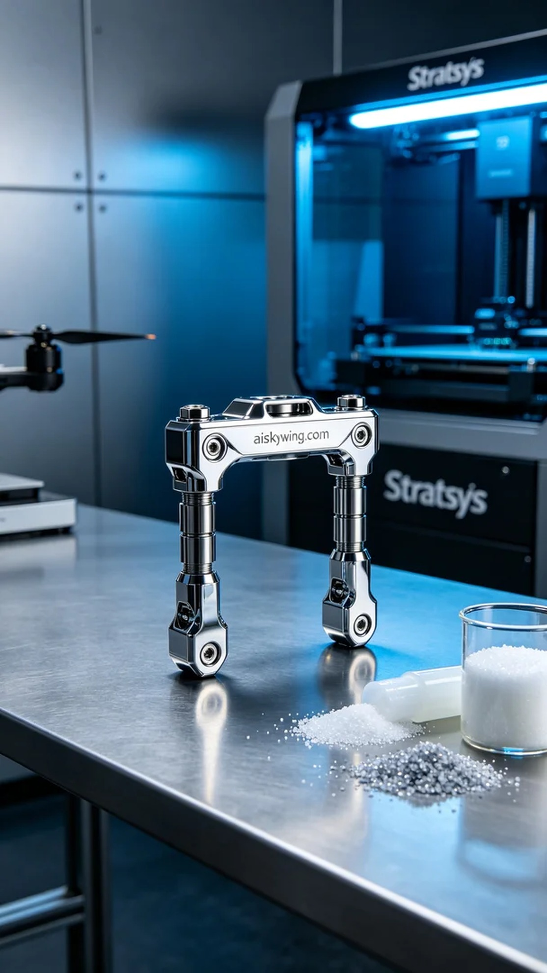
这次我们接到了一个关于无人机减震支柱的订单。有人希望能解决其在飞行过程中产生的震动问题，借助3D打印技术来实现更好的减震效果。我们决定采用SLA光固化工艺，为其提供高精度且耐用的产品。
在材料方面，我们选用了高质量的SLA树脂。这种材料不仅具备良好的强度和韧性，在光固化后还能呈现出高光泽的表面效果，让产品看起来更具科技感。为了确保打印效果，我们使用了Stratasys打印机，设定层厚为0.1毫米，打印温度保持在25摄氏度，功率设为50%，打印速度为30毫米每秒，预计打印时间为4小时。
打印过程中，Stratasys打印机稳定地运行着，液态树脂在光源的照射下逐层固化。我们仔细监控打印质量，确保每一层都能完美结合，避免出现任何气泡或缺陷。随着打印的进行，整个支柱逐渐成型，展现出精密的细节。
打印完成后，我们进行了一系列后处理工序。首先将成型的支柱放入清洗液中，彻底清除表面残留的未固化树脂。接着，我们用砂纸轻轻打磨，确保表面光滑无瑕疵。最后，经过固化处理，让支柱的力学性能得到进一步提升。经过严格的检验，确保每一个支柱都符合标准。
最终，这个无人机减震支柱顺利完成，经过各项工序的打磨和保证，达成了预期的效果。我们的努力让产品不仅美观大方，更具实用价值。
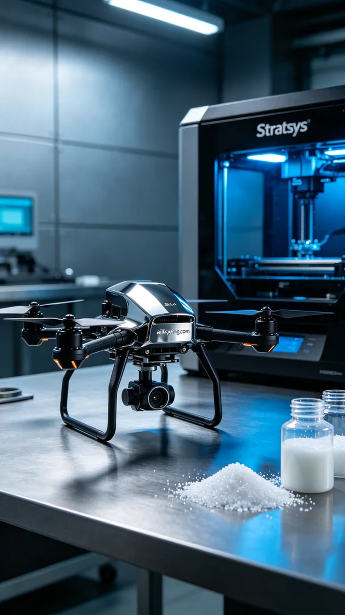
Aiskywing Industrial 3D Printing
Drone shock absorber pillar


