0525-无人机发动机罩3D打印生产记录
Drone engine cover
🖨️ SLA光固化
🖥️ 打印机: Stratasys
📦 材料: SLA
在WhatsApp上，有人向我求助，提到想要定制一款无人机发动机罩。生活就像这项工作，挑战再大，也要迎头而上。
On WhatsApp, someone reached out to me for help, mentioning that they wanted to customize a drone engine cover. Life is just like this job; no matter how big the challenges are, we must face them head-on.
________________________________________________________________________________
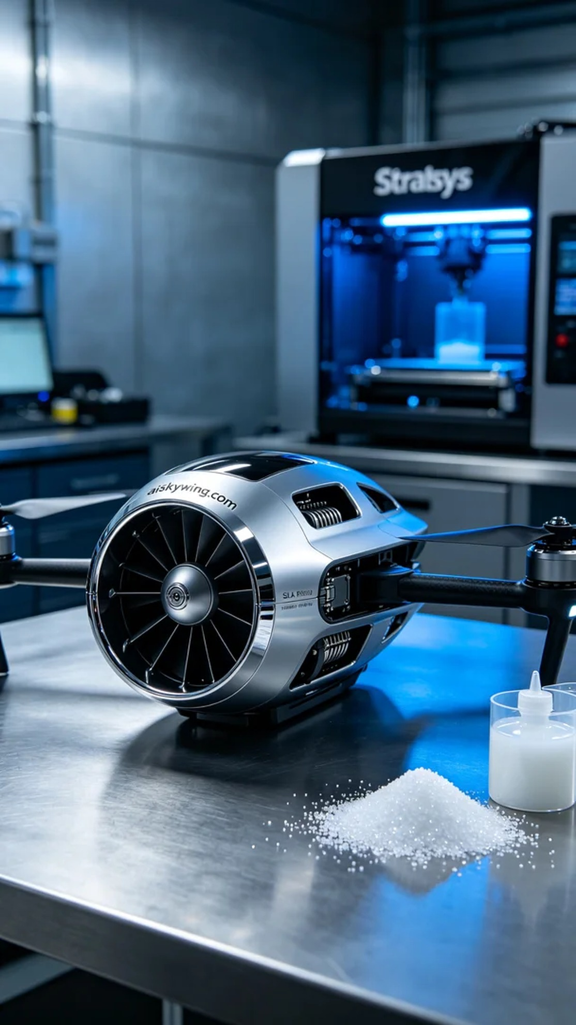
Recently, someone contacted me via WhatsApp, expressing their need for a custom drone engine cover. Life is much like this job; no matter how challenging it gets, we must rise to the occasion.
For this drone engine cover, we chose high-precision SLA (Stereolithography) resin as our raw material. This material boasts excellent flow properties and high-detail reproduction capabilities, making it perfect for products requiring precision. Our Stratasys printer was meticulously calibrated, with print parameters set to a layer thickness of 0.05mm, a temperature maintained at 25℃, a laser power of 100mW, and a print speed of 50mm/s to ensure quality and surface smoothness.
During the printing process, the Stratasys device operated steadily, with real-time quality monitoring in place. Each layer was cured strictly according to the set time to ensure the resin fully solidified, avoiding warping and shrinkage. I kept a close eye on the device status throughout the process, making necessary adjustments to handle any anomalies, ensuring that each layer stacked accurately.
Once the printing was finished, the post-processing phase became crucial. We started by placing the printed parts into a cleaning tank, using isopropyl alcohol to thoroughly wash away any uncured resin. After cleaning, we meticulously sanded the surface to remove any minor imperfections, enhancing the overall smoothness. Following this, we performed UV curing to ensure that every inch of the surface achieved the desired hardness and gloss. Finally, a rigorous inspection ensured that every detail met our standards.
After a series of meticulous production steps, the drone engine cover was complete. It not only looked stunning but also performed exceptionally well, truly showcasing the charm of 3D printing.
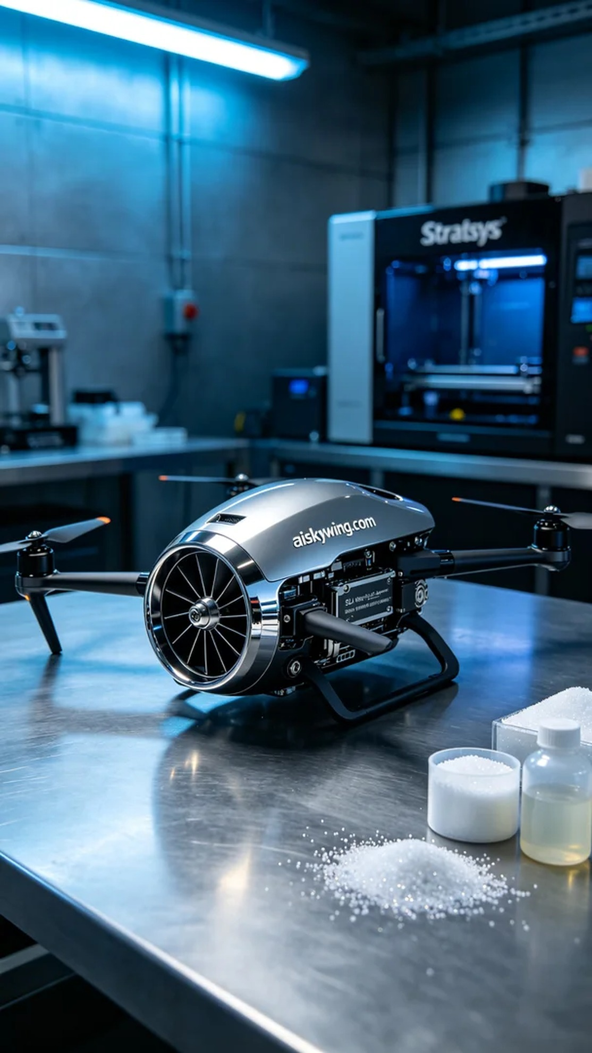
首先，关于这款无人机发动机罩的制作，原材料选择了高精度的SLA光敏树脂。这种材料具有优良的流动性和高细节还原能力，适合需要精密细节的产品。我们使用的Stratasys打印机经过精心调整，打印参数设定为层厚0.05mm，温度保持在25℃，激光功率为100mW，打印速度则调至50mm/s，以确保打印质量和表面光滑度。
在打印过程中，Stratasys设备稳步运行，实时监控打印质量。每一层的固化都严格按照设定的时间进行，确保树脂完全固化，避免翘曲和收缩。打印过程中，我时刻关注设备状态，及时调整任何异常情况，确保每一层都能准确叠加。
打印完成后，后处理工序也至关重要。我们首先将打印好的部件放入清洗槽中，使用异丙醇将未固化的树脂彻底清洗干净。清洗完成后，按照规定程序进行打磨，以去除表面细微的瑕疵，提升整体的光滑感。然后再进行UV固化，确保每一寸表面都能达到完美的硬度和光泽感。最后，经过严格的检验，确保每个细节都符合标准。
经过一系列精细的制作过程，这款无人机发动机罩终于完成。它不仅外观出色，更在性能上也能胜任各种挑战，真正展现了3D打印的魅力。
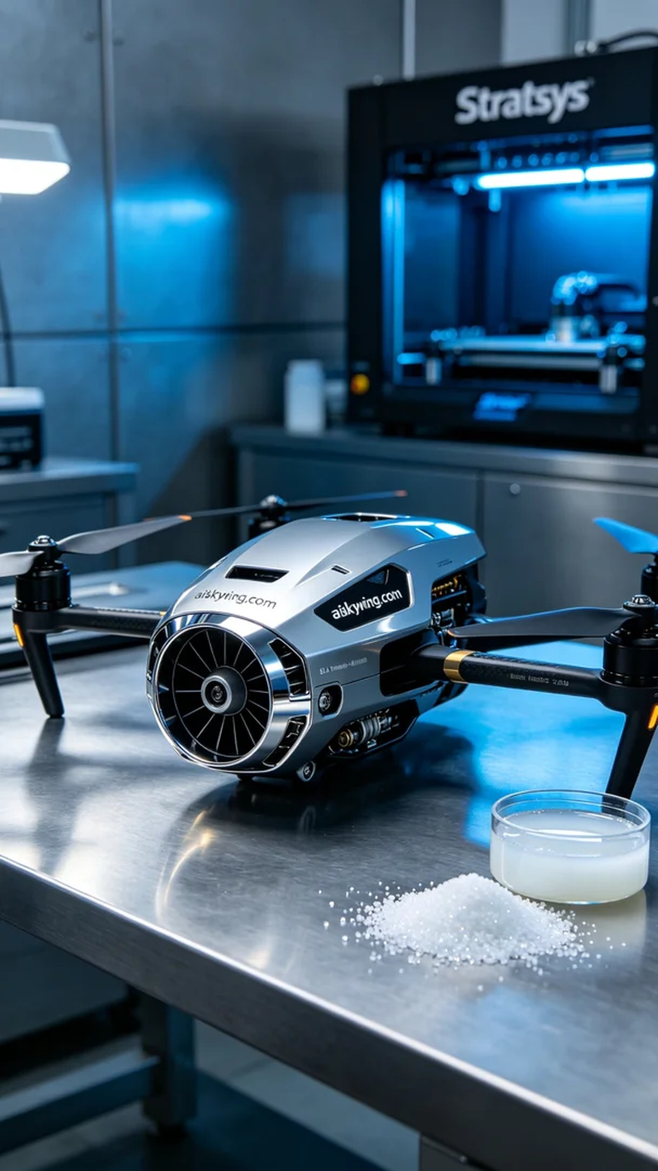
Aiskywing Industrial 3D Printing
Drone engine cover


