0526-无人机喷洒泵外壳3D打印记
Drone Spraying Pump Housing
🖨️ SLA光固化
🖥️ 打印机: Xjet
📦 材料: SLA
生活就像3D打印，每个层次都需要精心打磨。最近有人找我们做这个无人机喷洒泵外壳，遇到了一些挑战。
Life is like 3D printing, where each layer needs to be carefully polished. Recently, someone approached us to create the outer shell for a drone spraying pump, and we encountered some challenges.
________________________________________________________________________________
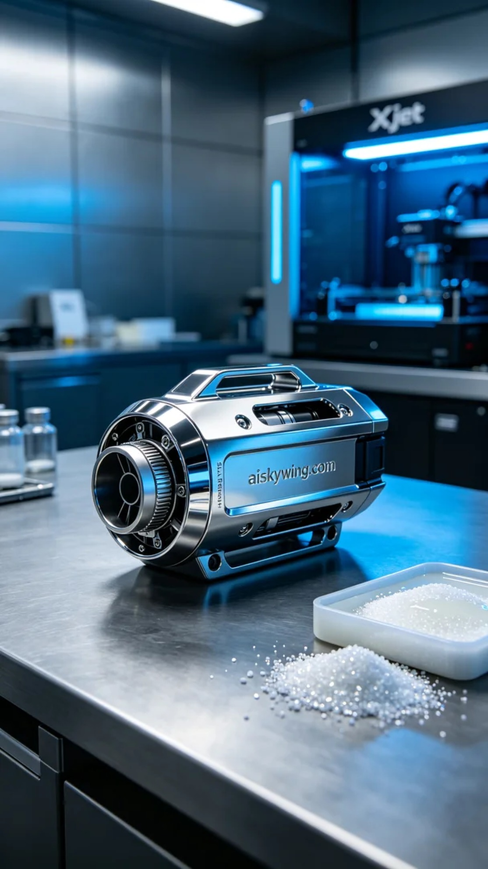
Life is like 3D printing; every layer needs careful polishing. Recently, someone reached out to us to create a drone spraying pump shell, facing some challenges.
We chose SLA (Stereolithography) technology for the print, known for its precision and detail. The material used is high-quality photosensitive resin, achieving extremely high resolution. To ensure print quality, we set up the Xjet printer with parameters: layer thickness of 0.05mm, temperature at 25°C, power set at 50mW, printing speed at 30mm per second, and an estimated print time of about 8 hours.
The printing process went smoothly, with the device operating steadily. We monitored the print quality throughout, ensuring each layer cured to standard. As time passed, the gradually forming pump shell showcased the expected details, and the engraved “aiskywing.com” text was clearly visible, bringing satisfaction.
Post-processing is crucial to ensure product quality. We first placed the printed part into a cleaning solution to remove excess resin from the surface, followed by sanding with fine sandpaper to eliminate any imperfections. Finally, we performed UV curing to ensure the shell's strength and durability. After thorough inspection, the finished product met our standards.
After a series of meticulous processes, the drone spraying pump shell was successfully completed. Every detail was carefully polished, perfectly presented.
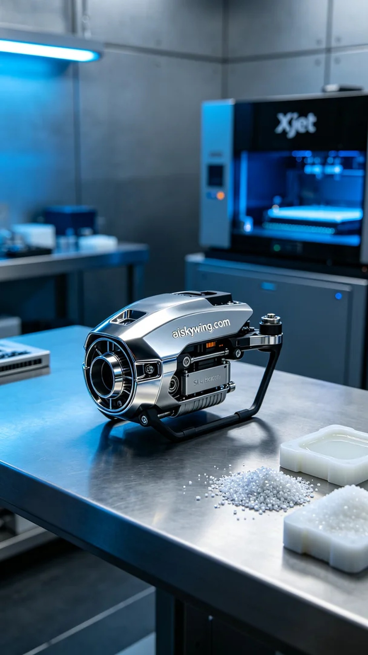
在Instagram上，一位朋友因为想提升无人机喷洒的效率而与我们联系。他们希望我们能够制造出一个坚固且功能完备的无人机喷洒泵外壳。这让我想起了3D打印的魅力，能将设想变为现实。
我们选择了SLA光固化技术进行打印，这种材料的优点在于其精度和细腻度。原材料是高质量的光敏树脂，能够实现极高的分辨率。为了确保打印质量，我们设置了Xjet打印机的参数：层厚0.05毫米，温度保持在25摄氏度，功率设定为50毫瓦，打印速度为30毫米每秒，预计打印时间约为8小时。
打印过程顺利，设备运行稳定。我们全程监控打印质量，确保每一层的固化都达到标准。随着时间的推移，逐渐成型的泵外壳展现出预期的细节，表面雕刻的“aiskywing.com”字样清晰可见，令人满意。
完成后处理是确保产品质量的关键。我们首先将打印件放入清洗液中，去除表面多余的树脂，接着使用细砂纸进行打磨，以消除任何可能的瑕疵。最后，我们进行了UV固化，确保外壳的强度和耐用性。经过严格的检验，成品达到了我们的标准。
经过一系列精细的工艺流程，这个无人机喷洒泵外壳终于成功完成了。每一个细节都经过精心打磨，完美呈现。
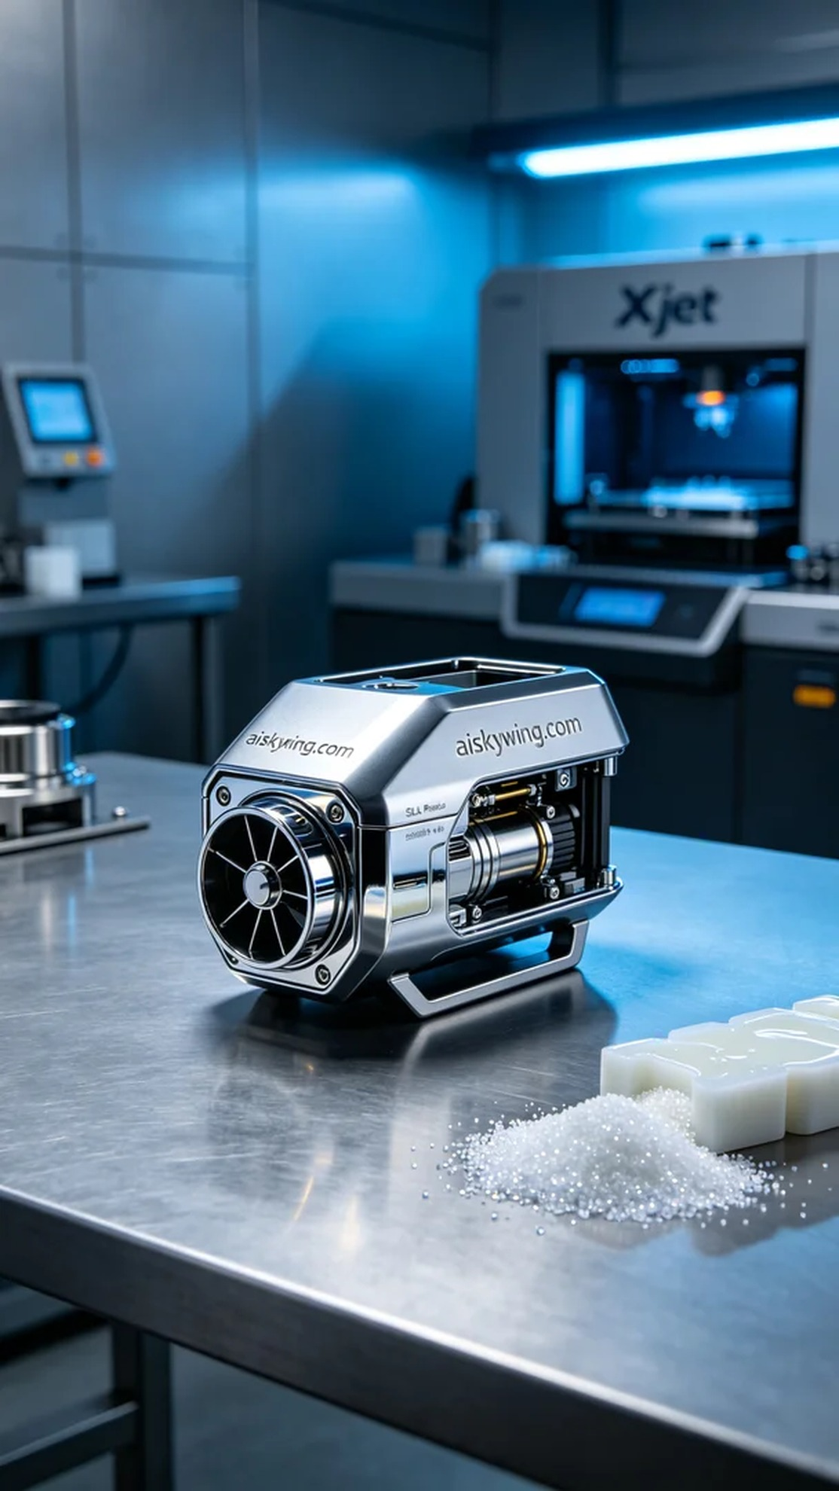
Aiskywing Industrial 3D Printing
Drone Spraying Pump Housing


