0528-无人机图传天线座3D打印生产记录
Drone transmission antenna base
🖨️ SLS尼龙烧结
🖥️ 打印机: Stratasys
📦 材料: 摆放着未成型的液态光敏
在现代工业中，每一个细节都至关重要。就像这款无人机图传天线座，今天我们将通过YouTube分享它的3D打印过程。
In modern industry, every detail is crucial. Just like this drone transmission antenna base, today we will share its 3D printing process on YouTube.
________________________________________________________________________________
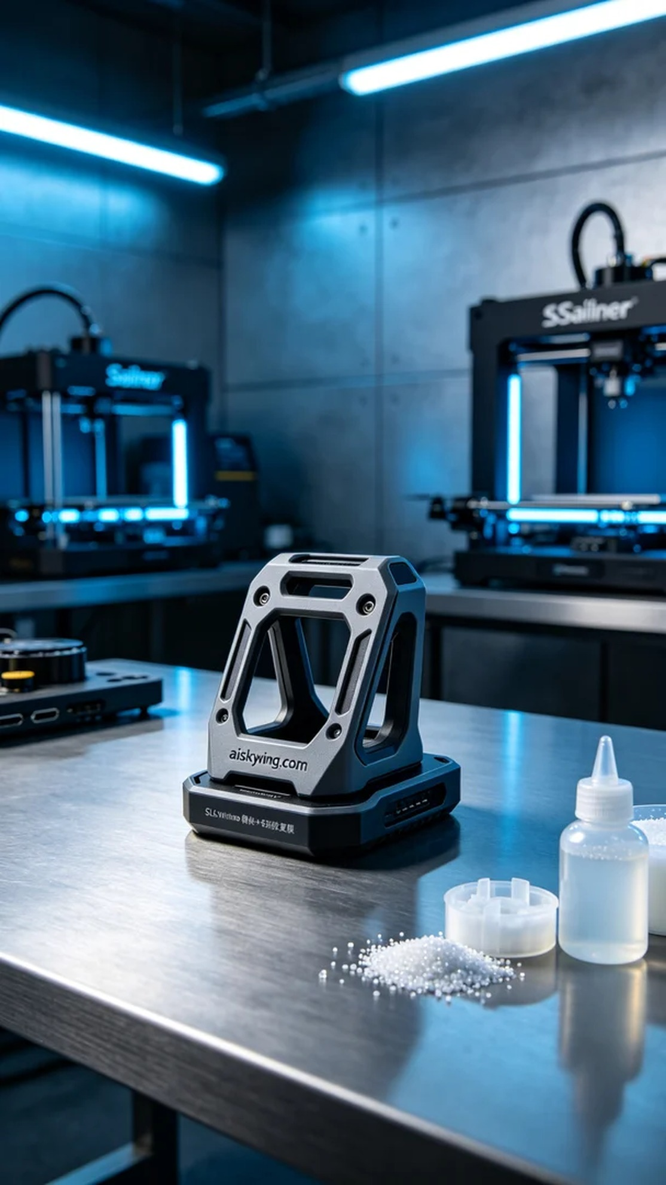
Today, someone reached out to us hoping to create a drone transmission antenna mount. They saw our work on YouTube and wanted to resolve their practical issues with antenna structures. This product needs to embody high strength and flexibility, perfectly showcasing the advantages of 3D printing.
To meet the project requirements, we chose SLS nylon sintering technology and prepared liquid photopolymer resin as raw material. Using a Stratasys printer, we set the printing parameters: a layer thickness of 0.1mm, a temperature of 180 degrees Celsius, a power setting of 80%, a printing speed of 40mm/s, and an estimated printing time of 12 hours to ensure the precision and strength of the product.
During the printing process, we closely monitored the operational status of the equipment, ensuring each layer was accurately stacked. The efficient performance of the Stratasys printer made the printing process smooth, with temperature and power adjustments providing timely feedback to ensure a smooth surface and perfect details.
After printing, we entered the post-processing stage. First, we cleaned the formed antenna mount to remove any residual resin from the surface. Then, we used sandpaper to polish it, ensuring the edges were smooth. After that, we performed curing treatment to enhance the material's strength and durability, followed by a comprehensive inspection of the product to ensure it met the expected quality standards.
After a series of professional processes, we successfully produced this drone transmission antenna mount, reflecting our expertise and passion in the field of 3D printing. We look forward to sharing more exciting projects with everyone.
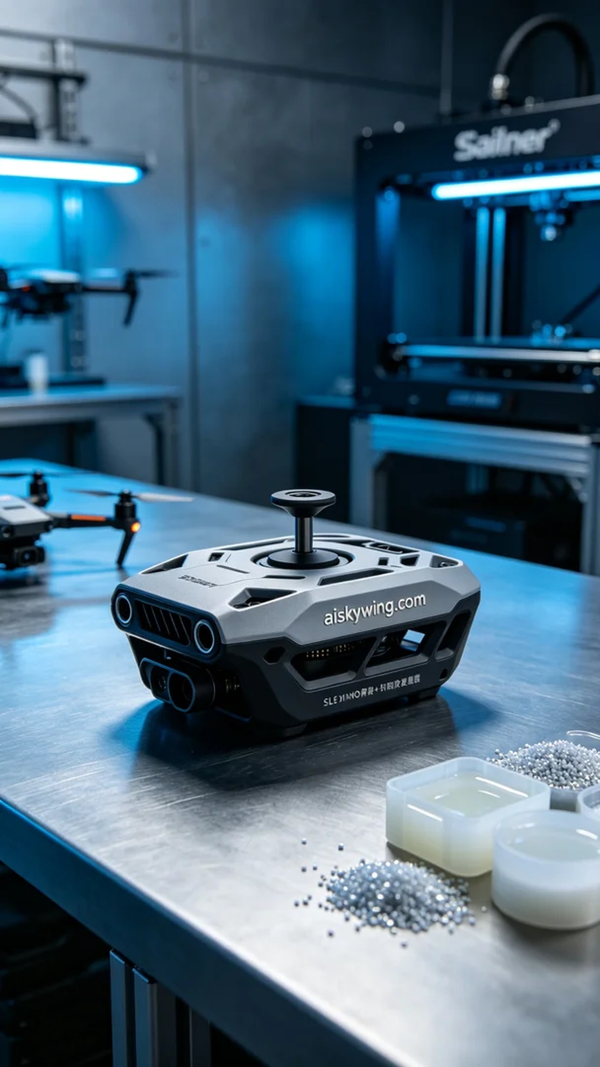
今天，有人找到我们，希望能制作一款无人机图传天线座。他们在YouTube上看到我们的作品，想要解决他们在天线架构方面的实际问题。这个产品需要具备高强度和灵活性的特性，正好能体现我们3D打印的优势。
为了满足这个项目的需求，我们选择了SLS尼龙烧结工艺，并准备了摆放着未成型的液态光敏树脂作为原材料。使用Stratasys打印机，我们设定打印参数，包括层厚0.1mm、温度适应设定在180摄氏度、功率控制在80%，打印速度为40mm/s，预计打印时间为12小时，以确保充分表达产品的精密度和强度。
在打印过程中，我们密切监控设备的运行状态，确保每一个层级都能准确叠加。Stratasys打印机的高效性能使得打印过程平稳流畅，温度和功率的调节也得到了及时反馈，确保产品表面平滑，细节完美。
打印完成后，我们进入后处理阶段。首先，我们将成型的天线座进行清洗，去除表面残留的树脂。接着，使用砂纸对其进行打磨，确保边缘光滑。然后，我们进行了固化处理，以增强材料的强度和耐久性，最后对产品进行了全面的检验，确保达到预期的质量标准。
经过一系列专业工序，我们成功制作出了这款无人机图传天线座，体现了我们在3D打印领域的技术与热情。期待下一个项目与大家分享更多的精彩。
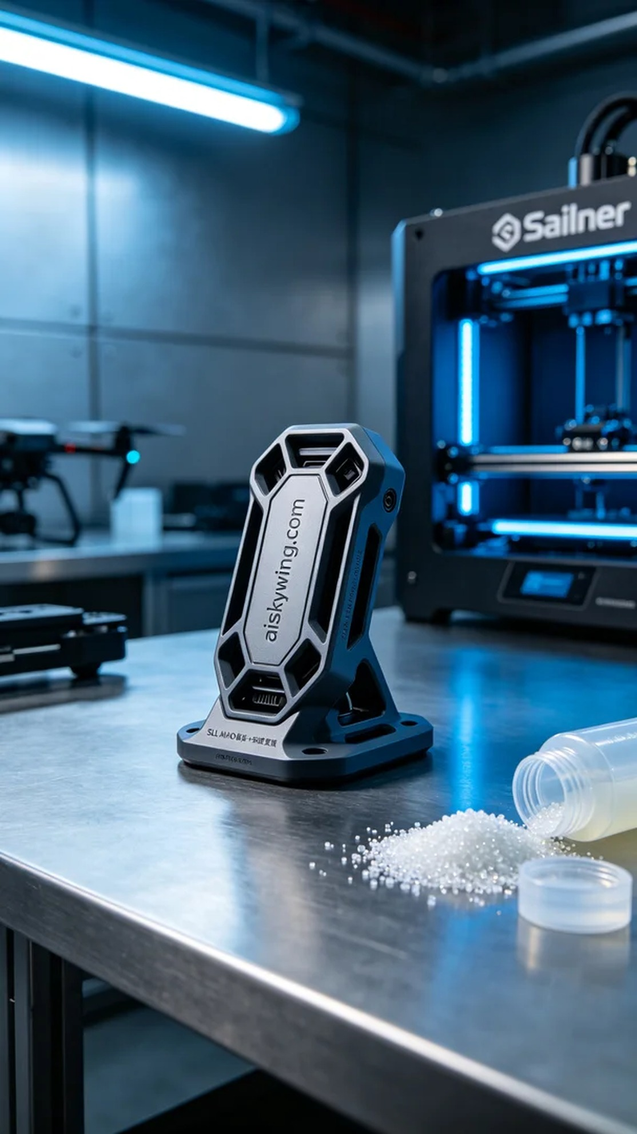
Aiskywing Industrial 3D Printing
Drone transmission antenna base


