0529-无人机投放器外壳的生产过程
Drone dispenser shell
🖨️ SLS尼龙烧结
🖥️ 打印机: Mimaki
📦 材料: 摆放着未成型的液态光敏
生活总会给我们带来挑战，就像这次接到一个无人机投放器外壳的项目，原本简单的事情却在细节上考验着我们。
Life always presents us with challenges, just like this time when we received a project for a drone dropper shell. What initially seemed like a simple task has tested us in the details.
________________________________________________________________________________
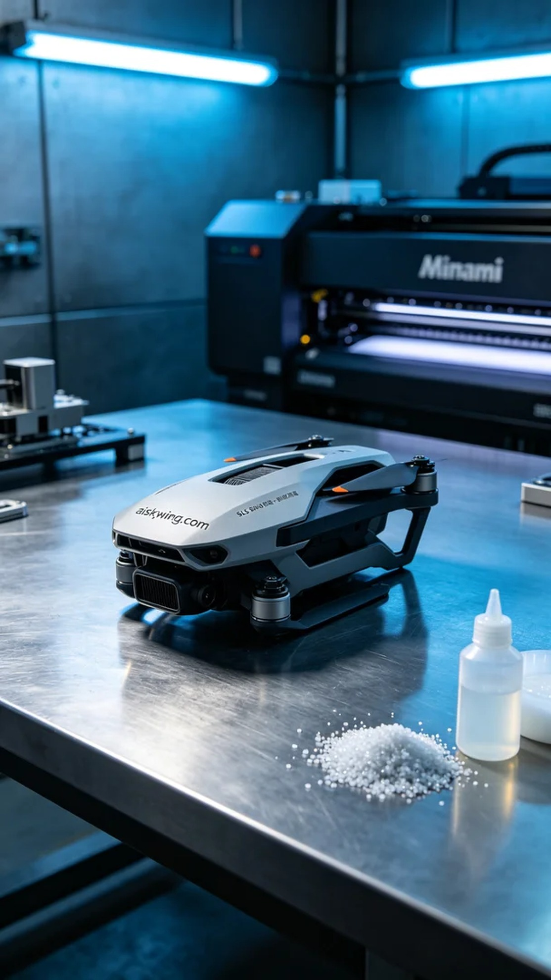
Recently, someone contacted us through Instagram, looking to customize a drone dropper shell. The challenge they faced was to ensure strength while achieving a fine and delicate appearance. Thus, we embarked on this exciting project.
We chose to use unformed liquid photopolymer resin as the main material and employed the Mimaki 3D printer for the job. The printing parameters were set with a layer thickness of 0.1 mm, maintaining a temperature of 25℃, a printing power of 60W, and a speed of 50mm/s. This setup ensured that each layer fused perfectly, allowing for a high-precision shell.
Once the printing process began, the Mimaki printer operated smoothly, spraying the liquid photopolymer resin layer by layer to form the preliminary structure of the drone dropper shell. We monitored the printing quality throughout, ensuring every layer bonded correctly while keeping an eye on the temperature changes to guarantee stable printing results.
After completing the print, we moved on to post-processing. First, we cleaned the printed part to remove any excess resin from the surface, followed by sanding to achieve a smooth and fine surface. Next, we placed it into the curing chamber, where it was cured under UV light. Finally, we conducted a thorough inspection of the finished product to ensure all details met the required standards.
In the end, the production process of this drone dropper shell was successfully completed, with outstanding quality that met the demands. This experience further reinforced our confidence in the capabilities of 3D printing.
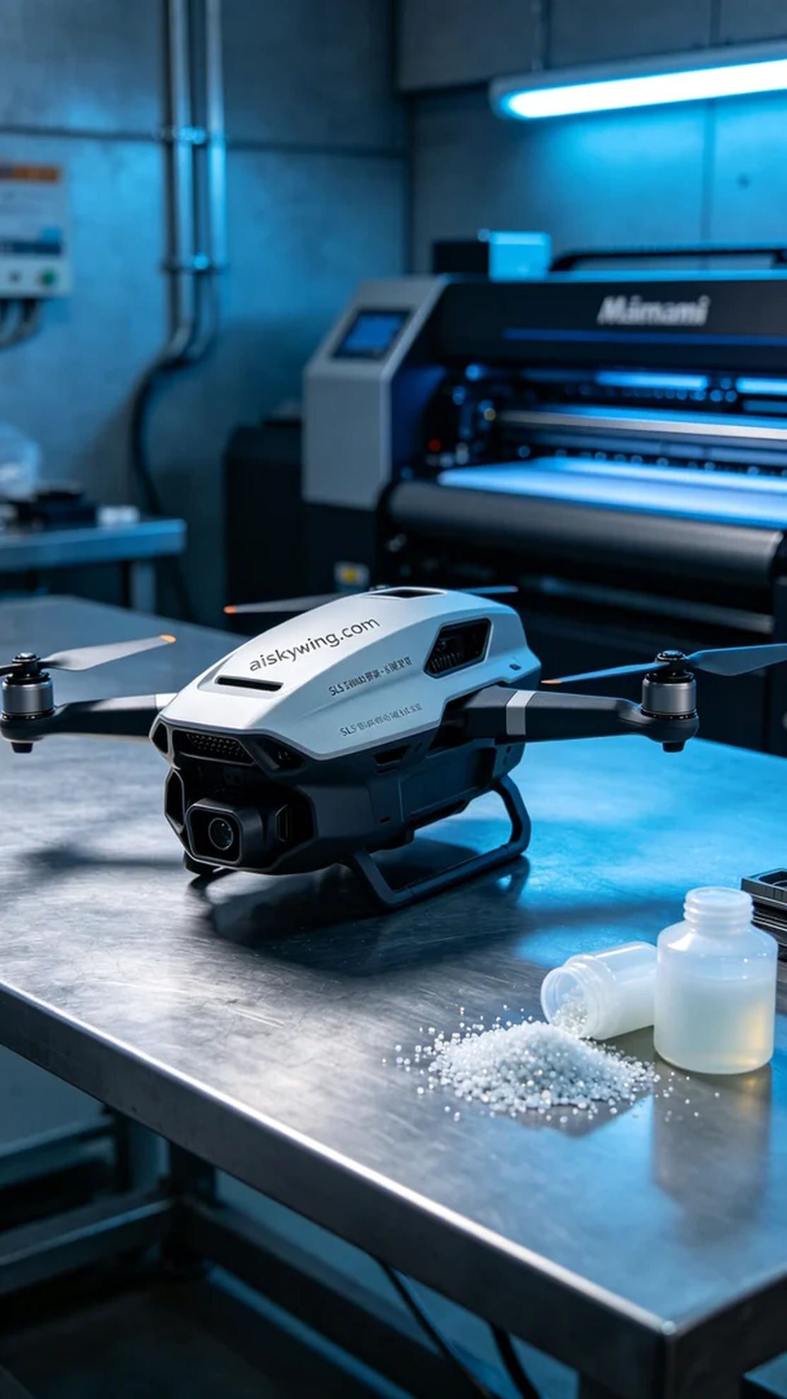
最近，有人通过Instagram找上我们，希望定制一款无人机投放器外壳。他们面临的问题是希望在保证强度的前提下，实现外观的精致和细腻。于是，我们开始了这个充满挑战的项目。
我们选择了摆放着未成型的液态光敏树脂作为主要材料，结合Mimaki 3D打印机进行打印。打印参数设定层厚为0.1毫米，温度保持在25℃，打印功率设定为60W，速度为50mm/s。这样的设置可以确保每一层都能完美融合，从而实现高精度的外壳。
打印过程开始后，Mimaki打印机运转顺利，液态光敏树脂被喷射并逐层固化，形成了无人机投放器外壳的初步结构。我们全程监控打印质量，确保每一层的粘接都没有问题，同时关注设备的温度变化，以保证打印效果稳定。
完成打印后，我们进入了后处理工序。首先对打印件进行了清洗，去除表面多余的树脂，然后进行打磨处理，确保外壳表面光滑细腻。接着，我们将其放入固化箱，经过UV光照射最终固化。最后，我们对成品进行了仔细的检验，确保所有细节都符合要求。
最终，这款无人机投放器外壳的生产过程圆满完成，品质出众，满足了需求。这样的过程也让我们更加坚定了对3D打印的信心。
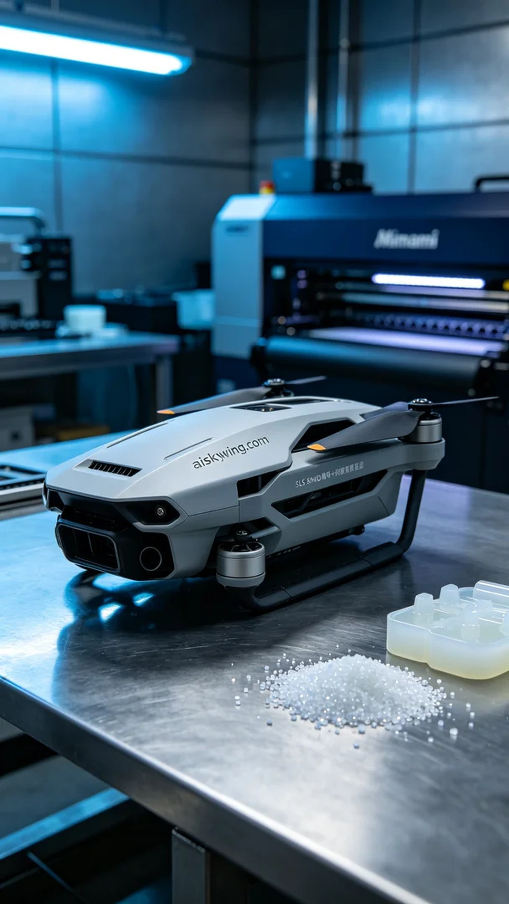
Aiskywing Industrial 3D Printing
Drone dispenser shell


