0530-高精度无人机排气管3D打印记录
Drone exhaust pipe
🖨️ SLM金属打印
🖥️ 打印机: Carbon
📦 材料: 摆放着未成型的液态光敏
在Facebook上，有人因为对无人机排气管的质量要求而找到了我们，这正是我们展示技术实力的机会。
On Facebook, someone reached out to us due to their quality requirements for drone exhaust pipes, which is exactly the opportunity for us to showcase our technical strength.
________________________________________________________________________________
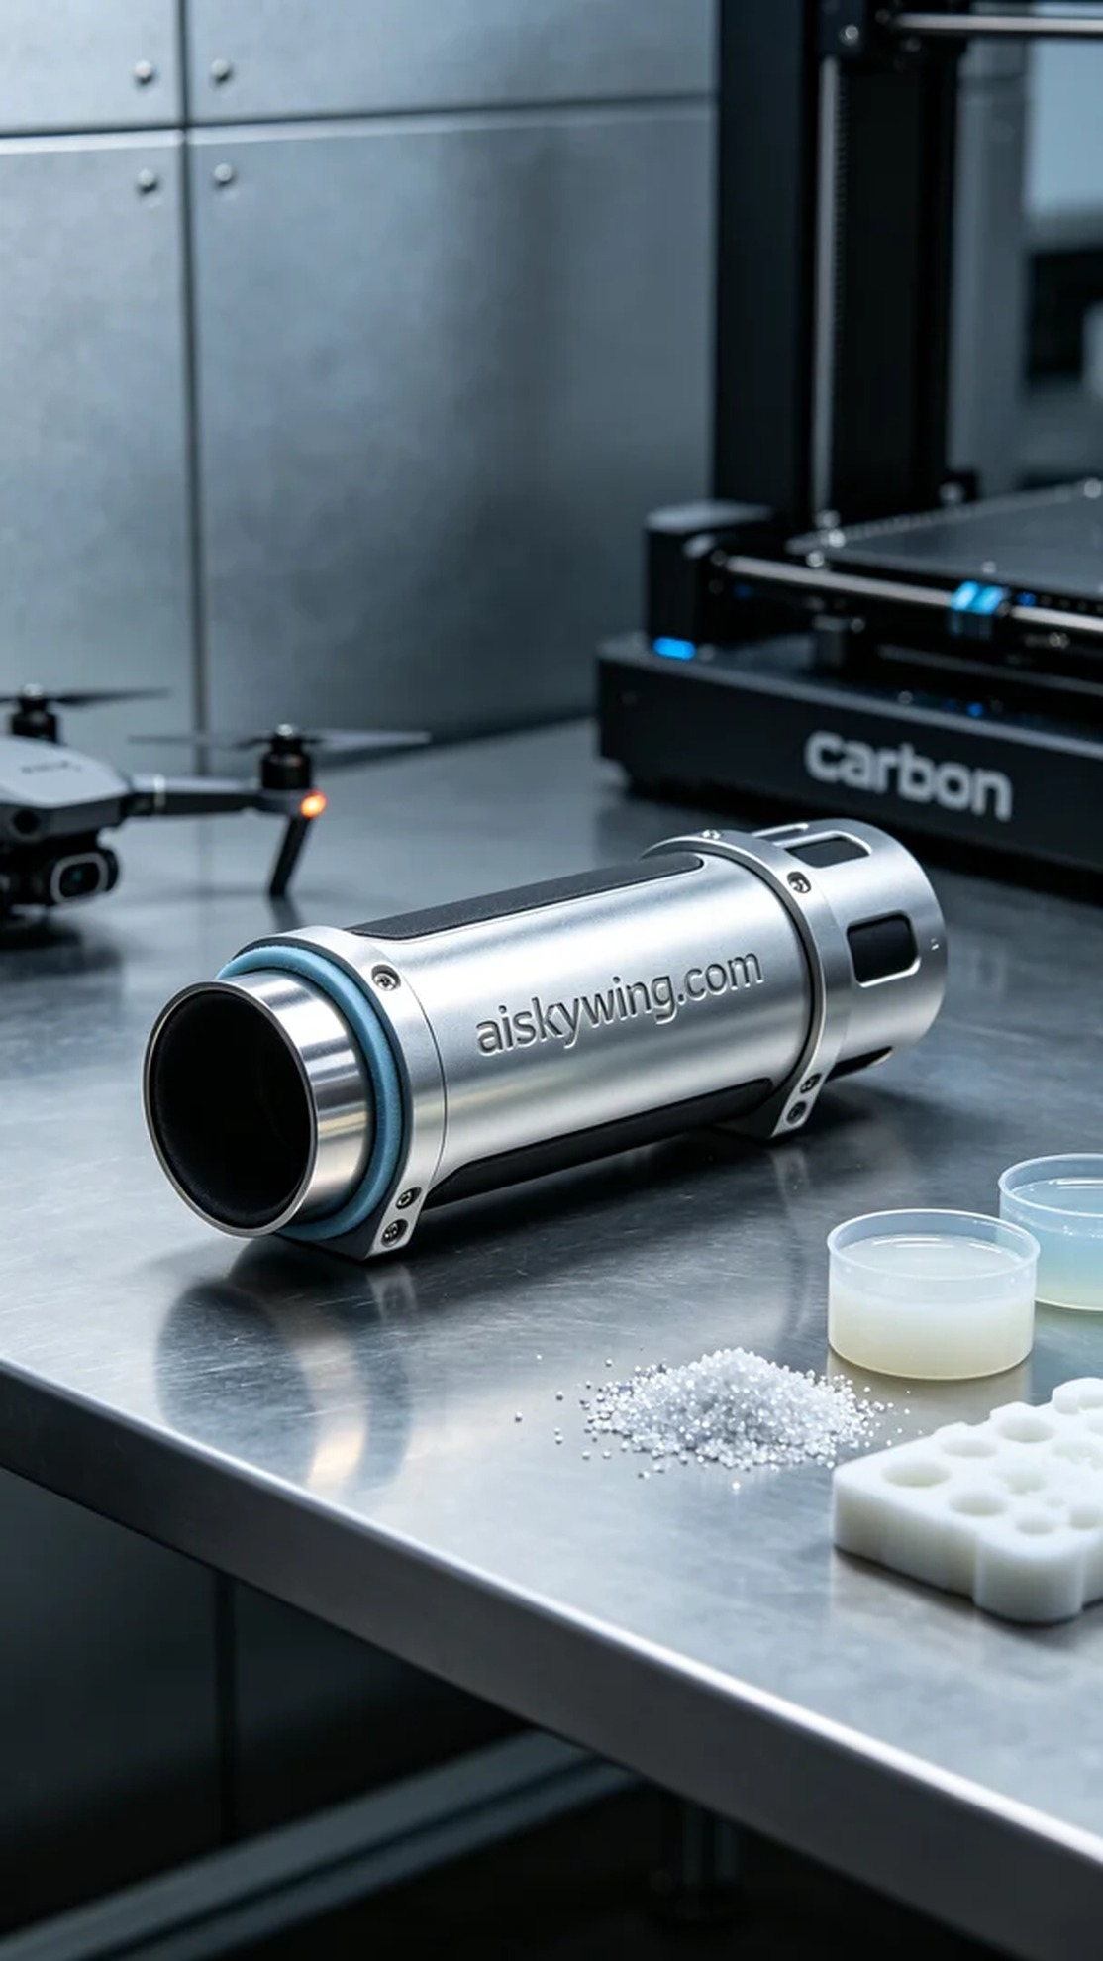
Today, we received an order for a drone exhaust pipe, with someone needing a high-quality, precise finished product. As 3D printing technology becomes more popular, more people hope to solve various complex manufacturing needs through our services. The design of this exhaust pipe is crucial; it must withstand high temperatures and ensure the overall performance of the drone, which adds to our sense of responsibility.
For materials, we used a supply of unformed liquid photosensitive resin, which has excellent flow properties and curing effects, making it suitable for printing complex structures. On the equipment side, we chose a Carbon 3D printer, and after adjustments, we set the layer thickness to 0.1mm, the printing temperature at 25°C, the laser power to 5W, and the printing speed to 50mm/s. These parameters laid a solid foundation for our subsequent production.
The printing process went quite smoothly, with the Carbon printer operating steadily. The liquid photosensitive resin was cured layer by layer by the laser, forming a clear profile of the exhaust pipe. Throughout this process, we continuously monitored the print quality to ensure that every detail met expectations, paying special attention to the engraving of “aiskywing.com” on the surface to avoid any flaws.
The post-processing steps are critical for ensuring the quality of the final product. First, we placed the printed exhaust pipe into a cleaning tank, using a cleaning solution to remove any uncured resin from the surface. Following that, we performed sanding to ensure a smooth finish, and then cured the material with UV light to enhance its durability. Finally, after a strict inspection, we ensured that each product met quality standards and was ready for delivery.
After a series of meticulous tasks, this drone exhaust pipe was finally completed. Every detail was carefully refined, and we look forward to its performance in practical use.
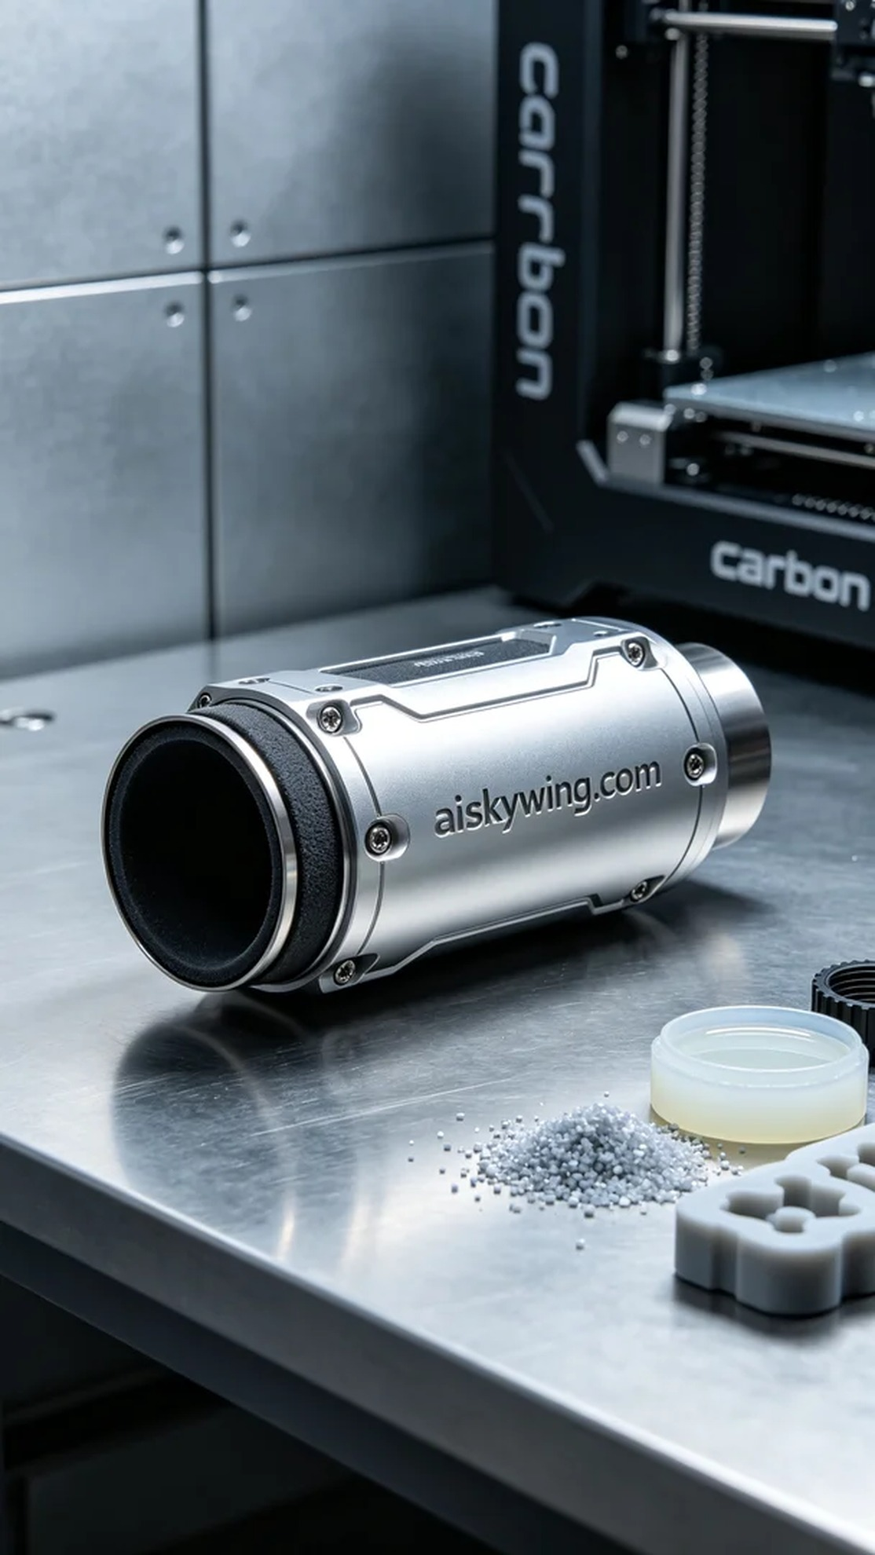
今天，我们接到一个关于无人机排气管的订单，客户需要的是高质量、精密的成品。随着3D打印技术的普及，越来越多人希望通过我们的服务解决各类复杂的制造需求。这个排气管的设计非常关键，它不仅要承受高温，还需确保无人机的整体性能，这让我们倍感责任重大。
在材料方面，我们使用的是摆放着未成型的液态光敏树脂，这种材料具有优异的流动性和固化效果，适合复杂结构的打印。设备方面，我们选用了Carbon品牌的3D打印机，经过调试后，设置了0.1mm的层厚，打印温度设定在25℃，激光功率为5W，打印速度为50mm/s。这些参数为我们后续的生产打下了良好的基础。
打印过程进行得相当顺利，Carbon打印机的运行稳定，液态光敏树脂通过激光逐层固化，形成了清晰的排气管轮廓。在这一过程中，我们不断监控打印质量，确保每个细节都达到预期效果。尤其是在表面雕刻“aiskywing.com”字样时，我们保持了高度的关注，以避免任何瑕疵的出现。
后处理工序是确保成品质量的关键步骤。首先，我们将打印完成的排气管放入清洗槽中，使用清洁液体去除表面未固化的树脂。之后，我们进行打磨，确保表面的光滑度，然后通过紫外线固化加固材料，提高其耐用性。最后，经过严格的检验，确保每一件产品符合质量标准，准备交付使用。
经过一系列细致的工作，这个无人机排气管终于完成了。每个细节都经过认真打磨，我们期待着它在实际使用中的表现。
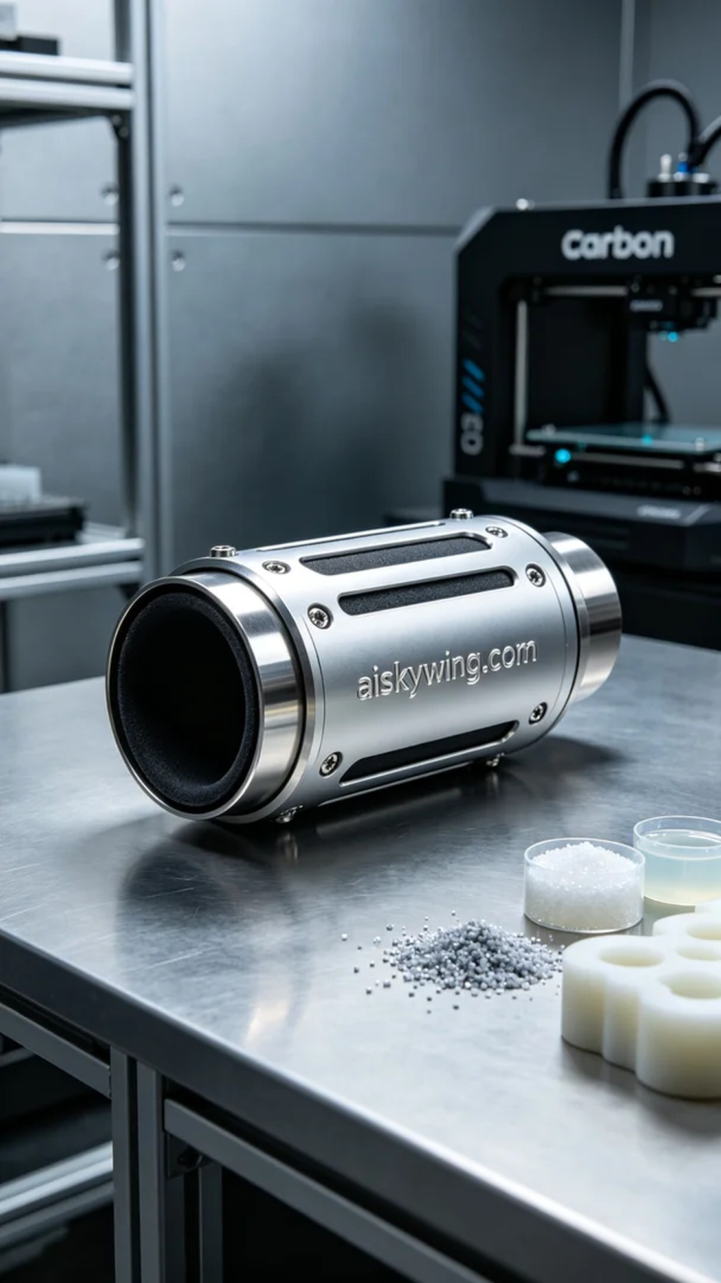
Aiskywing Industrial 3D Printing
Drone exhaust pipe


