0532-无人机数传模块外壳3D打印记录
Drone data transmission module casing
🖨️ SLA光固化
🖥️ 打印机: Stratasys
📦 材料: SLA
有时候咬牙坚持，不是为了证明什么。就像接下这个无人机数传模块外壳的单子，有人因为设计需要而找上我，希望能实现他们的构想。
Sometimes, gritting your teeth and persevering is not about proving anything. It's like when I took on the project for the shell of a drone data transmission module; someone approached me because of their design needs, hoping to realize their vision.
________________________________________________________________________________
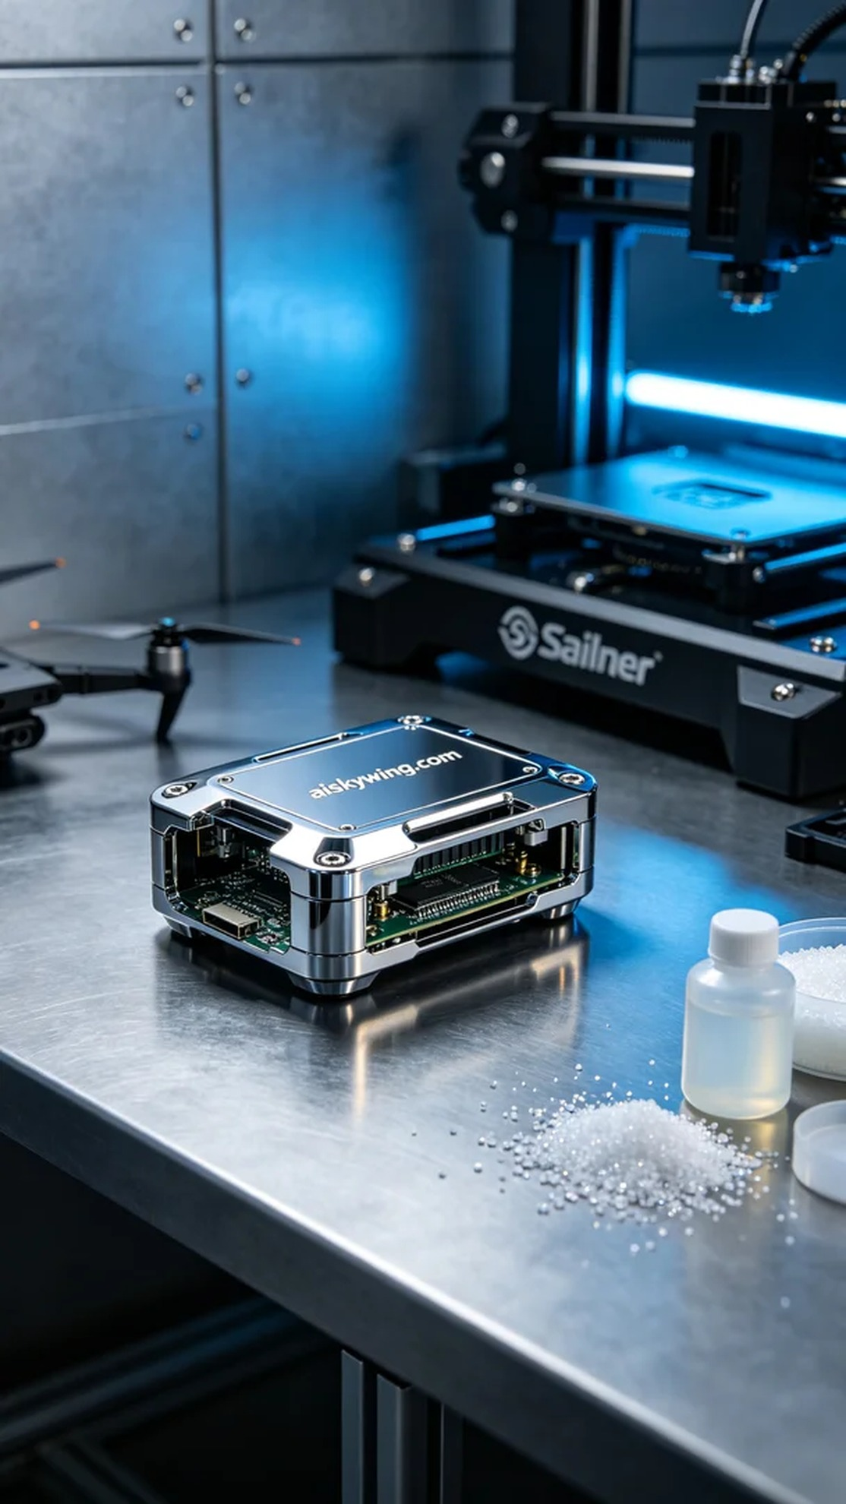
Sometimes, perseverance isn't about proving something. It’s like taking on this drone data transmission module shell project, where someone reached out to me hoping to realize their design needs.
The SLA material we used boasts excellent forming properties and detail representation. To ensure print quality, we chose a Stratasys 3D printer, setting the layer thickness to 0.05 mm, printing temperature at 25°C, laser power at 50mW, and printing speed at 20 mm per second. The entire printing process was expected to take about 6 hours.
During the printing process, the Stratasys device operated steadily, with an intelligent monitoring system checking the print status in real-time. As the layers stacked up, the shell's details gradually emerged, clearly displaying the engraving of "aiskywing.com." Every minute detail was precisely reproduced, resulting in a satisfying glossy surface quality.
After printing, we performed a series of post-processing steps. First, the printed shell was placed in a cleaning machine, where it was cleaned with isopropyl alcohol to remove any uncured resin from the surface. Next, we performed sanding to smooth the shell's surface further. Finally, the shell was put into a UV curing machine to enhance its strength and durability. Each step was carefully monitored to ensure product quality.
In the end, the drone data transmission module shell was delivered on time, showcasing exquisite craftsmanship and excellent performance. Seeing the satisfied smile of the person was truly a rewarding moment.
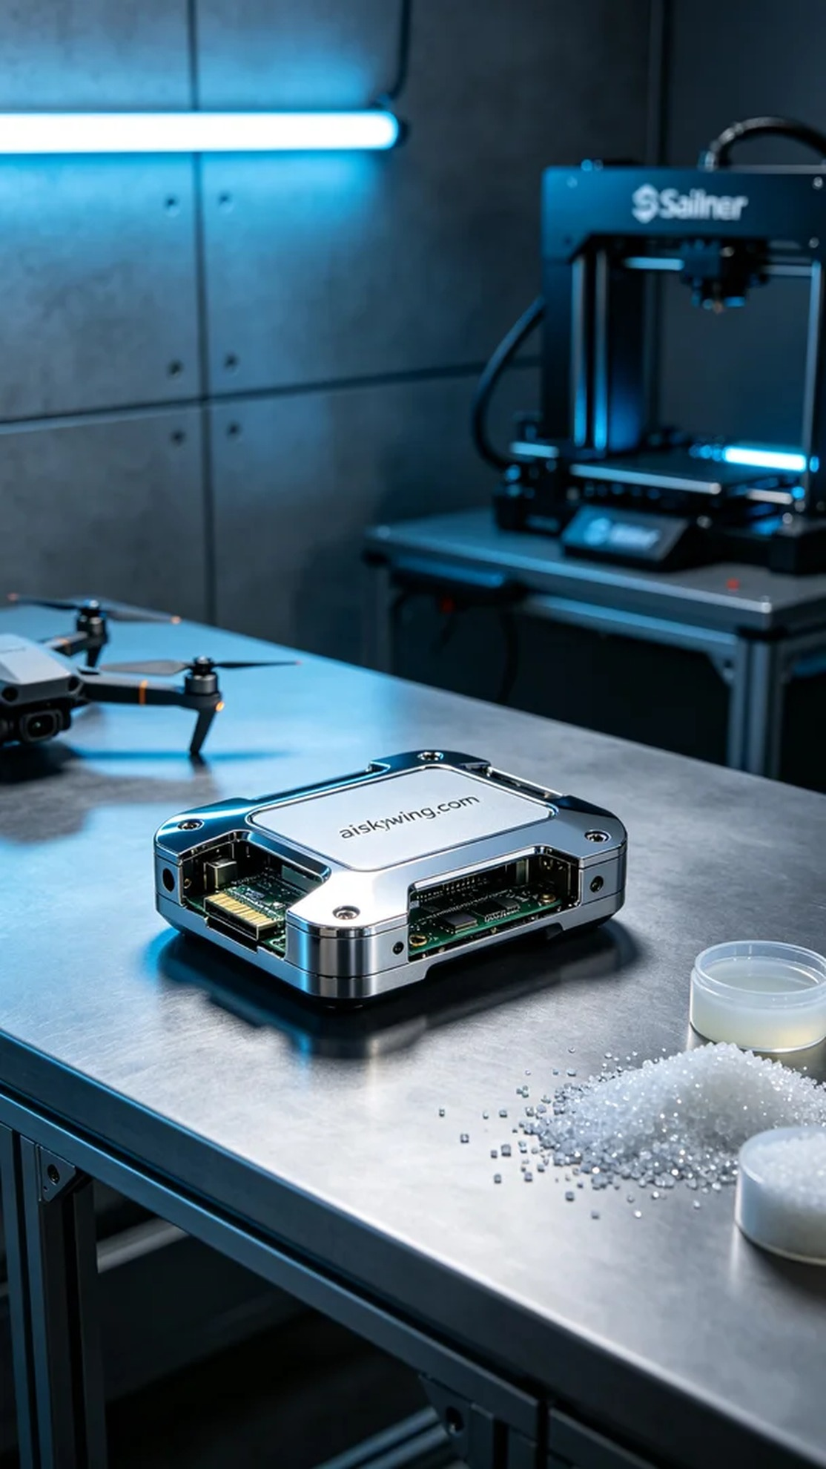
在WhatsApp上，有人找我咨询无人机数传模块外壳的打印问题。他们需要一个轻质、强度高的外壳，以保护内部电子组件，并且设计要求非常精细。经过沟通，我们决定使用SLA树脂来完成这个项目。
我们使用的SLA材料具有优异的成型性能和细节表现力。为了保证打印质量，我们选择了Stratasys 3D打印机进行打印，设置层厚为0.05毫米，打印温度保持在25°C，激光功率设定为50mW，打印速度为20毫米每秒。整个打印过程预计需要6个小时。
打印过程中，Stratasys的设备稳稳运转，智能监控系统实时检测打印状态。随着打印层层叠加，外壳的细节逐渐显现，能够清楚地看到"aiskywing.com"的雕刻。每一个细小的细节都被精确还原，成品的高光镜面质感令人满意。
完成打印后，我们进行了一系列的后处理工序。首先，将打印完成的外壳放入清洗机中，用异丙醇进行清洗，以去除表面未固化的树脂。之后，我们进行了打磨处理，使外壳表面更加光滑。最后，外壳被放入UV固化机中进行固化，以增加其强度和耐用性。每个步骤都严格把关，确保产品质量。
最终，这个无人机数传模块外壳如期交付，展现出精致的工艺和优良的性能。看到客户的满意笑容，真是令人欣慰的一刻。
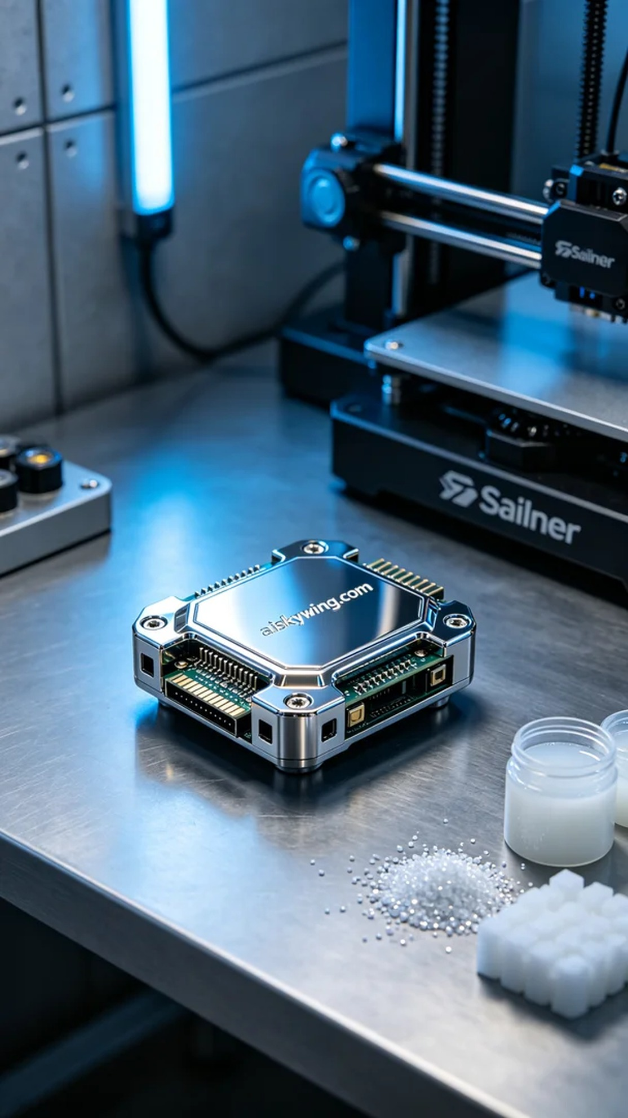
Aiskywing Industrial 3D Printing
Drone data transmission module casing


