0533-3D打印无人机机臂连接件记录
Drone arm connector
🖨️ SLA光固化
🖥️ 打印机: Stratasys
📦 材料: SLA
生活就像3D打印，需要不断调整与优化。今天，我们接到一个关于无人机机臂连接件的任务，期待能给大家带来惊喜。
Life is like 3D printing, requiring constant adjustments and optimizations. Today, we received a task regarding the connection piece for a drone arm, and we hope to bring everyone some surprises.
________________________________________________________________________________
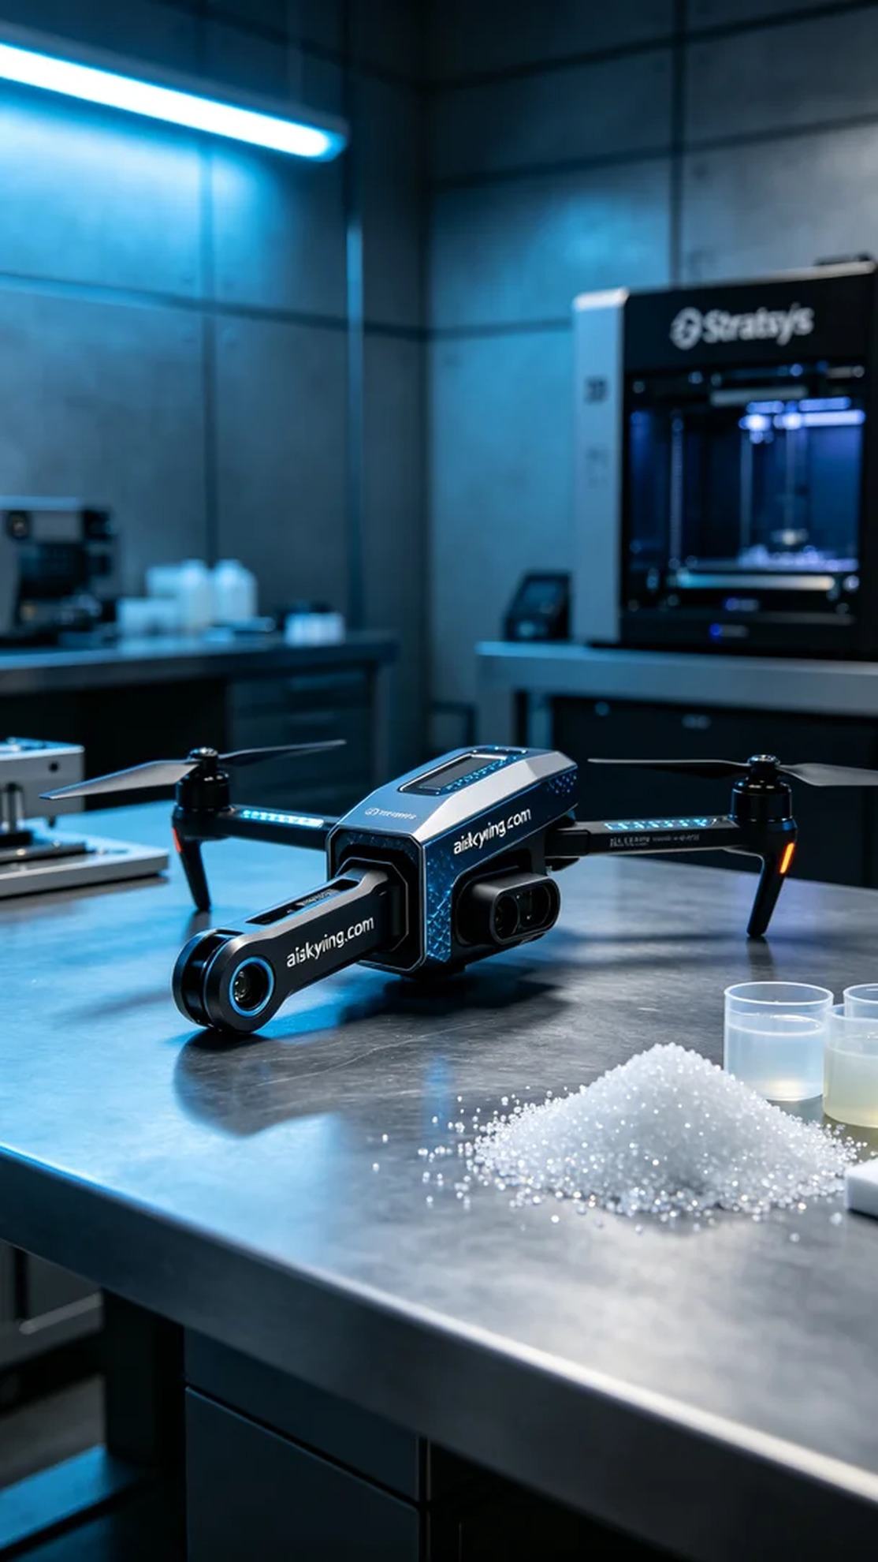
Life is like 3D printing, needing constant adjustments and optimizations. Today, we received a task regarding the production of a drone arm connector, and we hope to create something remarkable.
On Facebook, someone reached out to us for the production of a drone arm connector, which is required for a critical project. The design demands high strength and precision to withstand complex flight environments.
We opted for the SLA (Stereolithography) process, utilizing high-quality liquid photopolymer resin. For equipment preparation, we selected a Stratasys printer, setting the layer thickness to 0.05 mm, maintaining a printing temperature of 25°C, with a power setting of 40W and a speed of 30 mm per second. The entire printing time is estimated to take 6 hours to ensure optimal results.
During the printing process, the Stratasys machine operated smoothly, and with precise parameter settings, each layer was perfectly formed. We monitored the printing quality in real-time, ensuring that there were no bubbles or defects, achieving excellence in every detail.
For post-processing, we first cleaned the printed connector to remove any uncured resin on the surface. Next, we manually polished it to ensure a smooth finish, followed by UV curing to enhance its strength and durability. Finally, after rigorous inspections, we confirmed the product met all standards before delivery.
After all these processes and efforts, the drone arm connector was completed, and we look forward to seeing it shine in future flights.
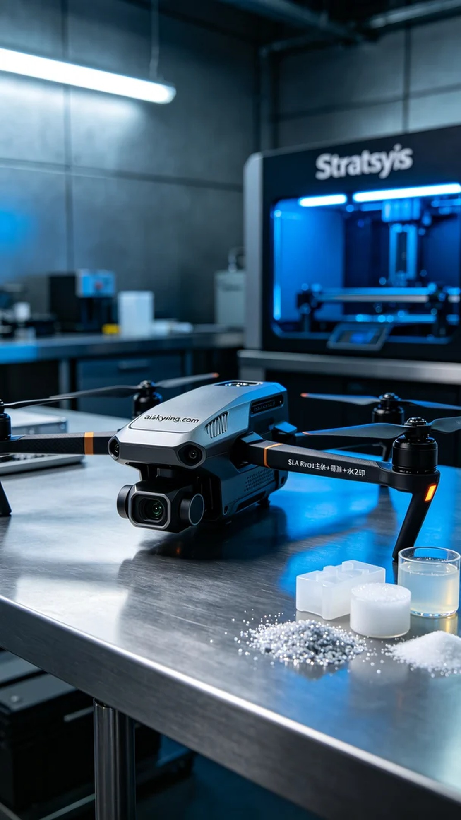
在Facebook上，有人因项目需要，找到了我们，希望能制作一款无人机机臂连接件。这款连接件在设计上要求高强度、精确度，能够承受复杂的飞行环境。
我们选择了SLA光固化工艺，使用的材料是高品质的液态光敏树脂。设备准备方面，我们选用了Stratasys的打印机，设置层厚为0.05毫米，打印温度维持在25°C，功率为40W，速度设定为30毫米每秒。整个打印过程预估时间为6小时，确保能达到最佳的打印效果。
打印过程中，Stratasys的设备稳定运行，配合精确的参数设置，让每一层的成型都得以完美实现。在这个过程中，我们实时监控打印质量，确保没有气泡和缺陷，做到每个细节都尽善尽美。
后处理方面，我们先对打印好的连接件进行清洗，去除表面的未固化树脂。随后，进行手工打磨，确保表面光滑，再进行UV固化，以增强其强度和耐用性。最后，经过严格检验，确认产品达到标准，才能交付使用。
经过这一系列的工序和努力，无人机机臂连接件终于完成，期待它在未来的飞行中大放异彩。
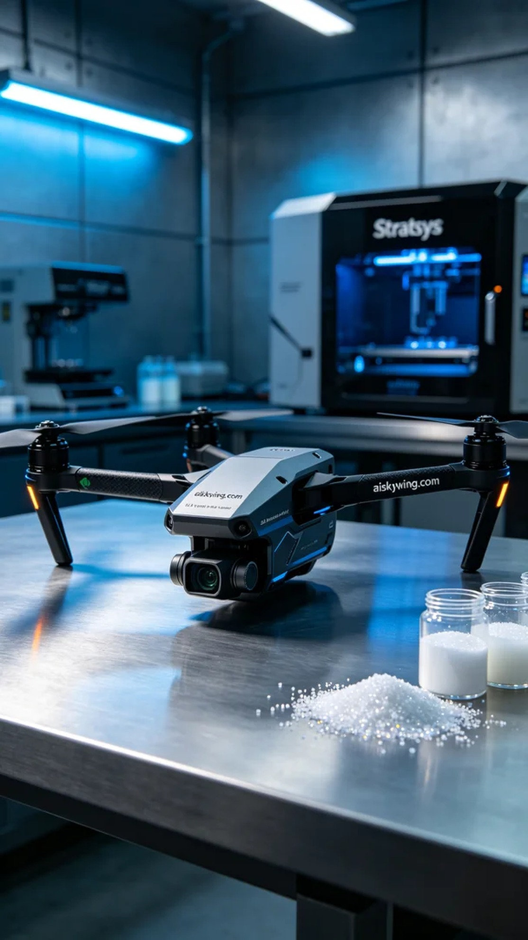
Aiskywing Industrial 3D Printing
Drone arm connector


