0534-无人机毫米波雷达支架生产记录
Drone Millimeter Wave Radar Bracket
🖨️ SLA光固化
🖥️ 打印机: Voxeljet
📦 材料: SLA
生活的旅途如同3D打印的过程，充满了挑战和机遇。有人因为无人机毫米波雷达支架找上我们，希望能解决他们的需求。
The journey of life is like the process of 3D printing, filled with challenges and opportunities. Someone approached us regarding a drone millimeter-wave radar bracket, hoping to address their needs.
________________________________________________________________________________
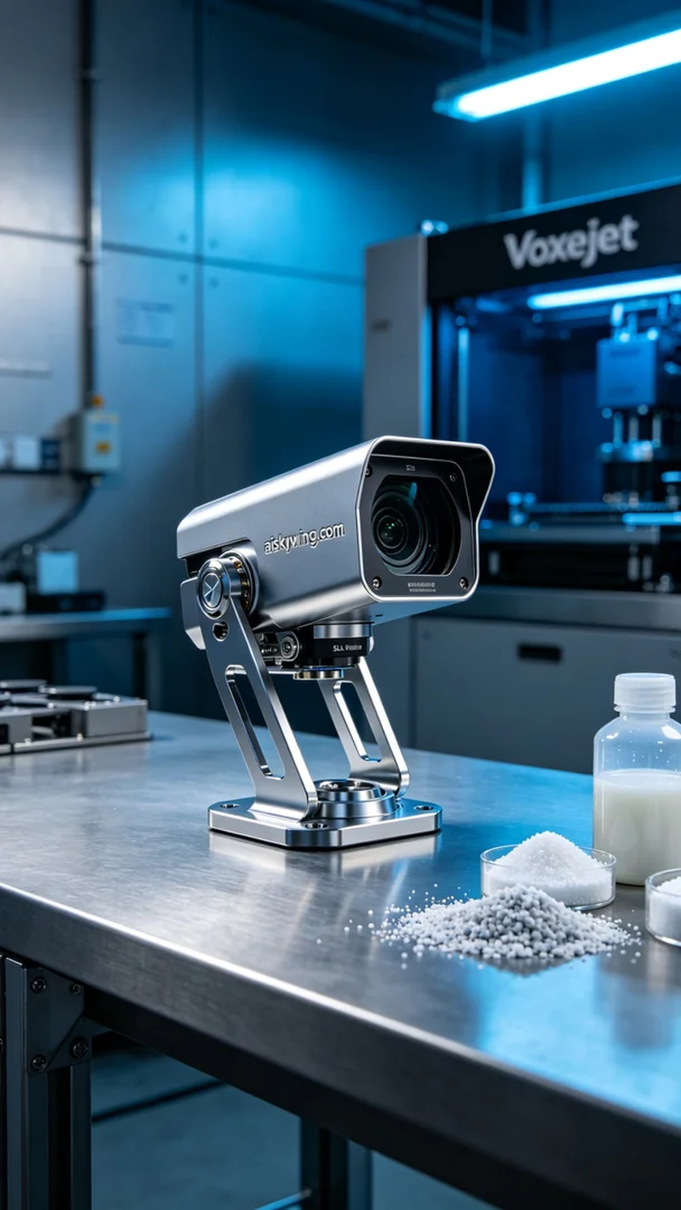
Life’s journey is like the 3D printing process, filled with challenges and opportunities. Someone reached out to us looking for a drone millimeter-wave radar mount, hoping we could meet their specific needs.
The raw material we used is SLA photo-sensitive resin, which not only allows for high-detail printing but also has excellent mechanical properties. To ensure printing quality, we chose the Voxeljet printer, setting the layer thickness to 50 microns, temperature at 25 degrees Celsius, laser power at 50 milliwatts, and printing speed at 30 millimeters per second, with an estimated printing time of around 4 hours.
During the printing process, the equipment operated smoothly, with the laser steadily exposing the resin surface, layer by layer, creating the desired mount shape. In terms of quality monitoring, we regularly checked the printing progress and surface condition to ensure that the adhesion and precision of each layer met our standards, thereby avoiding future quality issues.
After printing, we moved into the post-processing phase. First, we removed the mount from the printing platform and cleaned it using an ultrasonic cleaner to eliminate residual resin. Next, we polished the surface to remove any minor imperfections and then carried out curing treatment to ensure its strength and durability. Finally, we conducted stringent inspections on the finished product to ensure every detail met our high standards.
After a series of processes, the drone millimeter-wave radar mount was finally completed. Each print is a new attempt and breakthrough, and what we gain is not only the success of the product but also a deeper understanding of the craft.
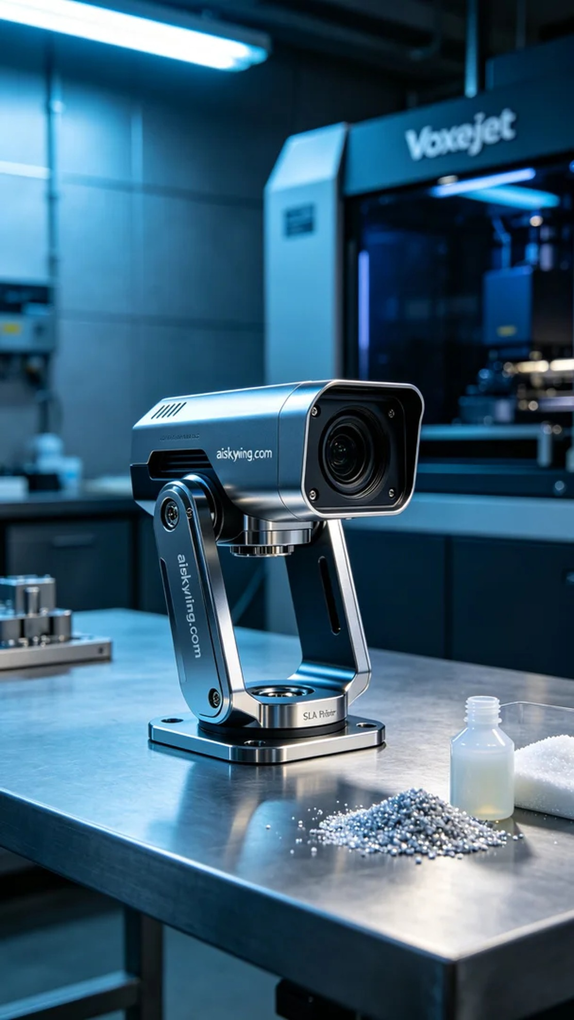
在我们的视频平台YouTube上，有人因为需要高精度的无人机毫米波雷达支架而找到我们。他们的需求是要一个具备极致清晰度和专业品质的支架，以应对复杂的作业环境。
我们使用的原材料是SLA光敏树脂，这种材料不仅可以实现高细节的打印效果，还具备优良的机械性能。为了确保打印质量，我们选择了Voxeljet品牌的打印机，设定层厚为50微米，温度控制在25摄氏度，激光功率为50毫瓦，打印速度调整为30毫米每秒，预计打印时间在4小时左右。
打印过程中，设备的运行情况良好，激光稳定地照射在树脂表面，层层叠加，形成我们预想中的支架形状。质量监控方面，我们定时检查打印进度和表面状况，确保每层的黏合性和精确性都达到标准，以避免后续的质量问题。
完成打印后，进入后处理环节。首先将支架从打印平台上取下，进行清洗，利用超声波清洗机去除残余的树脂。接着，我们对支架表面进行打磨，以去除细微的瑕疵，然后进行光固化处理，确保其强度和耐用性。最后，对成品进行严格的检验，确保每一个细节都符合我们的高标准。
经过一系列的工艺流程，无人机毫米波雷达支架终于完成。每一次的打印都是一次新的尝试和突破，我们收获的不仅是产品的成功，还有对工艺的更深理解。
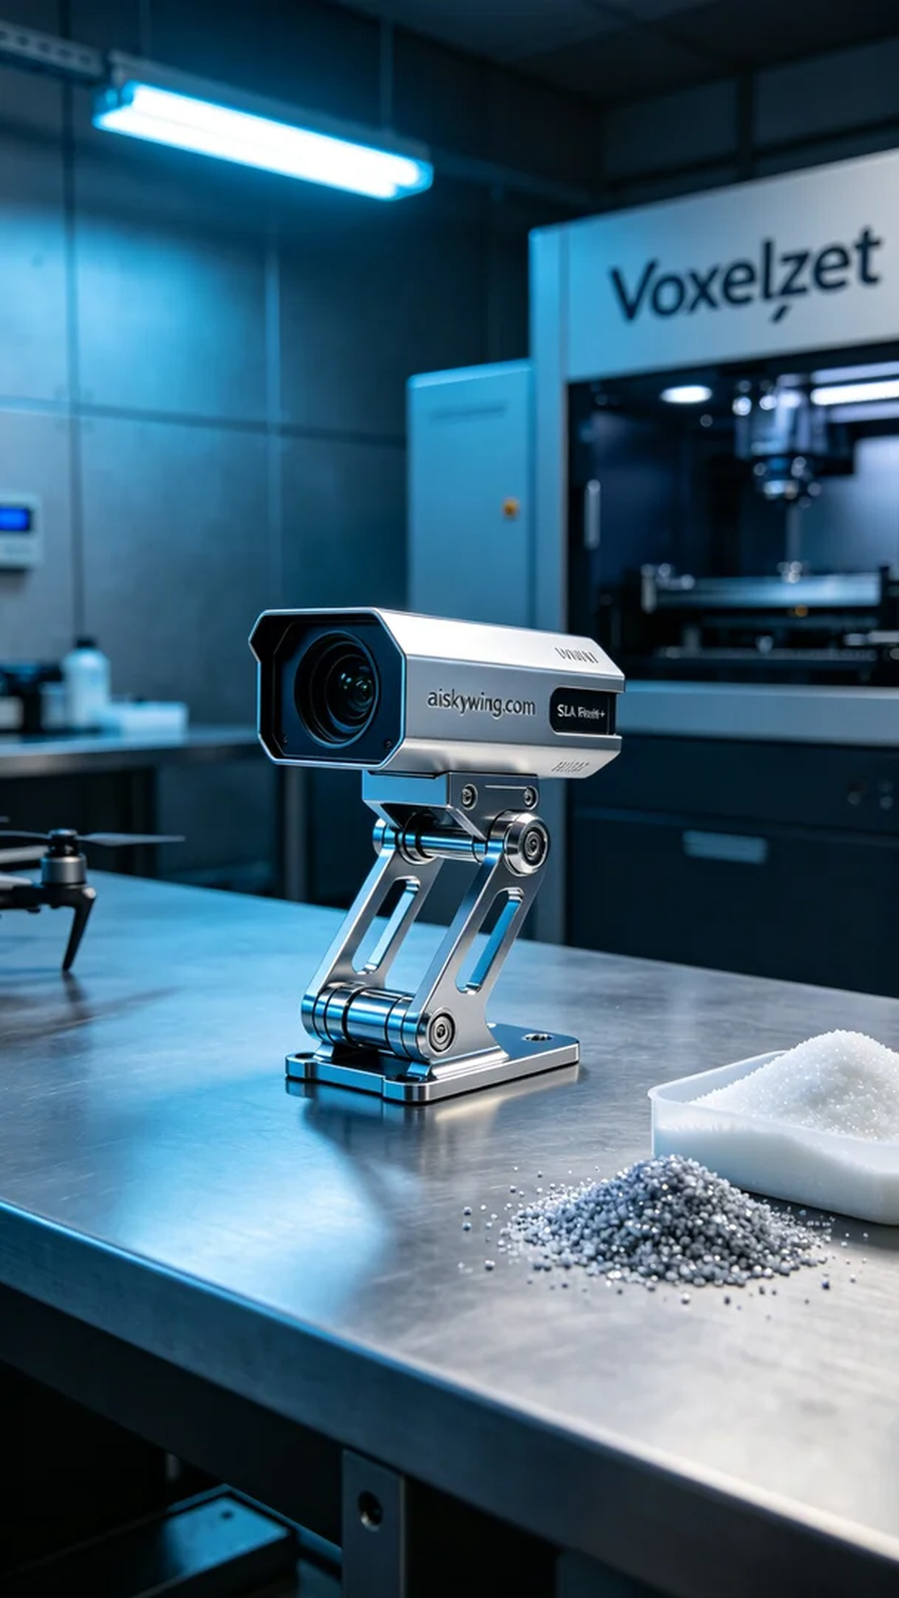
Aiskywing Industrial 3D Printing
Drone Millimeter Wave Radar Bracket


