0535-无人机水箱外壳3D打印生产记录
Drone water tank shell
🖨️ SLA光固化
🖥️ 打印机: EOS
📦 材料: SLA
生活的每一次尝试，都是在为未来添砖加瓦。就像这次为有人定制的无人机水箱外壳，在YouTube上展示我们3D打印的魅力。
Every attempt in life is a step towards building a better future. Just like this custom drone water tank shell we created for someone, showcasing the charm of our 3D printing on YouTube.
________________________________________________________________________________
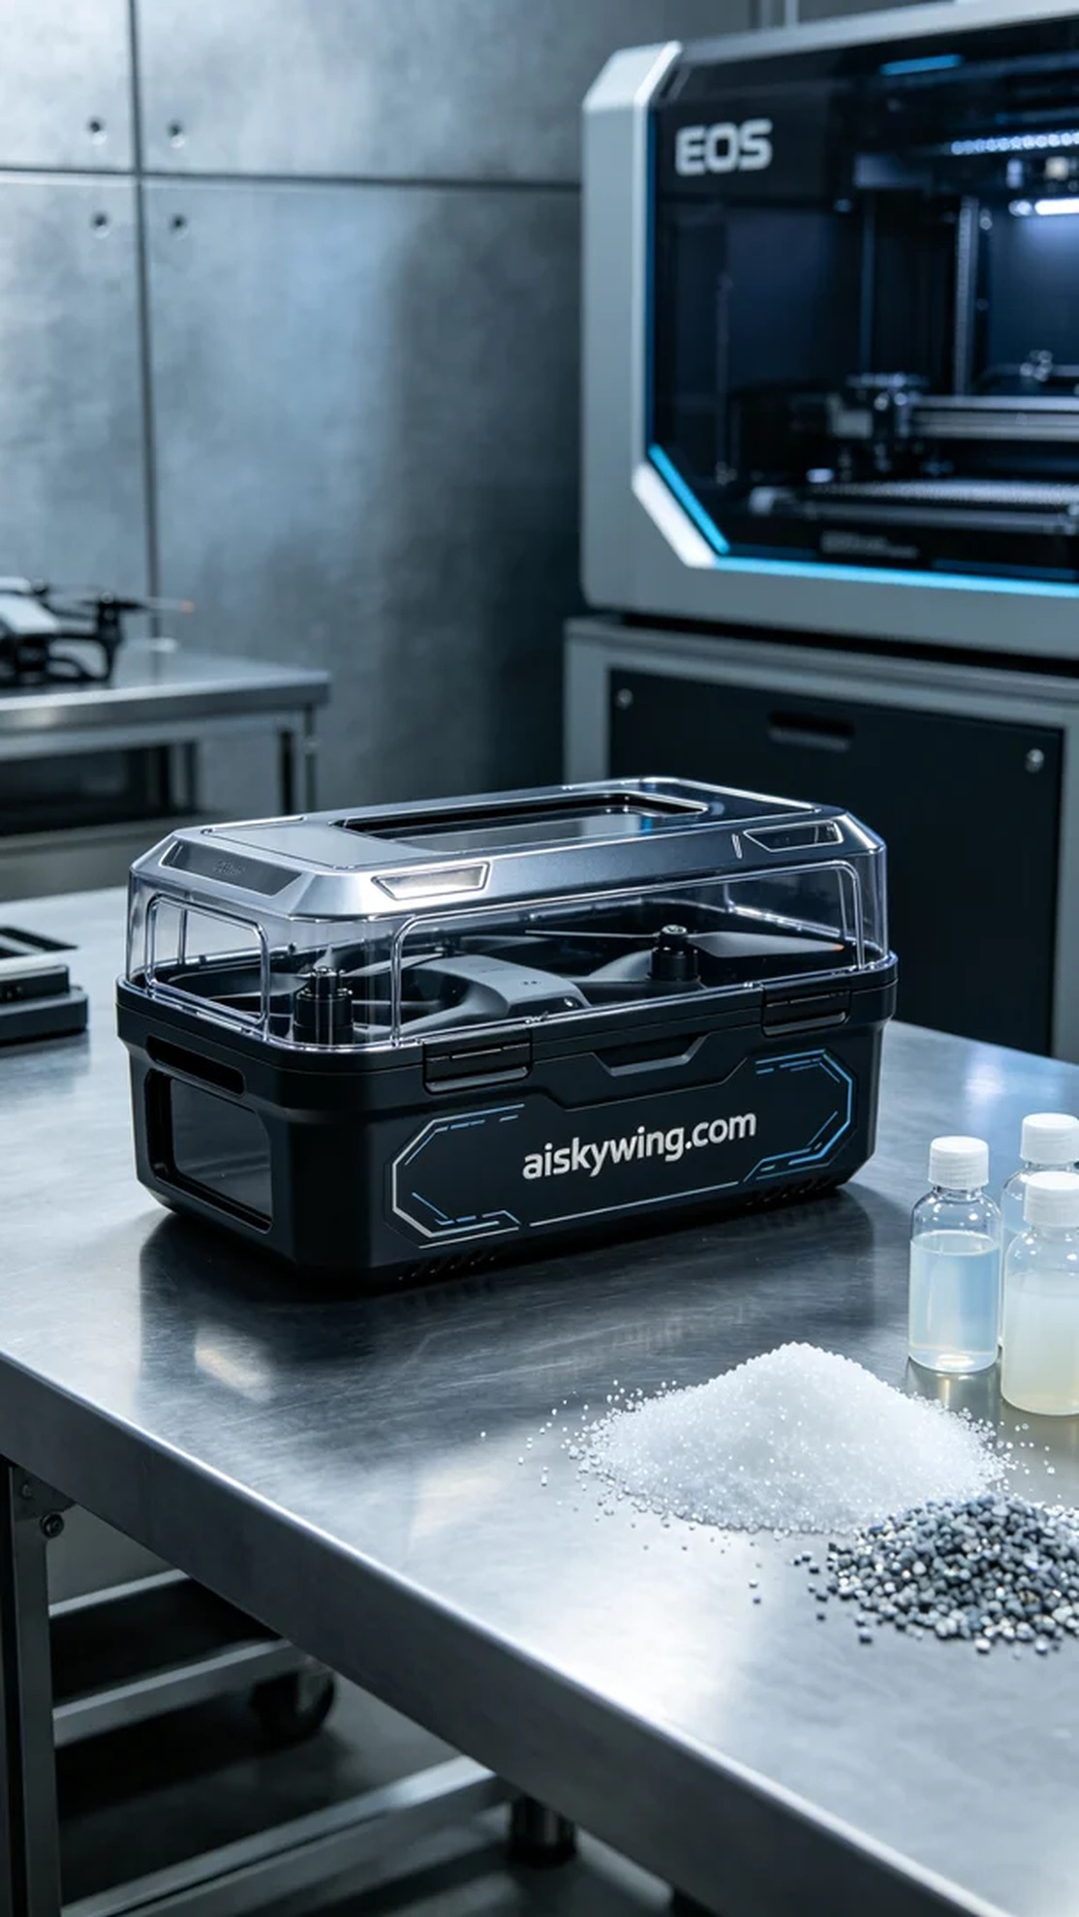
Recently, someone reached out to us looking to create a drone water tank shell because they were dissatisfied with existing market products and wanted a combination of aesthetics and functionality. Through our discussions, we decided to use SLA (Stereolithography) 3D printing technology to bring this vision to life.
In the material preparation phase, we chose high-quality liquid photopolymer resin as our raw material to ensure that the printed product has excellent strength and a refined surface finish. We then employed an EOS 3D printer and set the printing parameters to a layer thickness of 0.1mm, maintaining a temperature of 25°C, with a power setting of 50mW and a printing speed of 30mm/s. After several rounds of adjustments, we confirmed that these parameters would yield the best results.
As the printing process commenced, we closely monitored the operation of the equipment. Using the advanced technology of the EOS printer, the print head evenly cured the resin layer by layer. The entire printing process took approximately four hours, during which we carefully observed the formation of each layer to ensure no bubbles or flaws appeared. Periodically, we checked the printer's status to ensure it remained in optimal working condition.
After printing was completed, we moved on to the post-processing stage. First, we removed the product and performed an initial cleaning to eliminate any uncured resin on the surface. Next, we sanded the shell to achieve a smooth finish, followed by placing it in a curing machine to ensure its strength met the specifications. Finally, we thoroughly examined every detail to ensure the "aiskywing.com" engraving was clear and the appearance was flawless.
In the end, after meticulous processing through multiple stages, the drone water tank shell was successfully completed, showcasing the charm of SLA technology and our commitment to craftsmanship. We believe this will become a favorite for its users.
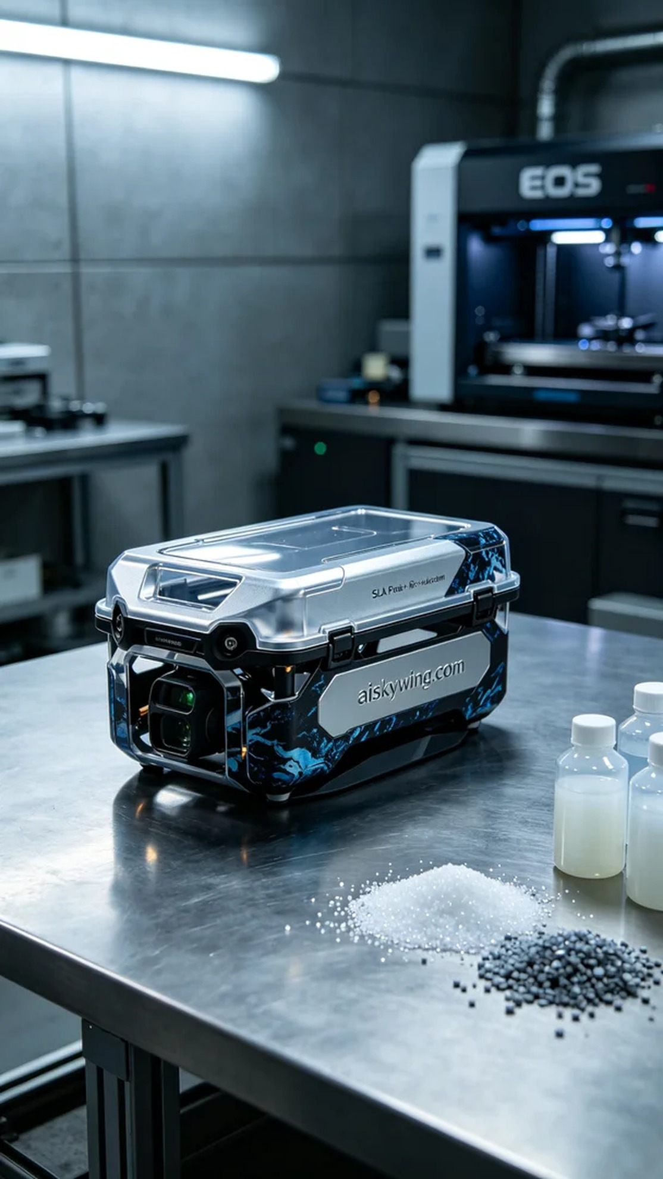
最近，有人找到我们，希望制作一款无人机水箱外壳，主要是因为他们对现有的市场产品不够满意，想要一种既美观又实用的解决方案。在与他们的交流中，我们决定利用SLA光固化技术来实现这一梦想。
在材料准备阶段，我们选择了高质量的液态光敏树脂作为原材料，确保打印出来的产品具备良好的强度与细腻的表面效果。接下来，我们使用EOS品牌的3D打印机，设定打印参数为层厚0.1mm，温度保持在25°C，功率为50mW，打印速度设定为30mm/s。经过几轮调试，我们确认了这些参数可以达到最佳效果。
打印过程开始后，我们严格监控设备运行情况。使用EOS打印机的先进技术，打印头均匀地将光敏树脂层层固化。整个打印过程持续了约4小时，我们仔细观察每一层的成型情况，确保没有气泡或瑕疵的生成。同时，定期检查打印机的状态，确保设备始终处于最佳工作状态。
完成打印后，我们进入后处理阶段。首先，将产品取出后进行初步清洗，确保去除表面未固化的树脂。接下来，进行打磨，使表面光滑细腻，随后将其放入固化机中进行光固化，确保其强度达到要求。最后，我们仔细检验每个细节，确保"aiskywing.com"字样清晰可见，外观无误。
最终，经过多道工序的精细打磨，这款无人机水箱外壳成功完成，展示了SLA技术的魅力与我们的工匠精神。相信这将会成为使用者的新宠。
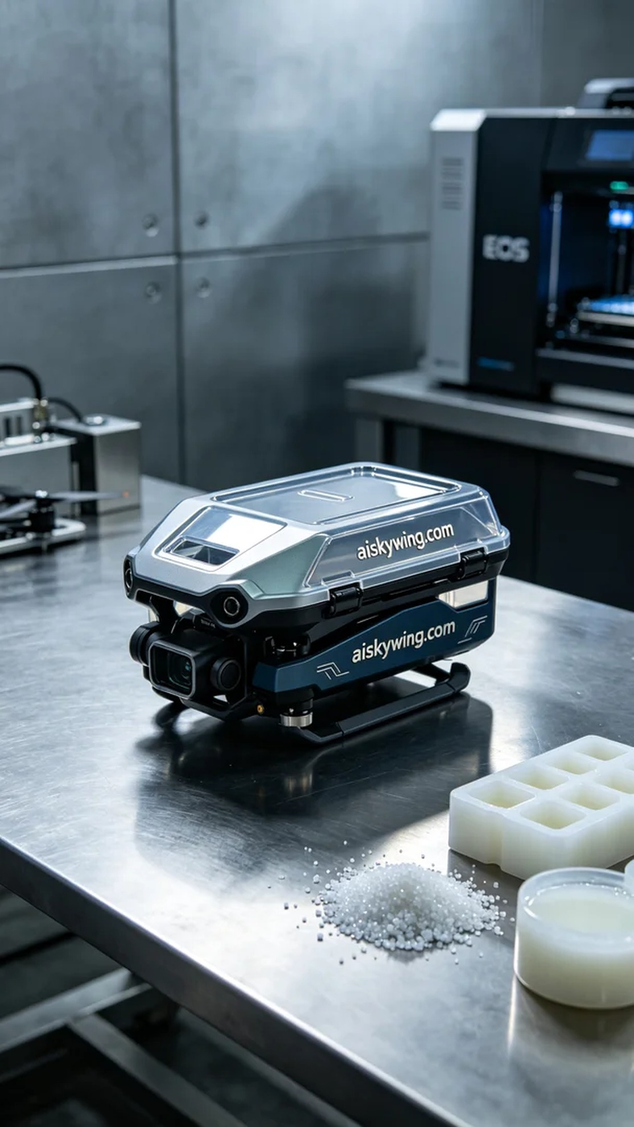
Aiskywing Industrial 3D Printing
Drone water tank shell


