0536-无人机油箱外壳3D打印实录
Drone fuel tank shell
🖨️ SLS尼龙烧结
🖥️ 打印机: Systems
📦 材料: 摆放着未成型的液态光敏
生活中总有挑战，但我们不能退缩。就像接下这个无人机油箱外壳的单子，有人因为寻找更轻更耐用的解决方案找到了我们。
Life is always full of challenges, but we must not back down. Just like when we took on the order for the drone fuel tank shell; someone found us while searching for a lighter and more durable solution.
________________________________________________________________________________
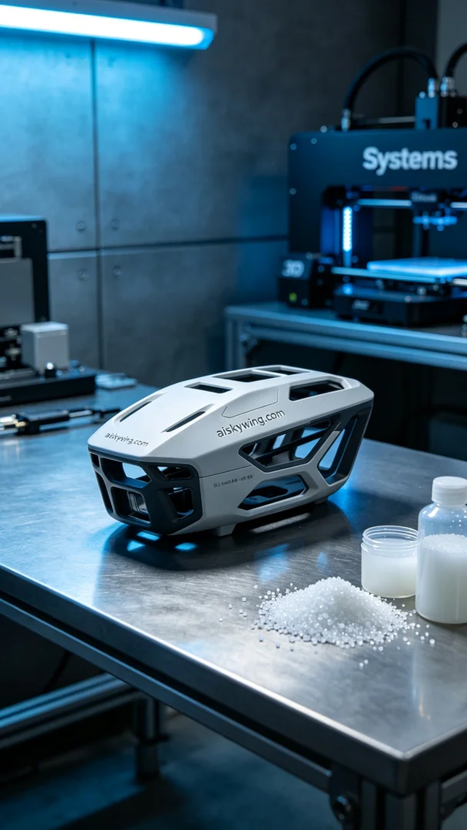
The creation of the drone fuel tank shell began with an inquiry on Twitter, where someone sought a better solution due to the inadequacies of traditional materials. We accepted the challenge to print a high-performance fuel tank shell for them.
The material we used was unformed liquid photopolymer resin, which possesses excellent strength and toughness after curing. As for the equipment, we chose the Systems brand 3D printer. To ensure print quality, we set a layer thickness of 0.1mm, a printing temperature of 25°C, a light source power of 50mW, and an adjusted printing speed of 40mm/s, estimating the entire print process to take about 8 hours.
During the printing process, the Systems printer operated steadily, with the print head precisely working on each layer. We closely monitored the print quality, ensuring there were no bubbles or adhesion issues, checking the print status periodically to avoid any surprises.
After printing, we carried out detailed post-processing steps. First, we cleaned the surface with solvent to remove any uncured resin residue. Then, we meticulously sanded the surface using professional tools to ensure smoothness, and finally, we placed it in a UV curing chamber, where it underwent curing for 30 minutes before conducting a final quality inspection to ensure that every detail met high standards.
With this production, we successfully delivered a precise drone fuel tank shell, proving the immense potential of 3D printing technology in the manufacturing field.
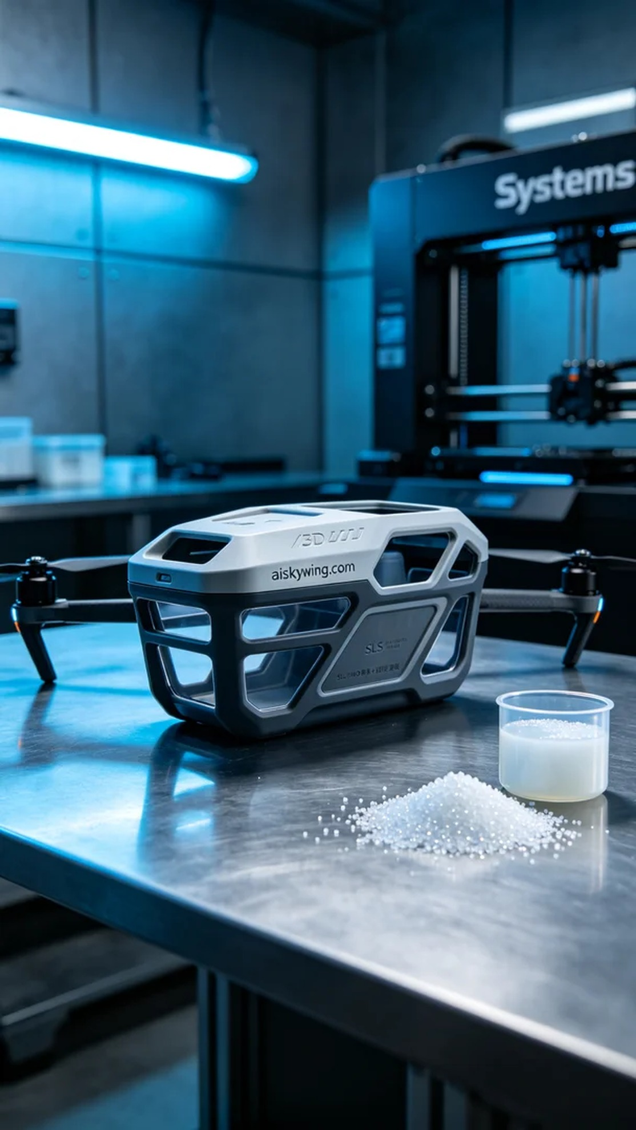
无人机油箱外壳的制作始于Twitter上的一个询问，有人因为传统材料的不足而希望能找到一个更优的解决方案。我们接受了这个挑战，准备为他们打印出一个高性能的油箱外壳。
我们使用的是未成型的液态光敏树脂，这种材料在固化后具备优良的强度和韧性。而设备方面，我们选择的是Systems品牌的3D打印机。为了确保打印质量，我们设置了0.1毫米的层厚，打印温度设定在25°C，光源功率保持在50mW，打印速度调整为40mm/s，整个打印过程预计需要耗时8小时。
在打印过程中，Systems打印机稳定运行，打印头精确地在每一层上进行作业。我们密切监控打印质量，确保没有气泡和材料附着不良的问题，每隔一段时间就检查一下打印状态，以防出现任何意外。
打印完成后，我们进行了精细的后处理工序。首先用溶剂清洗表面，去除未固化的树脂残留。随后，采用专业的打磨工具细致地打磨表面，确保光滑度，最后将其放入UV固化箱中，经过30分钟的固化后，我们进行了最终的质量检验，确保每个细节都达到高标准。
经过这次生产，我们成功地交付了一个精密的无人机油箱外壳，证明了3D打印技术在制造领域的巨大潜力。
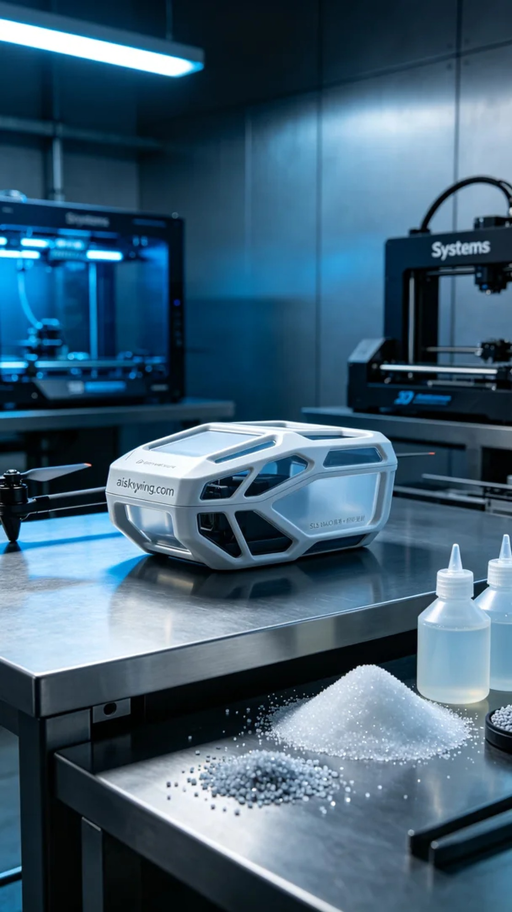
Aiskywing Industrial 3D Printing
Drone fuel tank shell


