0537-无人机激光雷达支架3D打印记录
Drone LiDAR Mount
🖨️ SLS尼龙烧结
🖥️ 打印机: Carbon
📦 材料: 摆放着未成型的液态光敏
生活就像3D打印一样，需要耐心和细致。有人因为技术要求高找上我们，制作这个无人机激光雷达支架，挑战在于如何实现其精密的设计。
Life is like 3D printing; it requires patience and attention to detail. Some people come to us because of the high technical requirements, seeking to create this drone LiDAR mount. The challenge lies in how to achieve its precise design.
________________________________________________________________________________
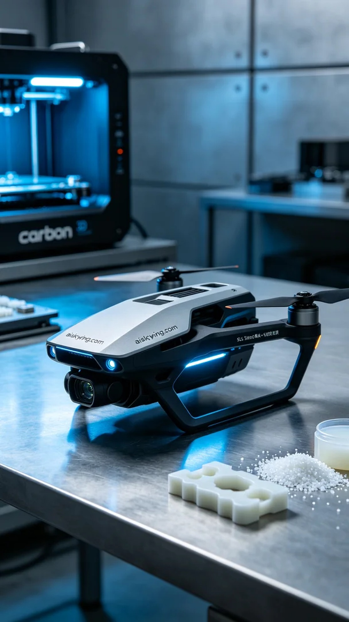
Life is like 3D printing; it requires patience and attention to detail. Recently, someone reached out to us through LinkedIn, seeking to produce a drone LiDAR support. The challenge lay in achieving its precise design while ensuring it met the required technical specifications.
We opted for SLS nylon sintering technology, using liquid photopolymer resin as the raw material. For the printing process, we utilized a Carbon printer and set the parameters accordingly. The layer thickness was adjusted to 0.1 mm, maintaining a temperature of 65 degrees Celsius, with a power setting of 80%. The printing speed was tuned to 30 mm per hour, with an estimated total print time of 6 hours, ensuring the resulting support would have optimum precision and surface smoothness.
Once the printing started, the equipment operated smoothly. We monitored the process closely, ensuring that each layer formed accurately. High-resolution sensors were employed to detect any issues in real-time, preventing problems like warping or adhesion, thus maintaining the integrity and strength of the support.
After printing, we conducted a thorough post-processing of the support. First, we used cleaning solution to remove residual material from the surface. Next, through sanding, we achieved a smoother surface to reduce unwanted friction. Finally, the support was placed in a curing device to ensure the material's strength was maximized. After a series of inspections, the final product not only met the requirements but also boasted an exquisite appearance.
Ultimately, the drone LiDAR support was successfully completed, meeting all expectations. Through this experience, we once again validated the immense potential of 3D printing technology in product design and application.
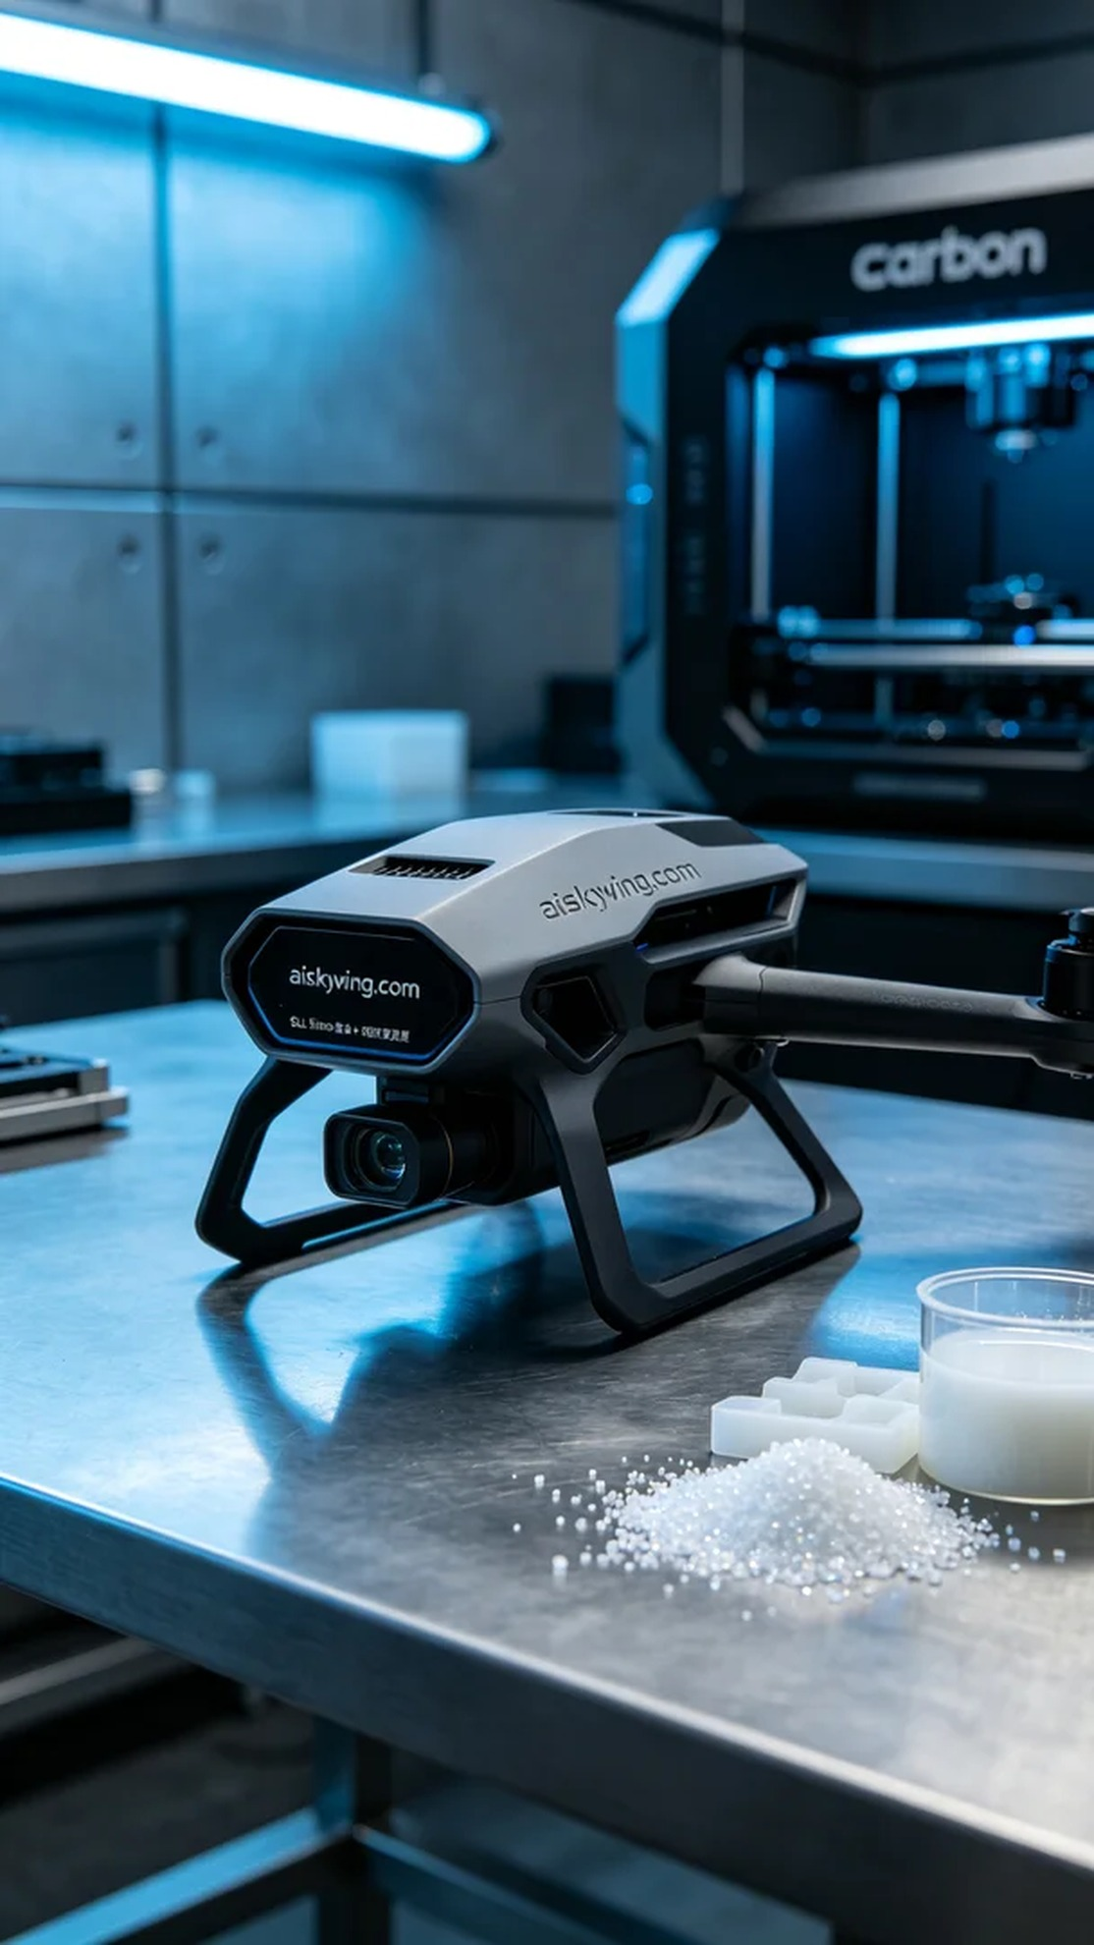
最近，有人通过LinkedIn找到我们，提到需要制作一个无人机激光雷达支架。他们在寻找一种既能满足轻量化又能保持强度的解决方案。这个支架不仅要能够承载各种雷达设备，还要具备一定的抗冲击能力，以应对复杂环境。
我们选择了SLS尼龙烧结工艺，并使用摆放着未成型的液态光敏作为原材料。打印机方面，我们使用了Carbon品牌的设备，准备了合适的参数。打印层厚设定为0.1毫米，温度保持在65摄氏度，功率为80%，打印速度调至每小时30毫米，整体预计打印时间为6小时，这样可以确保打印出的支架具有更好的精度和表面光滑度。
打印开始后，设备稳定运行。我们全程监控打印过程，确保每一层都能精准成型。在整个过程中，使用高分辨率的传感器随时检测打印质量，确保没有出现翘曲或粘连等问题，这样可以保证支架的精密度和强度。
在打印完成后，我们对支架进行了详细的后处理。首先，使用清洗液将支架表面的残余材料清洗干净。接着通过打磨工序，使表面更加光滑，减少不必要的摩擦。最后，我们将支架放置在固化设备中进行固化，确保材料的强度达到最佳状态。经过一系列检验，最终的支架不仅符合要求，而且在外观上也十分精致。
最终，这个无人机激光雷达支架成功完成，达到了预期效果。通过这次经验，我们再次验证了3D打印技术在产品设计与应用上的强大潜力。
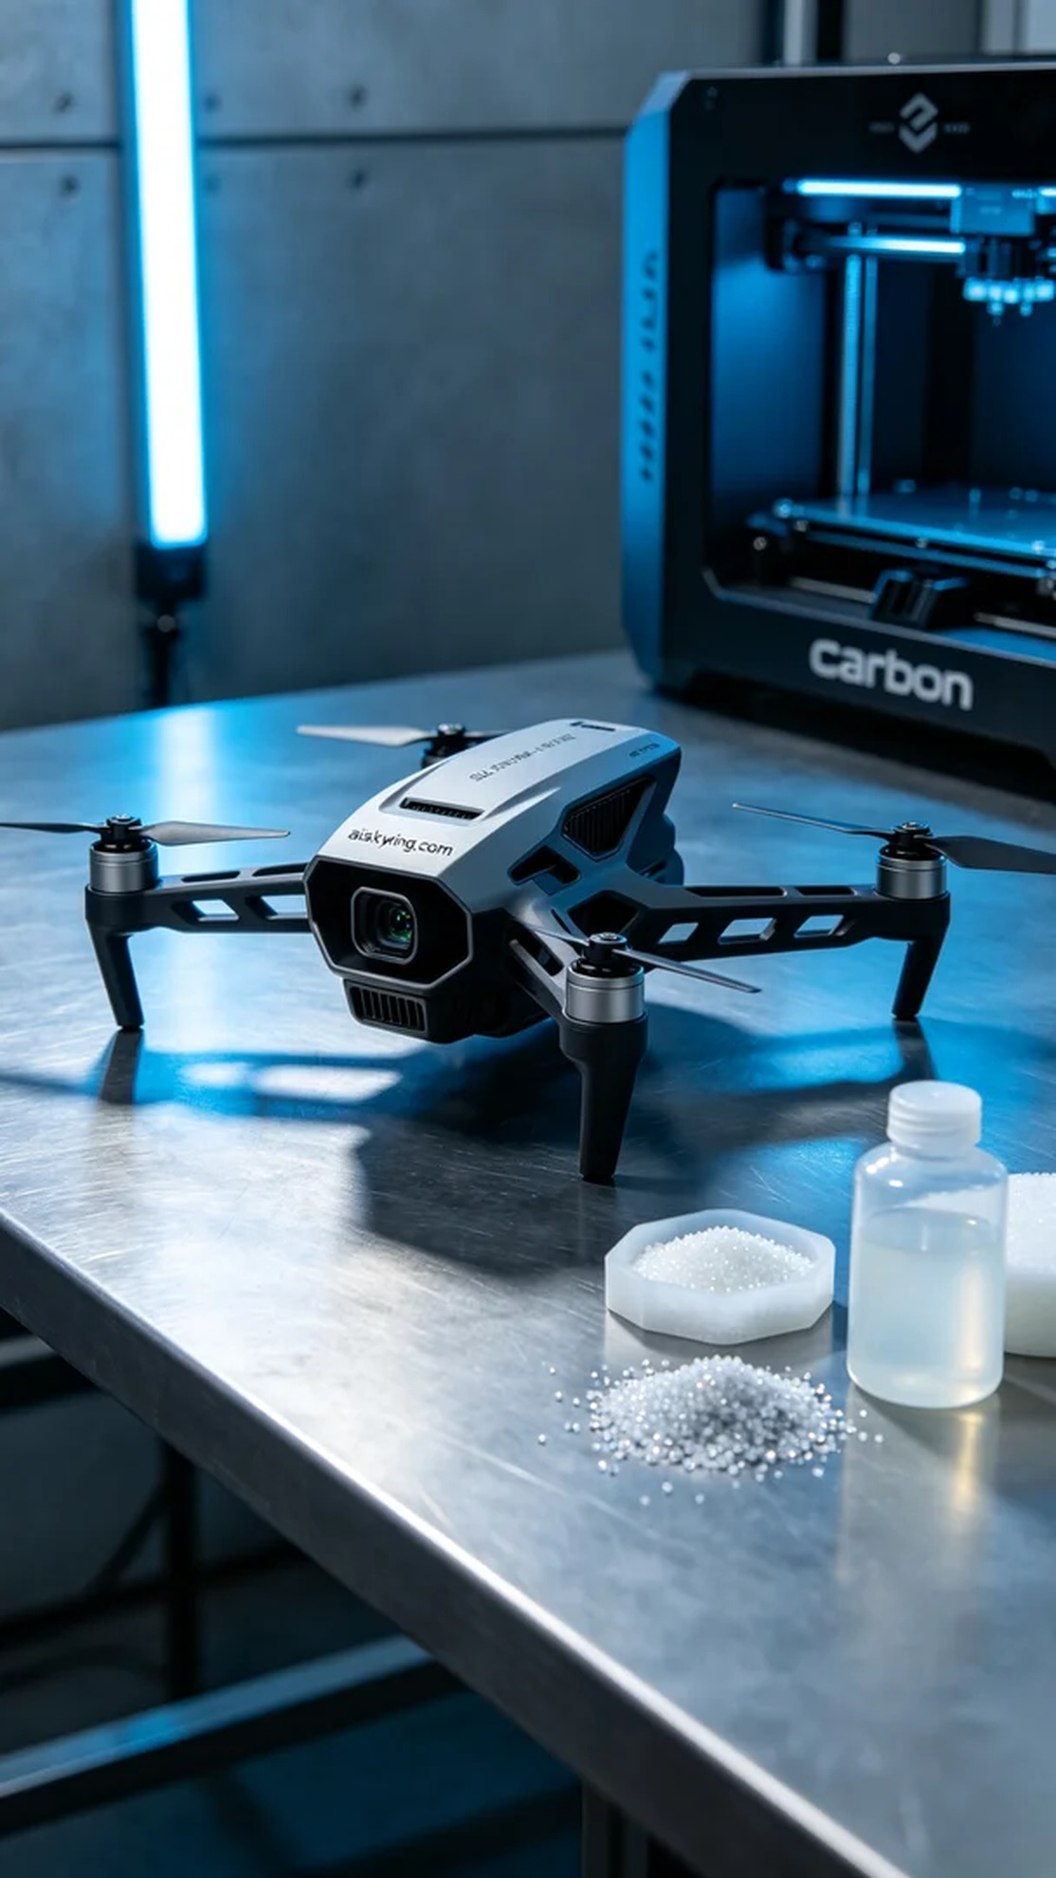
Aiskywing Industrial 3D Printing
Drone LiDAR Mount


