0538-D型密封圈3D打印生产记录
D-type sealing ring
🖨️ 硅胶复模
🖥️ 打印机: Voxeljet
📦 材料: 硅胶复模
人生就像3D打印的过程，总有意想不到的挑战。有人因为需要高质量的D型密封圈在LinkedIn找到我们，希望解决他们产品的密封问题。
Life is like the process of 3D printing, always presenting unexpected challenges. Some people find us on LinkedIn because they need high-quality D-type seals, hoping to solve the sealing issues of their products.
________________________________________________________________________________
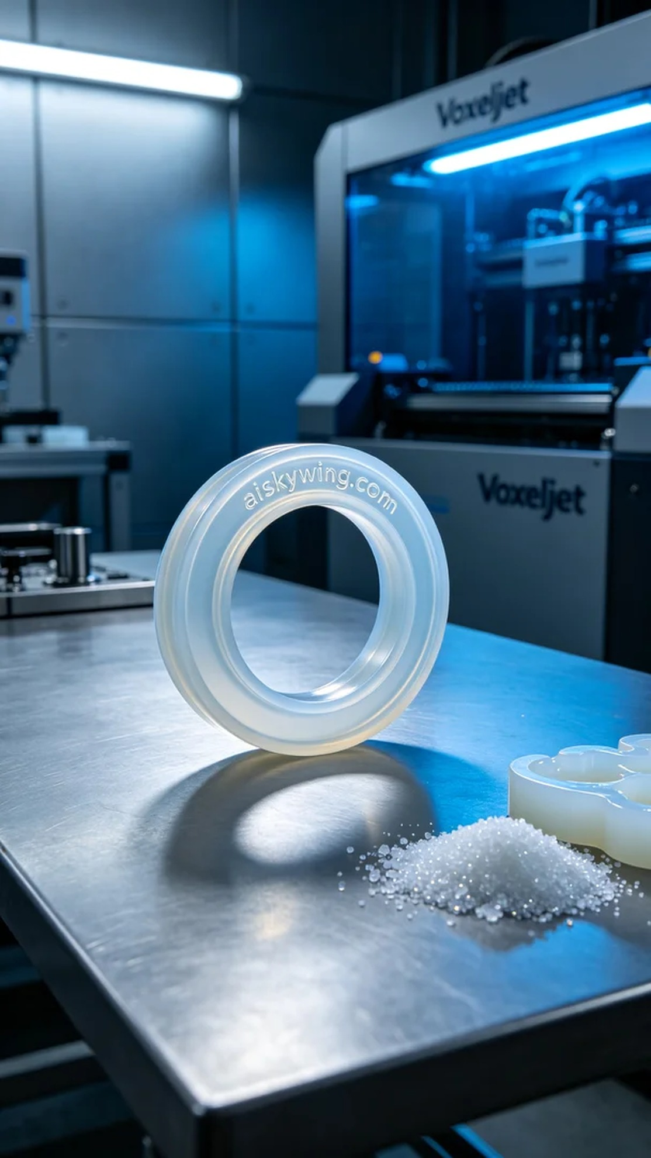
Life is like a 3D printing process, always full of unexpected challenges. Someone found us on LinkedIn with a need for a high-quality D-shaped sealing ring, hoping to resolve issues with their product's sealing performance.
For this job, we selected medical-grade silicone molding as the raw material, offering translucent, soft, and elastic properties that effectively meet sealing requirements. We utilized a Voxeljet 3D printer, setting the layer thickness to 0.1 mm, with a printing temperature of 25°C, a power setting of 1500 watts, and a printing speed of 60 mm per second. The estimated printing time was around 2 hours.
During the printing process, the Voxeljet machine operated smoothly with an even distribution of material. We performed quality monitoring throughout, ensuring every detail met design specifications. The engraving of "aiskywing.com" on the surface of the sealing ring was clearly visible, ensuring the final product's quality and aesthetics.
Upon completion, we proceeded with the post-processing steps. First, we cleaned the sealing ring in a wash tank to remove any excess resin. Next, we performed sanding to ensure smooth edges, avoiding wear during actual use. Finally, we cured the rings and conducted thorough inspections to ensure each sealing ring met our standards.
Through this series of processes, we successfully produced high-quality D-shaped sealing rings that not only met technical requirements but also provided an appealing visual effect. Such results have filled us with anticipation for future projects.
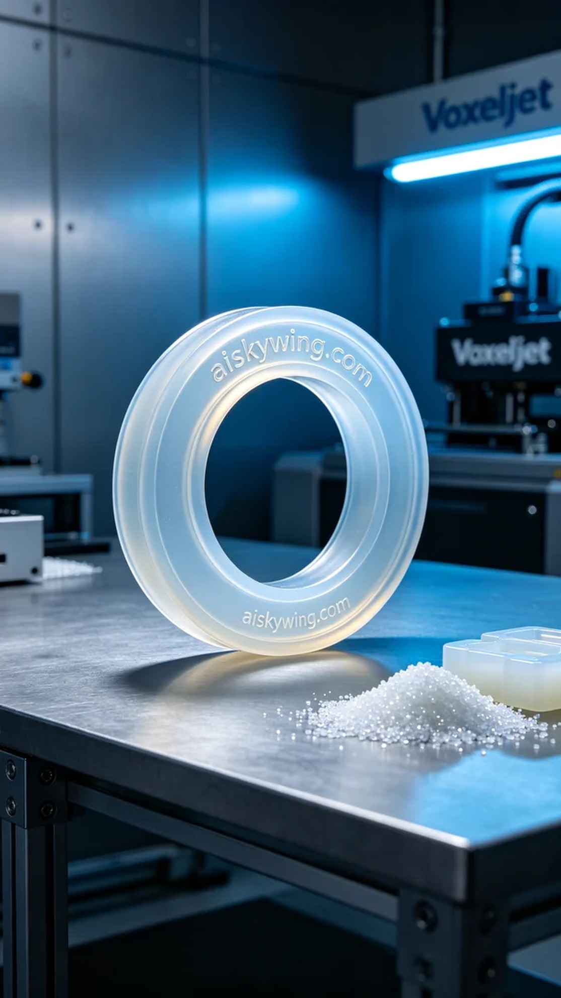
这次的工作是为了一位在LinkedIn上寻求帮助的人，他们面临着产品密封性不足的问题。在沟通后，我们决定使用硅胶复模制作一个高质量的D型密封圈，以确保其在使用中的可靠性和耐用性。
我们选择了医用级硅胶复模作为原材料，拥有半透明、柔软和弹性的特性，可以有效满足密封需求。在设备方面，我们使用了Voxeljet品牌的3D打印机，设置了层厚0.1毫米，打印温度为25℃，功率设定在1500瓦，打印速度则调整为60毫米每秒，整个打印过程预计耗时约2小时。
打印的过程中，Voxeljet的设备运行平稳，材料均匀分布。在打印时，我们还进行了一些质量监控，确保每个细节都符合设计要求。观察到D型密封圈的表面雕刻字样清晰可见，确保了最终产品的质量和美观。
打印完成后，我们进入了后处理工序。首先将密封圈在清洗槽中进行清洗，去除多余的光敏树脂。之后进行打磨，以确保边缘光滑，避免在实际应用中的磨损。最后，我们进行了固化处理，并认真进行了逐个检验，确保每个密封圈都能达到我们的标准。
经过这一系列的工序，我们成功制作出高质量的D型密封圈，既符合技术要求，又具备良好的视觉效果。这样的结果让我们对未来的工作充满期待。
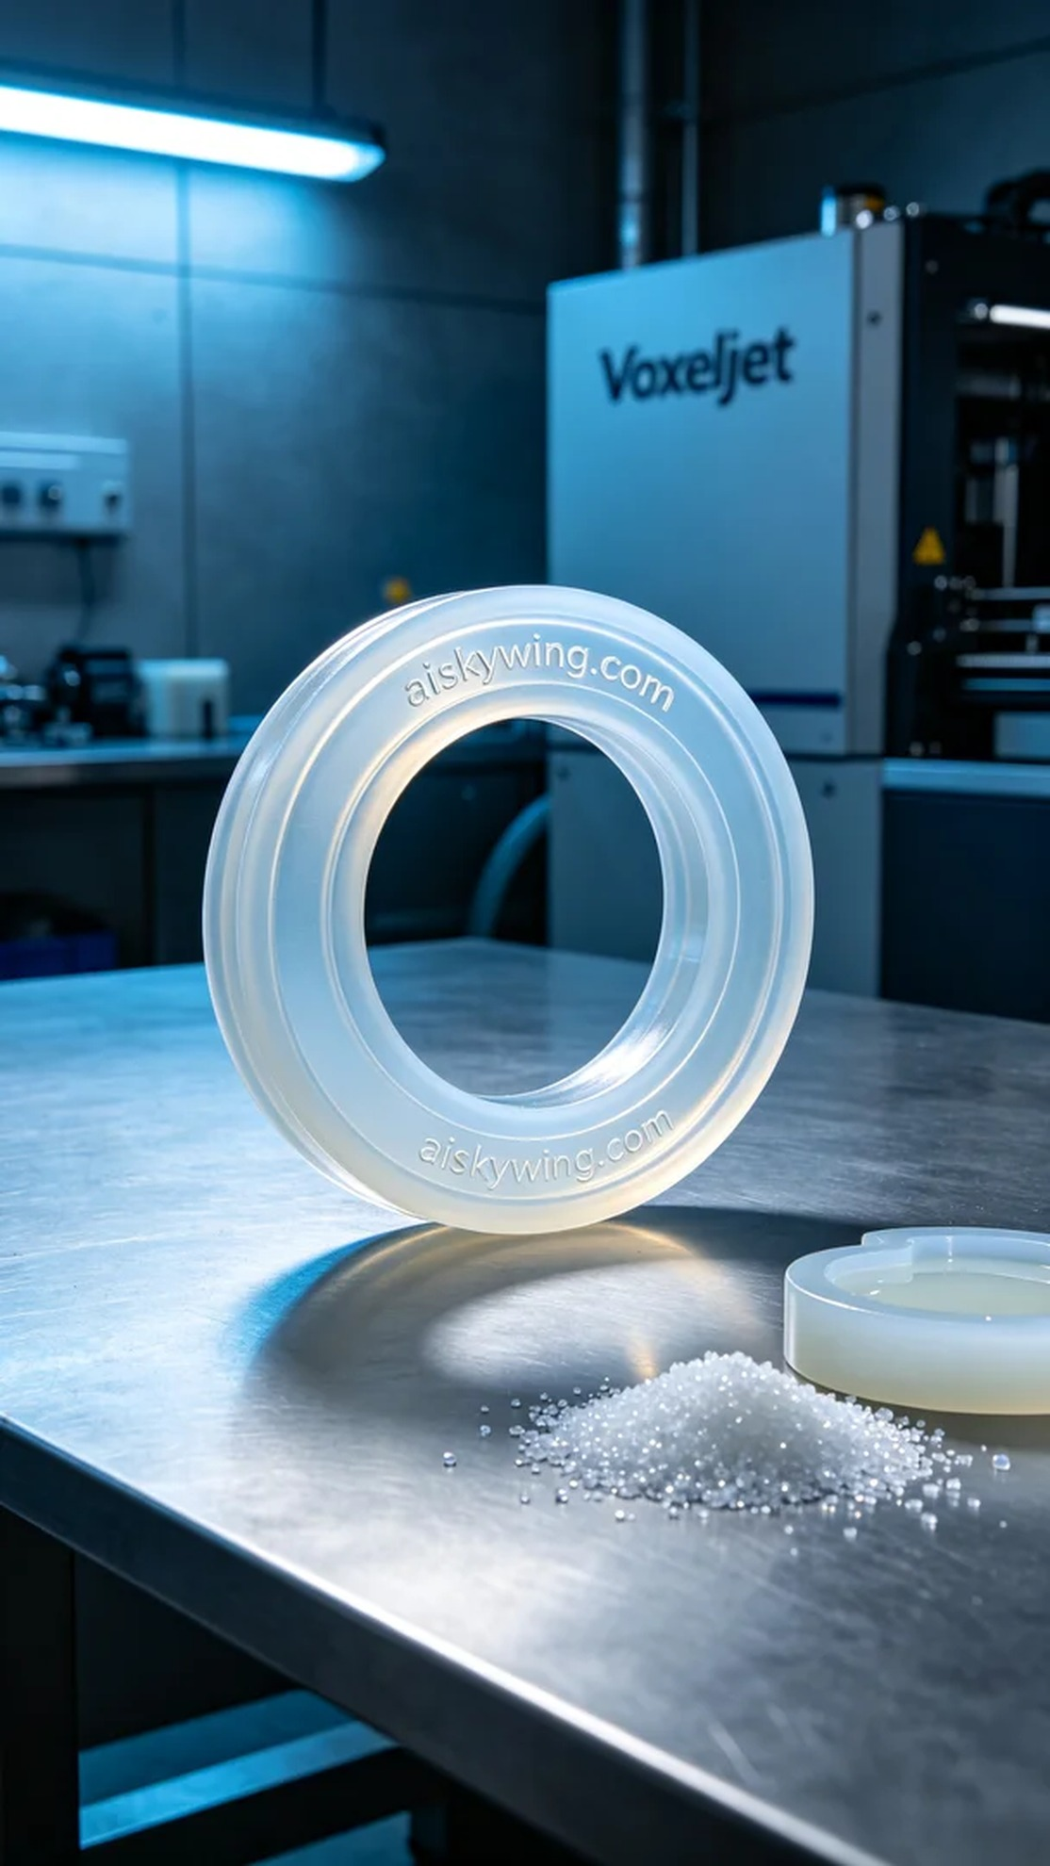
Aiskywing Industrial 3D Printing
D-type sealing ring


