0539-J型密封圈3D打印生产记录
J-type sealing ring
🖨️ 硅胶复模
🖥️ 打印机: Voxeljet
📦 材料: 硅胶复模
生活再难，也别停下脚步。就像接下这个J型密封圈的单子，有人因为需要解决生产线的密封问题找到我们，期待的就是这个成品。
No matter how difficult life gets, don't stop moving forward. Just like when we took on the order for this J-type sealing ring; someone reached out to us because they needed to solve a sealing issue on their production line, and they were looking forward to this finished product.
________________________________________________________________________________
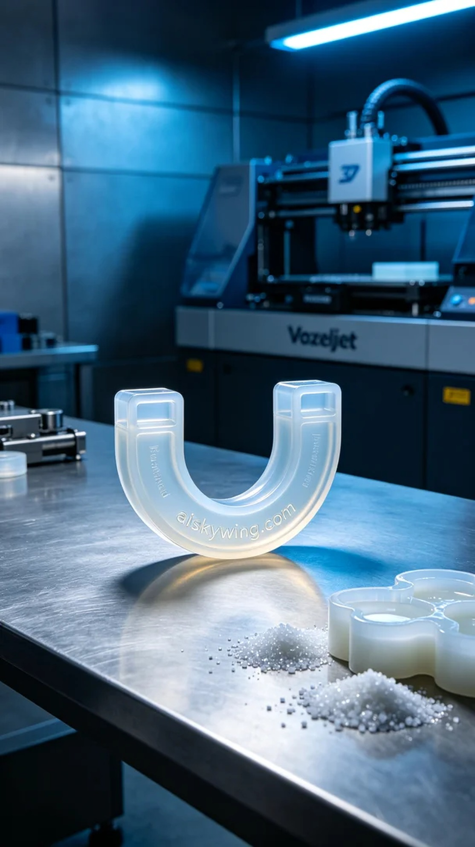
Sometimes, life throws challenges our way, and we must adapt. Recently, someone reached out to us on YouTube regarding a leak issue in their production line, leading us to create a J-shaped sealing ring to address their needs.
For this project, we selected silicone replication as the raw material, known for its translucent and flexible properties, providing excellent sealing performance. Using the Voxeljet printer, we set the layer thickness to 0.1mm, maintained a printing temperature of 30°C, set the power to 80%, and the printing speed to 45mm per hour, with an estimated printing time of 8 hours.
During the printing process, the machine operated smoothly, and we strictly monitored the overall quality. After each printing layer was completed, we carefully examined the adhesion between layers to ensure no bubbles or defects occurred. As time passed, the J-shaped sealing ring gradually took form, with clear contours and the “aiskywing.com” engraving standing out prominently.
Once the printing was complete, we carried out a series of post-processing steps. First, we cleaned the printed product using an ultrasonic cleaner to remove any residual resin. This was followed by sanding to ensure smooth edges. Next, we cured the sealing ring under UV light to enhance material stability and durability. The final step involved a thorough inspection to ensure each product met our quality standards.
The production process turned out to be a resounding success. The final J-shaped sealing ring not only functioned well but also met our aesthetic expectations. Every effort we put in is a testament to our commitment to quality.
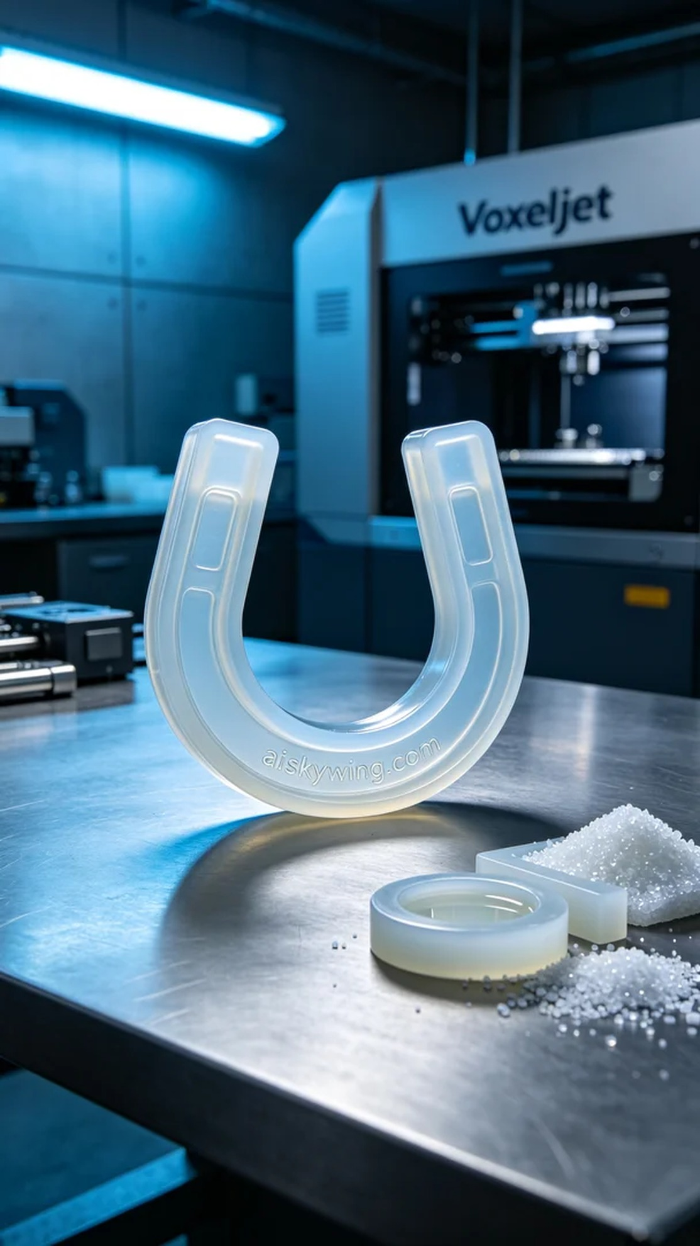
在YouTube上，有人因为生产线漏气的问题联系到我们，需要一款高效的密封解决方案。于是我们决定采用3D打印技术，制作出一款J型密封圈，以满足他们的需求。
我们选用了硅胶复模作为原材料，这种材料具备半透明和柔软弹性的特点，能够提供优质的密封性能。为了确保打印的精准度，我们使用Voxeljet打印机，设置层厚为0.1毫米，打印温度保持在30度，功率设定为80%，打印速度为每小时45毫米，预计打印时间为8小时。
打印过程中，机器运行平稳，整体质量监控严格。在每一个打印层完成后，我们都会仔细检查层与层之间的粘合情况，确保没有出现气泡和瑕疵。随着时间的推移，J型密封圈逐渐成型，轮廓清晰，表面的“aiskywing.com”字样也显得格外醒目。
打印完成后，我们进行了一系列的后处理工序。首先是清洗，将打印好的产品放入超声波清洗机，去除表面的残留树脂。接下来进行打磨处理，确保边缘光滑。然后是固化，将密封圈放置在UV灯下进行固化，确保材料的稳定性和耐用性。最后一步是全面检验，确保每一个产品都能达到我们的质量标准。
这次的制作过程非常成功，最终的J型密封圈不仅具备了良好的功能性，还在外观上达到了预期效果。每一次的努力，都是对自己的肯定。
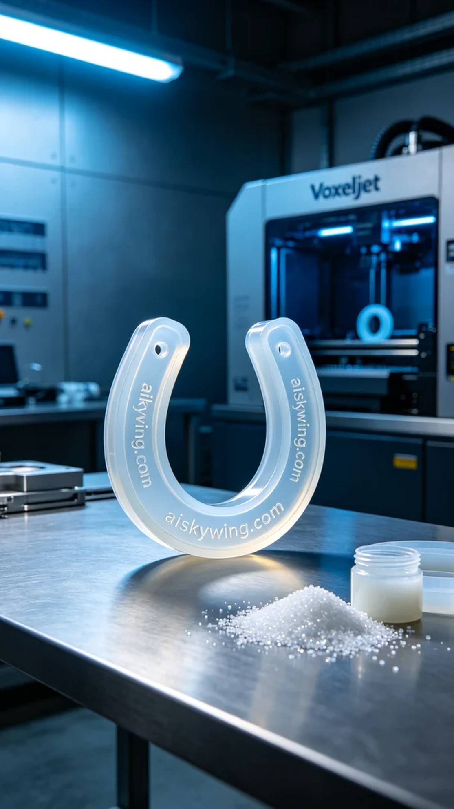
Aiskywing Industrial 3D Printing
J-type sealing ring


