0540-L型密封圈3D打印生产日志
L-shaped sealing ring
🖨️ 硅胶复模
🖥️ 打印机: Systems
📦 材料: 硅胶复模
生活总有困难，但我们不能退缩。就像有人通过WhatsApp联系我，想要解决L型密封圈的生产问题一样。
Life always has its difficulties, but we cannot back down. Just like someone contacted me through WhatsApp, wanting to resolve the production issue of the L-shaped sealing ring.
________________________________________________________________________________
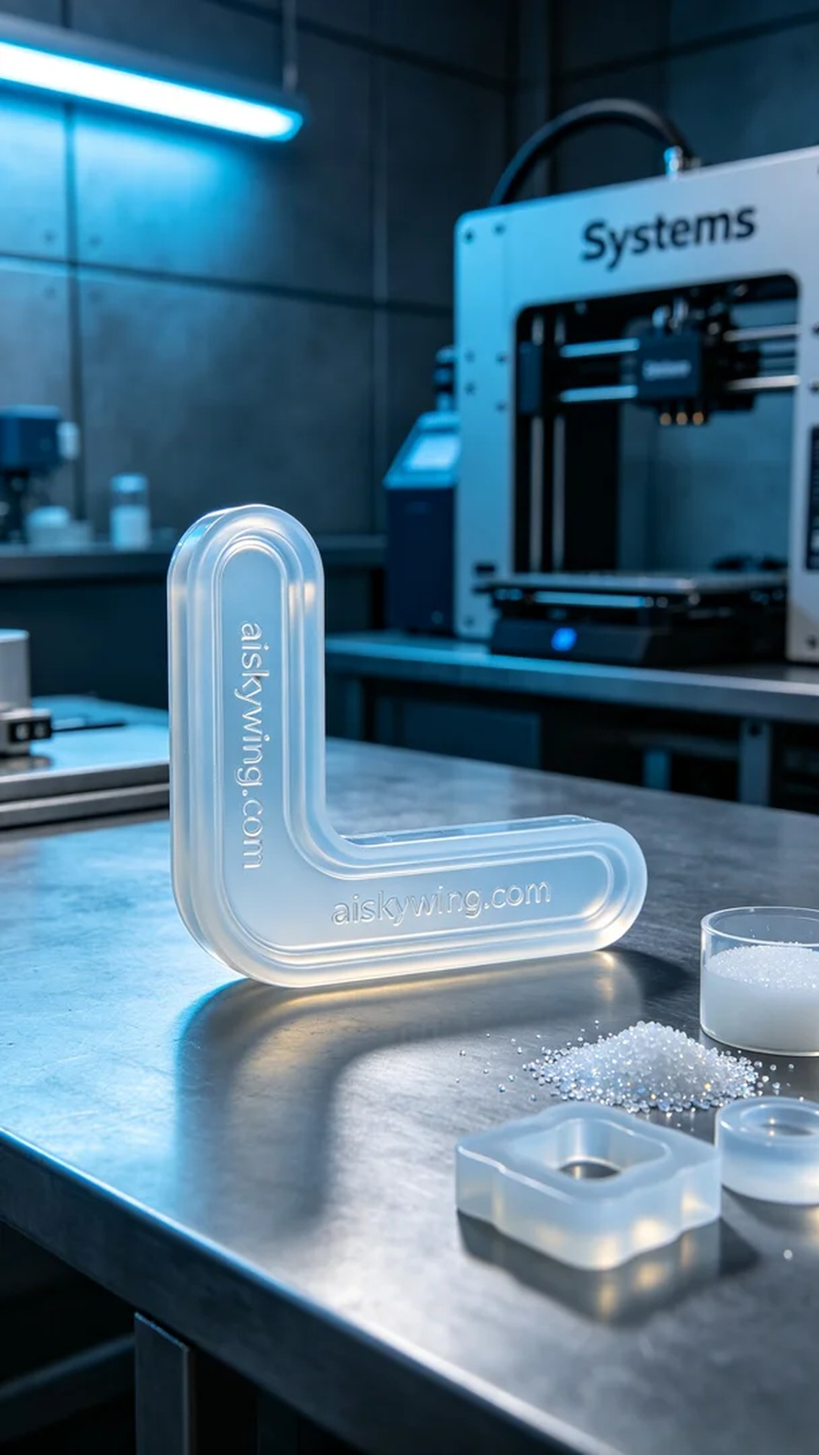
Life can be tough, but we must not back down. Just like someone reached out to me via WhatsApp to address the production issue of an L-shaped sealing ring.
We chose silicone casting as the raw material for this project. Its transparency and flexibility allow it to better fit ergonomic designs. To ensure high-quality printing, we used a Systems brand printer, setting the layer thickness to 0.05mm, printing temperature to 25 degrees Celsius, power to 80%, printing speed to 50mm/s, and estimating a print time of 4 hours.
During the printing process, the Systems printer ran smoothly, with the print head precisely moving to build the shape of the sealing ring layer by layer. We closely monitored the print quality to ensure that every detail was perfectly replicated. The cool-toned lighting illuminated the workstation, creating a tech-savvy atmosphere.
Once printing was completed, we began the post-processing steps. First, we placed the printed L-shaped sealing ring in a cleaning tank and used ultrasonic cleaning to remove any residual materials from the surface. We then proceeded to sand the edges to ensure a smooth finish. After curing, we confirmed the resilience and durability of the sealing ring, followed by a comprehensive inspection to ensure the product met all standards.
In the end, this L-shaped sealing ring was successfully produced. Every effort put into each step was worth it, and seeing the final result brought a great sense of satisfaction.
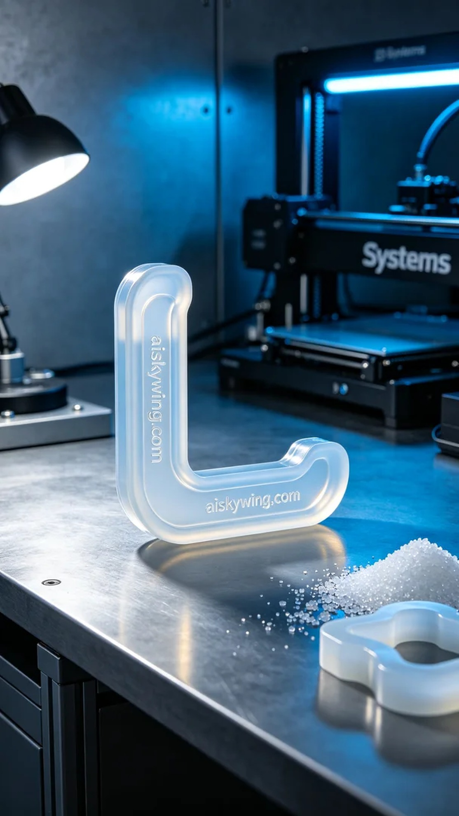
有人因为需要一款高质量的L型密封圈而找到了我们。他们希望这款密封圈能够完美地贴合，并且耐用。通过WhatsApp交流后，我们确认了他们的需求，决定使用硅胶复模进行生产。
我们选择了硅胶复模作为原材料，这种材料的透明性和柔软性使得它能够更好地适应人体工程学设计。为了确保打印效果，我们使用了Systems品牌的打印机，设置层厚为0.05毫米，打印温度为25摄氏度，功率设定为80%，打印速度为50毫米每秒，预计打印时间为4小时。
打印过程中，Systems打印机稳定运行，打印头精准移动，逐层构建出密封圈的形状。我们时刻监控着打印质量，以确保每个细节都能完美还原。打印过程中，冷色调的灯光照亮了整个工作台，给人一种科技感十足的氛围。
打印完成后，我们开始了后处理工序。首先将打印好的L型密封圈放入清洗槽中，使用超声波清洗去除表面的残留物。接着进行打磨，以确保边缘光滑无毛刺。之后我们进行了固化处理，确保密封圈的韧性和耐用性，最后进行全面检验，确保产品符合标准。
最终，这款L型密封圈顺利完成了生产，通过严格的每一步流程，达到了预期效果。每一份努力都值得，看到满意的结果，内心倍感欣慰。
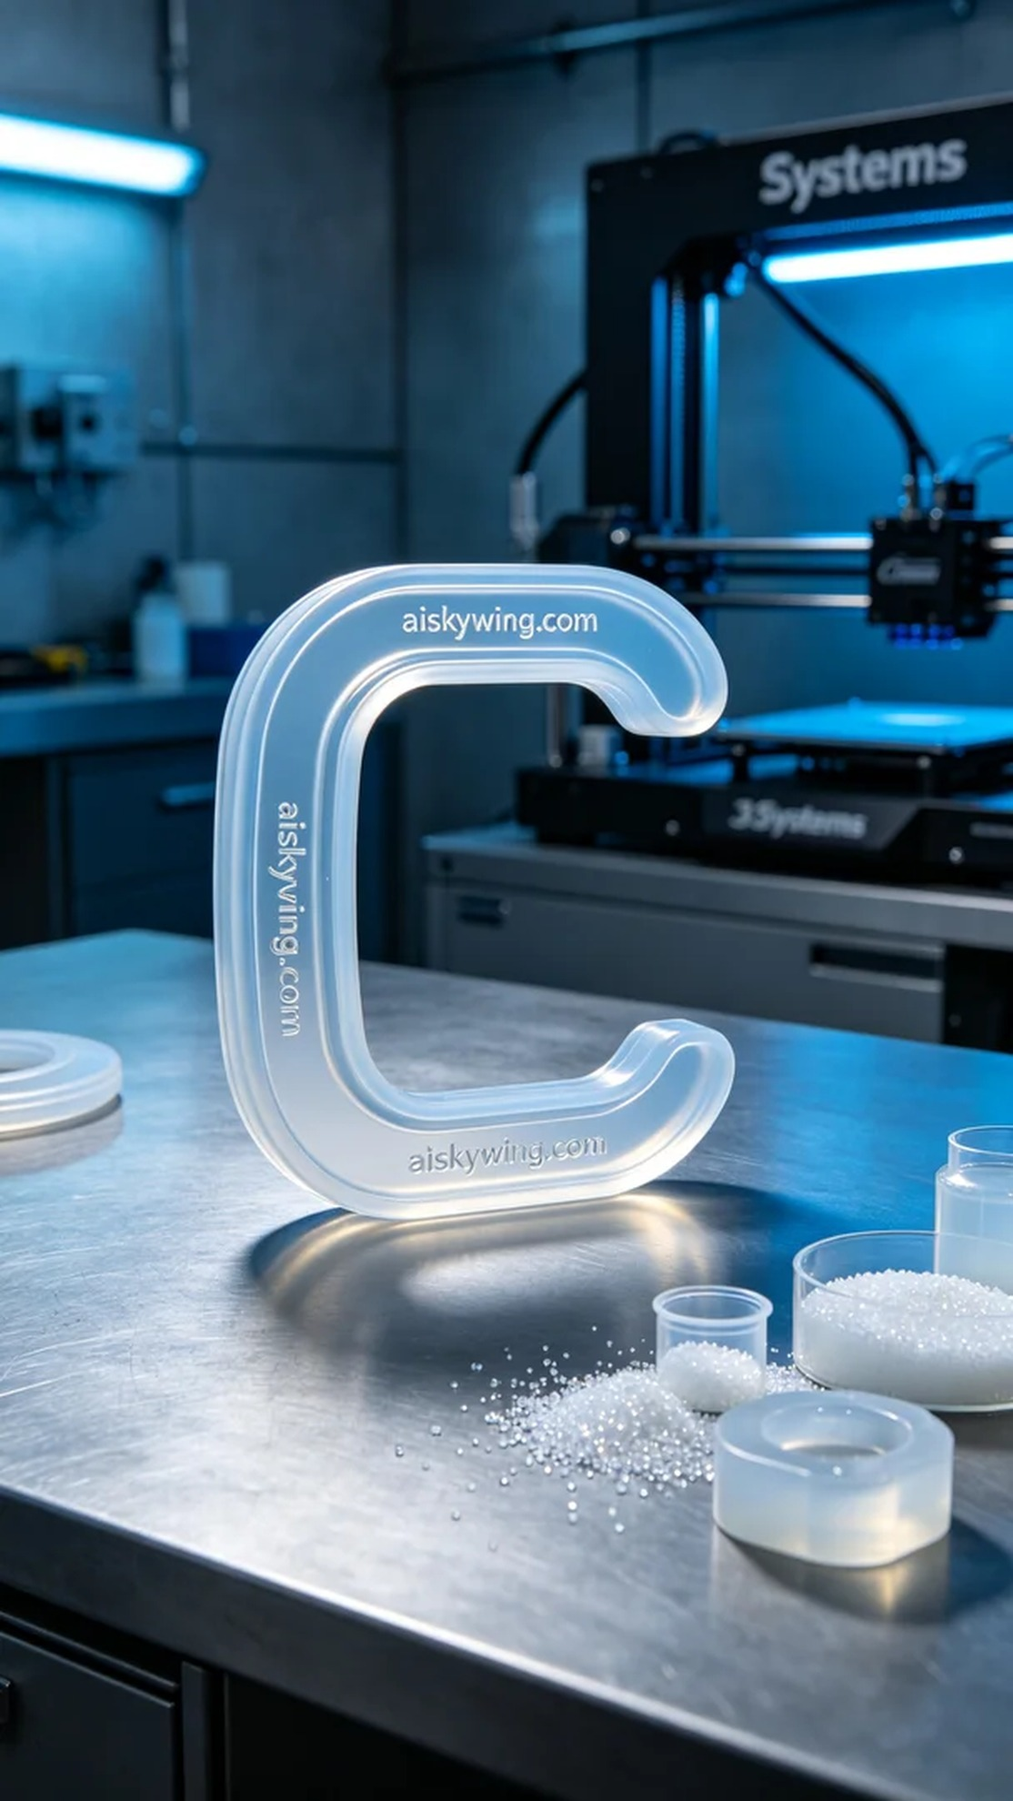
Aiskywing Industrial 3D Printing
L-shaped sealing ring


