0541-O型密封圈的3D打印生产记录
O-ring
🖨️ 硅胶复模
🖥️ 打印机: Carbon
📦 材料: 硅胶复模
生活就像3D打印的每一步，耐心与坚持是成功的关键。有人因为需要高性能的O型密封圈找到我们。
Life is like every step of 3D printing; patience and persistence are the keys to success. Some people come to us because they need high-performance O-rings.
________________________________________________________________________________
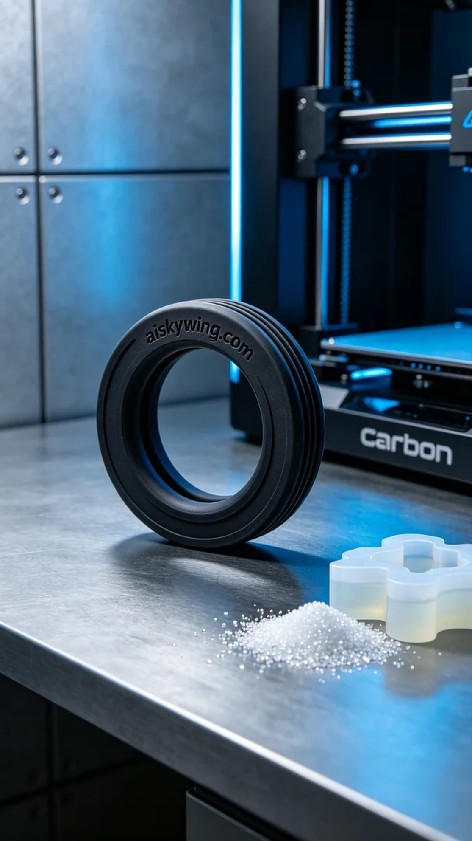
Recently, someone reached out to us through LinkedIn seeking a solution for a specific sealing issue in their industrial application. They required a high-quality O-ring, a product widely used in the industry that demands materials that are both soft and durable.
We planned to produce the O-ring using silicone molding materials, which have excellent flexibility and anti-slip texture, making them ideal for sealing applications. For the equipment, we chose the Carbon brand 3D printer and set the printing parameters to a layer thickness of 0.1 mm, a printing temperature of 25°C, keeping power and speed at moderate levels to ensure printing accuracy and material performance.
During the printing process, the Carbon printer operated smoothly, and we monitored the entire process in real-time. The results for each layer were ideal, meeting our expectations. We paid particular attention to the material flow and the adhesion between layers, ensuring the final product was sturdy.
After printing, we moved on to the post-processing stage. First, we thoroughly cleaned the O-rings with a cleaning solution to remove any residuals from the surface. Next, we polished them to ensure a smooth surface and placed them in a curing chamber for adequate curing. Finally, we conducted a rigorous inspection of the finished products to ensure each O-ring met the quality standards.
The birth of each product is not accidental; through meticulous processes and strict controls, we delivered a series of high-quality O-rings ready to meet the demands of industrial applications.
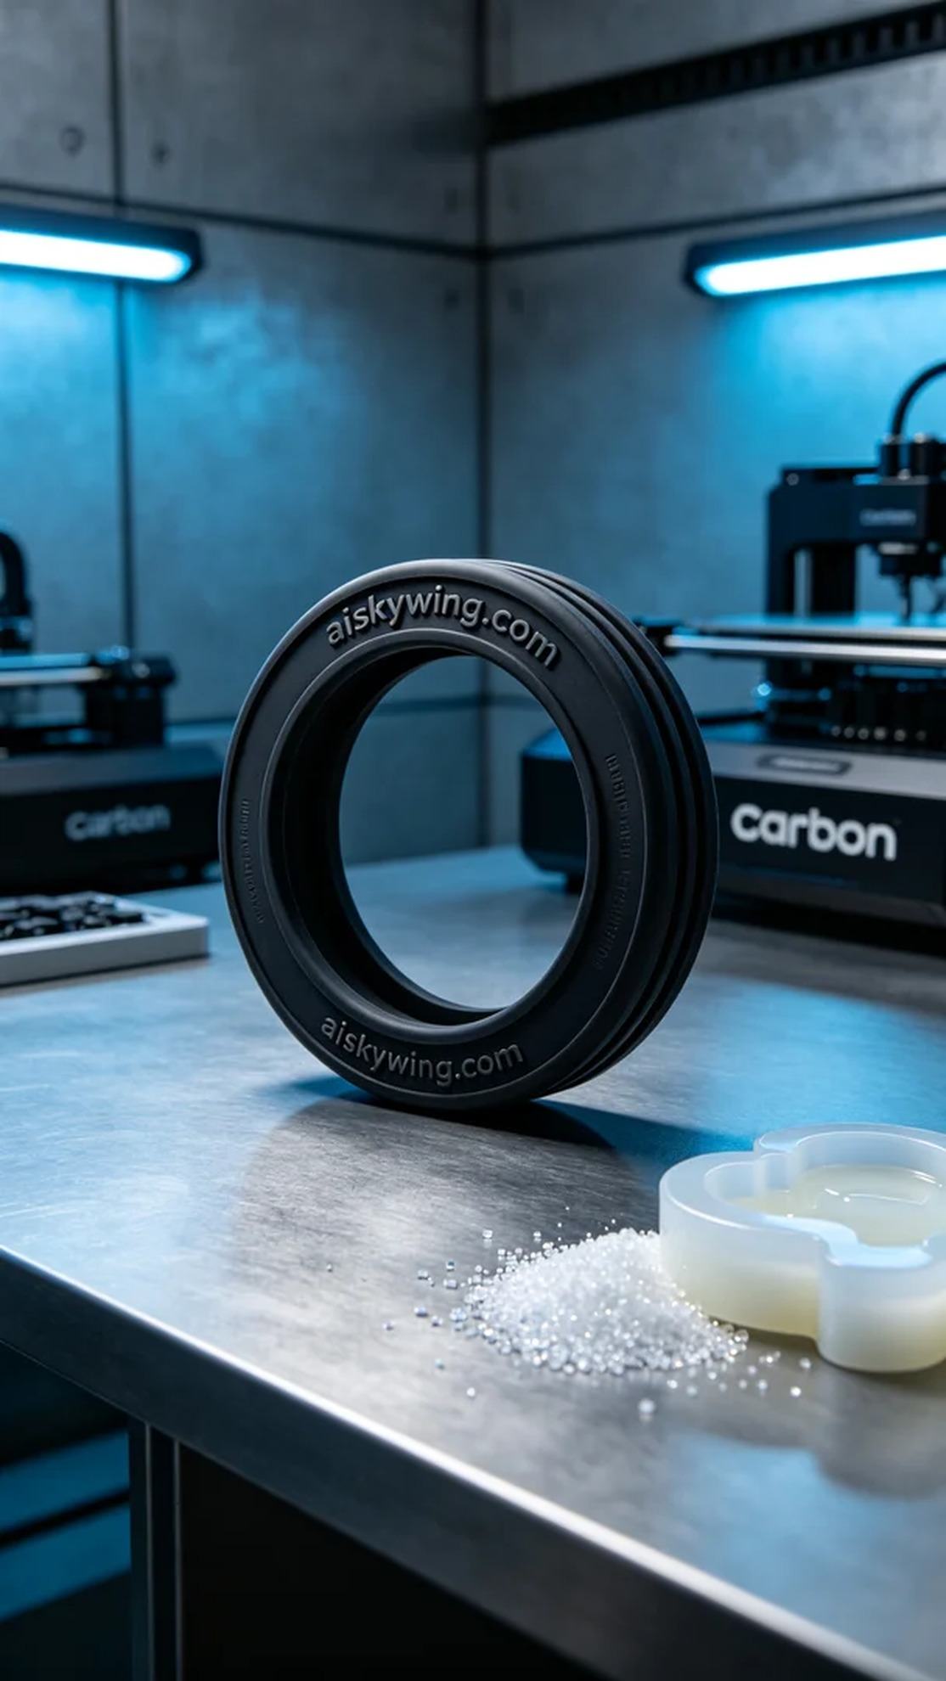
最近，有人通过LinkedIn联系到我们，寻求解决特定工业应用中的密封问题。他们需要的是一款高质量的O型密封圈，这个产品在工业领域应用广泛，要求材料既柔软又耐用。
我们计划使用硅胶复模材料进行生产，这种材料具备很好的柔性特性和防滑纹理，非常适合密封圈的需求。设备方面，我们选择了Carbon品牌的3D打印机，准备将打印参数设置为层厚0.1毫米，打印温度设定在25°C，功率和速度则保持在适中的水平，以确保打印精度和材料性能。
在打印过程中，Carbon打印机运转顺利，整个过程实时监控。每一层的打印效果都很理想，质量符合预期。我们特别注意了材料的流动性和层与层之间的粘合度，确保最终产品的稳固性。
完成打印后，我们进入了后处理阶段。首先使用清洗液对密封圈进行彻底清洗，去除表面的残留物。接着进行了打磨，以确保表面光滑，然后将其放入固化箱中，进行充分固化。最后，我们对成品进行严格的检验，确保每个O型密封圈都能满足质量标准。
每一款产品的诞生都不是偶然，经过细致的工序和严格的把控，最终我们得到了一系列高质量的O型密封圈，满足了需求，期待为更多的工业应用提供支持。
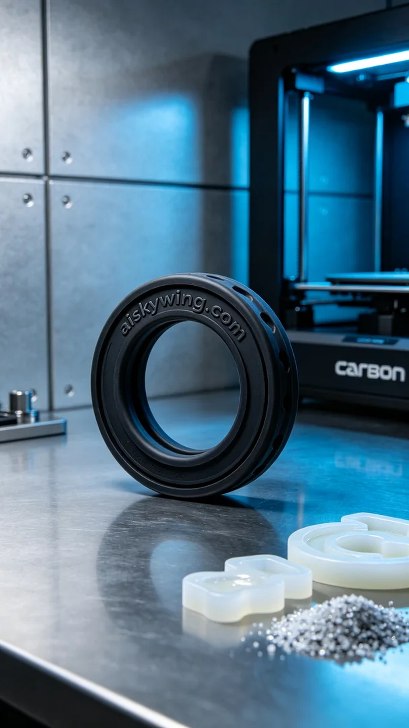
Aiskywing Industrial 3D Printing
O-ring


