0542-精密T型密封圈的3D打印制作
T-shaped seal ring
🖨️ 硅胶复模
🖥️ 打印机: Mimaki
📦 材料: 硅胶复模
生活再难，也别停下脚步。就像接下这个T型密封圈的单子，面对挑战，我们总能找到解决方案。
No matter how difficult life gets, don't stop moving forward. Just like taking on this T-shaped sealing ring order, we can always find solutions when faced with challenges.
________________________________________________________________________________
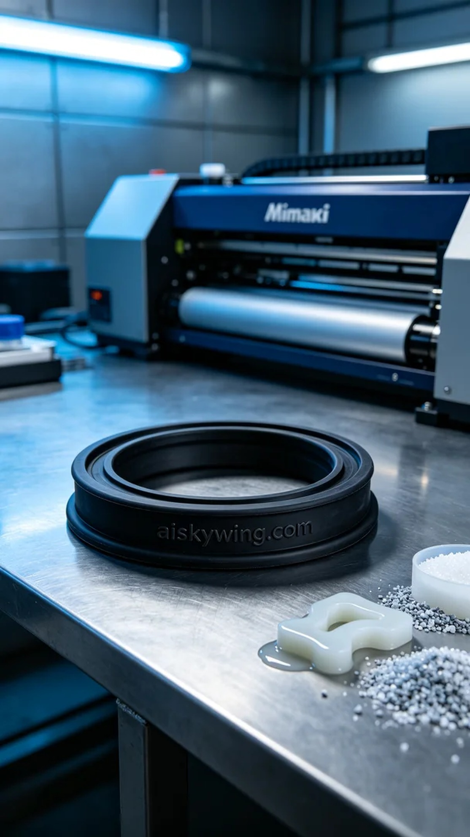
On Instagram, someone reached out to us regarding issues with inadequate sealing, specifically requesting a T-shaped seal. This need highlighted the importance of precision sealing products in industrial applications.
To ensure production quality, we chose silicone casting as the material. Silicone casting offers excellent flexibility and durability, making it ideal for manufacturing seals. During the preparation, we utilized a Mimaki printer, setting the layer thickness to 0.1mm, the temperature to 30°C, power at 80%, and a print speed of 50mm/s, which effectively ensured the precision and integrity of the print.
As the printing process commenced, the Mimaki printer operated steadily, and I monitored the device closely. With each layer printed, the liquid photopolymer resin spread evenly, forming the T-shaped seal we aimed for. Throughout the process, I kept a vigilant eye on every detail to ensure no bubbles or defects appeared.
Once printing was complete, we moved on to a series of post-processing steps. First, we placed the T-shaped seal in a cleaning bath, using ultrasonic cleaning to remove any uncured residual material; next, we proceeded to sanding to ensure a smooth surface; finally, we cured it with UV light to enhance its strength and durability, with all steps being meticulously inspected to ensure every product met the standards.
After these meticulous procedures, we finally achieved the desired T-shaped seal. Throughout this process, I gained a deeper understanding of the importance of detail and patience, as a perfect product always brings us a sense of satisfaction.
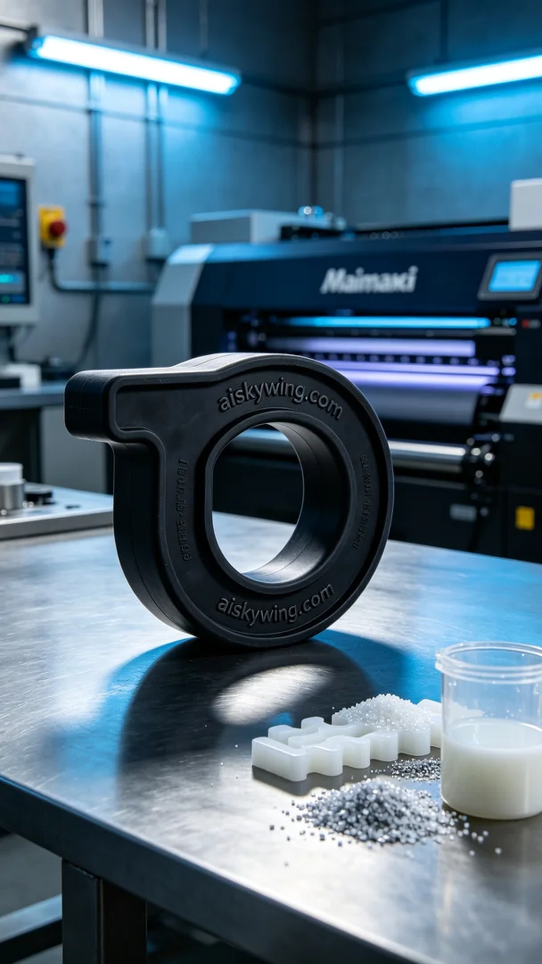
在Instagram上，有人因为密封性不佳的问题找到了我们，特别提到他们需要一款T型密封圈。这个需求让我们意识到，精密的密封产品在工业应用中的重要性。
为确保生产质量，我们选择了硅胶复模作为原材料。硅胶复模具有良好的柔韧性和耐用性，适合制造密封件。准备工作时，我们使用Mimaki打印机，设定层厚为0.1mm，温度控制在30°C，功率设定为80%，打印速度为50mm/s，这样的参数能够有效确保打印的精度和产品的完整性。
打印过程开始后，Mimaki打印机稳定运行，我时刻关注着设备的状态。随着打印层层推进，液态光敏树脂均匀铺展，形成了我们计划中的T型密封圈。期间，我对每个细节进行质量监控，确保没有任何气泡或瑕疵产生。
完成打印后，我们对产品进行了一系列的后处理工序。首先，将T型密封圈放入清洗槽中，利用超声波清洗去除未固化残余材料；接下来，进行打磨，以确保表面光滑；最后，通过UV灯固化，增强其强度和耐久性，所有步骤均经过严格的检验，确保每一件产品都符合标准。
经过这些细致的工序，我们终于得到了理想的T型密封圈。在这个过程中，我更加理解了细节和耐心的重要性，完美的产品总能给我们带来满足感。
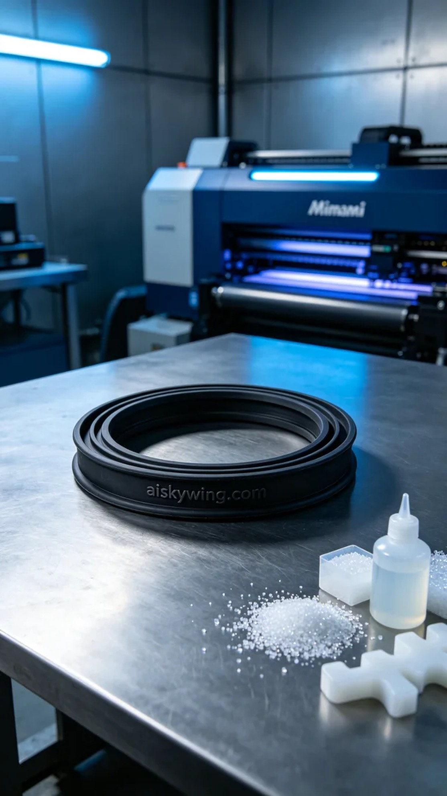
Aiskywing Industrial 3D Printing
T-shaped seal ring


