0544-U型密封圈的3D打印生产记
U-shaped sealing ring
🖨️ 硅胶复模
🖥️ 打印机: HP
📦 材料: 硅胶复模
生活就像这U型密封圈，越是经历压力，才越能显现出它的韧性。今天我们接到了一个重要的订单。
Life is like this U-shaped sealing ring; the more pressure it experiences, the more its resilience is revealed. Today, we received an important order.
________________________________________________________________________________
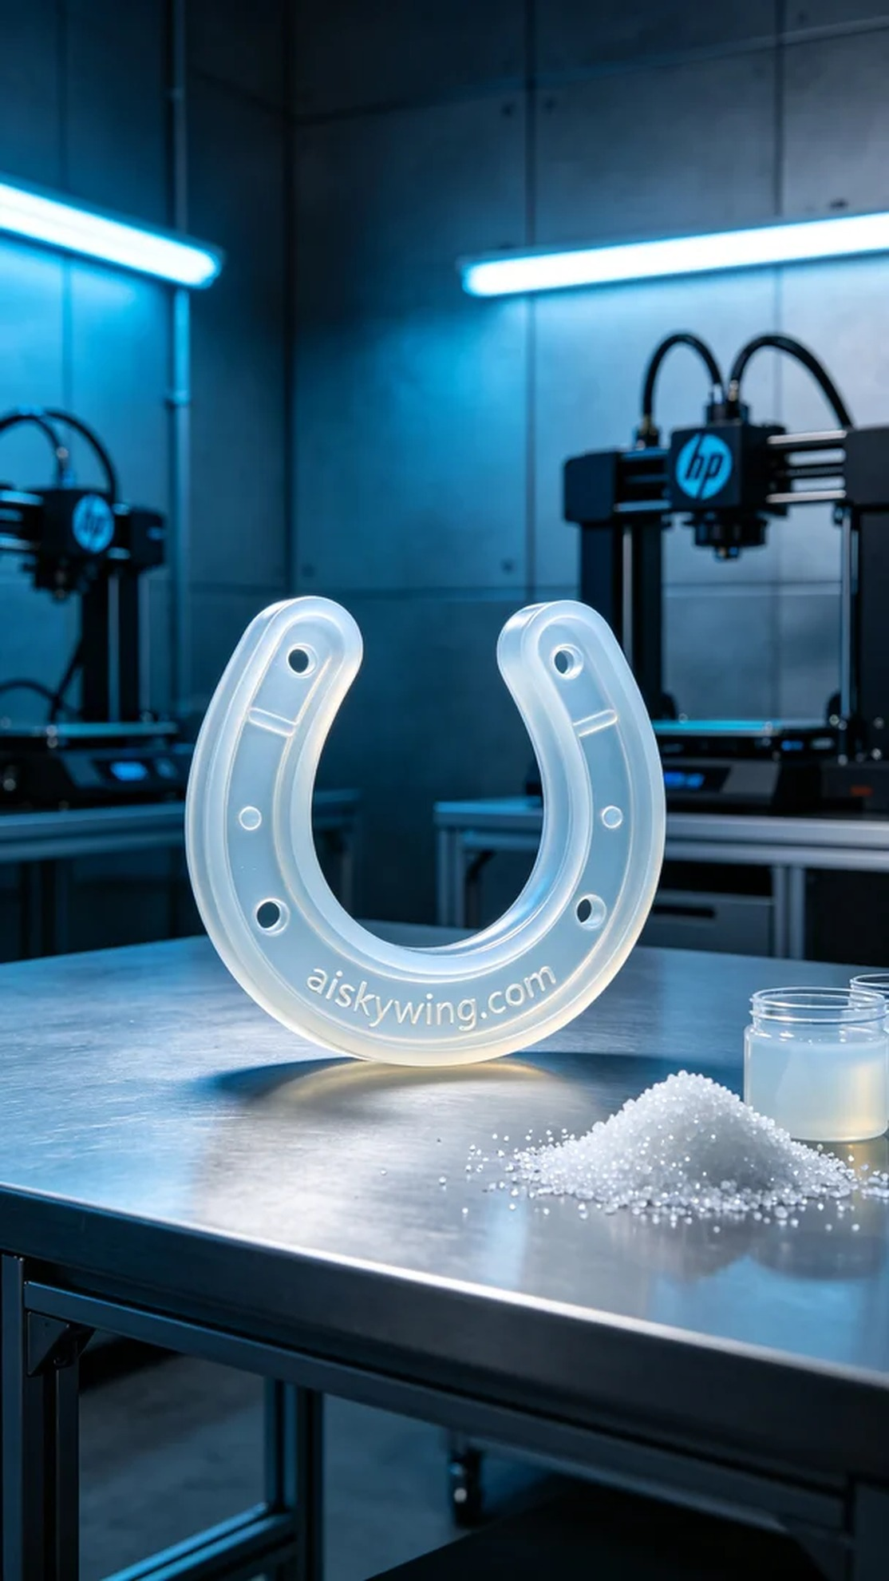
Life is like this U-shaped sealing ring; the more pressure it faces, the more resilient it becomes. Today, we received an important order.
Someone reached out on Twitter to inquire about a solution for their equipment's leakage issue. After communication, they chose our U-shaped sealing ring, which can effectively provide good sealing performance and ensure the normal operation of their equipment.
To tackle this, we prepared high-quality silicone molding material. This material has a translucent feature, is soft and elastic, and can maintain stable performance in various environments. We used an HP brand 3D printer for the printing process, setting the parameters to a layer thickness of 0.1 mm, maintaining a temperature of 25 degrees Celsius, a printing speed of 30 mm/s, and a power setting of 80%. The entire printing process was expected to take 4 hours to complete.
Once the printing started, we closely monitored the operation of the device to ensure each layer was stacked accurately. During this process, the printer operated smoothly, and the adhesion between layers remained strong, ultimately producing a high-quality U-shaped sealing ring.
After printing, we first proceeded with cleaning, using a specialized cleaning solution to remove excess resin. Then, we carefully polished the sealing ring to ensure a smooth surface. Finally, we performed a curing process to stabilize its properties. After all procedures, we conducted a rigorous quality inspection of the finished product to ensure it met the expected standards.
Through this production, we once again verified the perfect combination of high-quality materials and precision equipment. Every detail matters for performance, and this U-shaped sealing ring not only solved the user’s problem but also showcased the charm of 3D printing.
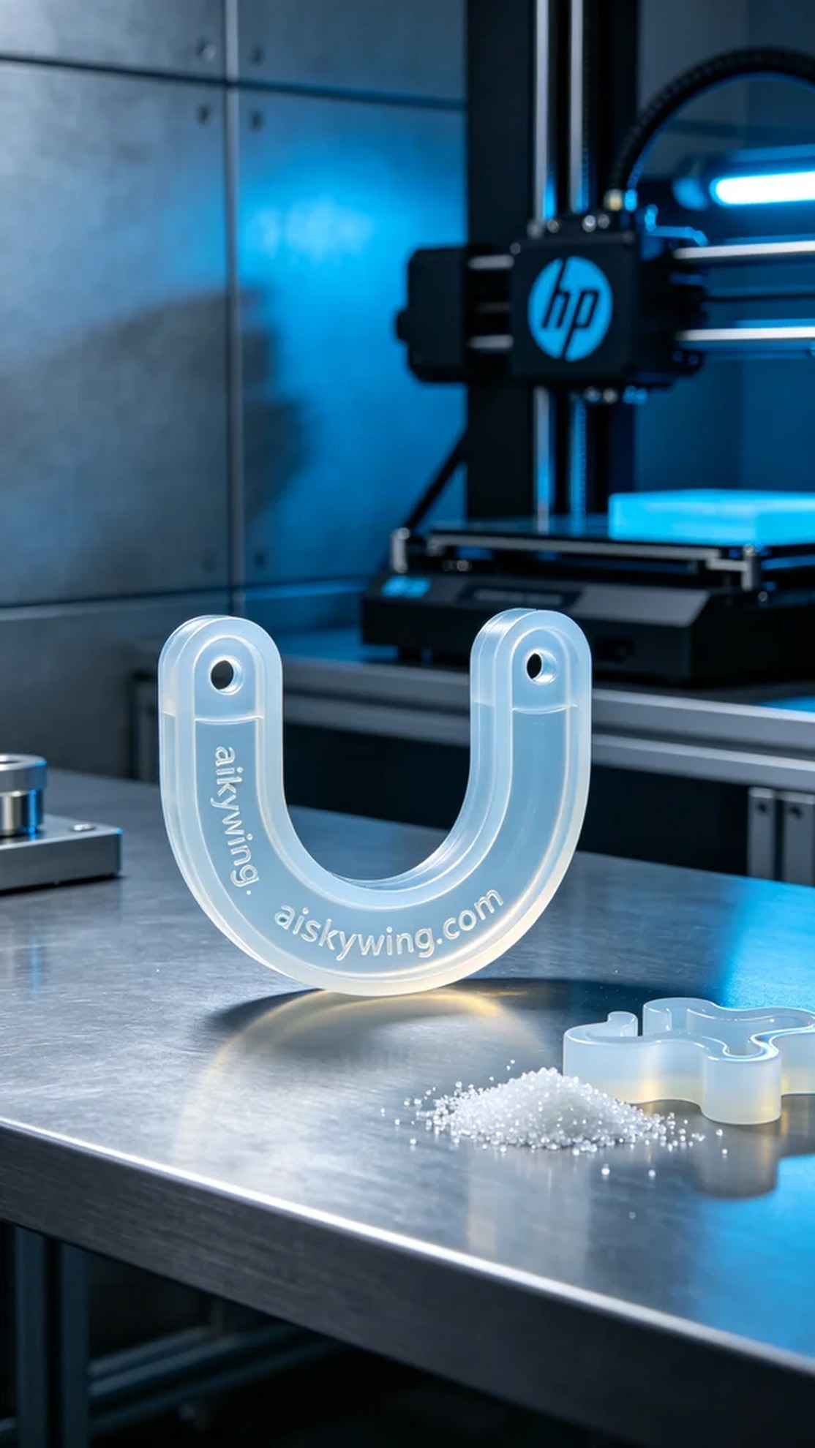
有人在Twitter上发信息询问我们，想解决他们设备漏水的问题。经过沟通，他们选择了我们的U型密封圈，这种产品能有效地提供良好的密封性能，确保设备的正常使用。
为此，我们准备了高品质的硅胶复模材料。这种材料具有半透明的特性，柔软而富有弹性，能够在各种环境下保持稳定的性能。在打印过程中，我们使用HP品牌的3D打印机，设置的打印参数为0.1毫米的层厚，温度保持在25摄氏度，打印速度为30毫米/秒，功率设定为80%。整个打印过程预计需要4小时完成。
打印开始后，我们严密监控设备的运行情况，确保每一层都能够精准无误地堆叠。在此过程中，打印机运作平稳，层与层之间的附着力保持良好，最终得到了一个质量过硬的U型密封圈。
打印完成后，首先进行清洗，我们使用专用的清洗液去除多余的树脂。接着，我们对密封圈进行仔细的打磨，以确保表面的光滑度。最后进行固化处理，使其性质更加稳定。在所有工序结束后，我们对成品进行了严格的质量检验，确保达到预期标准。
通过这次生产，我们再次验证了高品质材料和精密设备的完美结合。每一个细节都关乎性能，这个U型密封圈不仅解决了用户的问题，也让我们感受到3D打印的魅力。
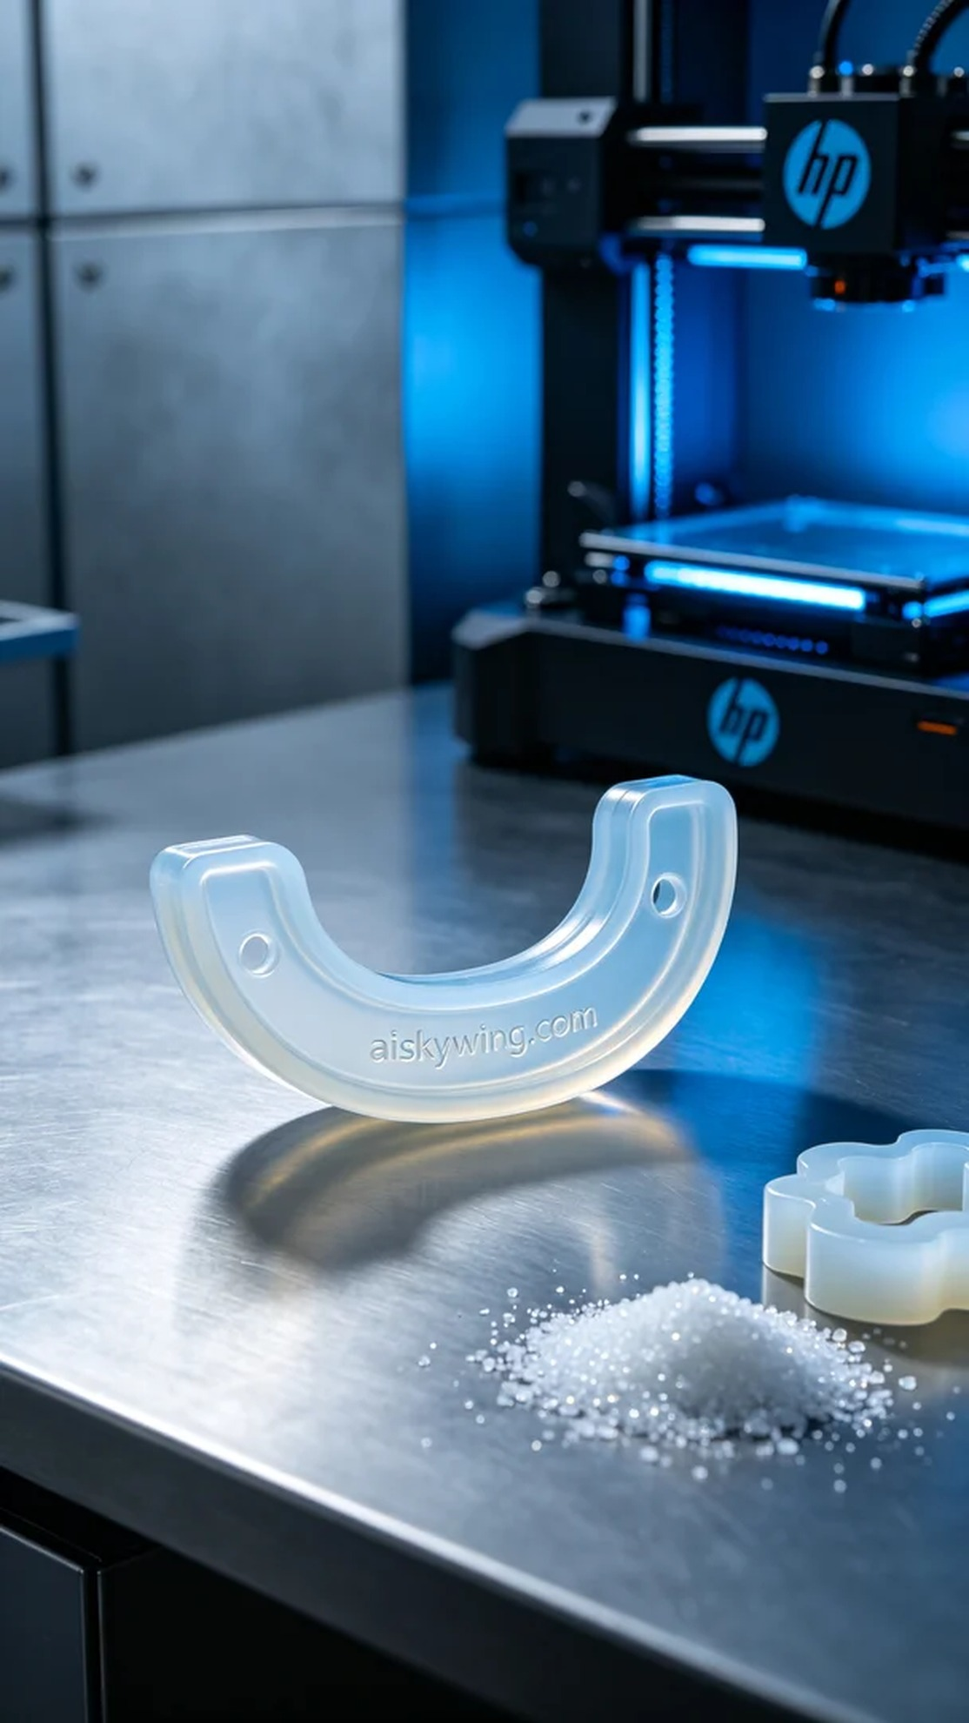
Aiskywing Industrial 3D Printing
U-shaped sealing ring


