0545-V型密封圈的3D打印生产记录
V-shaped sealing ring
🖨️ 硅胶复模
🖥️ 打印机: Systems
📦 材料: 硅胶复模
在Twitter上，有人因为高强度的工业环境需要我们的V型密封圈，来解决他们的密封难题。生活总会让我们遇到挑战，但只要坚持，必能迎来转机。
On Twitter, someone needs our V-type sealing rings to solve their sealing problems due to the high-intensity industrial environment. Life always presents us with challenges, but as long as we persevere, we will surely encounter a turning point.
________________________________________________________________________________
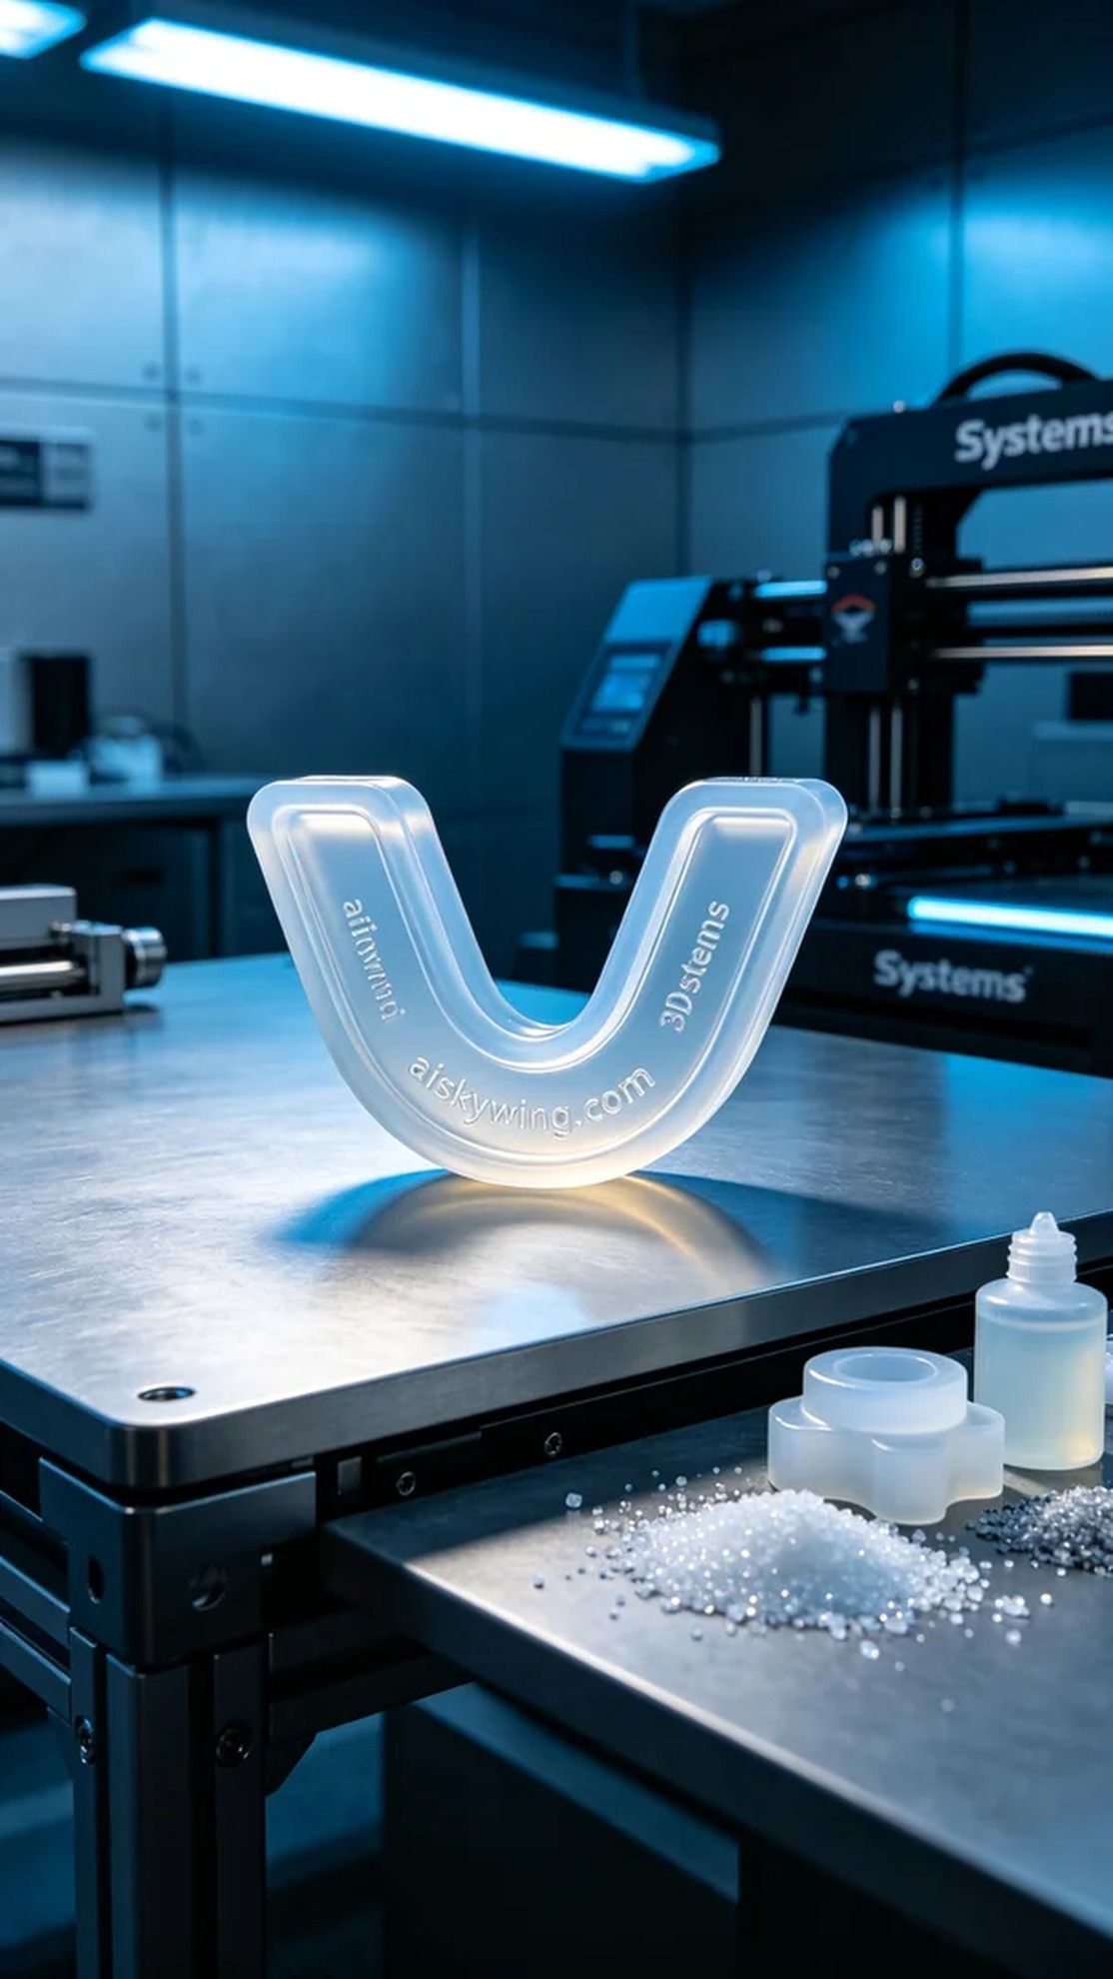
The production task came from a colleague who sought help due to the inability of traditional seals to meet their needs in a high-intensity working environment. They required a durable V-shaped sealing ring designed for ergonomic fit to enhance the efficiency of their equipment.
We utilized silicone molding material for this project, which is transparent and soft, effectively adapting to various sealing requirements. During preparation, we selected the Systems brand 3D printer, setting a layer thickness of 0.1mm, maintaining a printing temperature of 25℃, with a power setting of 50W and a printing speed of 30mm/s. The entire printing process was expected to take 4 hours.
Once printing began, the equipment operated smoothly, as the liquid photopolymer resin continuously layered to form the V-shaped sealing ring. We closely monitored the quality of the print to ensure each layer was evenly cured, avoiding any defects. With precise lighting effects, the product gradually revealed its sharp and clear features.
After printing, a series of post-processing steps were performed. First, the finished product was placed in a cleaning tank to remove excess resin; then we used fine sandpaper to smooth the surface, ensuring every part was flawless; finally, it was cured in a UV curing box to enhance the hardness and durability of the sealing ring. After thorough inspection, the final product met all requirements.
This production process of the V-shaped sealing ring went smoothly; through meticulous craftsmanship and strict quality control, we successfully addressed their needs and welcomed new collaboration opportunities.
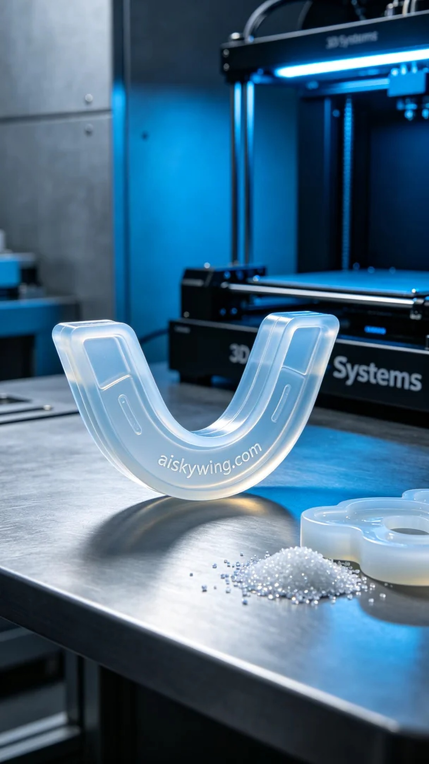
这次生产任务来自于某个同行的求助，他们在高强度的工作环境中发现，传统密封圈无法满足他们的使用需求。他们需要一款耐用且符合人机工程学设计的V型密封圈，来改善设备的运行效率。
我们所使用的材料是硅胶复模，这种材料透明柔软，能够很好地适应各种形状的密封需求。准备过程中，我们选用了Systems品牌的3D打印机，设定了层厚为0.1mm，打印温度保持在25℃，功率设定为50W，打印速度为30mm/s。整个打印过程预计需要4小时完成。
打印开始后，设备运行平稳，液态光敏树脂在打印床上不断叠加，呈现出V型密封圈的形状。我们仔细监控打印质量，确保每一层都均匀固化，避免出现任何瑕疵。伴随着精准的布光效果，产品逐渐显现出其清晰锐利的特征。
打印完成后，我们进行了一系列后处理工序。首先将成品放入清洗槽中，去除多余的树脂；接着用细砂纸对表面进行打磨，确保每处都光滑无瑕；最后在紫外线固化箱中进行固化，以增强密封圈的硬度并提高耐用性。经过全面检验后，最终产品达到了客户的要求。
这次的V型密封圈生产过程顺利，通过精细的工艺和严格的质量控制，我们成功解决了他们的问题，迎来了新的合作机会。
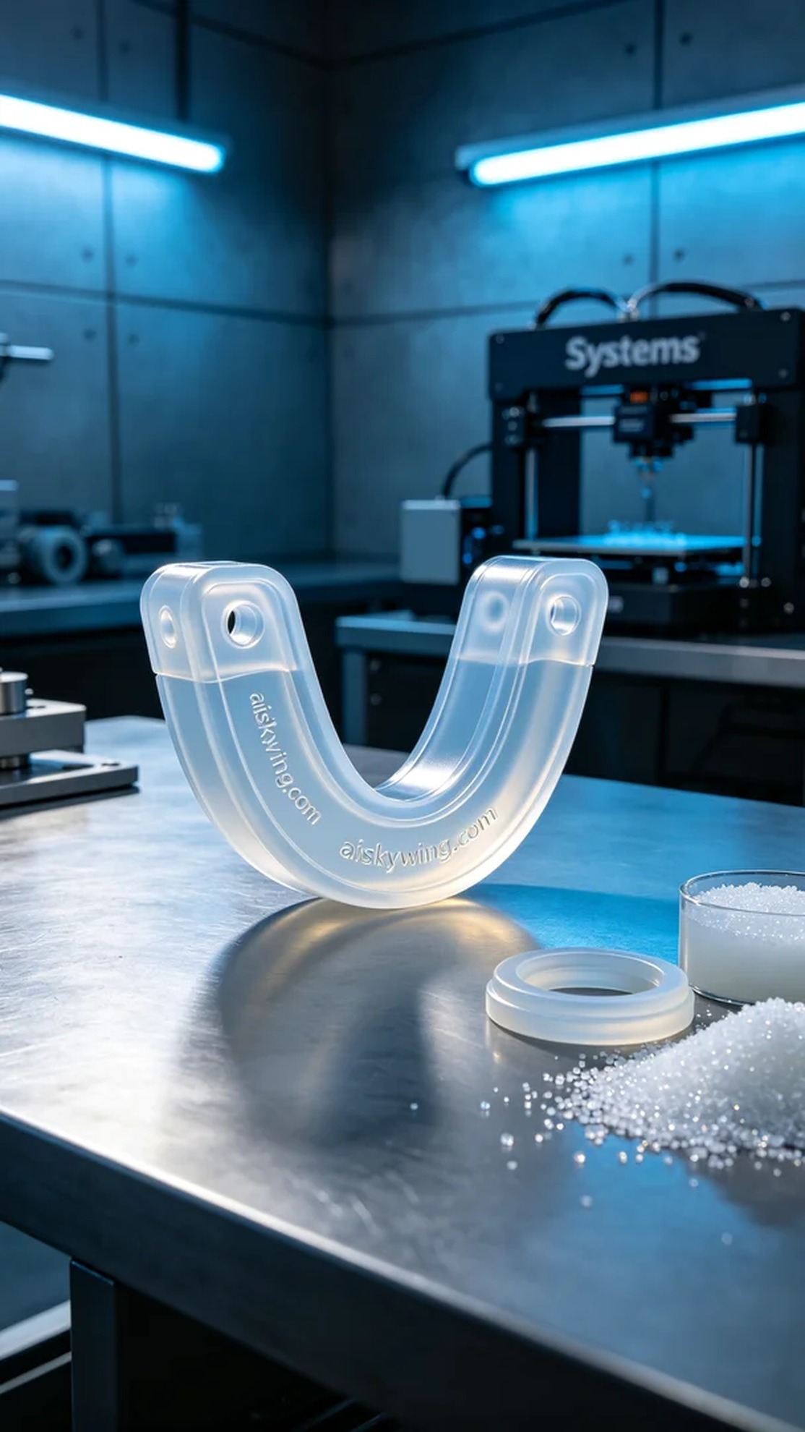
Aiskywing Industrial 3D Printing
V-shaped sealing ring


