0546-X型密封圈3D打印生产记录
X-type sealing ring
🖨️ 硅胶复模
🖥️ 打印机: HP
📦 材料: 硅胶复模
生活就像3D打印，有时需要精准与耐心。最近在Facebook上，有人找我们做这个X型密封圈，正是为了应对一些密封不严的问题。
Life is like 3D printing; it sometimes requires precision and patience. Recently, someone reached out to us on Facebook to create this X-shaped sealing ring, specifically to address some sealing issues.
________________________________________________________________________________
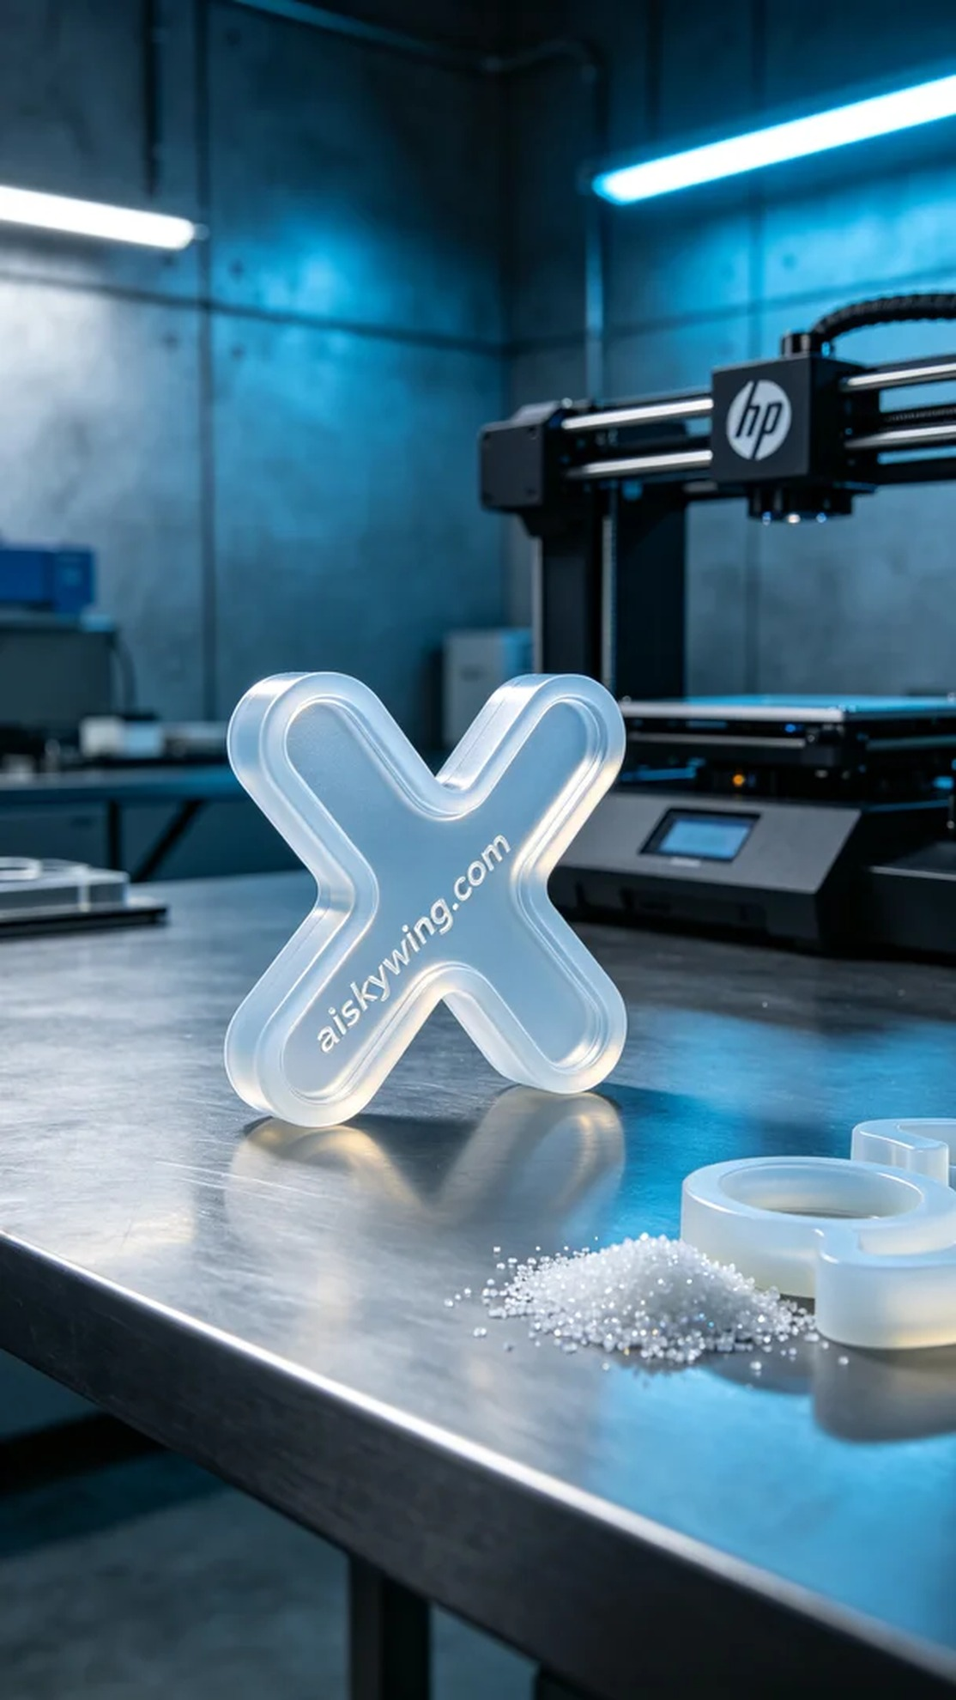
Life is like 3D printing; sometimes it requires precision and patience. Recently, someone reached out to us on Facebook to create an X-shaped sealing ring for addressing sealing issues they encountered with their equipment.
For this production task, we used high-quality silicone casting material to ensure transparency and flexibility. We chose an HP 3D printer for the printing process, setting the layer thickness at 0.1mm, keeping the temperature at 25 degrees Celsius, setting the power at 50%, and the print speed at 30 mm per second, with an estimated print time of about 90 minutes.
During the printing process, the equipment operated smoothly, and the print head moved with precision, building the liquid photopolymer resin layer by layer. We regularly checked the print quality to ensure each layer was even, without any bubbles or defects. Throughout the process, the noise and vibration of the equipment were kept within an acceptable range, reflecting the superior performance of the HP printer.
Once printing was completed, we proceeded with the necessary post-processing. First, we placed the printed sealing rings in a washing tank and used ultrasonic cleaning to remove excess resin from the surface. Next, we performed sanding to ensure smooth edges and finally placed them under a UV curing lamp to ensure the strength and durability of the sealing rings. After strict inspection, all sealing rings successfully passed quality checks.
The entire production process was smooth and efficient, with the final X-shaped sealing rings meeting the desired design standards and functional requirements, providing a great user experience for our friend’s equipment.
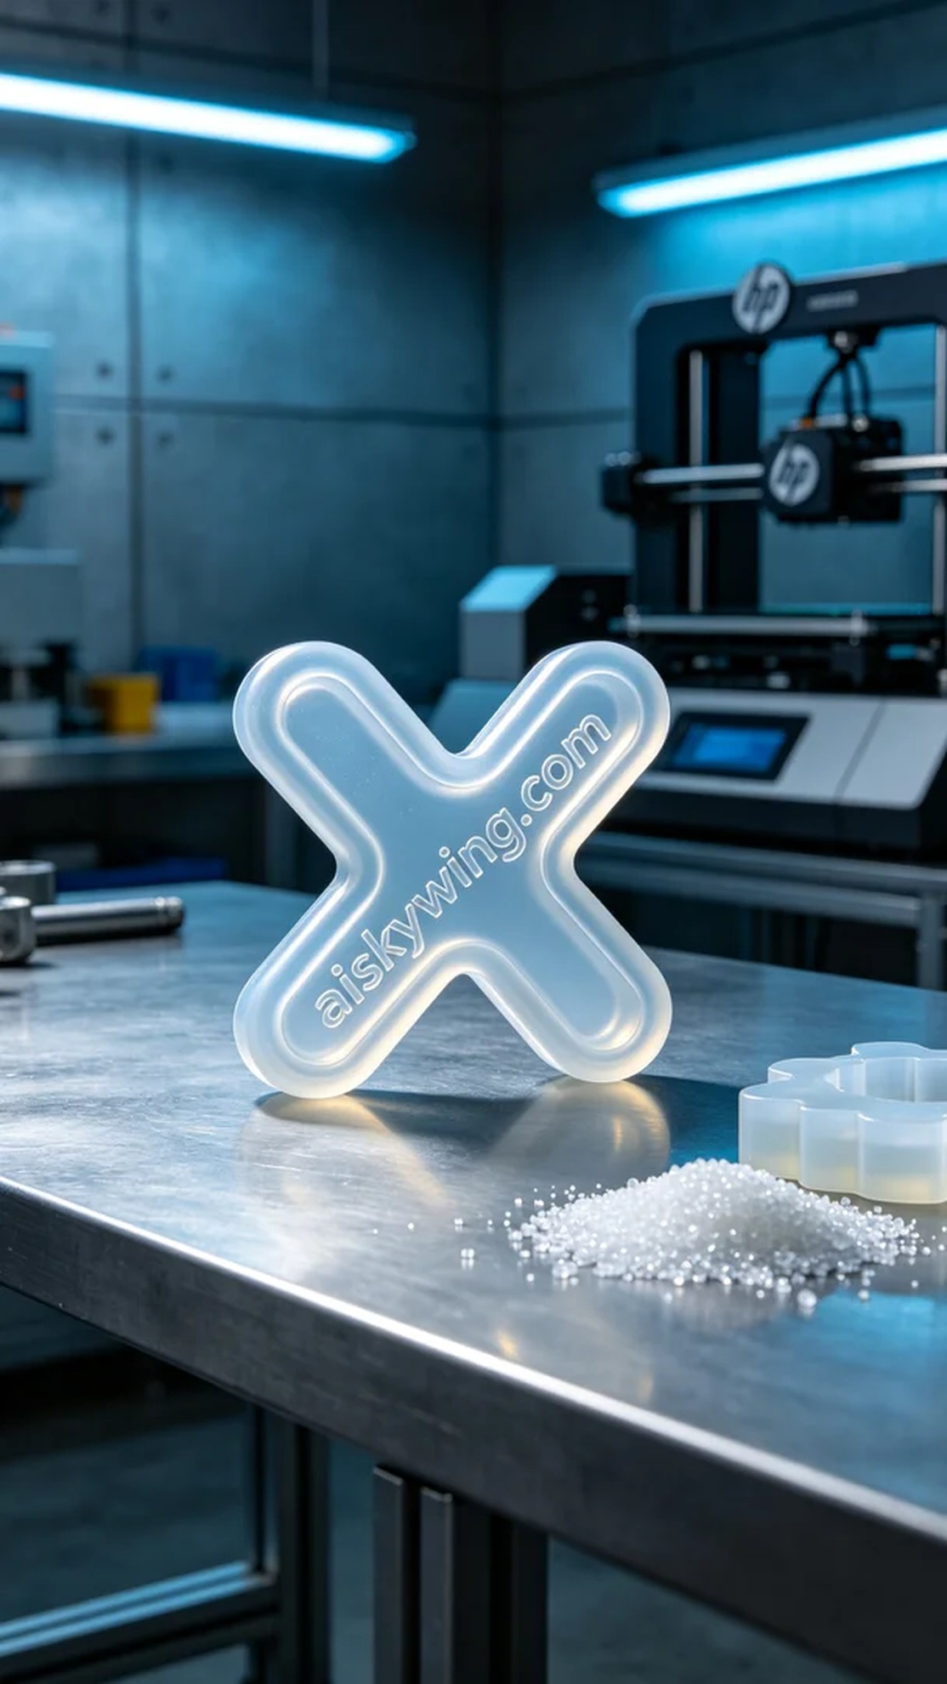
这次的生产任务是为一位朋友制作X型密封圈，他们在使用一些设备时发现密封效果不理想。经过沟通，我们决定使用硅胶复模工艺，以确保密封圈的柔软性和贴合度，完美解决他们面临的问题。
在原材料方面，我们使用了优质的硅胶复模，确保其透明度和柔韧性。为了达到最佳效果，我们选择了HP 3D打印机进行打印，设置层厚为0.1毫米，温度控制在25摄氏度，功率设置为50%，打印速度为30毫米每秒，预计打印时间约为90分钟。
打印过程中，设备运行稳定，打印头精准移动，液态光敏树脂逐层成型。期间，我们定期检查打印质量，确保每一层均匀，没有出现气泡或缺陷。整个过程中，设备的噪音和振动都在可控范围内，体现了HP打印机的优越性能。
完成打印后，我们进行了必要的后处理。首先将打印好的密封圈放入清洗槽中，用超声波清洗去除表面多余的树脂。接着，进行打磨以确保边缘光滑，最后将其放在紫外线固化灯下进行固化，确保密封圈的强度和耐用性。经过严格检验，所有密封圈都顺利通过了质量检测。
这次的制作过程顺利而高效，最终的X型密封圈达到了预期的设计标准与功能需求，为朋友的设备带来了良好的使用体验。
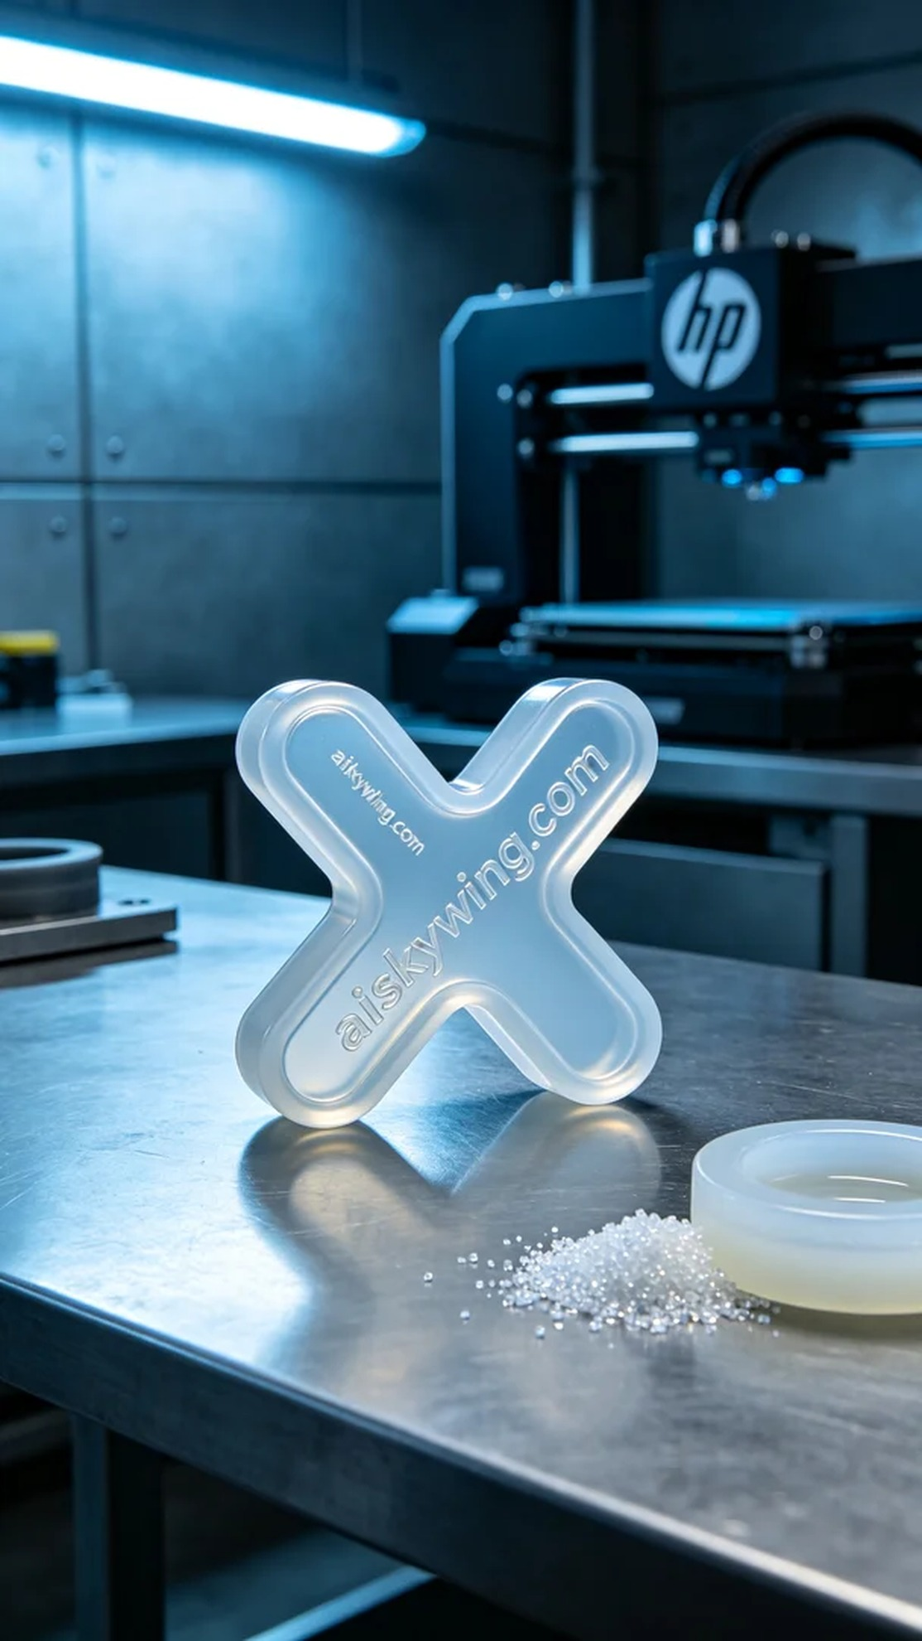
Aiskywing Industrial 3D Printing
X-type sealing ring


