0547-Y型密封圈的3D打印记录
Y-shaped sealing ring
🖨️ 硅胶复模
🖥️ 打印机: Stratasys
📦 材料: 硅胶复模
生活就像3D打印，有时候需要一层一层地堆积，才能成就完整的形状。这次，我们接到了关于Y型密封圈的订单，来解决一个关键的密封问题。
Life is like 3D printing; sometimes it requires layer by layer accumulation to achieve a complete shape. This time, we received an order for Y-shaped seals to address a critical sealing issue.
________________________________________________________________________________
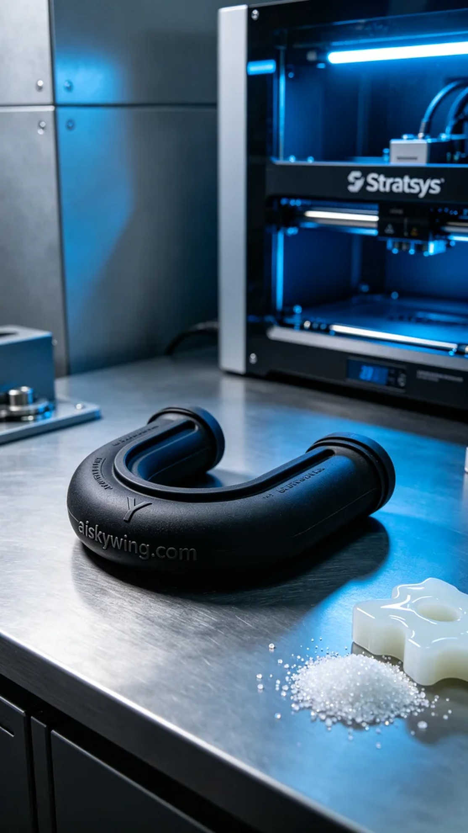
Life is like 3D printing; sometimes, we need to layer upon layer to form a complete shape. This time, we received an order for a Y-shaped sealing ring to solve a critical sealing problem.
We chose high-quality silicone molding material, which offers excellent flexibility and durability. The Stratasys printer was set to a layer thickness of 0.1 mm, with a printing temperature maintained at 25 degrees Celsius, power set to 50%, and a print speed of 30 mm per second. These parameters ensured optimal material flow and forming during the printing process.
During the printing process, the Stratasys printer operated smoothly, with noise levels well controlled. We regularly monitored the print progress to ensure that each layer covered evenly, especially at the critical joint points, to guarantee structural integrity and avoid any defects.
Once printing was completed, the post-processing steps were crucial. First, we placed the printed Y-shaped sealing ring into a washing tank to thoroughly clean off any excess resin. Then, we moved on to sanding to ensure the edges of the sealing ring were smooth. Finally, we employed UV curing technology to cure the sealing ring, ensuring its mechanical properties reached their peak, followed by a final quality check to confirm every detail met the standards.
This Y-shaped sealing ring printing not only completed smoothly but also met the expected quality standards, perfectly fitting the usage requirements and providing an ideal solution.
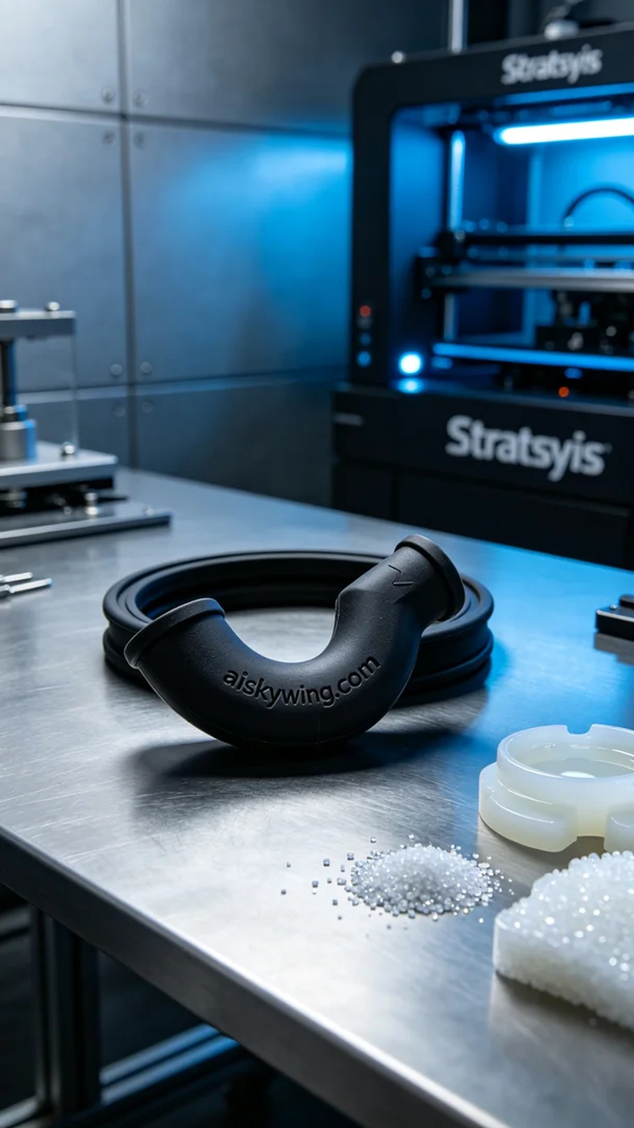
在TikTok上，有人在寻找高效的密封解决方案时，发现了我们的Y型密封圈。他们希望能通过硅胶复模技术，生产出既柔软又耐用的密封圈，以应对各种工业应用中的密封需求。
我们选择了高品质的硅胶复模作为原材料，具备优秀的柔性和耐磨性。使用的Stratasys打印机设置了层厚为0.1毫米，打印温度保持在25摄氏度，功率调至50%，打印速度为30毫米每秒。这些参数确保了打印过程中，材料的流动性和成型效果。
在打印的过程中，Stratasys打印机运转平稳，机器的噪声控制得当。我们定期监控打印进程，确保每一层都能均匀覆盖，特别是在关节点处，确保结构的稳固性，避免出现任何瑕疵。
完成打印后，后处理工序是至关重要的。首先，将打印好的Y型密封圈放入清洗槽中，用溶剂彻底清洗，去除多余的树脂。接着，进行打磨，确保密封圈的边缘光滑。最后，我们采用紫外线固化技术对密封圈进行固化处理，确保其机械性能提升到最佳状态，并进行最终的质量检验，确保每个细节都符合标准。
这次的Y型密封圈打印，不仅顺利完成，而且达到了预期的质量标准，完美契合了使用需求，为客户提供了理想的解决方案。
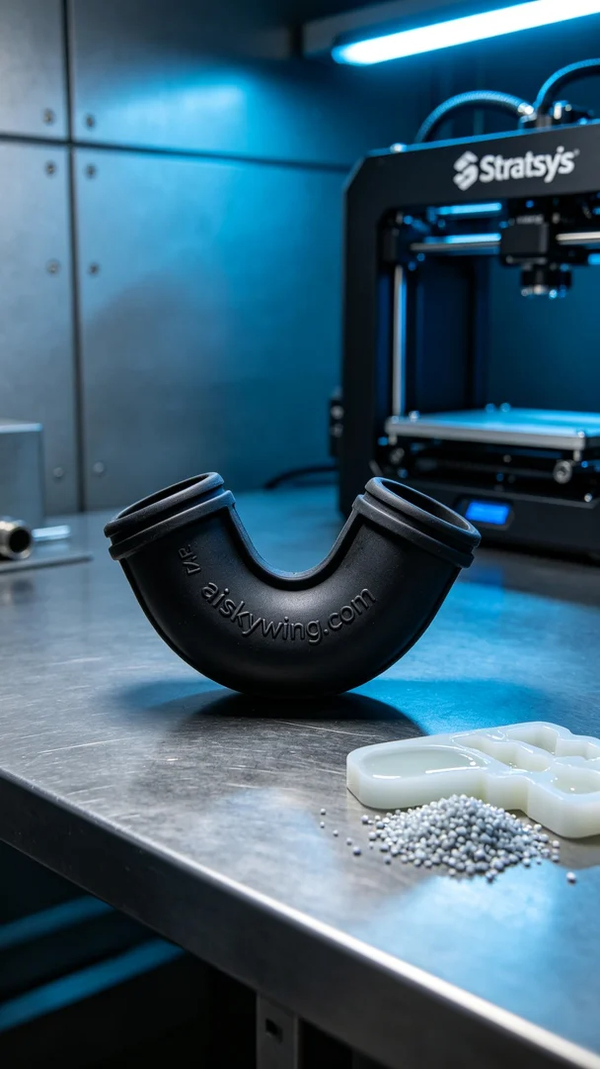
Aiskywing Industrial 3D Printing
Y-shaped sealing ring


