0548-义乳硅胶生产记录
Prosthetic breast silicone
🖨️ 硅胶复模
🖥️ 打印机: Stratasys
📦 材料: 硅胶复模
生活就像一场不断的探索，今天我们接到一个关于义乳硅胶的任务，从Instagram上有人询问我们的服务，心中默默为他们加油。
Life is like a continuous exploration. Today, we received a task regarding silicone breast prostheses, as someone inquired about our services on Instagram. We silently cheer for them in our hearts.
________________________________________________________________________________
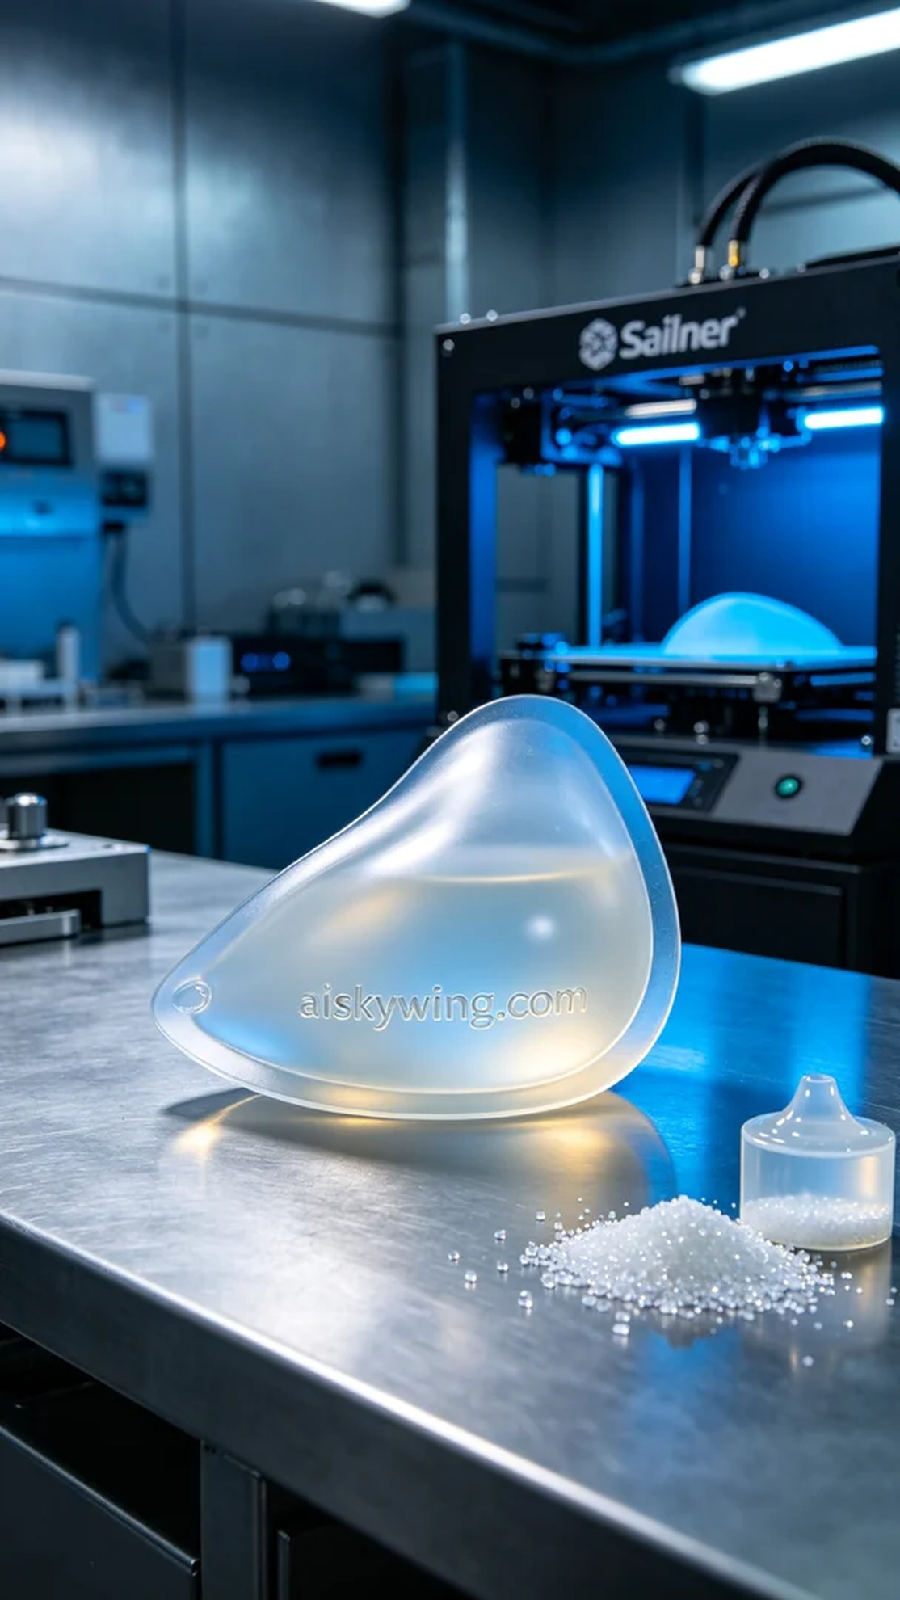
Life is like an ongoing exploration, and today we received a request for a breast prosthesis silicone from someone on Instagram, silently cheering for them as we take on this task.
We chose high-quality silicone molding material, which is transparent and soft, allowing it to fit the human body well. In terms of equipment, we prepared the Stratasys printer, setting the layer thickness to 0.1mm and the printing temperature at 220 degrees Celsius, adjusting power and speed according to the material characteristics to ensure every detail is perfectly presented.
The printing process was like a meticulous dialogue, with the Stratasys printer operating under precise settings. We monitored the quality throughout the process to ensure each layer adhered perfectly. As time passed, the outline of the breast prosthesis gradually became clear, and the entire process proceeded without error.
After printing, we entered the post-processing phase. First, the molded silicone was placed in clean water for rinsing to remove any residues on the surface. Next, we meticulously sanded the finished product to ensure a smooth touch. Finally, curing treatment was applied to enhance durability and strength, followed by strict inspections for each product's quality.
After a series of detailed processes, the breast prosthesis silicone was successfully completed, carrying our understanding and perseverance about life. It is not just a product but a reflection of our care for users.
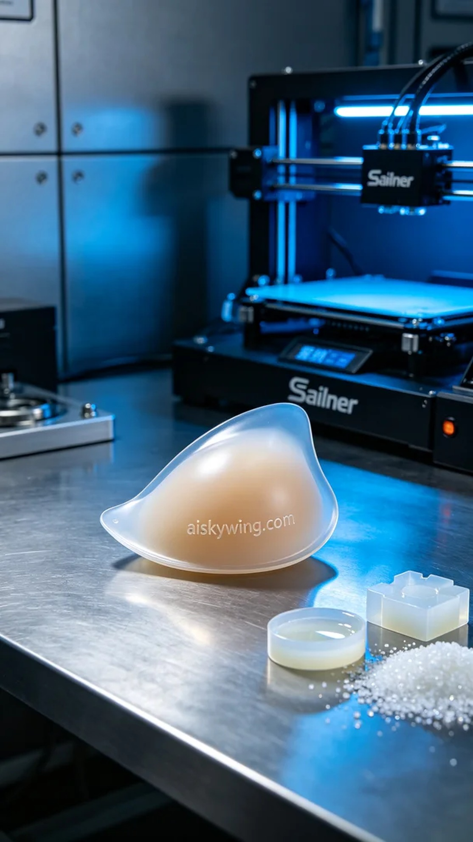
在Instagram上，有人因对义乳的需求而找到了我们，想要制作一款符合人体工学设计的义乳硅胶。这个需求引起了我们的重视，因为这是关乎生活品质的重要产品。
我们选用了优质的硅胶复模材料，具有透明性与柔软性，能够很好地贴合人体。设备方面，我们准备了Stratasys打印机，设定了层厚0.1mm，打印温度设定在220摄氏度，功率和速度根据材料特性进行了适当调整，确保打印的每个细节都能完美呈现。
打印过程如同一场严谨的对话，Stratasys打印机在精细的设置下开始运转。我们全程监控质量，确保每一层都能完美附着。随着时间的推移，义乳硅胶的轮廓逐渐清晰，整个过程无误差地进行着。
打印完成后，我们进入了后处理阶段。首先将成型的硅胶置于清水中进行清洗，以去除表面的残留物。接着，我们对成品进行了细致的打磨，以确保触感光滑。最后，进行固化处理，从而提升耐用性和强度，随后严格检验每一件产品的质量。
经过一系列精细的工序，义乳硅胶终于顺利完成，带着我们对生活的理解与坚持。这不仅是一款产品，更是我们对用户关爱的体现。
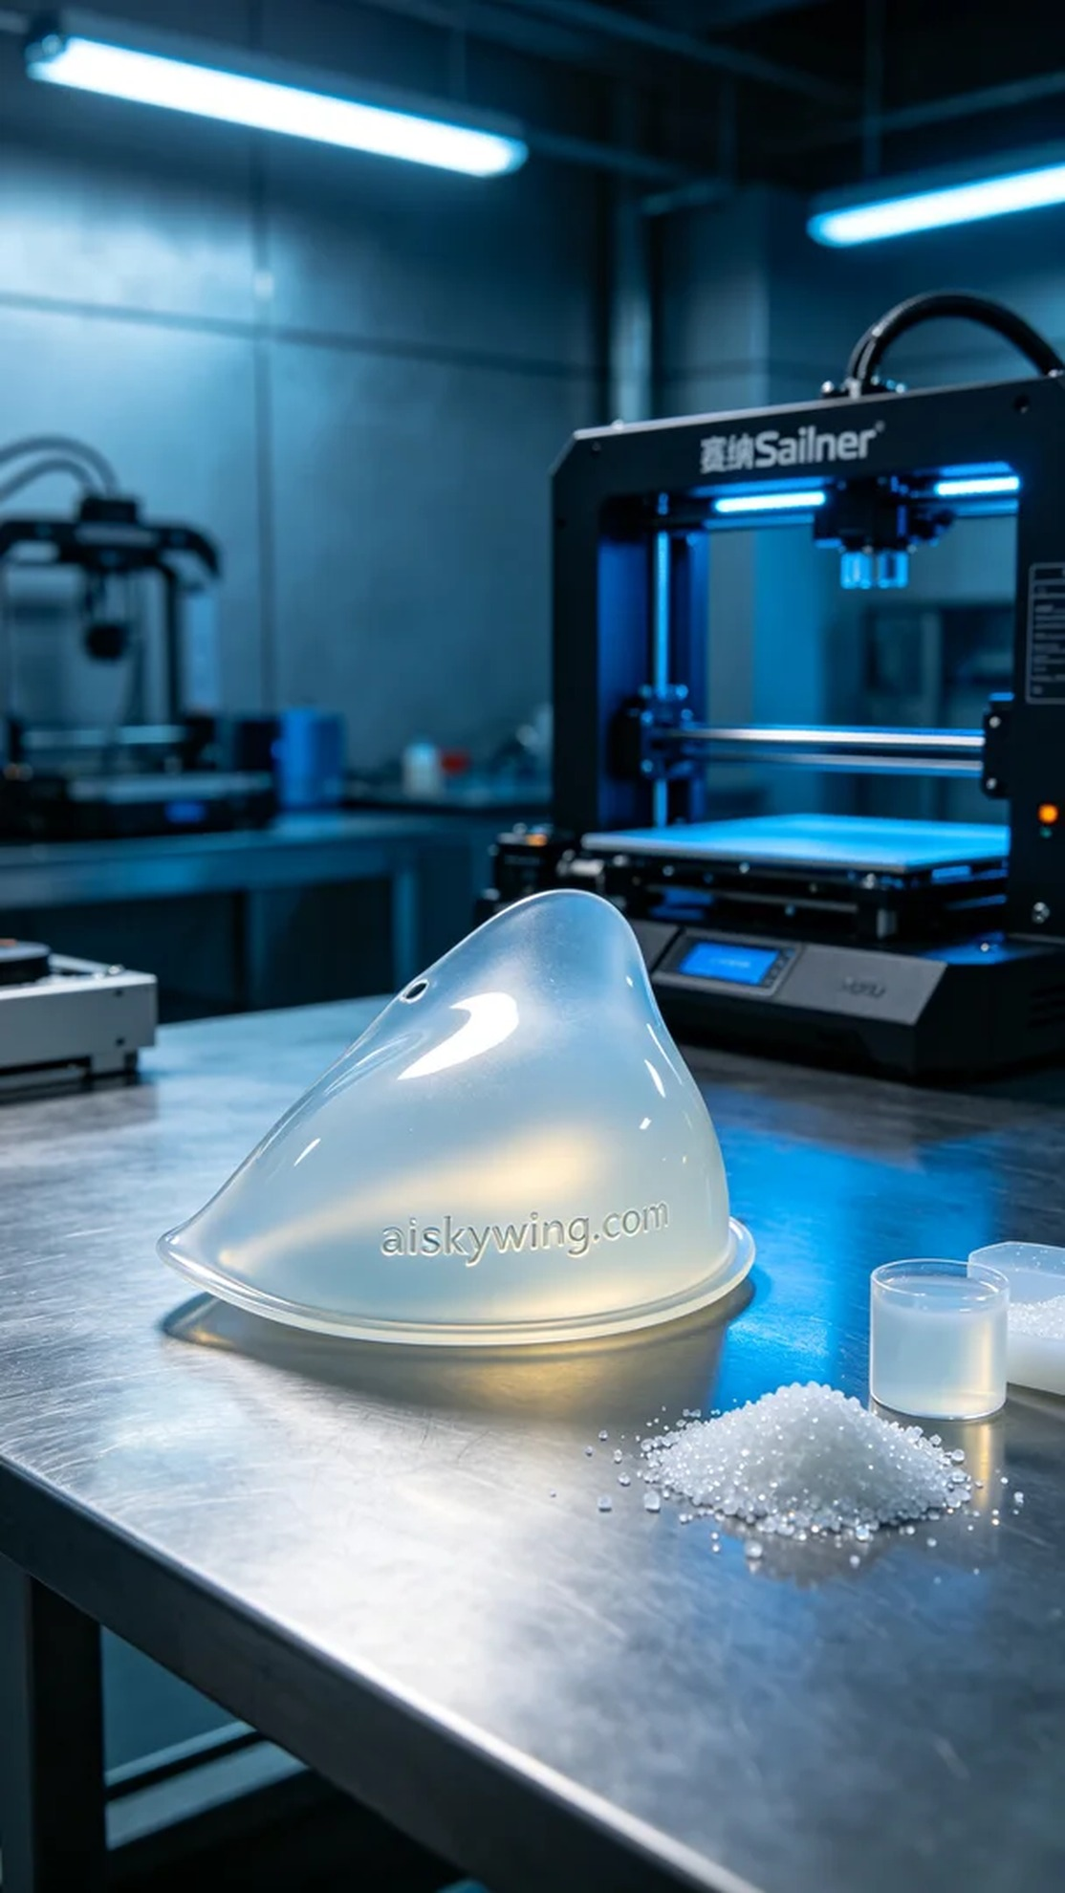
Aiskywing Industrial 3D Printing
Prosthetic breast silicone


