0549-传感器硅胶护套3D打印生产记录
Sensor silicone sleeve
🖨️ 硅胶复模
🖥️ 打印机: Rize
📦 材料: 硅胶复模
生活总会有意外的挑战，就像最近在TikTok上看到的，有人因为保护传感器而找上我做这个传感器硅胶护套。
Life always presents unexpected challenges. Recently, I saw on TikTok that someone approached me to create a silicone cover for a sensor to protect it.
________________________________________________________________________________
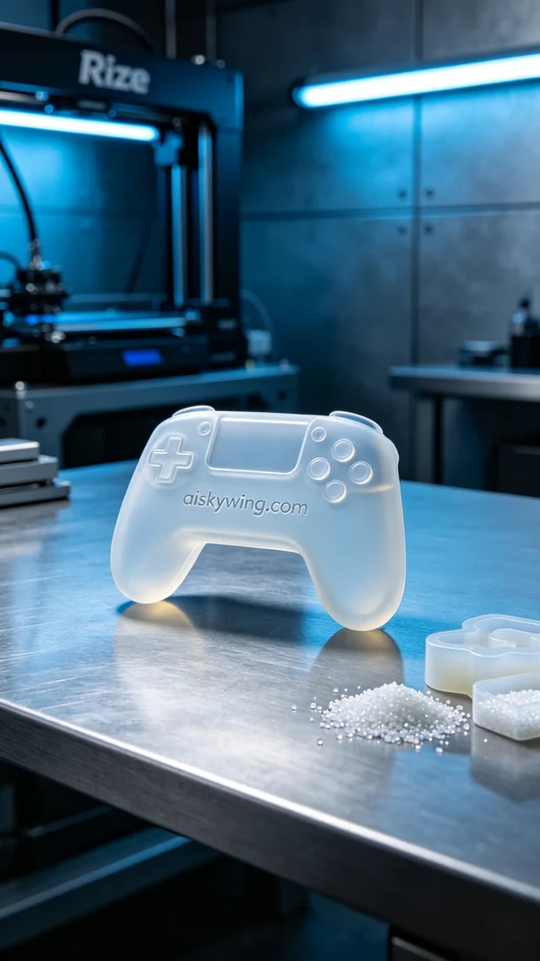
Life is always full of unexpected challenges, just like what I saw recently on TikTok, where someone reached out to me for help in making a sensor silicone sleeve to protect their device.
The sensor silicone sleeve we created is aimed at addressing the common issue of sensor damage that users face in their daily operations. Many overlook the need for protective measures while using their devices, leading to unfortunate damage. Thus, we took on this order to provide them with a sleeve that is both soft and sturdy, enhancing the durability of their equipment.
For the materials, we selected high-quality silicone molding material known for its excellent transparency and flexibility, ensuring a perfect fit for the sensor. We prepared the Rize 3D printer and set the appropriate printing parameters. The layer thickness was set to 0.1mm, the printing temperature maintained at 220℃, with a power setting of 50W and a printing speed of approximately 30mm/s, anticipating a total printing time of around 4 hours.
As the printing process commenced, the Rize printer ran smoothly while I closely monitored the print quality. I checked every step to ensure that each detail of the silicone sleeve was perfectly realized. Thanks to the precise control of the Rize printer, the engraving of "aiskywing.com" on the surface of the sleeve was remarkably clear, reflecting the cold industrial light. There were no detachments or deformations throughout, ensuring the product's integrity.
Upon completing the print, we moved on to the post-processing phase. First, we cleaned the sleeve to remove any excess resin residue. Next, we used fine sandpaper for sanding to ensure a smooth and flawless surface. The sleeve was then placed in a UV curing machine to enhance its durability. Finally, after a rigorous inspection, both dimensions and surface quality met our high standards.
In the end, through meticulous processes, we successfully produced this sensor silicone sleeve, perfectly meeting the users' needs. Life may throw unexpected challenges our way, but our efforts can always bring a sense of reassurance.
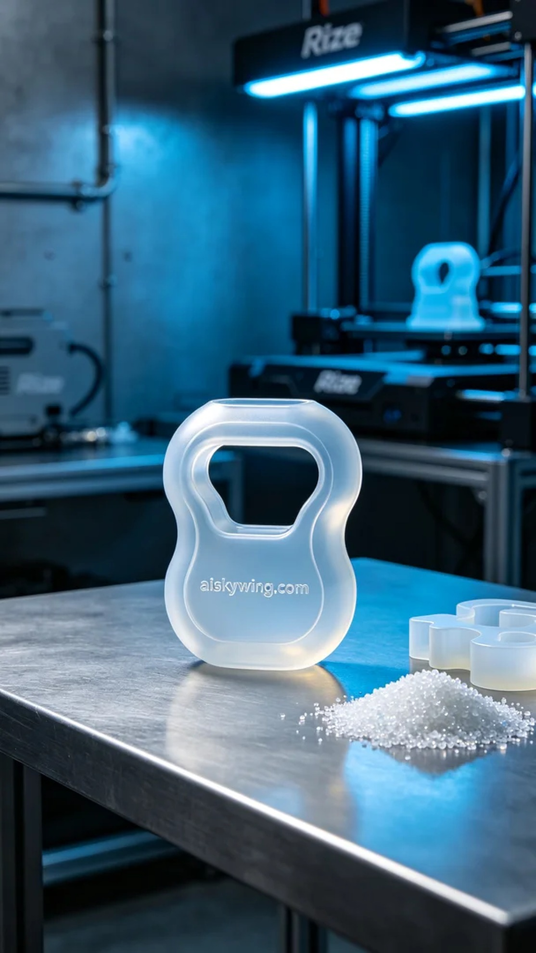
这次制作的传感器硅胶护套主要是为了帮助一些用户解决在日常使用中遇到的传感器损伤问题。大家在使用设备时，往往忽略了保护措施，导致传感器受到损害。于是，我们接到了这个订单，希望能为他们提供一个既柔软又坚固的硅胶护套，提高设备的耐用性。
在原材料方面，我们选用了高质量的硅胶复模材料，这种材料具有良好的透明性和柔韧性，能够精确贴合传感器的外形。同时，准备了Rize 3D打印机，设置了合适的打印参数。层厚设置为0.1毫米，打印温度保持在220℃，功率设定为50W，打印速度约为30mm/s，整个打印过程预计需要4个小时。
打印过程开始后，Rize打印机运行顺利，持续监控打印质量。我仔细检查每一步，确保硅胶护套的每个细节都能完美体现。借助于Rize打印机的精准控制，护套表面的“aiskywing.com”字样雕刻得异常清晰，反射着冷峻的工业光线。整个过程中没有出现脱落或变形的情况，确保了产品的完整性。
完成打印后，进入后处理工序。首先进行了清洗，去除多余的树脂残留。接着，使用细砂纸进行打磨，以确保护套表面光滑无瑕。然后，将护套放入UV光固化机内进行固化，使其增强耐用性。最后，经过严格的检验，无论是尺寸还是表面质量都达到我们的高标准。
最终，经过多道严谨的工序，我们成功制作出这款传感器硅胶护套，完美满足了用户的需求。生活中总是会有意外，但我们的努力总能为他们带来一丝安心。
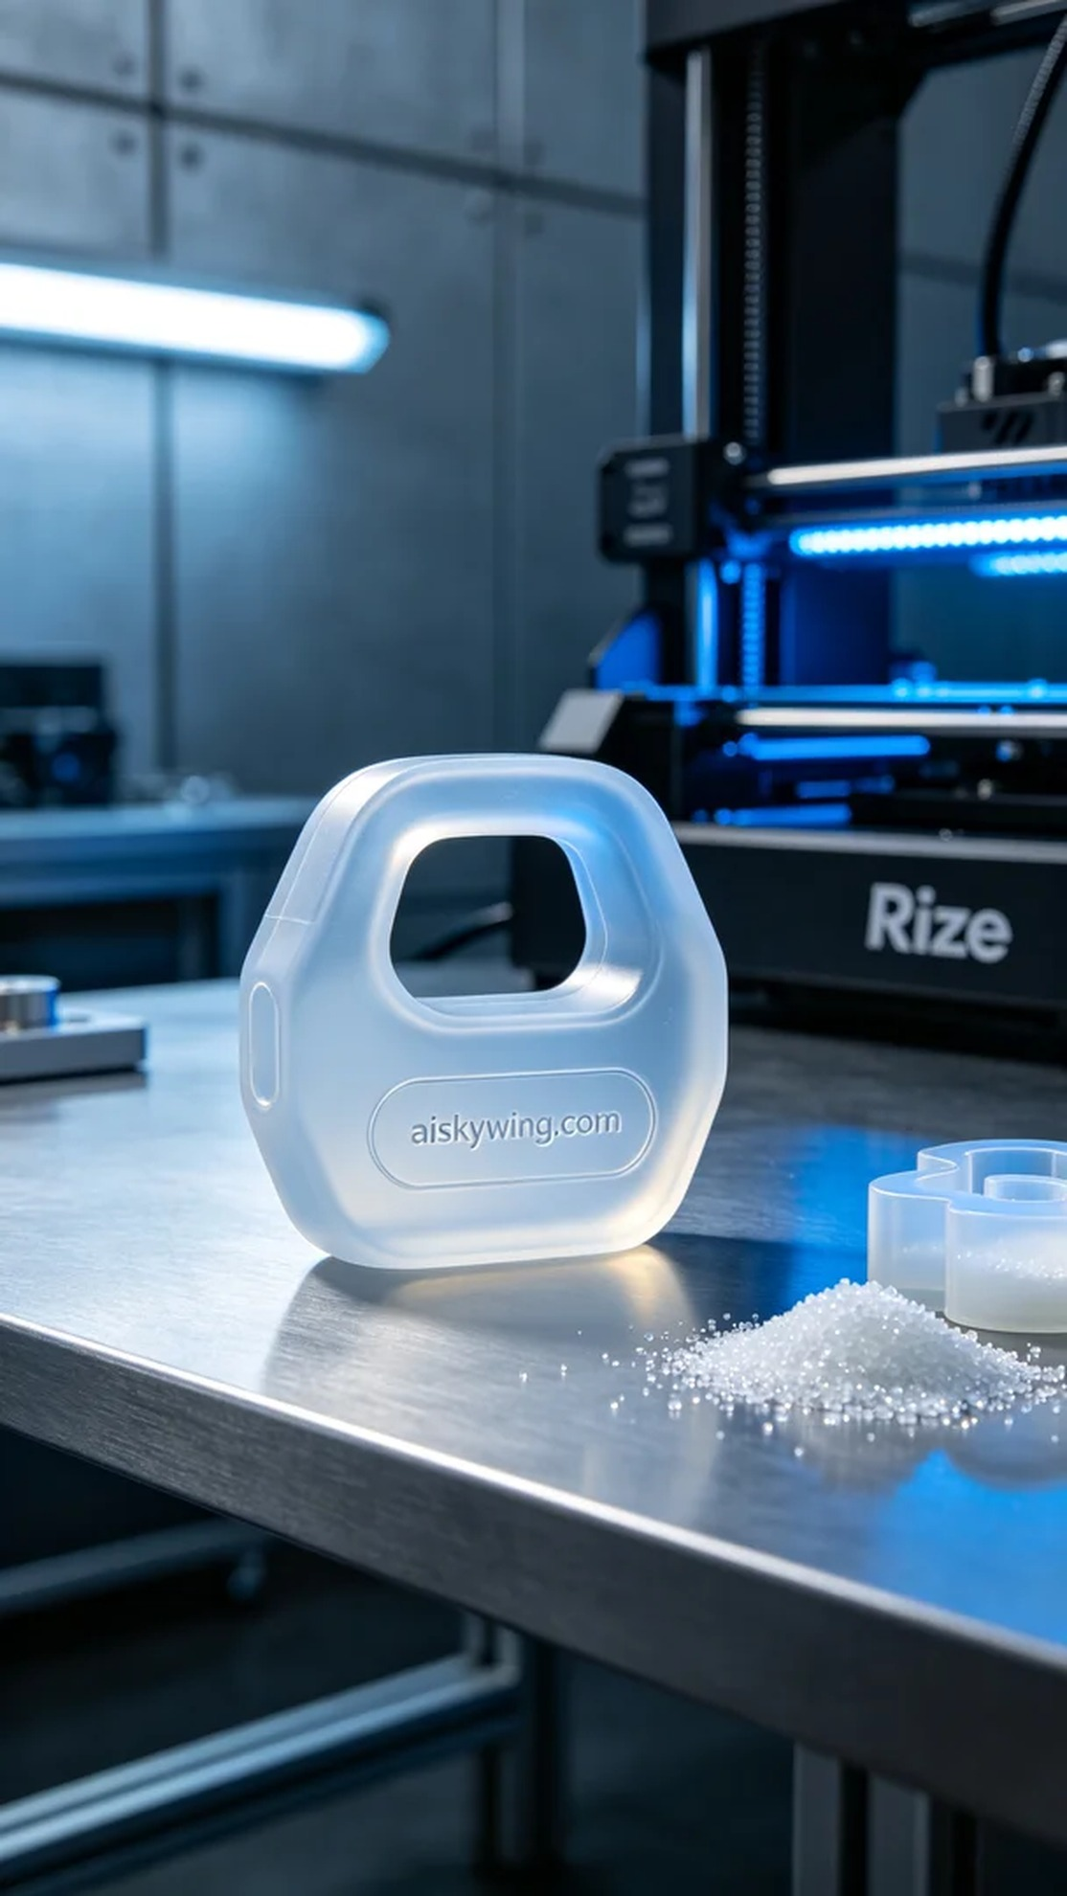
Aiskywing Industrial 3D Printing
Sensor silicone sleeve


