0550-传送带防滑垫的3D打印记录
Conveyor Belt Anti-Slip Mat
🖨️ 硅胶复模
🖥️ 打印机: Voxeljet
📦 材料: 硅胶复模
生活再难，也别停下脚步。就像接下这个传送带防滑垫的单子，有人因为生产线滑动而烦恼，寻求我们的帮助。
No matter how difficult life gets, don't stop moving forward. Just like taking on this order for conveyor belt anti-slip mats, some people are troubled by the sliding on the production line and seek our help.
________________________________________________________________________________
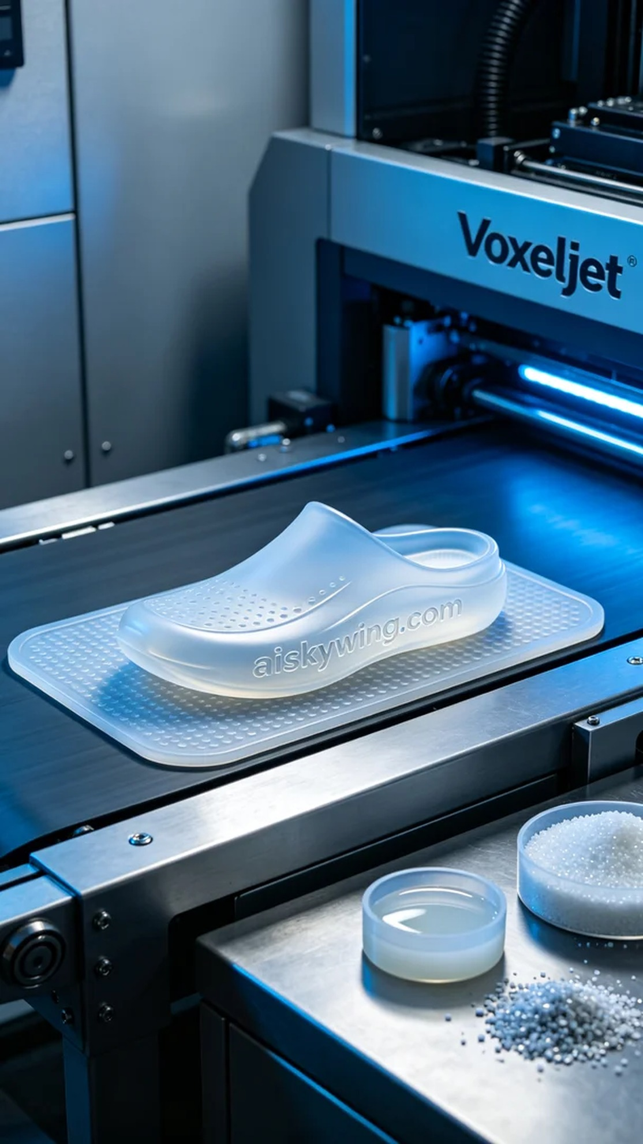
On Instagram, someone reached out to us regarding the issue of items sliding on their conveyor belt, looking for a specialized anti-slip mat. So, we decided to create a custom conveyor anti-slip mat to help them solve this problem.
We chose silicone rubber molding as the material because it offers excellent flexibility and transparency, along with outstanding wear resistance, making it ideal for the application of an anti-slip mat. To ensure print quality, we used the Voxeljet 3D printer, setting the layer thickness to 0.1 mm, print temperature at 25 degrees Celsius, power control at 80%, print speed around 60 mm per second, with an estimated print time of 4 hours.
During the printing process, the equipment operated as expected with stable temperature and power, ensuring the precision and consistency of the print. We continuously monitored the printing process to ensure each layer was deposited evenly and the surface smooth, ultimately achieving a clear engraving of the “aiskywing.com” text.
After printing, we carried out multiple post-processing steps on the anti-slip mat. First, we cleaned it with alcohol to remove surface residues; next, we meticulously polished it to ensure smooth edges; finally, we cured it with UV light to enhance the material's durability and resistance to aging, followed by a rigorous quality inspection to ensure each mat met the standards.
In the end, this conveyor anti-slip mat not only solved the sliding issue on the production line but also showcased our professional standards through precise craftsmanship and high-quality materials.
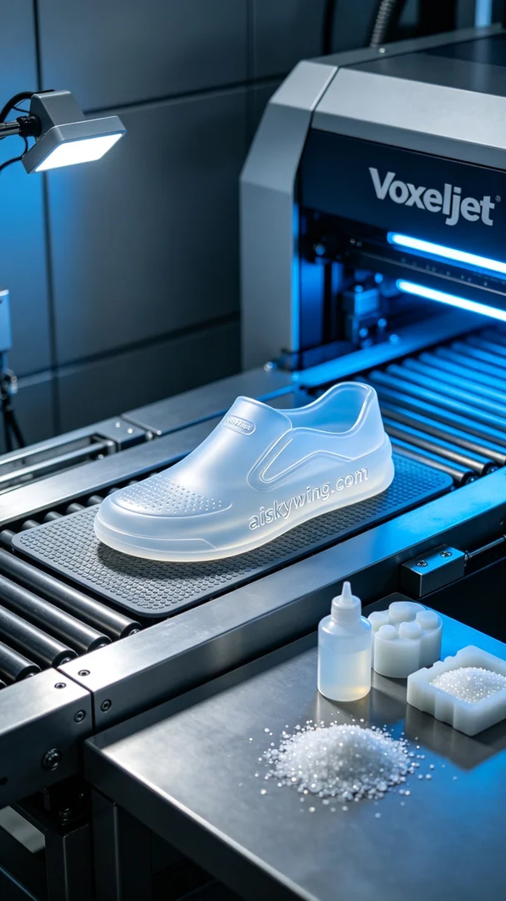
在Instagram上，有人因为传送带在运行时物品滑动的问题找到了我们，想要一款专门设计的防滑垫。于是，我们决定为其定制一个传送带防滑垫，帮助他们解决这一困扰。
我们选择了硅胶复模作为材料，这种材料不仅具备良好的柔软性和透明性，还有着出色的耐磨性，非常适合防滑垫的应用。为了确保打印质量，我们使用了Voxeljet 3D打印机，设置层厚为0.1毫米，打印温度设定在25摄氏度，功率控制在80%，打印速度约为60毫米每秒，预计打印时间为4小时。
在打印过程中，设备如预期运行良好，温度和功率稳定，确保了打印的精准度和一致性。我们不断监控打印过程，确保每一层都能均匀沉积，表面光滑，最终实现了“aiskywing.com”字样的清晰雕刻。
完成打印后，我们对防滑垫进行了多道后处理工序。首先，用酒精清洗，去除表面残留物；接着，进行细致打磨，确保边缘光滑；最后，经过UV灯固化，以增强材料的耐久性和抗老化性能，最后进行严格的质量检验，确保每一块防滑垫都能达到标准。
最终，这款传送带防滑垫不仅解决了生产线滑动的问题，更通过精准的工艺和优质的材料展现了我们的专业水平。
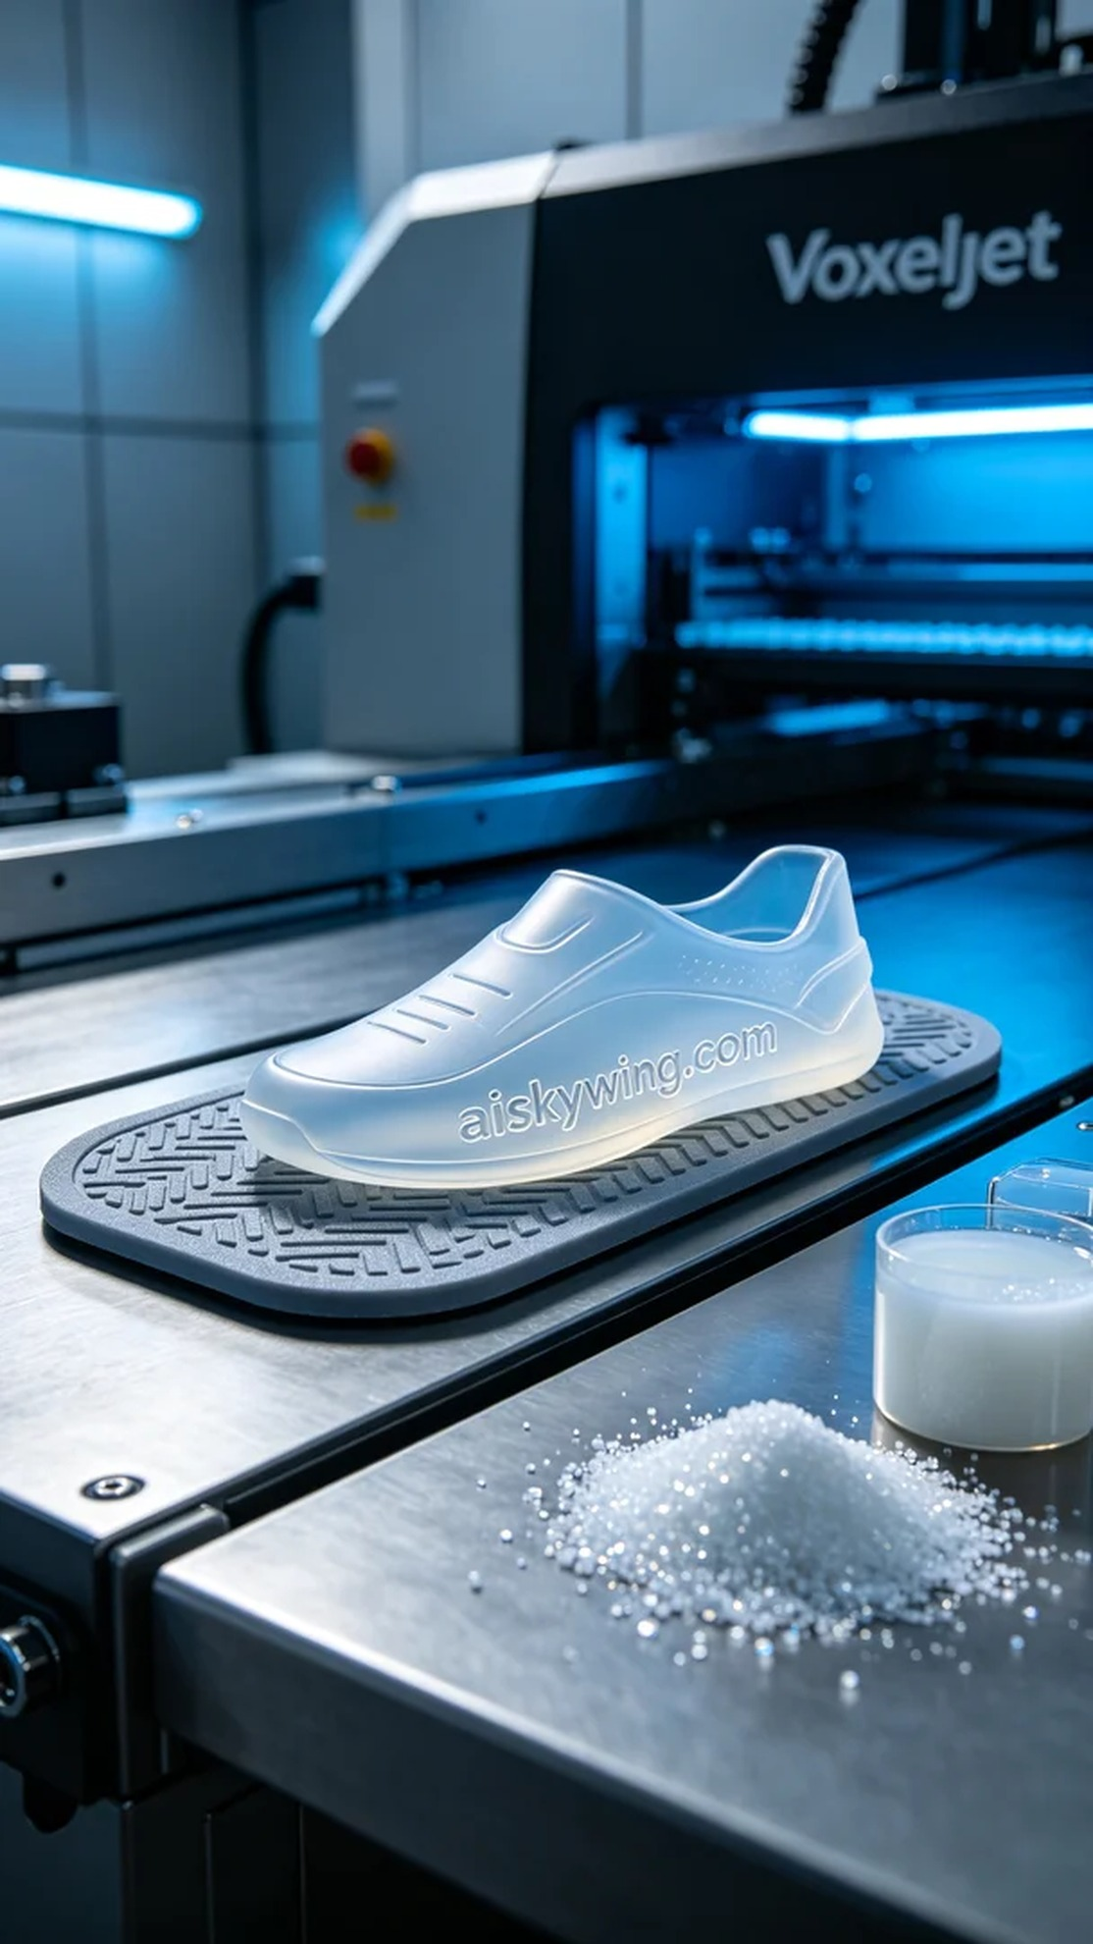
Aiskywing Industrial 3D Printing
Conveyor Belt Anti-Slip Mat


