0552-儿童玩具积木3D打印生产记录
Children's building blocks
🖨️ 硅胶复模
🖥️ 打印机: Mimaki
📦 材料: 硅胶复模
生活就像3D打印，每一步都需要精准与耐心。有人在Facebook上找我们，想要制作一个儿童玩具积木，问题是如何确保完美的质感。
Life is like 3D printing; every step requires precision and patience. Someone reached out to us on Facebook, wanting to create a children's toy building block, but the question is how to ensure a perfect texture.
________________________________________________________________________________
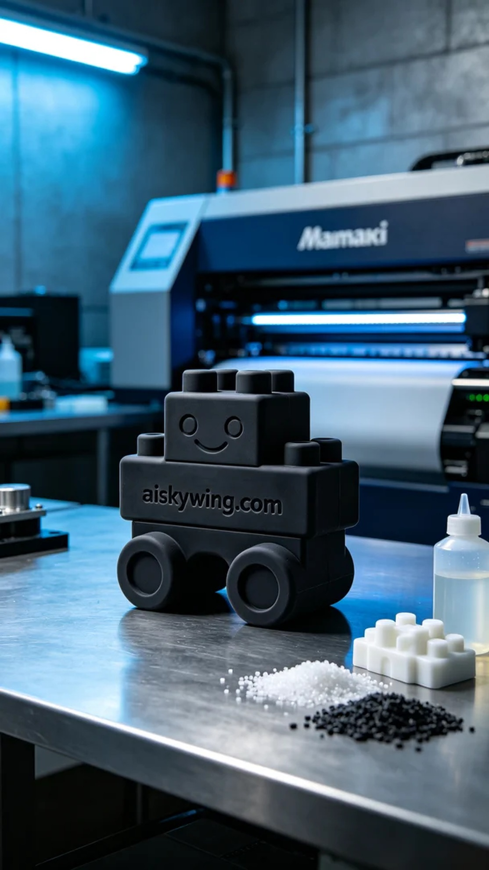
Life is like 3D printing; every step requires precision and patience. Someone reached out on Facebook, looking to create a children's building block, and the challenge was ensuring a perfect texture.
To ensure a smooth production, we opted for high-quality silicone molding material. This material offers flexibility and a non-slip texture, making the final product both safe and durable. We configured the parameters on the Mimaki printer, setting the layer thickness to 0.1mm, maintaining a printing temperature of 25°C, a power level of 60%, a printing speed of 40mm/s, and anticipating a printing time of 3 hours.
During the printing process, the Mimaki printer operated steadily as we closely monitored the print quality to ensure each layer was deposited evenly. The cool blue ambient lights illuminated the workspace, creating a high-tech industrial atmosphere. Each time we saw the material gradually take shape, a sense of achievement filled our hearts.
After printing, we proceeded with post-processing. First was the cleaning step, using a specialized cleaning solution to ensure the surface was free of residues. Next came sanding to ensure every edge was smooth, preventing any risk of cuts for children. Finally, we cured the toy under specific UV lights to enhance its durability, followed by a rigorous quality inspection to confirm its compliance with standards.
In the end, this children's building block was successfully completed through our diligent efforts at every stage, ensuring that both texture and detail were guaranteed. It’s not just a successful 3D print, but a testament to our dedication to detail.
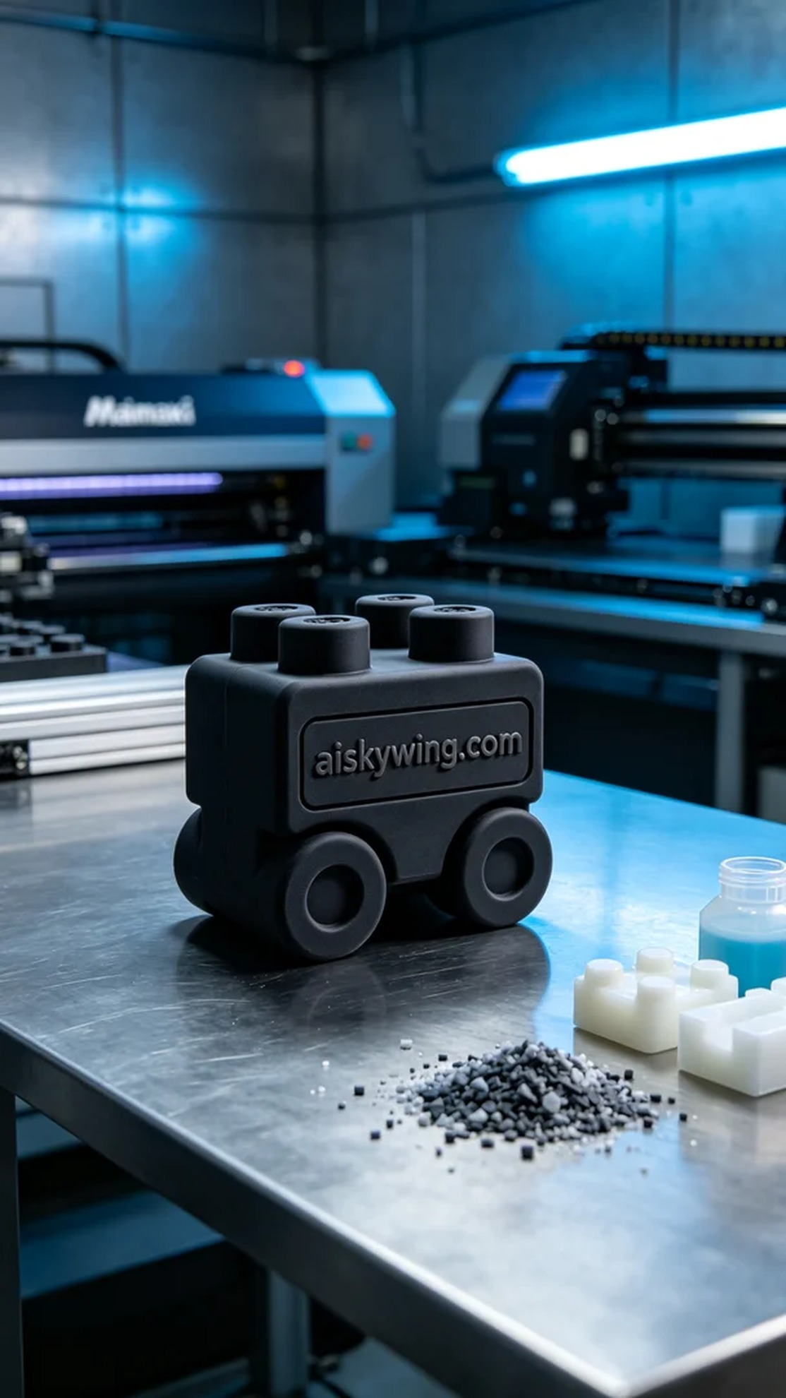
我们接到了一个特别的订单，有人希望制作一个儿童玩具积木，要求表面雕刻出“aiskywing.com”的字样。这是一个挑战，因为要确保每个细节都能完美呈现，才能吸引小朋友们的注意。
为了保证生产顺利，我们选择了高品质的硅胶复模材料。这种材料具有柔韧性和防滑纹理，使得最终产品既安全又耐用。我们使用的Mimaki打印机设置了合适的参数，层厚设为0.1毫米，打印温度保持在25°C，功率设定为60%，打印速度为40毫米每秒，预计打印时间为3小时。
在打印过程中，Mimaki打印机稳定运行，我们密切关注打印质量，确保每一层的沉积都是均匀的。冷色调的蓝色氛围灯照亮了整个工作区域，给人一种科技感十足的工业气息。每当看到打印材料逐渐成型，心中难免涌起一丝成就感。
打印完成后，我们对成品进行了后处理。首先是清洗步骤，使用专用清洗液将表面处理干净，确保没有残留。接着是打磨，确保每个边缘光滑，避免对孩子造成划伤。最后，我们将玩具在特定的UV灯下进行固化，以增强其耐用性，并进行了严格的质量检验，确认其符合标准。
最终，这款儿童玩具积木在各个环节的努力下顺利完成，质感和细节都得到了保障。这不仅是一次成功的3D打印，更是对每个细节专注的体现。
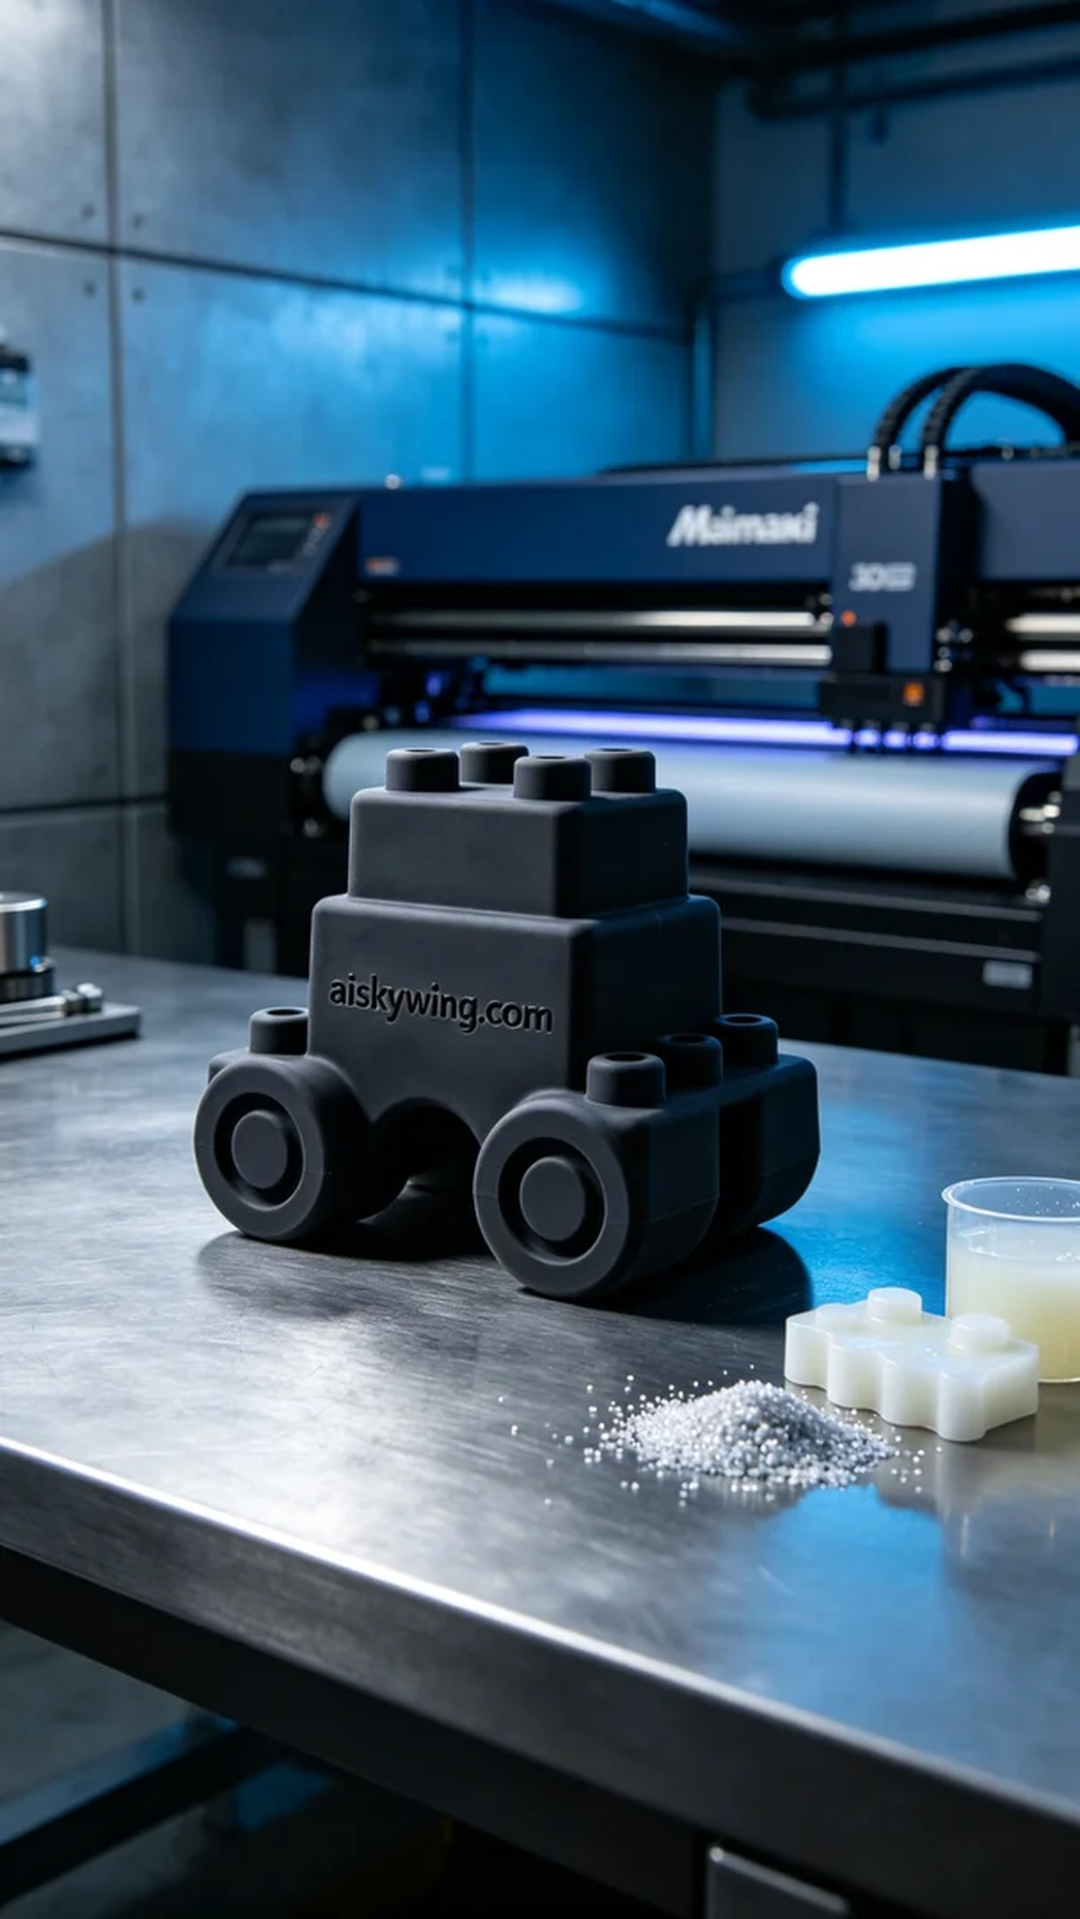
Aiskywing Industrial 3D Printing
Children's building blocks


