0558-TWS蓝牙耳机充电仓3D打印生产记录
TWS Bluetooth earphone charging case
🖨️ SLA光固化
🖥️ 打印机: Stratasys
📦 材料: SLA光固化树脂
在Facebook上，有人因为蓝牙耳机充电仓的外观和实用性向我们求助。于是我们接下了这个TWS蓝牙耳机充电仓的项目，开始了我们的3D打印之旅。
On Facebook, someone reached out to us for help regarding the appearance and practicality of a Bluetooth earbuds charging case. Thus, we took on the project of this TWS Bluetooth earbuds charging case and began our 3D printing journey.
________________________________________________________________________________
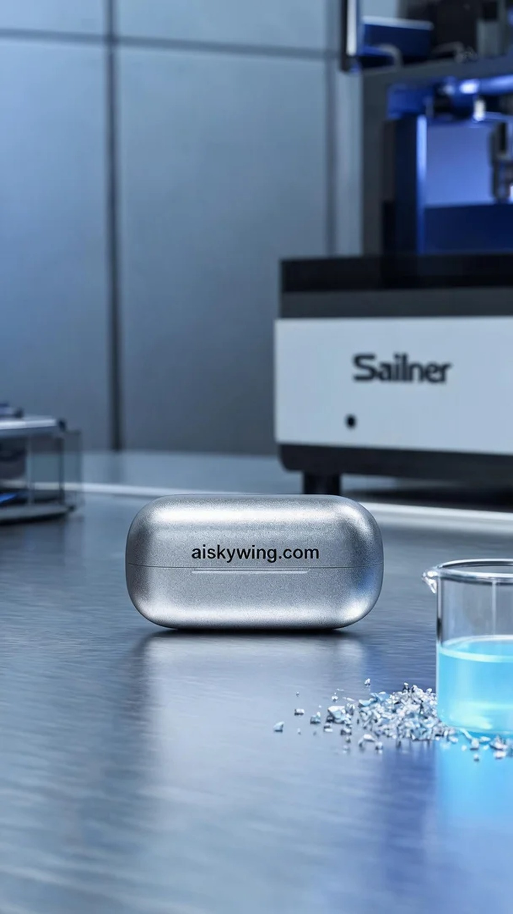
On Facebook, someone reached out to us for help with the appearance and functionality of a Bluetooth earbud charging case. Thus, we took on the project of creating this TWS Bluetooth earbud charging case and embarked on our 3D printing journey.
To realize the design of the TWS Bluetooth earbud charging case, we chose SLA photopolymer resin as our material. This material not only excels in detail representation but also possesses good strength and toughness. During preparation, we set up the Stratasys printer with a layer thickness of 0.05mm, a printing temperature of 25°C, a power setting of 40%, and a print speed of 30mm/s, estimating a total print time of about 4 hours.
During the printing process, the Stratasys printer ran smoothly with a low noise level as the liquid resin gradually solidified under the light source, layer by layer. We continuously monitored the print quality, carefully observing the curing of each layer to ensure the surface smoothness and the structural integrity of the product.
After printing, we moved on to the post-processing steps. First, we carefully removed the formed charging case from the print platform and cleaned it with solvent to eliminate any residual photopolymer resin. Next, we used fine sandpaper to polish the surface, making it smoother and more refined. Finally, the finished product was placed in a curing machine to ensure its strength met the required standards. After thorough inspections, we confirmed that every detail was in line with the design specifications.
After a series of meticulous operations, the TWS Bluetooth earbud charging case was finally completed. Each print is a new challenge, and every success brings an immense sense of satisfaction.
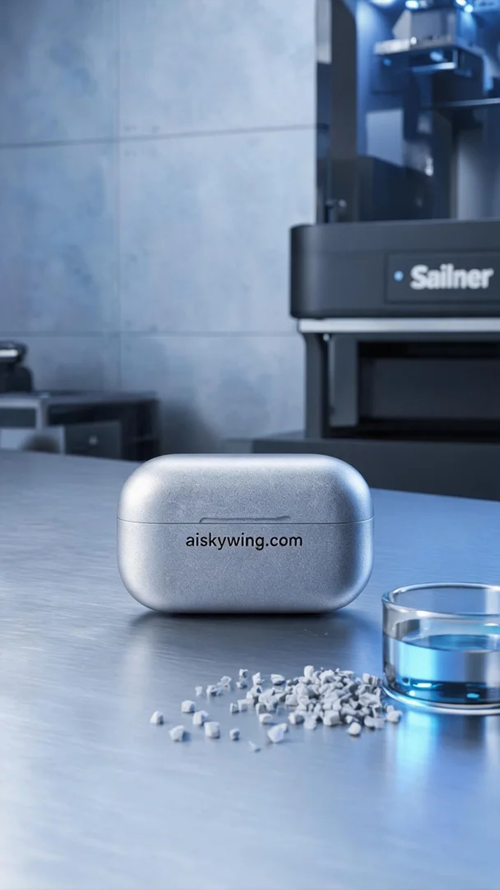
为了实现这个TWS蓝牙耳机充电仓的设计，我们选择了SLA光固化树脂作为原材料。这种材料不仅在细节表现上极为出色，同时也具备良好的强度和韧性。准备过程中，我们使用Stratasys打印机进行了详细的设置，层厚设定为0.05mm，打印温度为25°C，功率设置在40%，打印速度为30mm/s，预计打印时间约为4小时。
打印过程中，Stratasys打印机运作稳定，声音低沉，液态树脂在光源照射下逐层固化，逐渐形成所需的形状。我们始终保持对打印质量的监控，注意观察每一层的固化情况，以确保产品的表面光滑度和整体结构的完整性。
打印完成后，进入了后处理工序。首先将成型的充电仓从打印平台上取下，使用溶剂对其进行清洗，去除残留的光敏树脂。接着，使用细砂纸对表面进行打磨，使其更加光滑细腻。最后，将成品放入固化设备中进行固化处理，确保其强度达到标准。经过最后的检验，确认每个细节都符合设计要求。
经过一系列的精细操作，这个TWS蓝牙耳机充电仓终于完成了。每一次打印都是一次新的挑战，而每一次成功都让人感到无比满足。
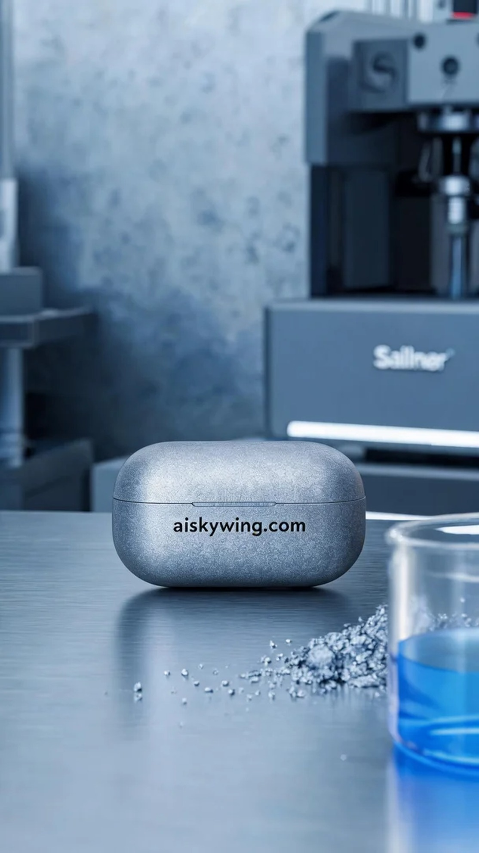
Aiskywing Industrial 3D Printing
TWS Bluetooth earphone charging case


