0559-USB集线器外壳3D打印记录
USB hub case
🖨️ SLA光固化
🖥️ 打印机: Carbon
📦 材料: SLA光固化树脂
在这个充满挑战的时代，我们都在努力寻找解决方案。最近，有人找我们要做一个USB集线器外壳，遇到了一些困难。
In this challenging era, we are all striving to find solutions. Recently, someone approached us to create a USB hub enclosure and encountered some difficulties.
________________________________________________________________________________
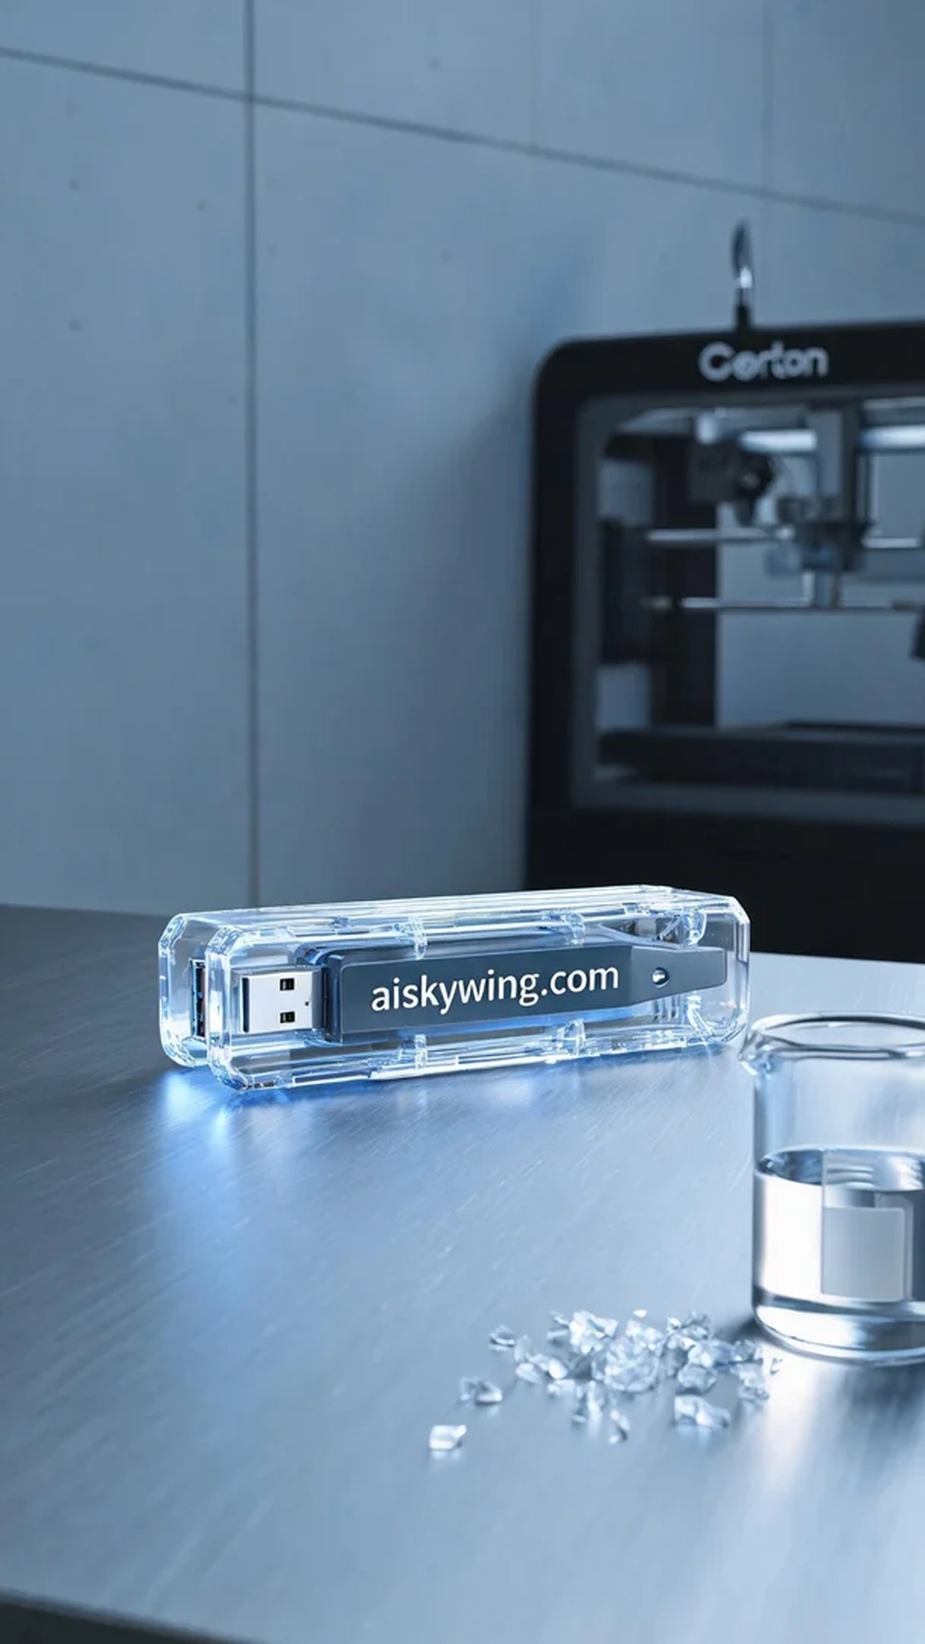
In this challenging era, we are all striving to find solutions. Recently, someone approached us to create a USB hub shell, facing some difficulties along the way.
To produce this USB hub shell, we chose SLA photopolymer resin as the material. Its high transparency and smooth surface make it perfect for crafting a modern industrial product. In terms of equipment, we used a Carbon 3D printer, setting the layer thickness at 50 microns, maintaining a printing temperature of 25 degrees, with power set at 80%, and a printing speed of 40 mm per second. The estimated printing time was approximately four hours.
As the printing process began, the machine operated smoothly, with the photopolymerization technology ensuring precise layering. We monitored the quality in real-time, ensuring that there were no bubbles or defects. As time went on, the shell gradually took shape, and the glossy surface shimmered under the lights, reflecting a cool industrial aesthetic.
Once printing was complete, we moved into the post-processing phase. First, we removed the finished product and washed it with a cleaning solution to eliminate excess resin. Next, we gently sanded the surface with fine sandpaper for added smoothness. Finally, we placed the shell into a curing machine to ensure its structural stability. After a thorough inspection to confirm there were no flaws, the USB hub shell was finally completed.
Today's work reminded me once again that the more complex the project, the greater the sense of achievement it brings. This USB hub shell not only resolved someone's problem but also allowed me to grow and gain experience in my work.
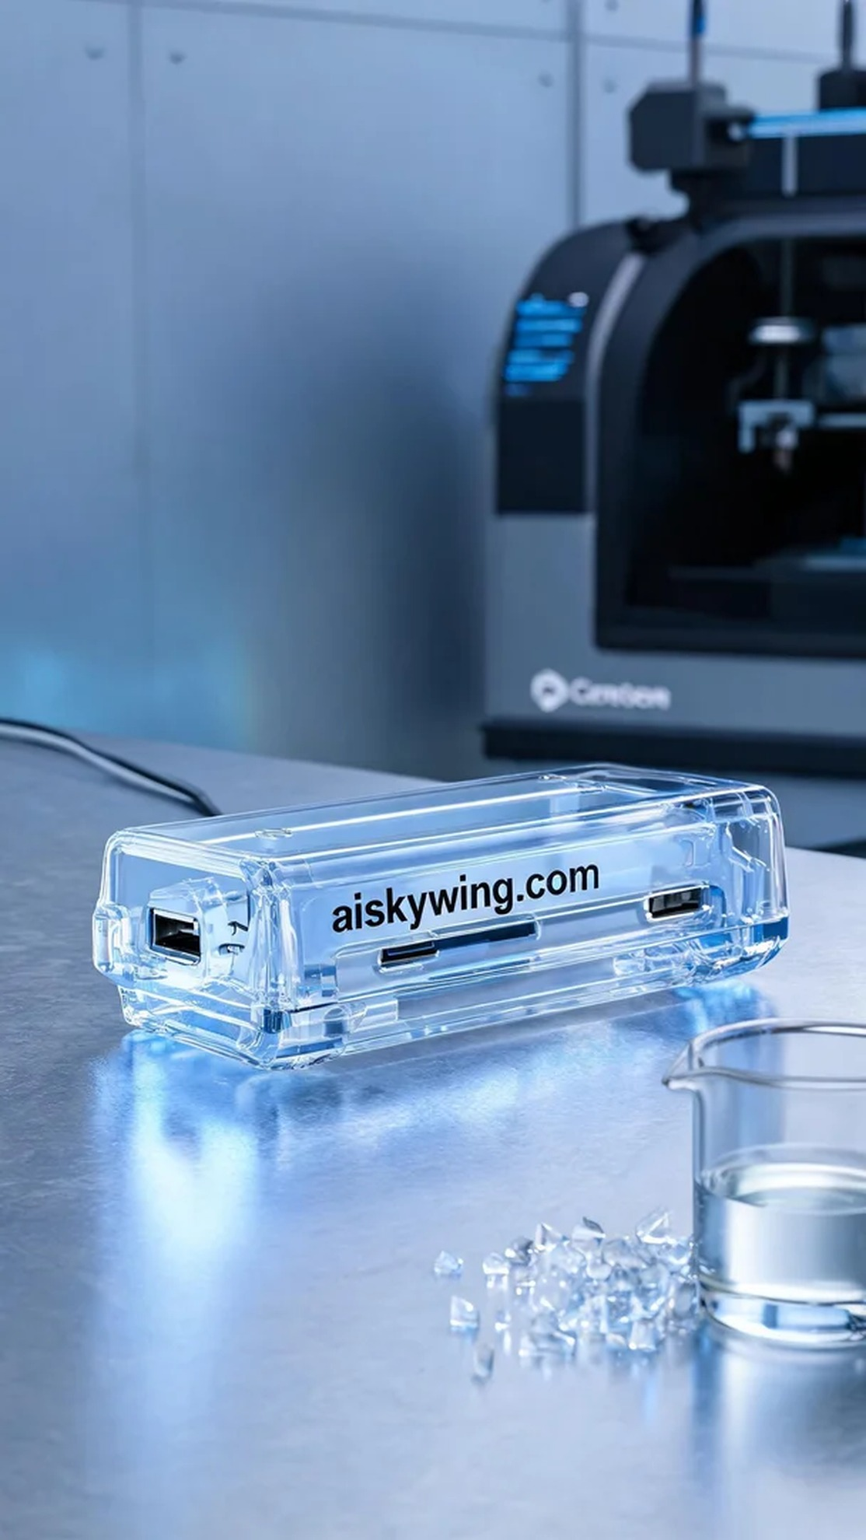
这位朋友在TikTok上看到我们，提到他想要一款独特的USB集线器外壳，但在设计和材料选择上面临困惑。于是，他找到了我们，希望能解决这个问题。
为了制作这个USB集线器外壳，我们选择了SLA光固化树脂作为材料。它的透明度高、表面光滑，非常适合打造现代感十足的工业风产品。设备准备方面，我们用的是Carbon品牌的3D打印机，设置了层厚为50微米，打印温度控制在25度，功率设定在80%，打印速度设定为40毫米每秒，预计打印时间为4小时。
打印过程一开始，机器运行得非常平稳，光固化技术确保了每一层的精确对接。我们实时监控着质量，确保没有气泡和缺陷。随着时间的推移，外壳逐渐成型，表面光泽在灯光下显得晶莹剔透，反射出冷峻的工业美感。
打印完成后，我们进入了后处理阶段。首先将成品取下，用清洗液清洗，去除多余的树脂。接着，我们用细砂纸轻轻打磨表面，使其更加光滑。最后，把外壳放入固化机中加固，以确保结构的稳定性。经过严格的检验，确保没有瑕疵后，这个USB集线器外壳终于完工。
今天的工作让我又一次感受到，越是复杂的项目，越能带来意想不到的成就感。这个USB集线器外壳不仅解决了某人的问题，也让我在工作中获得了成长与收获。
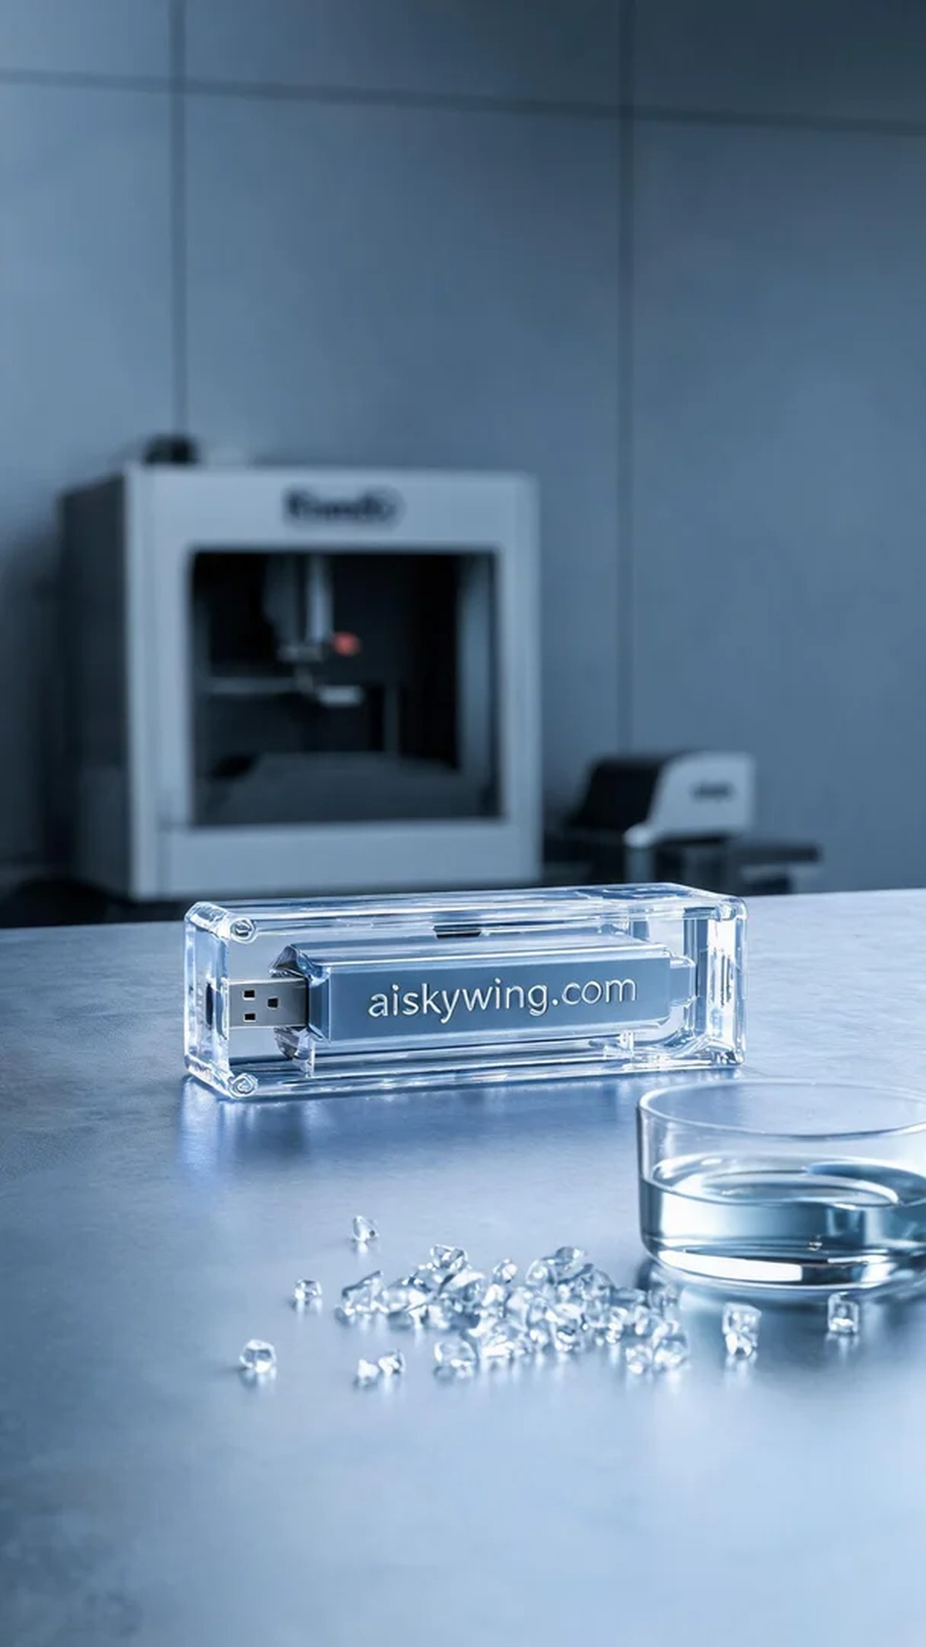
Aiskywing Industrial 3D Printing
USB hub case


