0562-3D打印产品的生产记录
3D printed products
🖨️ SLA光固化
🖥️ 打印机: Stratasys
📦 材料: 专用3D打印材料
生活就像3D打印，层层叠加才见真章。今天在Twitter上，有人找到我们，希望解决他们的3D打印产品需求。
Life is like 3D printing; true value emerges from layers upon layers. Today on Twitter, someone reached out to us, hoping to address their 3D printing product needs.
________________________________________________________________________________
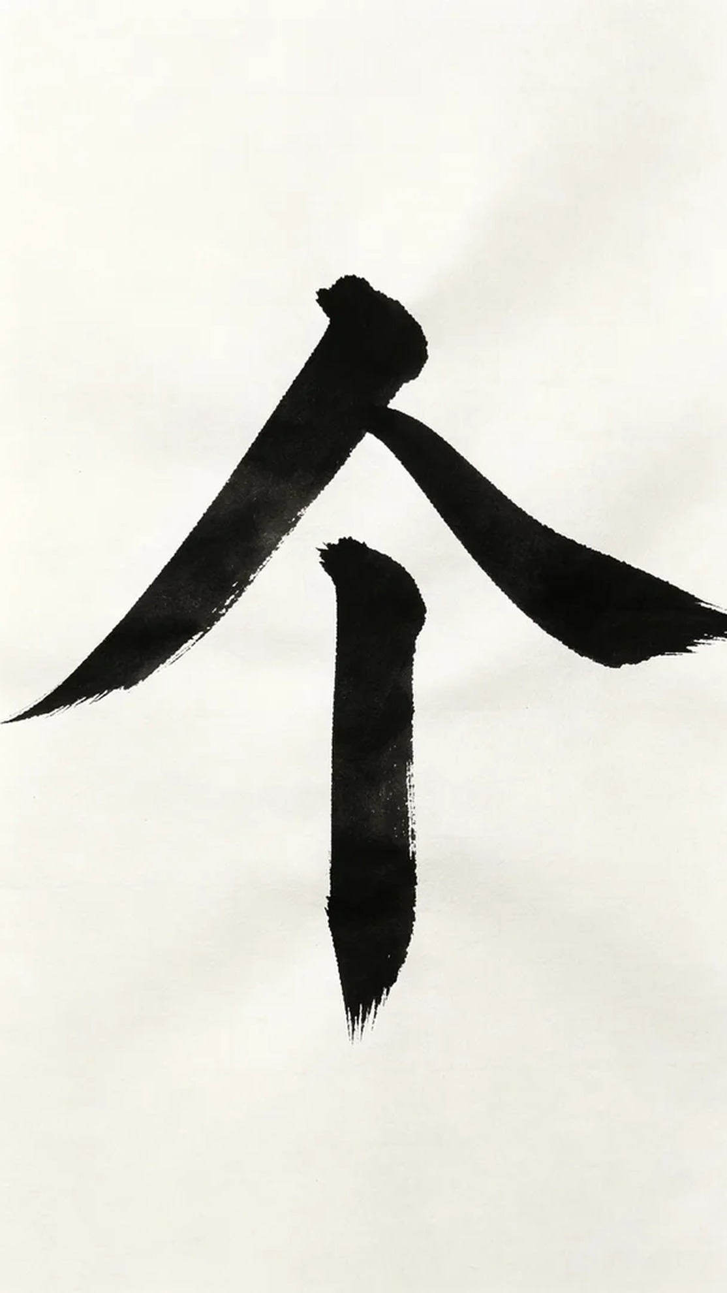
Life is like 3D printing, layer by layer we see the truth. Today on Twitter, someone reached out to us, seeking a solution for their 3D printed product needs.
We decided to use specialized 3D printing materials for the production, known for their excellent photopolymerization properties, ensuring precision and durability in the final product. During the preparation, we chose a Stratasys printer and set the layer thickness to 0.05 mm, printing temperature to 25 degrees Celsius, laser power to 100 milliwatts, and printing speed to 60 mm per second. The entire printing process was expected to take 8 hours.
Once the printing commenced, the machine ran smoothly, with the print head moving precisely over the material's surface. We monitored the process in real time, ensuring that there were no missed prints or warping issues, maintaining high-quality output. The process progressed well, with the machine operating in good condition.
After printing, we moved on to the post-processing stage. First, we cleaned the printed product to remove any uncured resin on the surface. Next, we sanded the product using fine sandpaper, giving it a smoother finish. We then performed a curing process to ensure every detail was solid and reliable. Finally, a comprehensive inspection was conducted to ensure the quality met the standards.
After a full day of effort, this 3D printed product was successfully completed, and the results were satisfying. Each step was carefully crafted, and we felt a quiet pride in achieving such an outcome.
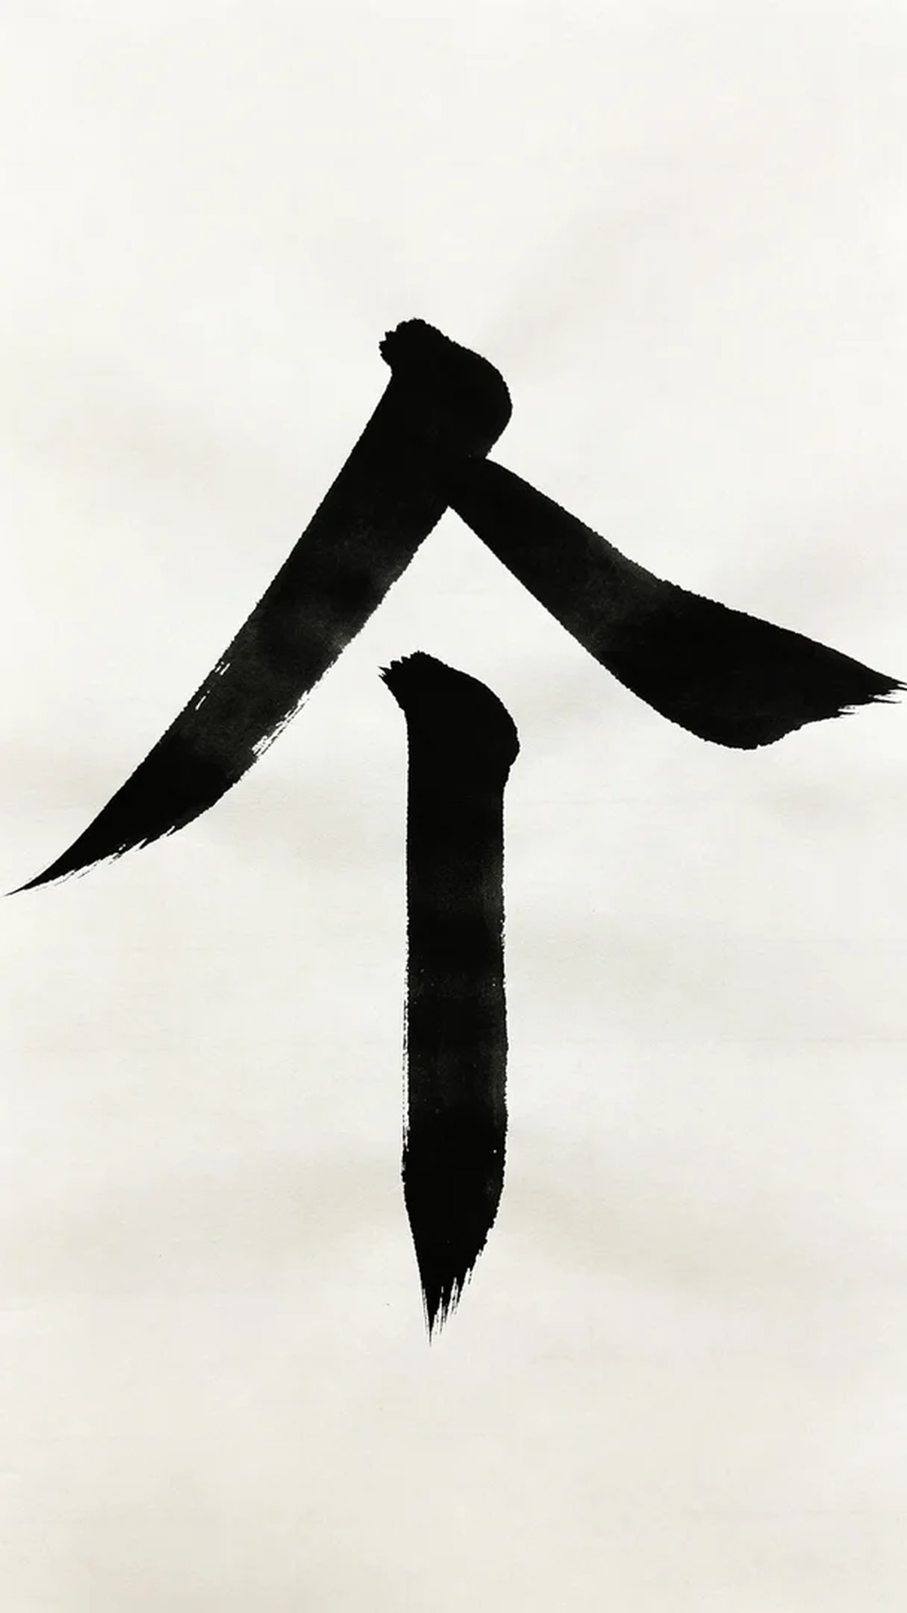
在Twitter上，有人因为急需一款精细的3D打印产品而找到了我们。原来，他们在制作模型时遇到了一些困难，希望借助我们的技术和设备，及时解决这个问题。
我们决定使用专用3D打印材料进行制作，这种材料具有优异的光固化性能，确保成品的精度和耐用性。准备工作中，我们选择了Stratasys品牌的打印机，设置了层厚为0.05毫米、打印温度为25摄氏度、激光功率为100毫瓦、打印速度为60毫米每秒。整个打印过程预计需要8个小时。
打印开始后，设备平稳运行，打印头在材料表面精准移动。我们通过实时监控系统，观察每一层的打印情况，确保没有出现任何漏打印或翘边的瑕疵，保持了高质量的输出效果。整个过程进展顺利，设备的状态良好。
打印完成后，我们进入后处理阶段。首先对打印出的产品进行了清洗，去除表面未固化的树脂。接着，我们使用细砂纸对产品进行打磨，使得表面更加光滑。随后进行了固化处理，确保每一个细节都牢固可靠。最后，对成品进行了全面检验，确保其质量符合标准。
经过一整天的努力，这款3D打印产品终于顺利完成，效果令人满意。每一步都在精心打磨，我们也默默为这样的成果而感到自豪。
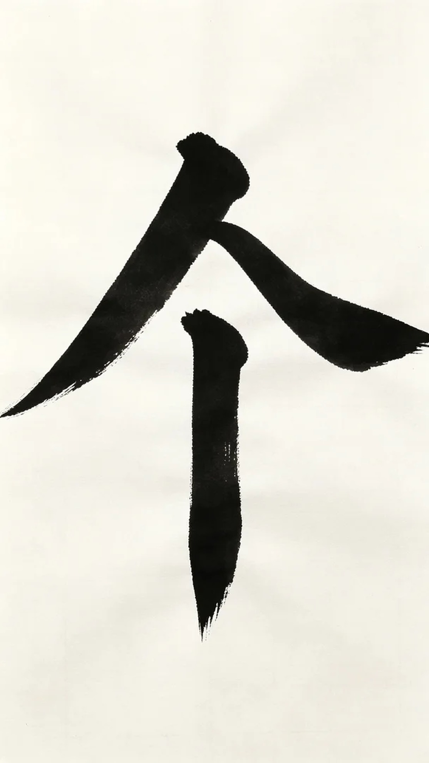
Aiskywing Industrial 3D Printing
3D printed products


