0563-仪表盘装饰条3D打印生产记录
Dashboard trim strip
🖨️ SLM金属打印
🖥️ 打印机: Systems
📦 材料: 摆放着未成型的液态光敏
生活再难，也别停下脚步。就像接下这个仪表盘装饰条的单子，来自WhatsApp的询问，让人倍感责任与动力。
No matter how difficult life gets, don’t stop moving forward. Just like taking on this order for the dashboard trim, the inquiry from WhatsApp brings a strong sense of responsibility and motivation.
________________________________________________________________________________
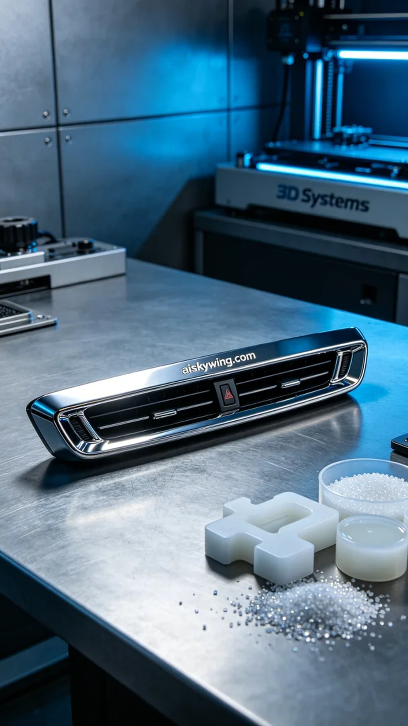
Someone reached out to us looking for a dashboard trim piece, seeking high-quality production through 3D printing technology. This trim not only needed a distinctive look but also had to perfectly match the original vehicle dashboard's functionality. Given the client’s requirements, material and process selections were particularly crucial.
To meet this demand, we chose to use liquid photopolymer resin as our primary material, which can achieve high-precision details during the curing process. The Systems printer we utilized is a high-performance device, with parameters set at a layer thickness of 0.05 mm, a print temperature of 25°C, a power setting of 80%, a print speed of 30 mm/s, and an estimated print time of 8 hours.
The 3D printing process went smoothly, with the Systems printer displaying remarkable stability during operation. The print head moved precisely, ensuring consistency in each layer. We also regularly checked the print progress to ensure the material and light source were working well together, documenting every printing status to keep production under control.
After printing, the post-processing steps were critical. First, we cleaned the printed piece to remove any uncured resin on the surface. Next, we sanded the surface of the trim using fine sandpaper to ensure a smooth finish. Following this, we placed it in a UV curing device for further solidification to enhance surface stability and durability. Finally, we conducted a thorough inspection to ensure every detail met our standards.
After this series of processes, the dashboard trim piece was completed on schedule. Looking at the finished product, it brings a sense of pride, and we eagerly anticipate its unique charm in future use.
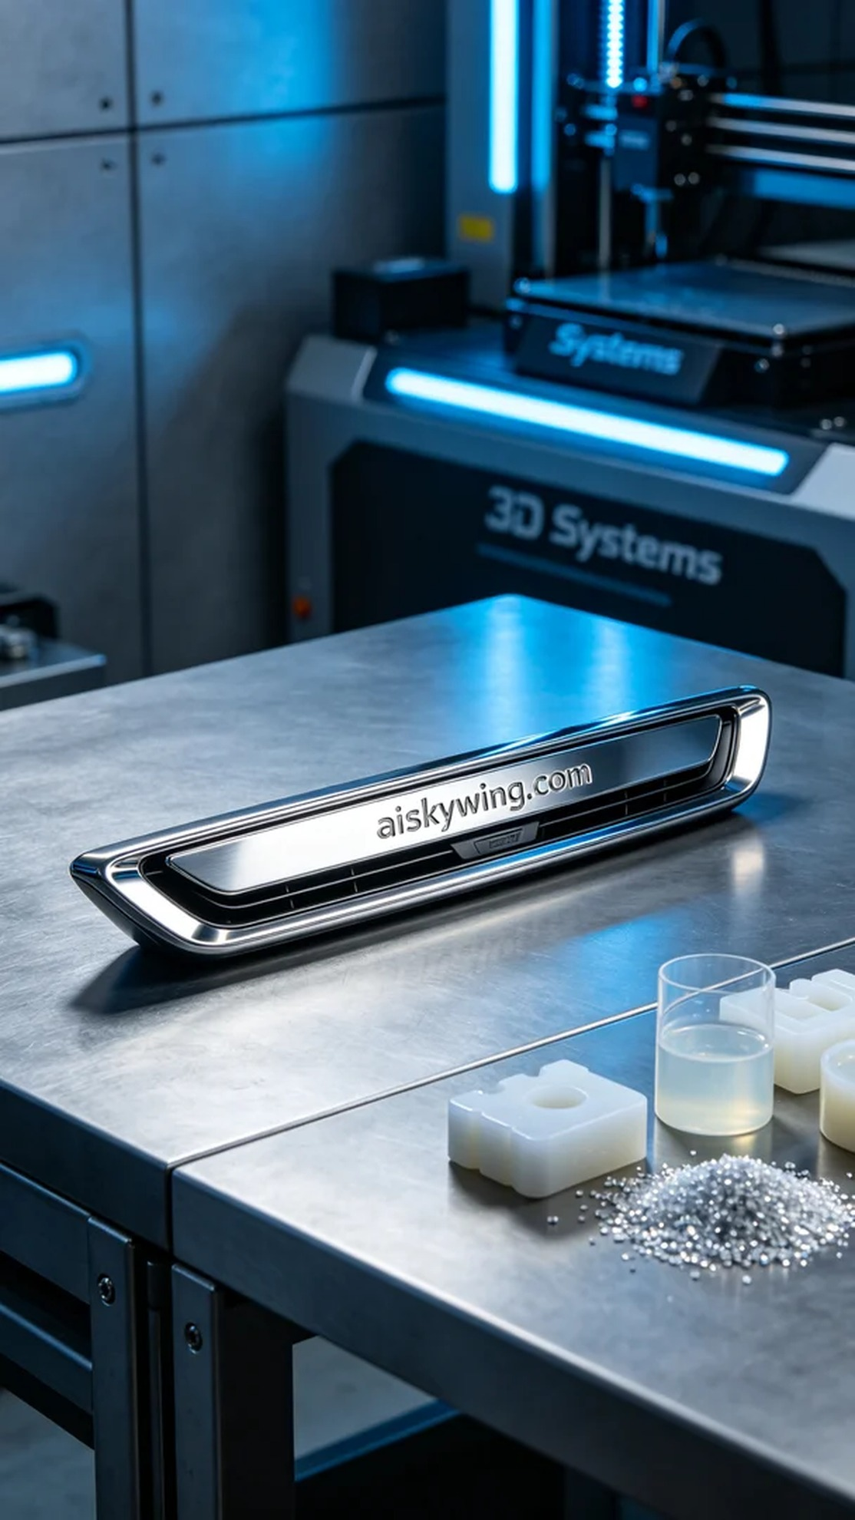
有人因仪表盘装饰条的设计需求找到我们，希望通过3D打印技术实现一个高质量的产品。该装饰条不仅具有独特的外观，还需要在功能上与原车仪表盘完美契合。由于客户的要求，材料与工艺选择上都显得尤为重要。
为了满足这一需求，我们选择了摆放着未成型的液态光敏树脂作为主要原材料，这种材料在光固化过程中能够形成高精度的细节。此外，使用的Systems打印机是一台性能卓越的设备，设置的参数为层厚0.05 mm，打印温度保持在25°C，功率设定为80%，打印速度为30 mm/s，预计打印时间为8小时。
3D打印的过程顺利进行，Systems打印机在运行时稳定性极高，打印头精确移动，确保了每一层的均匀性。我们也定期检查打印进度，确保材料与光源的配合良好，记录下每一次的打印状态，确保生产的每一步都在可控范围内。
完成打印后，后处理工序至关重要。首先，我们对打印件进行清洗，去除表面未固化的树脂。随后，通过细砂纸对打印条的表面进行打磨，确保其光滑度。接下来，将其放置在UV固化设备中，进行固化处理，以进一步提升表面的稳定性和耐磨性。最后，进行全面检验，确保每个细节都符合标准。
经过这一连串的流程，仪表盘装饰条终于如期完成。看着完工的产品，心中不免有些自豪，期待它在未来的使用中展现出独特的魅力。
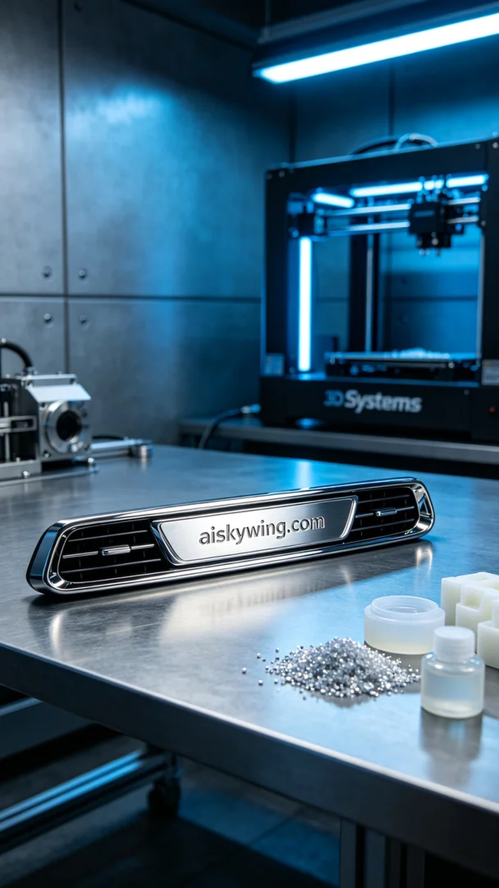
Aiskywing Industrial 3D Printing
Dashboard trim strip


