0564-高品质侧裙装饰条制作记录
Side skirt trim
🖨️ SLM金属打印
🖥️ 打印机: Stratasys
📦 材料: 摆放着未成型的液态光敏
生活总有磨难，我们要勇敢面对。就像制作这个侧裙装饰条的时候，有人找我们是因为他们需要品质与创意的结合。
Life is always full of hardships, and we must face them bravely. Just like when creating this side skirt trim, some people come to us because they need a combination of quality and creativity.
________________________________________________________________________________
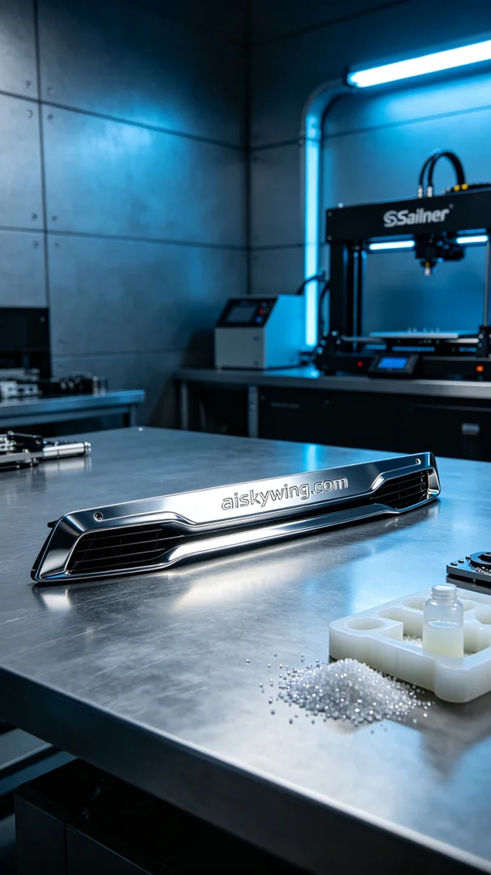
Life is not without its challenges, and we must face them bravely. Just like when creating this side skirt decorative trim, someone approached us because they needed a fusion of quality and creativity.
We selected unformed liquid photopolymer resin as the raw material, known for its excellent fluidity and high precision, making it perfect for intricate 3D printing. The Stratasys printer was set with a layer thickness of 0.1 mm, maintaining a printing temperature of 25 degrees Celsius, with moderate laser power and speed to ensure the material cures perfectly.
During the printing process, we closely monitored the machine's operation. The Stratasys printer precisely etched each layer along the predetermined path, ensuring that every detail was captured accurately. We employed a multi-point quality check to ensure there were no imperfections.
Post-processing was a critical step in the production. First, the printed side skirt decorative trim was placed in a cleaning tank to remove any residual resin using an ultrasonic cleaning agent. Next, we sanded it down with fine sandpaper to ensure a smooth surface. Then, we cured it under UV light to enhance its durability and surface gloss, followed by a comprehensive inspection to confirm that every dimension and detail met the requirements.
After a series of meticulous processes, the side skirt decorative trim was finally completed, showcasing a high-gloss metallic finish while meeting design expectations, truly merging technology with aesthetics.
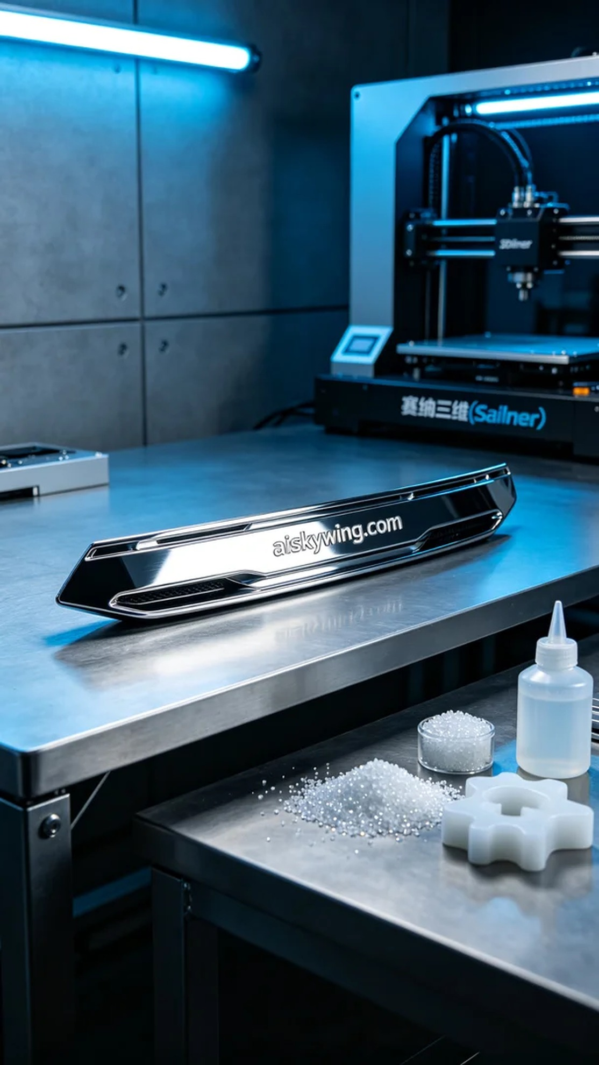
在Instagram上，有人因为想要一款独特的侧裙装饰条而找到了我们。他们希望这款产品不仅能提升车辆的外观，还能展现出高科技的质感和精致的工艺。
我们选用了未成型的液态光敏树脂作为原材料，这种材料具有极好的流动性和高精度的特性，适合复杂形状的3D打印。使用的Stratasys打印机设置了0.1毫米的层厚，打印温度保持在25摄氏度，并设定了适中的激光功率和速度，以确保材料的完美固化。
打印过程中，我们密切监控设备的运行状态。Stratasys打印机在运行时，激光精确地按照预设路径雕刻每一层，确保每个细节都能精准呈现。我们使用了多点质量检测，确保没有任何瑕疵。
后处理工序是制作的关键环节。首先，将打印完成的侧裙装饰条放入清洗槽中，用超声波清洗剂去除表面残留的树脂。接下来，采用细砂纸进行打磨，确保其表面光滑。然后，我们对其进行UV固化，以增强其耐用性和表面光泽，最后进行全面检验，确保每个尺寸和细节符合要求。
经过一系列精细的工序，侧裙装饰条终于完美呈现，既有高光金属质感，又符合设计要求，真正实现了科技与美感的结合。
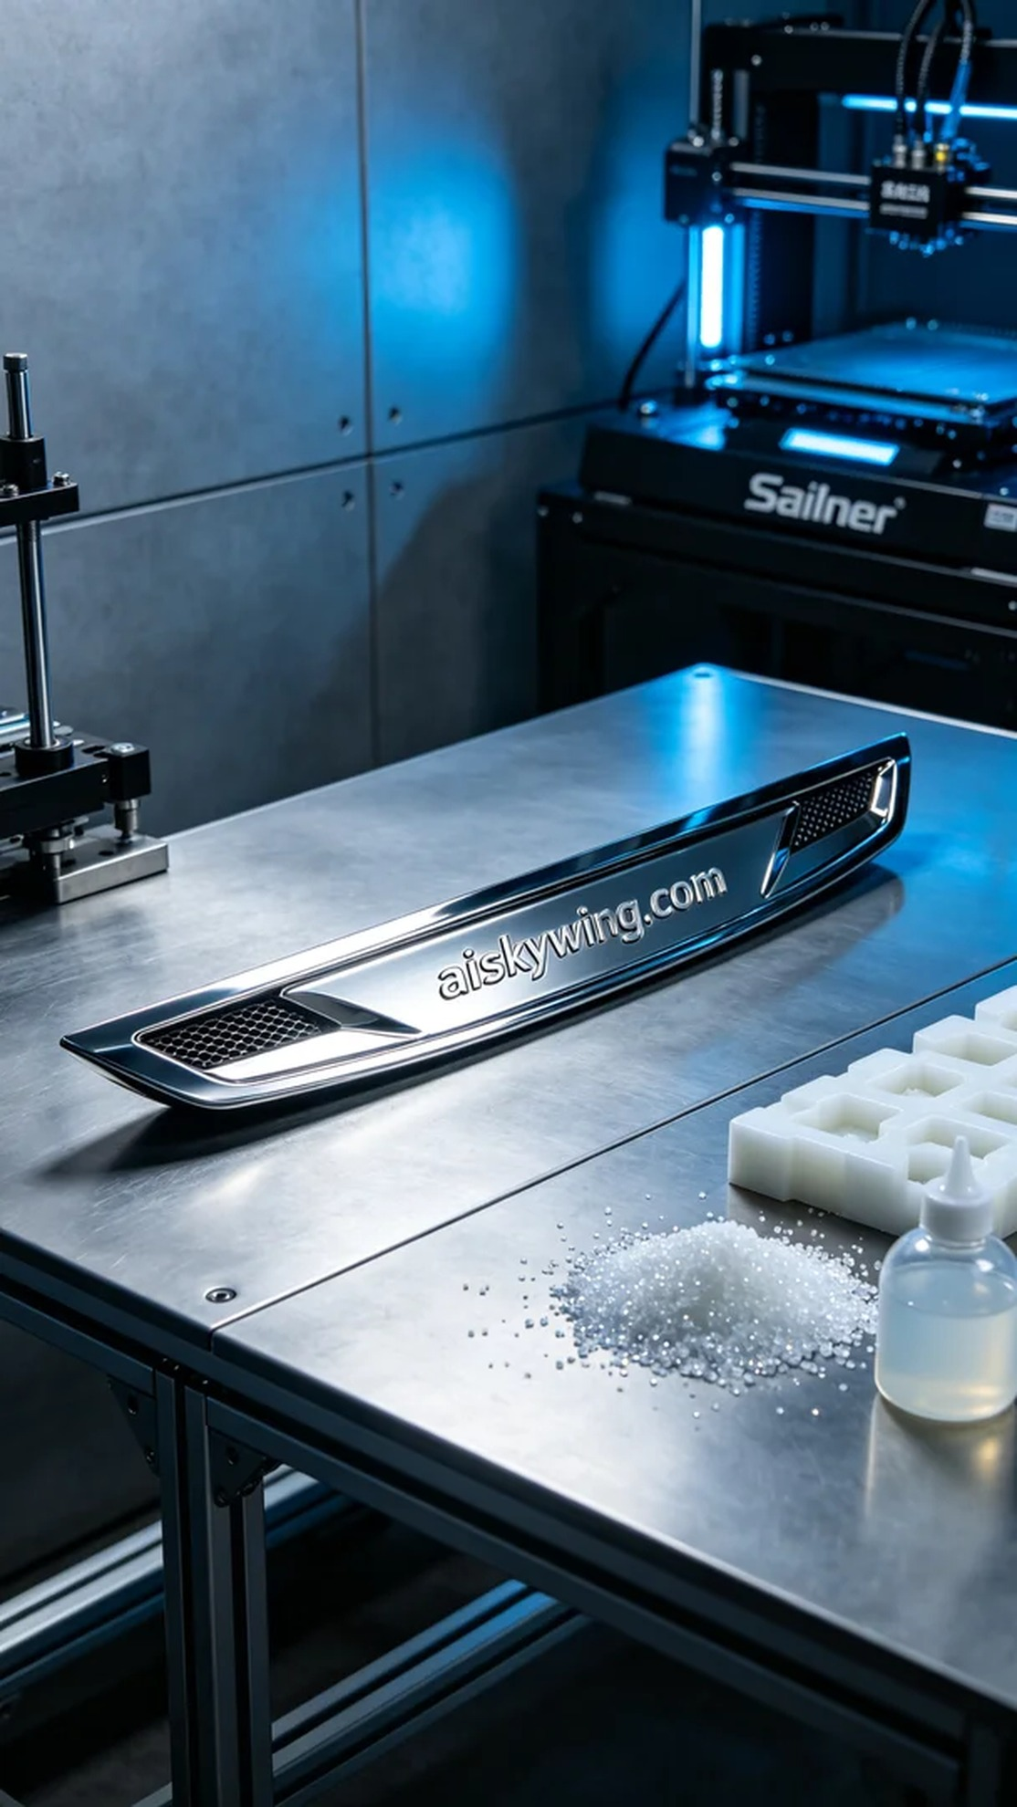
Aiskywing Industrial 3D Printing
Side skirt trim


