0567-储物盒底垫的3D打印记录
Storage box bottom mat
🖨️ SLM金属打印
🖥️ 打印机: Systems
📦 材料: 摆放着未成型的液态光敏
在TikTok上，有人因为想要一个完美的储物盒底垫，找到了我们。生活就像这项工作，难度总是有的，但我们总能找到解决办法。
On TikTok, someone found us because they wanted a perfect storage box mat. Life is like this job; there are always challenges, but we can always find a solution.
________________________________________________________________________________
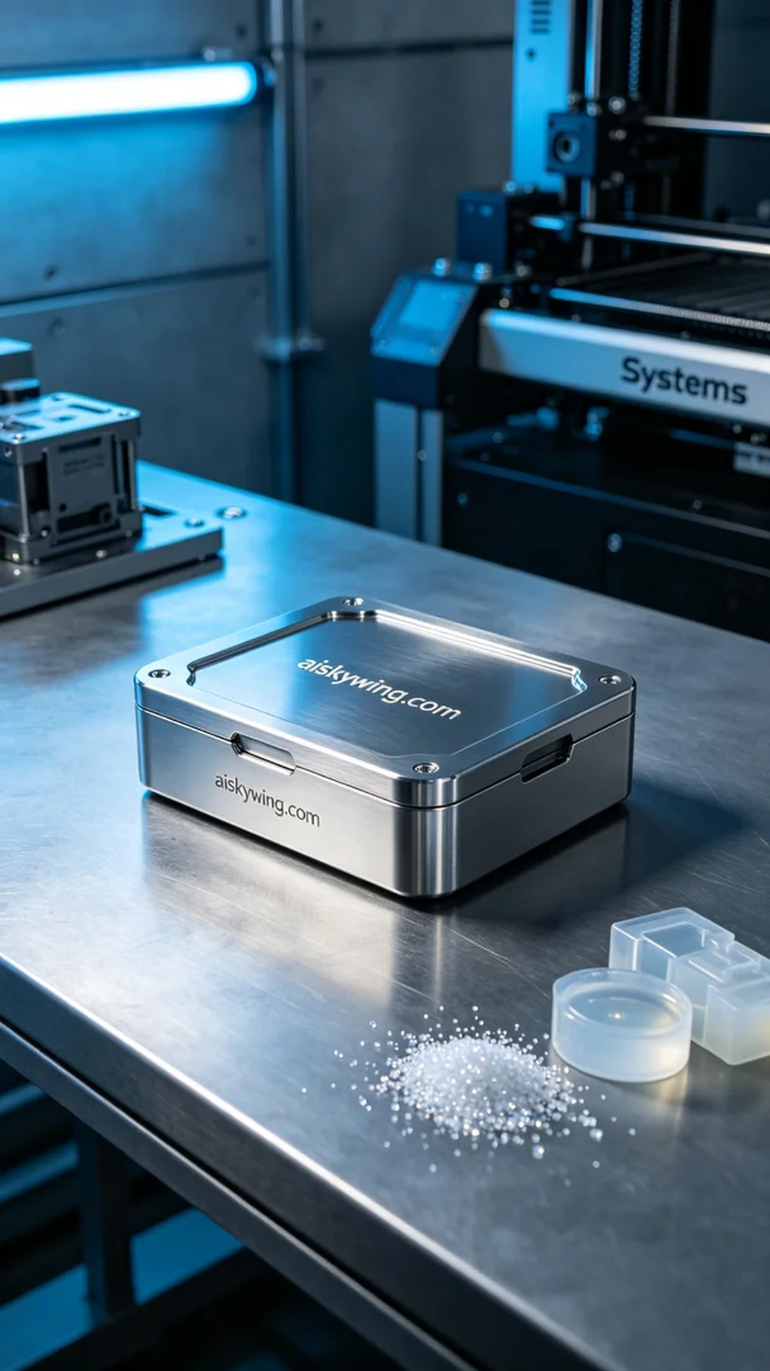
Recently, we received an order for a storage box pad, as someone sought a perfect solution to their storage space issues. This task, much like life, presents challenges, but we always find a way to make it work.
In the preparation phase, we selected unformed liquid photopolymer resin as our printing material. This resin's fluidity and curing properties are ideal for 3D printing, ensuring every detail is accurately represented. We configured the Systems printer with a layer thickness of 0.05 mm, a printing temperature of 60 degrees Celsius, a power setting of 90%, and a speed of 50 mm/s, anticipating an approximate printing duration of 8 hours.
During the printing process, the Systems printer operated steadily, constructing the storage box pad layer by layer. We closely monitored the equipment's performance to ensure each layer adhered perfectly. After preheating the device, the liquid photopolymer resin flowed smoothly, initiating the precise building of intricate structures. Throughout printing, we adjusted parameters to accommodate temperature and material changes, ensuring the final result met our high standards.
After printing, we followed strict post-processing procedures. First, we immersed the finished product in cleaning solution to thoroughly remove residual resin from the surface. Next, we polished the product to achieve a smoother finish, enhancing the overall texture. Finally, we cured the product to ensure its strength and durability. After a quality inspection, we confirmed that the storage box pad was flawless and successfully delivered it.
This storage box pad printing not only addressed the user's storage needs but also reaffirmed the power and versatility of 3D printing. Each success empowers our determination to move forward.
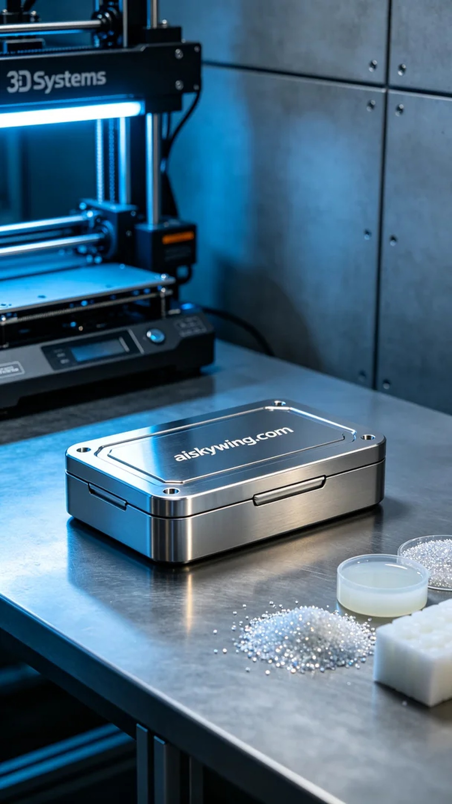
首先，我们接到一个关于储物盒底垫的订单，客户希望能够解决储物空间不足的问题。为了满足他们的需求，我们决定使用SLM金属打印工艺，确保产品的耐用性和美观性。
在准备阶段，我们选用了未成型的液态光敏树脂作为打印材料。这种树脂的流动性和固化特性非常适合3D打印，能确保每个细节都精准展现。我们使用的Systems打印机设置了每层厚度为0.05毫米，打印温度设定在60摄氏度，功率为90%，打印速度设为50毫米/秒，预计打印全过程将持续约8小时。
打印过程中，Systems打印机稳定运转，逐层构建储物盒底垫的形状。我们密切监控设备的运行状况，以确保每一层都能够完美贴合。设备经过预热后，液态光敏树脂顺利流动，开始了对精细结构的逐步构建。打印过程中，我们随时调整参数以应对温度和材料的变化，确保最终效果达到标准。
完成打印后，我们进行了严格的后处理工序。首先，将成品放入清洗液中，彻底清除表面残留的树脂。随后，经过打磨工序，使表面更加光滑，提升了整体的质感。最后，我们对成品进行固化，确保其强度和耐用性。经过质量检验，确认储物盒底垫无瑕疵，最终成功交付。
这次的储物盒底垫打印不仅解决了用户的储物需求，也再次证明了3D打印的强大与灵活。每次成功都让我们更加坚定前行的信心。
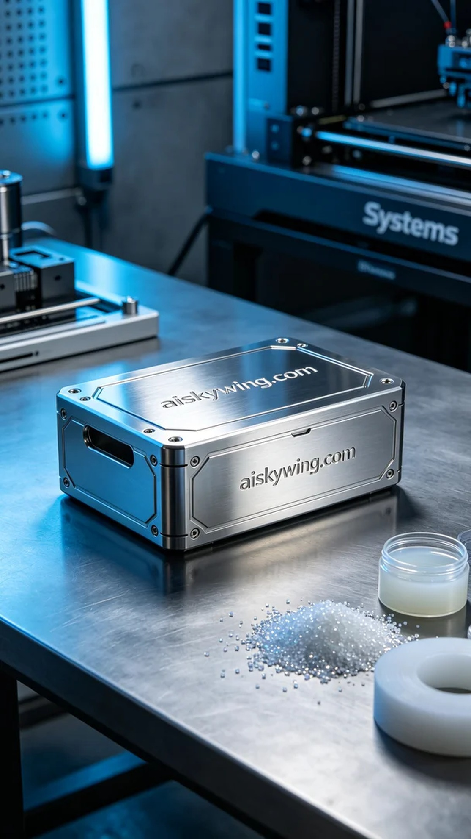
Aiskywing Industrial 3D Printing
Storage box bottom mat


