0568-储物盒隔垫的3D打印记录
Storage box divider
🖨️ SLM金属打印
🖥️ 打印机: Rize
📦 材料: 摆放着未成型的液态光敏
生活再难，也别停下脚步。就像接下这个储物盒隔垫置于画面正中央的单子，有人因为需求找到我们，期待能在3D打印领域实现他们的想法。
No matter how difficult life gets, don't stop moving forward. Just like the order for this storage box cushion placed right in the center of the picture, some people find us because of their needs, hoping to realize their ideas in the field of 3D printing.
________________________________________________________________________________
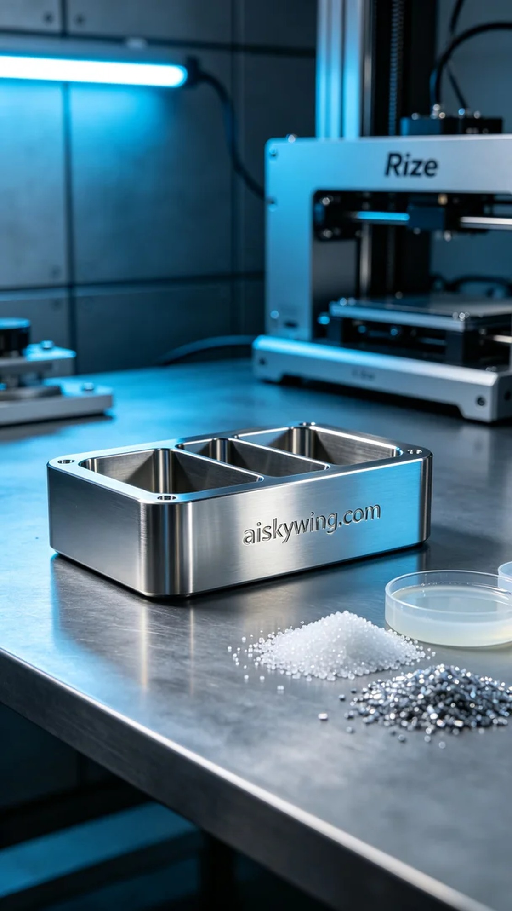
On YouTube, someone reached out to us looking for a sophisticated storage box pad. They wished for a product that would be both practical and aesthetically pleasing, enhancing the tidiness of their space.
We used liquid photopolymer resin, which offers a high gloss finish and intricate surface detail once cured. In terms of settings, we employed the Rize 3D printer, with a layer thickness of 0.1mm, a printing temperature of 25°C, a power level of 80W, and a printing speed of 50mm/s, estimating the entire process to take around 5 hours.
The printing process went smoothly, with the Rize printer operating steadily while we monitored the quality in real-time. With each layer added, we ensured that every detail was precisely replicated. The high metallic sheen began to reveal itself, raising our anticipation for the final result.
Post-processing was equally crucial. After printing, we cleaned the piece thoroughly to remove any uncured liquid resin. Next, we sanded it down to achieve a smooth surface texture. After that, we placed the finished product into a curing machine to ensure its strength and stability, followed by thorough inspection for any imperfections.
In the end, this storage box pad turned out just as we envisioned, showcasing ultimate clarity and exquisite craftsmanship. Completing this process reflects our deep understanding of material properties and the full application of 3D printing technology.
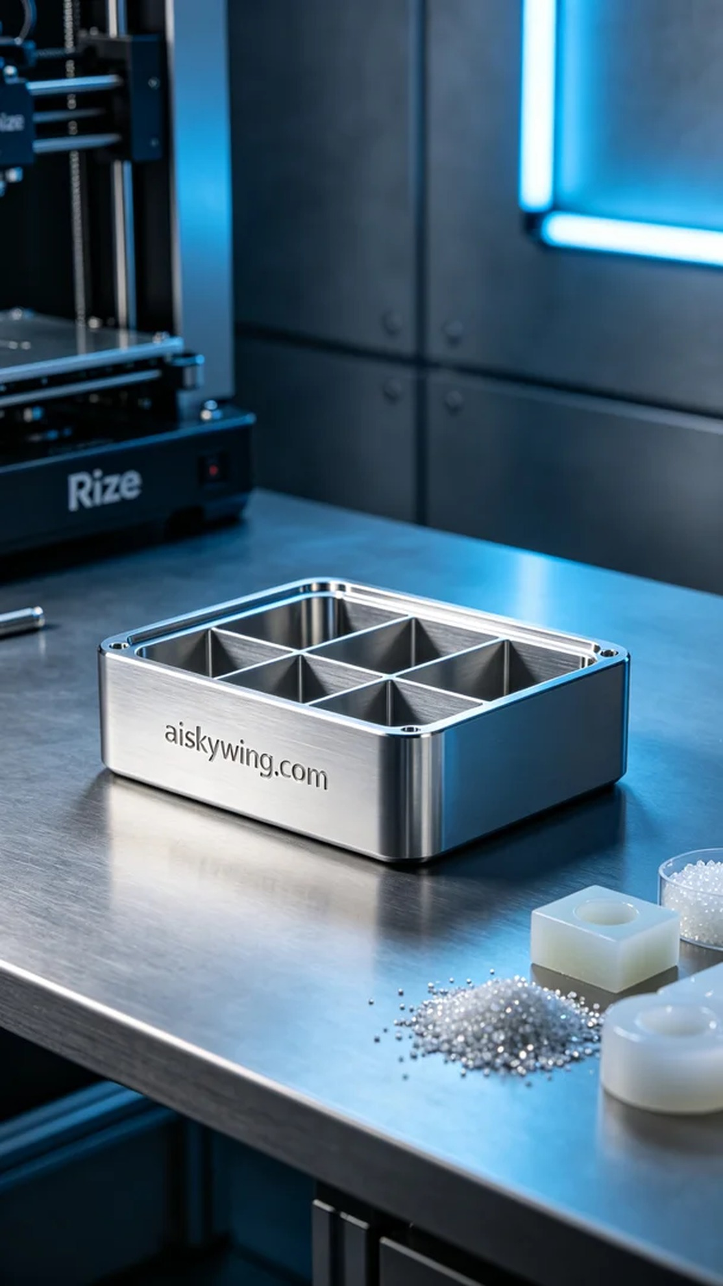
在YouTube上，有人因为想要一个精致的储物盒隔垫而联系了我们。他希望这个产品能够在设计上既实用又美观，适合日常使用，有助于提升空间的整洁感。
我们使用的是摆放着未成型的液态光敏材料，这种材料在固化后能够展现出高光泽度和细腻的表面质感。打印设置方面，使用了Rize品牌的3D打印机，层厚设置为0.1mm，打印温度维持在25℃，功率为80W，打印速度控制在50mm/s，整个打印过程预计需要5小时。
打印过程顺利进行，Rize打印机运转稳定，实时监控打印质量。在打印的每个阶段，我们都注意到材料的层层叠加，确保每一寸的细节都能够精准还原。高光的金属质感也在不断显现，让人对最终效果更加期待。
后处理步骤同样重要。打印完成后，我们进行了清洗，将未固化的液态树脂彻底清除。接下来是打磨，以确保表面的光滑度和触感。然后将成品放入固化机中，以确保其强度和稳定性，最后进行仔细的检验，确保没有瑕疵。
最终，这个储物盒隔垫如我们所愿，展现出极致的清晰和精致的工艺。能够完成这个过程，既是对材料特性的深刻理解，也是对3D打印技术的充分应用。
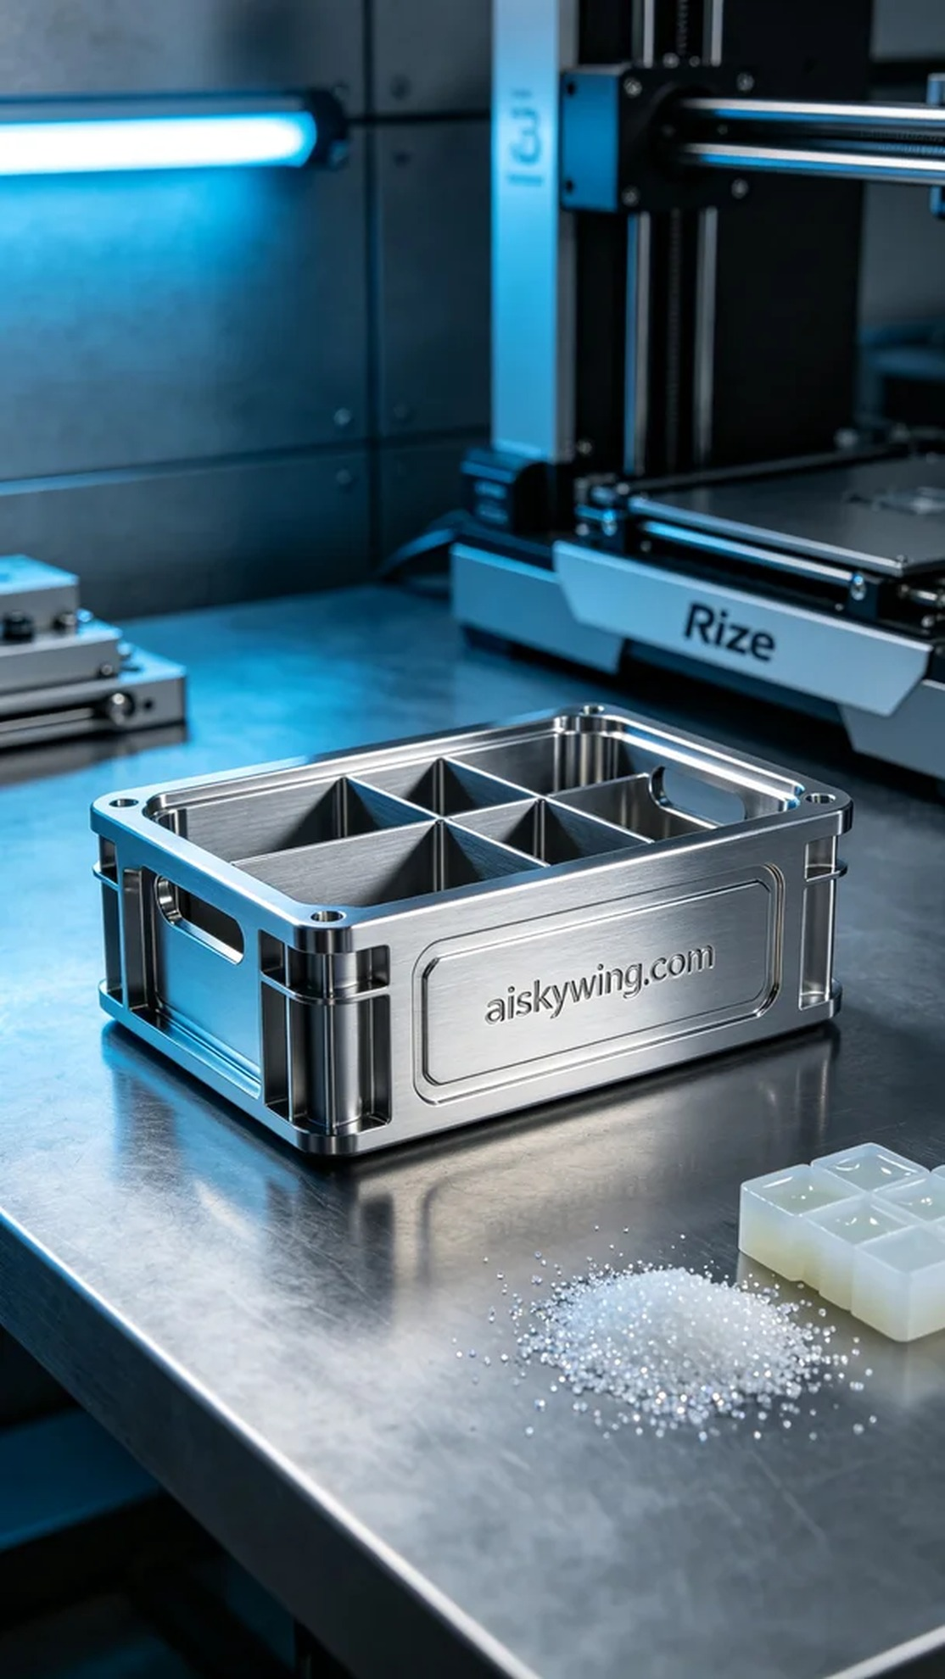
Aiskywing Industrial 3D Printing
Storage box divider


