0569-储物盒隔板的3D打印生产记录
Storage box divider
🖨️ CNC机加工
🖥️ 打印机: Carbon
📦 材料: 摆放着未成型的液态光敏
在LinkedIn上，有人因为储物盒隔板的需求找上我们。生活中总有一些需要整理的东西，就像这个储物盒隔板，让我们来一探究竟。
On LinkedIn, someone reached out to us due to a need for storage box dividers. In life, there are always things that need organizing, just like this storage box divider. Let's take a closer look.
________________________________________________________________________________
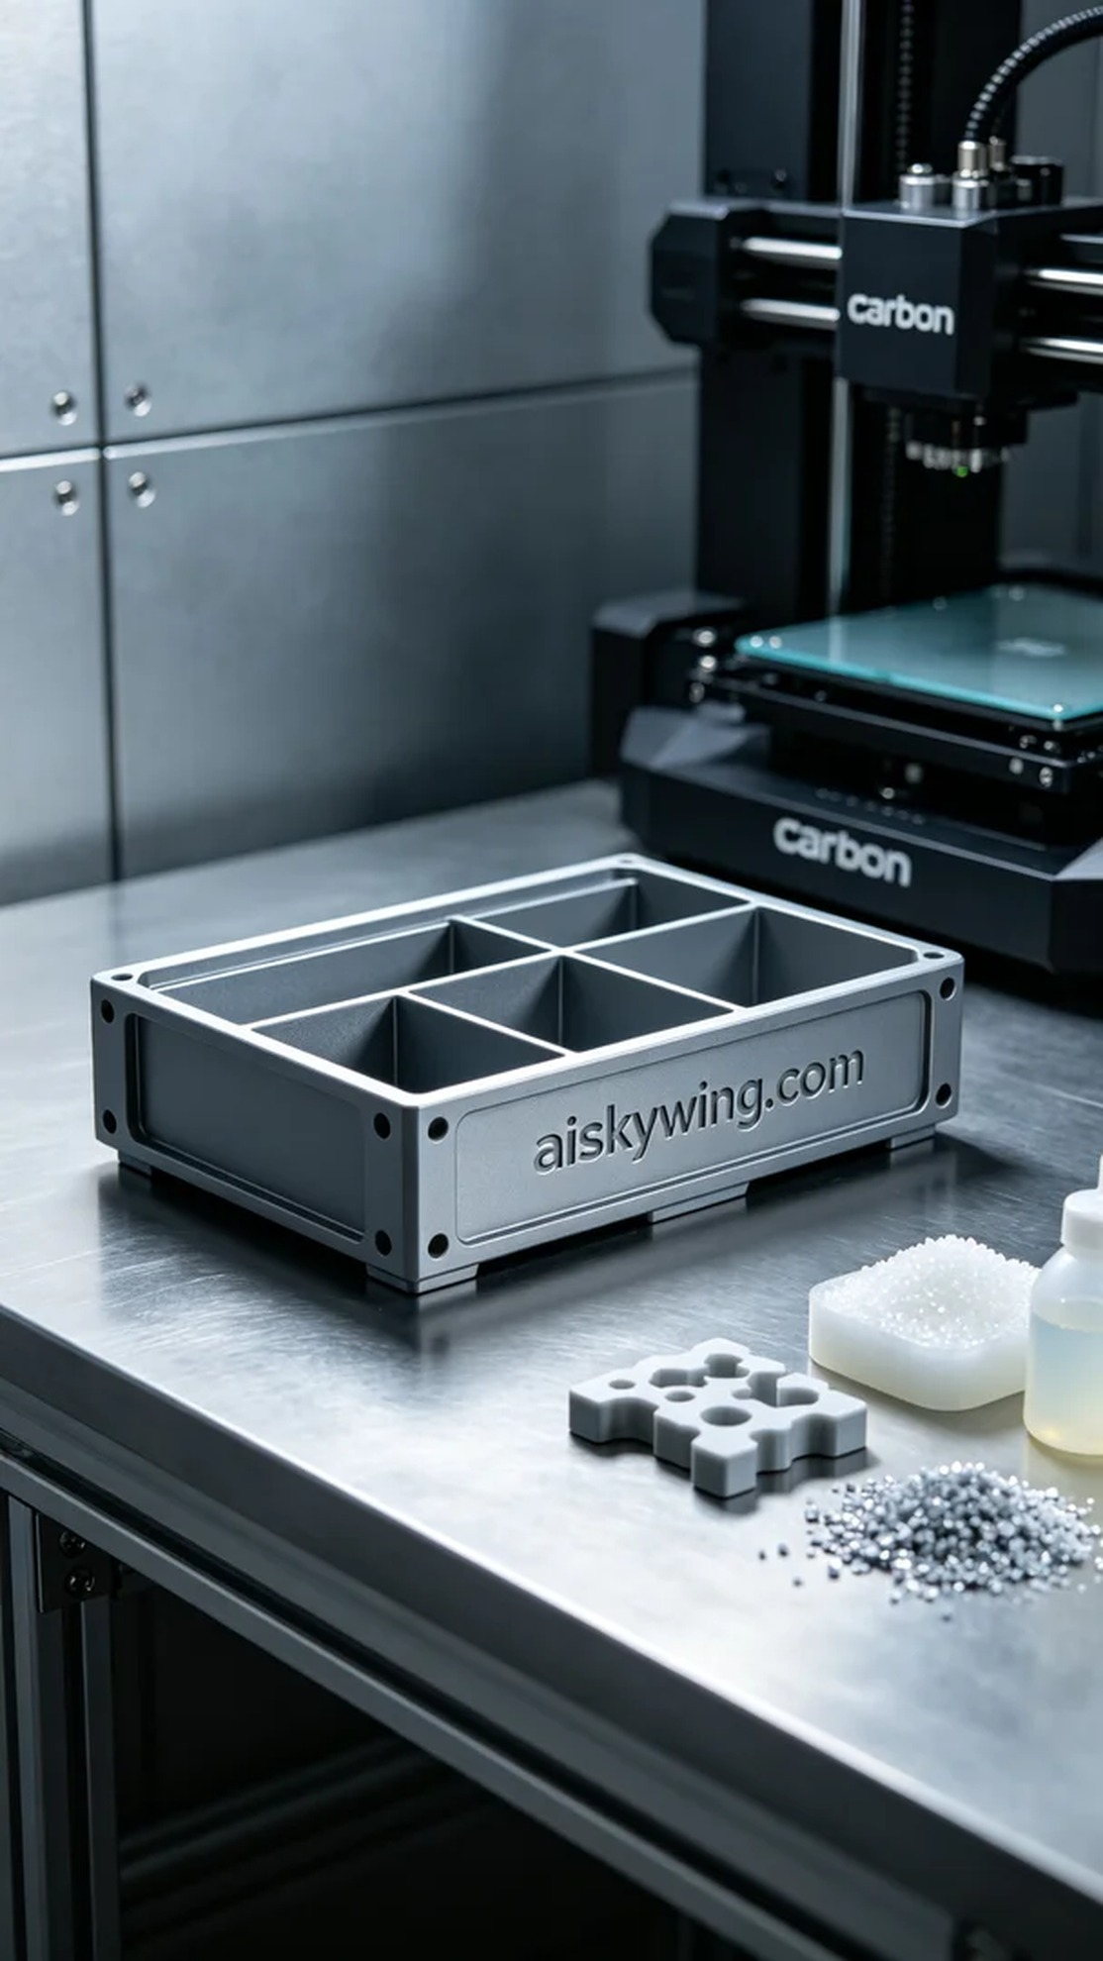
The task this time was to create a storage box divider for a friend who reached out through LinkedIn due to organizational issues he was facing. This product needed to be functional while making a strong visual impact, so we decided to use CNC machining for its production.
We chose unformed liquid photopolymer resin as the raw material, which offers excellent flow properties and molding effects, ensuring high detail performance during the printing process. For equipment, we utilized a Carbon printer, setting the layer thickness to 0.1mm, maintaining a printing temperature of 25 degrees Celsius, with a power of 50W and a printing speed of 60mm/s. The expected printing time was around 5 hours, allowing for stability and precision in the final product.
The printing process went smoothly, with the Carbon printer operating efficiently. We monitored every detail of the printing to ensure perfect formation on each layer. Under the cool-toned lighting, the liquid photopolymer resin gradually solidified, effectively reflecting the stark beauty of industrial aesthetics.
Once printing was complete, we proceeded to the post-processing stage. The first step was placing the finished product in a wash tank to remove any uncured resin from the surface using a specialized solvent. Next, we performed meticulous sanding to eliminate any imperfections and ensure a smooth surface. Finally, we cured the product in a UV curing machine to enhance the material's strength and durability, followed by a thorough inspection to meet the quality standards.
Reflecting on the entire production record of this storage box divider brings a sense of satisfaction. In the end, we not only addressed a practical need but also showcased industrial beauty through light and shadow.
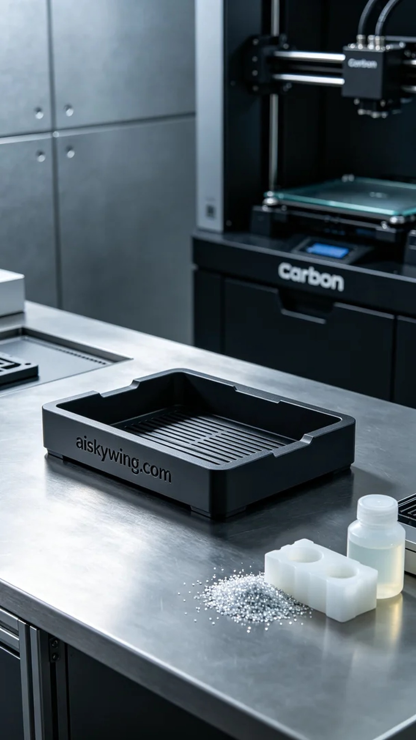
这次的任务是为一位朋友制作一个储物盒隔板，之前他在LinkedIn上遇到了整理空间的问题，因此找到了我们。这个产品不仅需要功能性，还要在视觉上给人以冲击，因此我们决定采用CNC机加工工艺来实现。
我们选择了未成型的液态光敏树脂作为原材料，这种树脂具有优异的流动性和成型效果，能在打印过程中保持高细节表现。设备方面，我们使用了Carbon打印机，设置层厚为0.1mm，打印温度控制在25摄氏度，功率为50W，打印速度为60mm/s，预计打印时间大约为5小时，这样的参数设置有助于确保成品的稳定性和精致度。
打印过程进行得很顺利，Carbon打印机的运行状态非常稳定。我们监控着每一个打印细节，确保每一层的成型完美。在冷色调的灯光下，液态光敏树脂逐渐变得坚固，有效地反射出工业风的冷峻美感。
完成打印后，我们进入后处理工序。首先将成品放入清洗槽中，使用专用溶剂去除表面未固化的树脂。接下来，我们进行了细致的打磨，以消除任何瑕疵，确保表面光滑。最后，在UV固化机中进行固化处理，以增强材料的强度和耐用性，最后进行检验，确保每一个细节都达到标准。
将这个储物盒隔板的生产记录完整地回顾一遍，让人倍感欣慰。最终，一件高质量的储物盒隔板不仅解决了实际问题，还在光影间展现出工业美感。
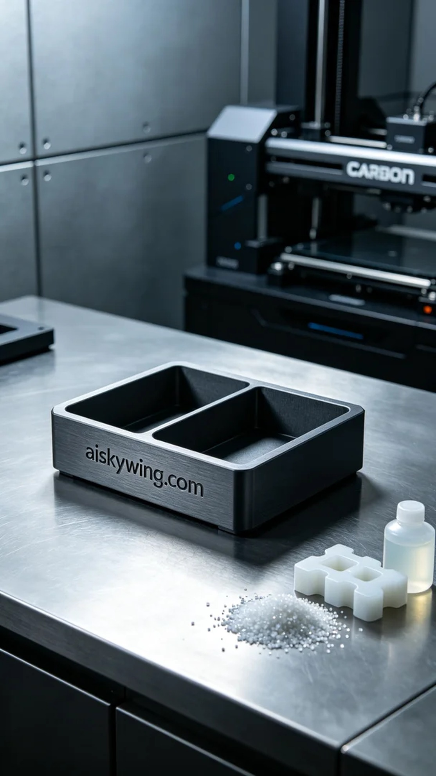
Aiskywing Industrial 3D Printing
Storage box divider


