0572-精准3D打印DPF外壳生产记录
DPF housing
🖨️ SLM金属打印
🖥️ 打印机: Xjet
📦 材料: 摆放着未成型的液态光敏
在LinkedIn上，有人因为寻找一个合适的3D打印解决方案而联系到我们。于是，我们接下了这个DPF外壳的制作任务。
On LinkedIn, someone reached out to us in search of a suitable 3D printing solution. As a result, we took on the task of producing this DPF casing.
________________________________________________________________________________
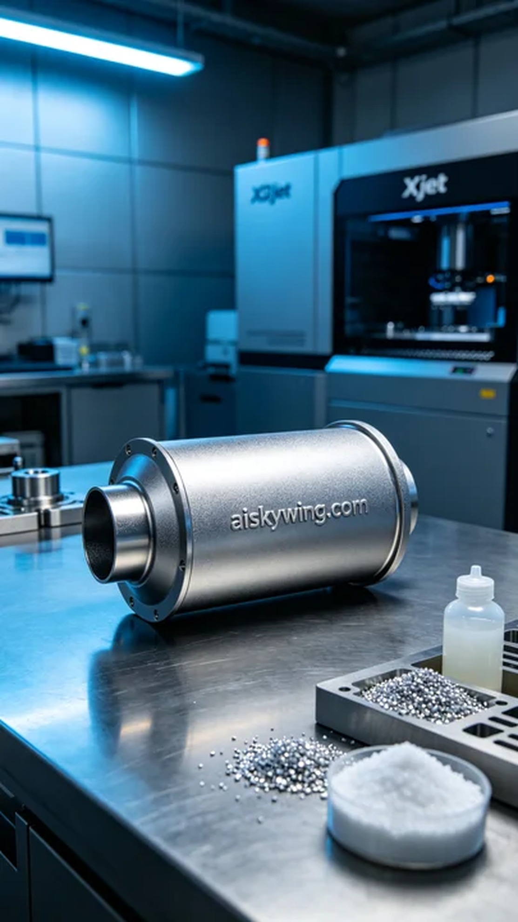
On LinkedIn, someone reached out to find a suitable 3D printing solution. Thus, we took on the task of producing this DPF shell.
This DPF shell project arose from someone's need for high strength and lightweight in product design. We decided to utilize SLM titanium alloy for 3D printing to meet the durability and structural safety requirements. After thorough discussions, we clarified the specific needs of the product and the technical parameters for printing.
We prepared unformed liquid photo-sensitive resin as the raw material to ensure optimal performance during the forming process. Using the Xjet printer, we set the layer thickness to 50 microns, nozzle temperature at 200 degrees Celsius, laser power at 200 watts, and printing speed at 50 mm per hour. The total estimated printing time was around 24 hours.
Every step of the printing process was crucial. During the printing, we closely monitored the device operation to ensure the optimal bonding between the laser and the material. We conducted real-time progress tracking to avoid any potential failures, ensuring each layer accurately formed. The stability of the Xjet printer provided us with reliable support.
After completing the print, we moved on to the post-processing stage. We first cleaned the printed part to remove any residual photo-sensitive resin from the surface. Next, we proceeded with sanding to ensure a smooth appearance and refined the details. Finally, we carried out a curing process to enhance its strength and durability, followed by strict quality inspection to ensure it met the expected standards.
Through this series of processes, we successfully produced a DPF shell that embodies high-tech industrial style while meeting design requirements, laying a solid foundation for subsequent product applications.
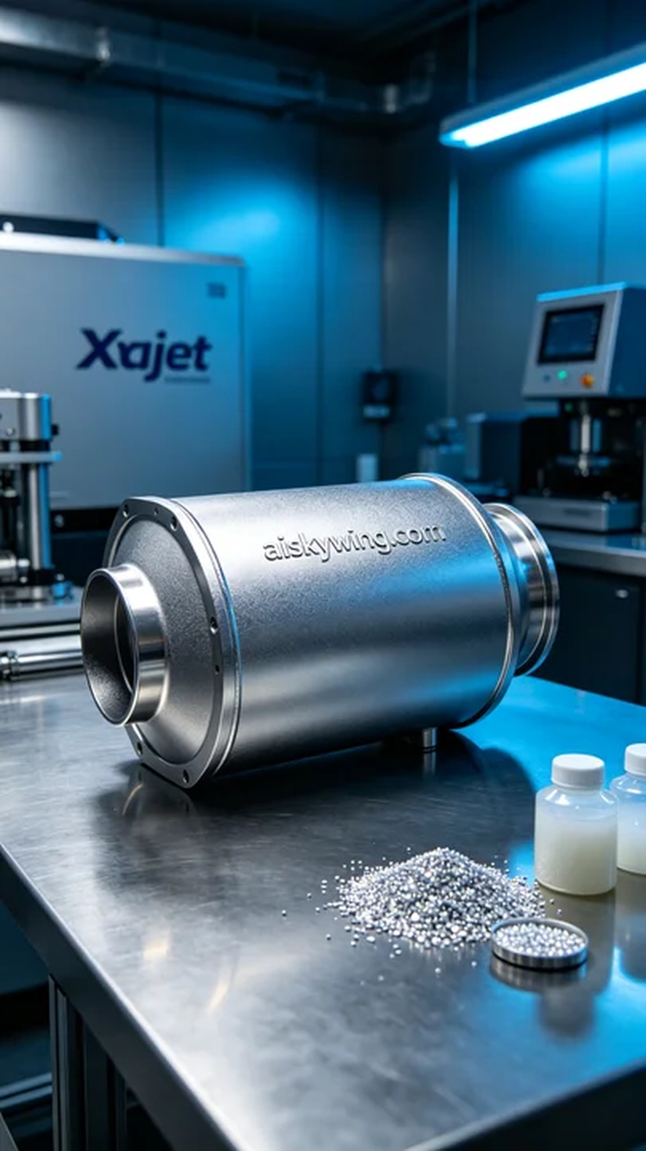
这次的DPF外壳项目是因为有人需要在产品设计中实现高强度和轻量化要求。我们决定采用SLM钛合金进行3D打印，以满足对耐用性和结构安全性的需求。经过详细讨论，我们明确了产品的具体需求和打印的技术参数。
我们准备了未成型的液态光敏树脂作为原材料，确保其在成型过程中能够达到最佳性能。使用了Xjet打印机进行打印，设置层厚为50微米，喷嘴温度控制在200摄氏度，激光功率为200瓦，打印速度为每小时50毫米。整个打印过程预估需要24小时完成。
打印过程中的每一步都至关重要。在打印过程中，我们严格监控设备运行，确保激光与材料的结合效果达到最佳状态。实时监测打印进度，避免任何可能的故障，以确保每一层都能精准成型。打印机Xjet的稳定性为我们提供了可靠的支持。
完成打印后，我们进入了后处理阶段。首先对打印件进行清洗，以去除表面残留的光敏树脂。接着，我们进行了打磨，以确保外观光滑，并对细节部分进行修整。最后，进行固化处理，以提高其强度和耐用性，最后进行严格的质量检验，确保符合预期标准。
通过这一系列流程，我们成功生产出了符合规格的DPF外壳，既体现了高科技的工业风格，又满足了设计要求，为后续的产品应用奠定了基础。
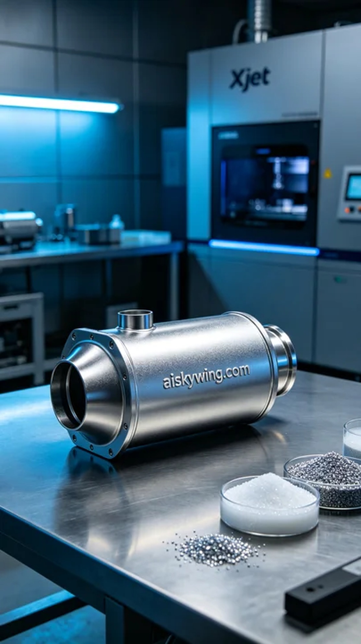
Aiskywing Industrial 3D Printing
DPF housing


