0573-EGR阀壳体3D打印生产记录
EGR valve housing
🖨️ SLM金属打印
🖥️ 打印机: Rize
📦 材料: 摆放着未成型的液态光敏
生活再难，也别停下脚步。就像接下这个EGR阀壳体的单子，很多人因为技术问题找到我们，希望能解决他们的难题。
No matter how difficult life gets, don't stop moving forward. Just like taking on this EGR valve housing order, many people come to us with technical issues, hoping we can solve their problems.
________________________________________________________________________________
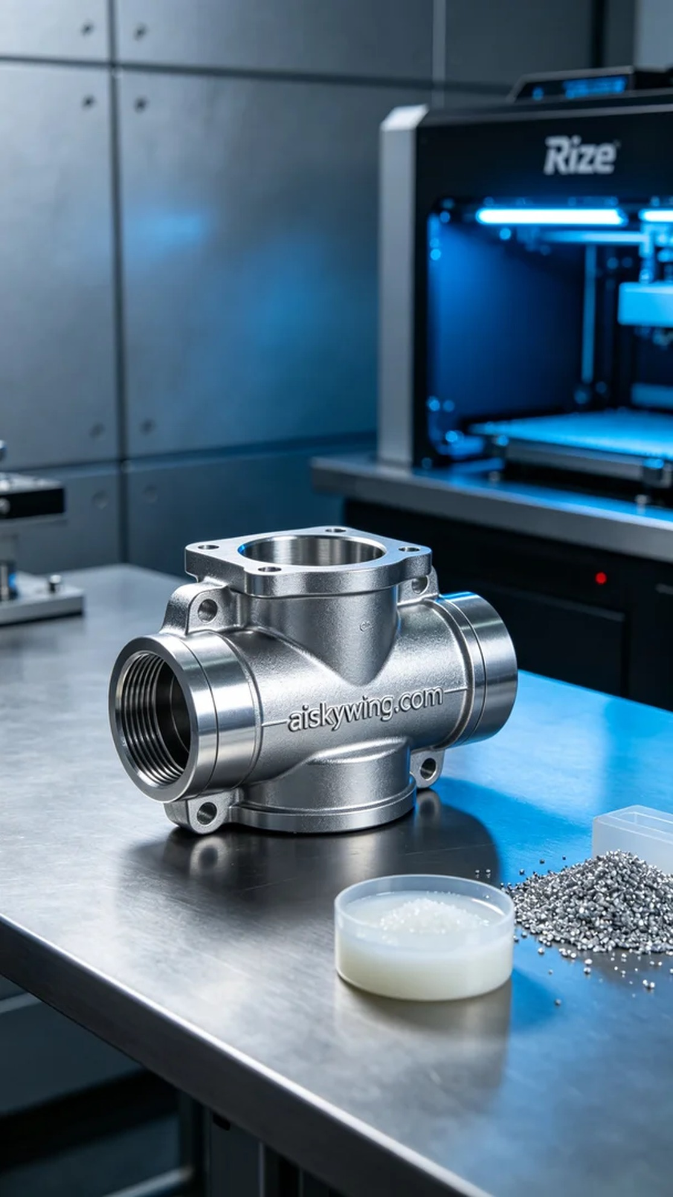
I saw a post on Twitter where someone was seeking help regarding issues they faced while manufacturing an EGR valve casing, specifically with materials and processing precision. I decided to take on the project to help them solve their challenges.
To ensure optimal printing results, we chose to use uncured liquid photopolymer resin as the raw material. This material has excellent fluidity and captures high detail well. We used a Rize printer, setting the layer thickness to 0.1 mm, maintaining the print temperature at 25°C, with a power setting of 200 watts and a print speed of 80 mm per second, estimating a total print time of 12 hours.
The printing process went smoothly, with the machine running very stably. I continuously monitored the print quality to ensure each layer was precisely stacked. After a few hours of observation, I found that the printed EGR valve casing had a smooth surface and clear details, meeting our expectations.
In terms of post-processing, we carried out comprehensive cleaning and polishing. First, the finished parts were placed in a cleaning tank, using alcohol to remove any residual resin. After cleaning, we carefully polished the surface to ensure a smooth finish. Finally, the printed piece was cured to enhance its strength and durability, followed by strict inspection to ensure it met quality standards.
This task of printing the EGR valve casing was successfully completed, helping the person who reached out to us overcome their manufacturing issues, while also adding valuable experience to our repertoire.
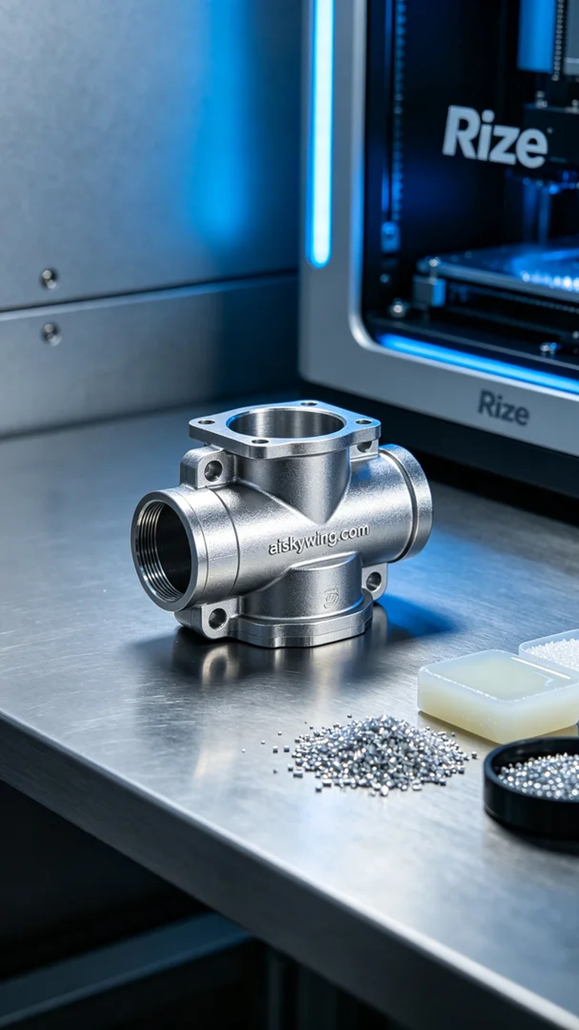
在Twitter上，我看到有人发帖求助，提到他们在制造EGR阀壳体时遇到了一些困难，特别是在材料和加工精度方面。于是我决定接下这个项目，帮助他们解决问题。
为了确保打印效果，我们选择使用未成型的液态光敏树脂作为原材料。这样的材料具有优良的流动性和高细节捕捉能力。我们使用Rize打印机，设置了层厚为0.1毫米，打印温度保持在25℃，功率控制在200瓦，打印速度设定在80毫米每秒，预计总打印时间为12小时。
打印过程顺利进行，设备运行得相当稳定。我时刻监控着打印质量，确保每一层都能精准叠加。经过几小时的观察，发现打印出来的EGR阀壳体表面光滑，细节清晰，达到了预期的效果。
后处理方面，我们进行了全面的清洗和打磨。首先，将成品放入清洗槽中，用酒精去除残留的树脂。清洗后，我们对表面进行细致打磨，确保光滑度。最后，对打印件进行固化处理，以提高其强度和耐用性，最后经过严格的检验，确保满足质量标准。
这次的EGR阀壳体打印任务圆满完成，成功帮助那位找我们的人解决了他们的制造问题，也为我们积累了宝贵的经验。
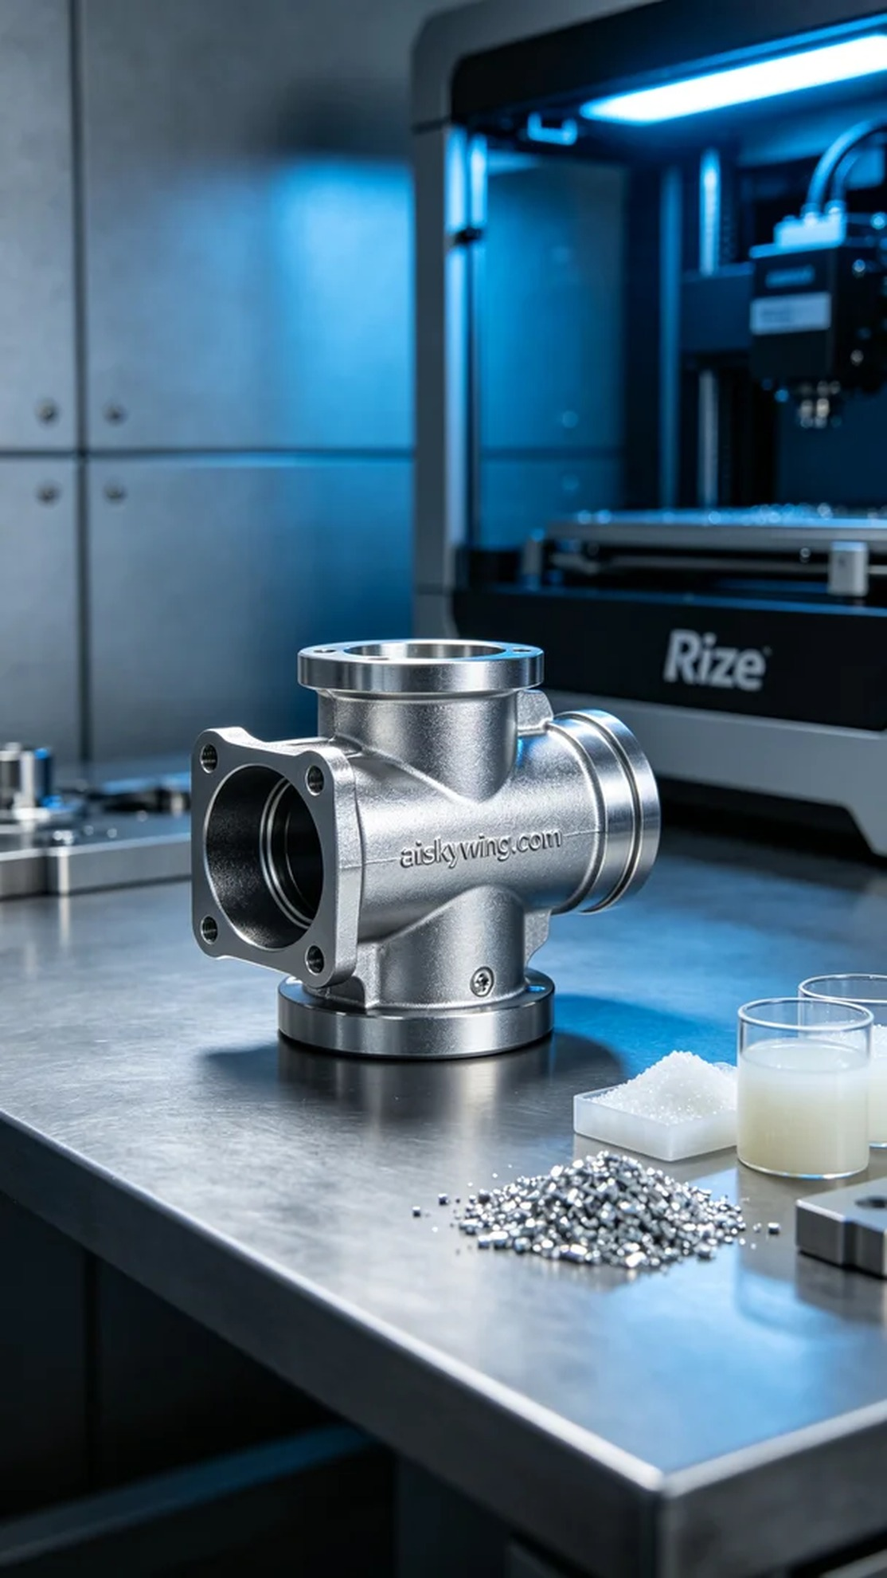
Aiskywing Industrial 3D Printing
EGR valve housing


