0578-AGV小车RFID天线支架的生产记录
AGV Cart RFID Antenna Bracket
🖨️ SLS尼龙烧结
🖥️ 打印机: Mimaki
📦 材料: SLS尼龙PA12
生活就像一场不断打印的过程，虽然有时会遇到挑战，但我们总能迎头赶上。这次，有人因为AGV小车RFID天线支架的问题找到了我们。
Life is like an ongoing printing process. Although we sometimes face challenges, we can always catch up. This time, someone reached out to us regarding an issue with the RFID antenna bracket for the AGV cart.
________________________________________________________________________________
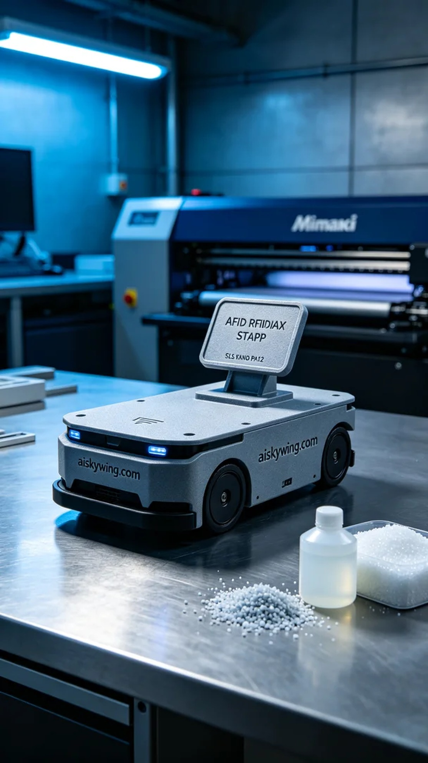
Life is like an ongoing printing process, and although we sometimes face challenges, we always manage to catch up. Recently, someone reached out to us via Twitter regarding their need for an AGV cart RFID antenna bracket.
In preparing for production, we chose SLS nylon PA12 for its outstanding strength and durability. For the equipment, we utilized a Mimaki 3D printer and set the printing parameters to a layer thickness of 0.1mm, a temperature of 185°C, a power setting of 80%, and a printing speed of 30mm/s. The estimated printing time was around 8 hours, allowing us to maximize the performance and quality of the bracket.
As the printing process commenced, the Mimaki printer operated steadily, depositing the material layer by layer with precision. We closely monitored the quality of each layer, ensuring there were no warps or noticeable defects. The low noise emitted by the equipment made the environment quiet and efficient, and every step of production was carried out under meticulous control.
Upon completion of printing, we proceeded with post-processing. First, the printed piece was placed in a cleaning tank to remove any uncured resin on the surface. Next, we sanded the bracket with fine sandpaper to ensure a smooth surface and perfect details. Lastly, it underwent UV curing to ensure its durability during use. After rigorous quality inspection, we confirmed the bracket met all requirements and was ready for delivery.
With that, the production process for the AGV cart RFID antenna bracket concluded successfully, resulting in a perfect final product ready for its practical application.
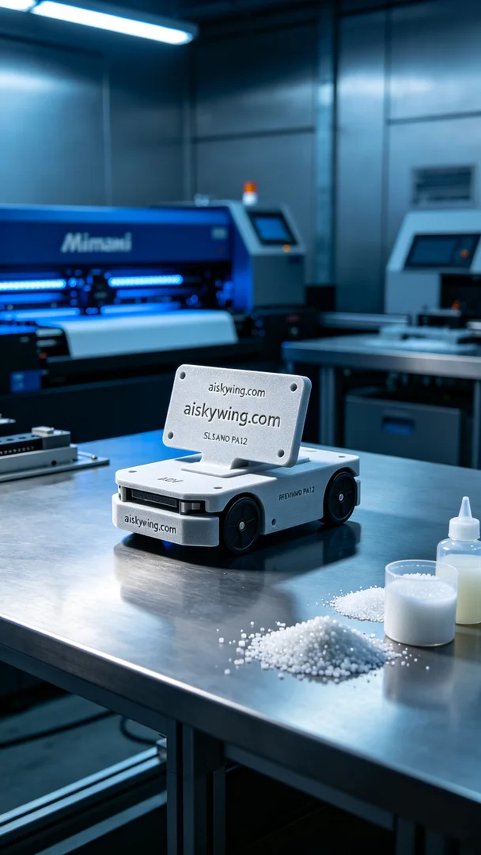
我们通过Twitter接到了一位工程师的求助，原来他们在使用AGV小车时，需要一个高强度的RFID天线支架，以确保信号稳定。这种支架不仅要有良好的强度，还要适应工业环境，因此我们决定使用SLS尼龙PA12材料来满足他们的需求。
在准备材料时，我们选择了SLS尼龙PA12，这种材料以其优异的强度和耐用性著称。设备方面，我们使用的是Mimaki 3D打印机，设定的打印参数为层厚0.1mm，温度为185°C，功率设置为80%，打印速度为30mm/s，预计打印时间为8小时。通过这些参数，我们可以最大程度地提升支架的性能和打印质量。
打印过程开始后，Mimaki打印机稳定运行，喷头精准地将材料逐层沉积。我们在此过程中严格监控每一层的质量，确保没有翘边或明显的缺陷。设备发出的低噪音，让整个环境显得安静而高效，生产的每一步都在精细的操控下进行。
完成打印后，我们进行了后处理，首先将打印件放入清洗槽，去除表面的未固化树脂。接着，用细砂纸对支架进行打磨，保证表面光滑，细节完美。最后，经过UV固化，确保支架在使用过程中的耐久性。经过严格的质量检验后，我们确认支架完全符合要求，准备交付给对方。
至此，这个AGV小车RFID天线支架的生产流程顺利结束，得到了完美的成品，期待它在实际应用中发挥作用。
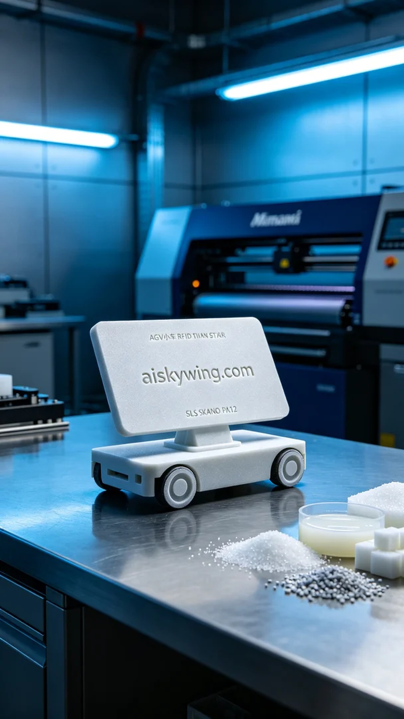
Aiskywing Industrial 3D Printing
AGV Cart RFID Antenna Bracket


