0579-AGV小车充电极片支架生产记录
AGV Cart Charging Electrode Plate Bracket
🖨️ SLS尼龙烧结
🖥️ 打印机: Xjet
📦 材料: SLS尼龙
在WhatsApp上，有人因为AGV小车充电极片支架的问题找我们，希望能得到解决方案。生活就像这份工作，别放弃，总能找到方法。
On WhatsApp, someone reached out to us regarding an issue with the charging electrode bracket for the AGV trolley, hoping to find a solution. Life is like this job; don’t give up, as there is always a way to find a solution.
________________________________________________________________________________
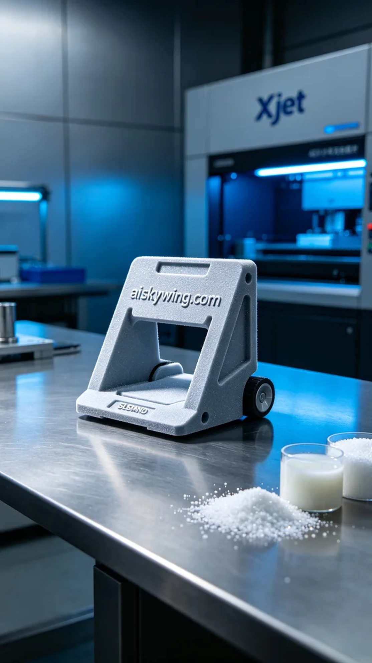
Recently, we received a task to produce a charging plate support for an AGV cart. Someone reached out to us on WhatsApp, mentioning that their existing support was unstable and they hoped we could design and produce a more lightweight solution. To meet this requirement, we decided to use SLS nylon material, known for its high strength and good toughness, making it ideal for industrial use.
During the preparation phase, we selected the Xjet brand 3D printer for the task. We chose SLS nylon as the material, which offers excellent powder flow and sintering properties. For the settings, we adjusted the layer thickness to 0.1 mm, maintained a printing temperature of 180 degrees Celsius, set the power to 60W, and the printing speed to 50 mm/s. The entire printing process was expected to take about 8 hours to ensure the best print quality.
As the printing process began, the equipment ran smoothly, with the powder sintering layer by layer at high temperature to form a sturdy support structure. Throughout the process, we routinely checked the print status to ensure there were no particle accumulations or other anomalies, keeping both the equipment and material in optimal condition. Real-time monitoring ensured that each layer conformed to our expectations.
Once printing was completed, we proceeded with the post-processing steps. First, we carefully removed the support from the printer and cleaned it to eliminate any unsintered nylon powder. Next, we used fine sandpaper for smoothing the surface to eliminate any imperfections. Finally, we conducted a curing process by placing the finished product under UV light to ensure its strength and stability met design specifications. After rigorous inspection, we confirmed that the support met all performance criteria.
After all these efforts, the AGV cart's charging plate support was successfully produced. This experience was not just a successful printing endeavor but also a testament to teamwork and accumulated technical expertise.
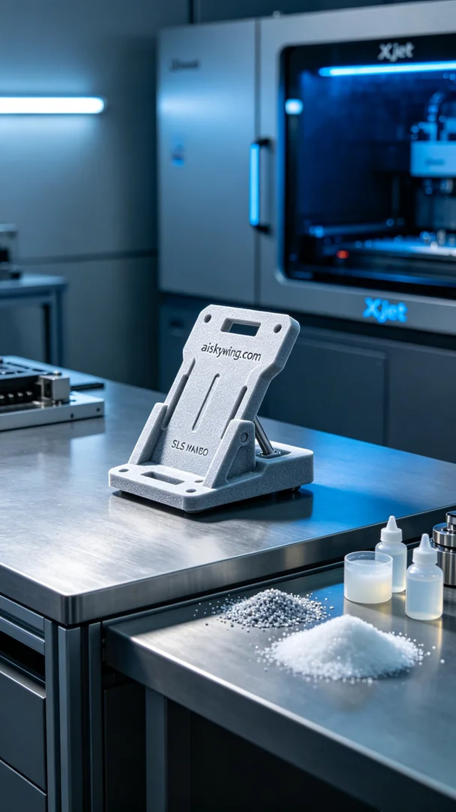
这次我们接到一个任务，要为一款AGV小车生产充电极片支架。通过WhatsApp联系到我们的人提到，现有的支架不够稳定，希望我们能用更轻质的材料来设计并生产。为了满足这个要求，我们决定采用SLS尼龙材质，这种材质强度高、韧性好，非常适合工业用途。
在准备阶段，我们挑选了Xjet品牌的3D打印机进行打印。材料方面，我们使用的是SLS尼龙，具有良好的粉末流动性和烧结特性。设置方面，层厚为0.1毫米，打印温度控制在180摄氏度，功率设置为60W，打印速度定为50mm/s。整个打印过程预计需要8小时完成，这样才能确保打印质量达到最佳效果。
打印过程开始后，设备运行平稳，粉末在高温下逐层烧结，形成坚固的支架结构。整个过程中，我们定期检查打印状态，确保没有颗粒堆积或其他异常现象，保持设备和材料的最佳性能。通过实时监控，确保每一层的塑形都符合预期。
打印完成后，我们进行了后处理工序。首先，将支架从打印机中取出，并进行清洗，去除未烧结的尼龙粉末。接着，使用细砂纸进行打磨，以确保表面光滑无瑕疵。最后，我们进行了固化处理，将成品放置在紫外线灯下，确保其强度和稳定性达到设计要求，经过严格的检验后，确认支架符合所有性能指标。
经过一系列的努力，AGV小车充电极片支架终于成功生产完成。这不仅是一次成功的打印经历，更是团队协作与技术积累的结晶。
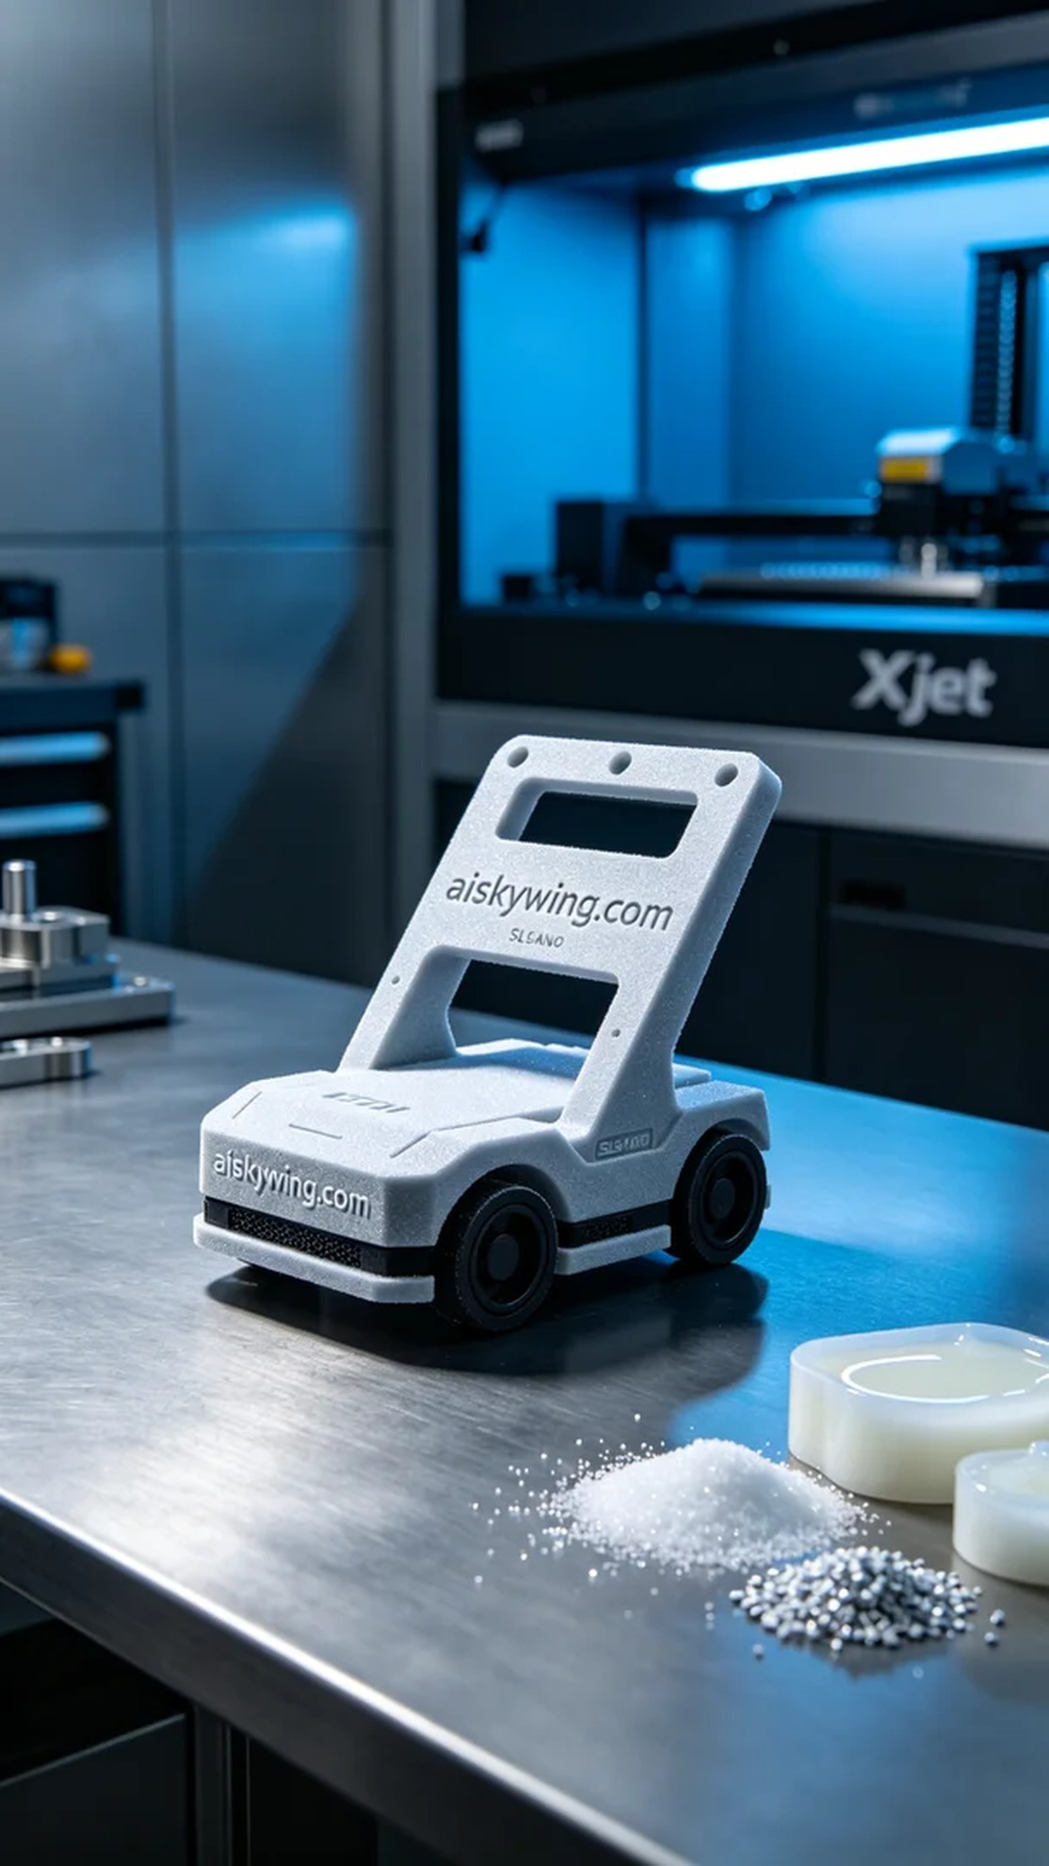
Aiskywing Industrial 3D Printing
AGV Cart Charging Electrode Plate Bracket


