0580-AGV小车导引传感器支架生产记录
AGV Cart Guidance Sensor Bracket
🖨️ SLS尼龙烧结
🖥️ 打印机: Systems
📦 材料: SLS阻燃尼龙
生活有时会让我们感到无力，但是每一次的坚持，都是为了实现我们的理想。就像今天，我接到了关于AGV小车导引传感器支架的打印任务。
Life can sometimes make us feel powerless, but every act of perseverance is aimed at realizing our ideals. Just like today, I received a printing task for the AGV cart guiding sensor bracket.
________________________________________________________________________________
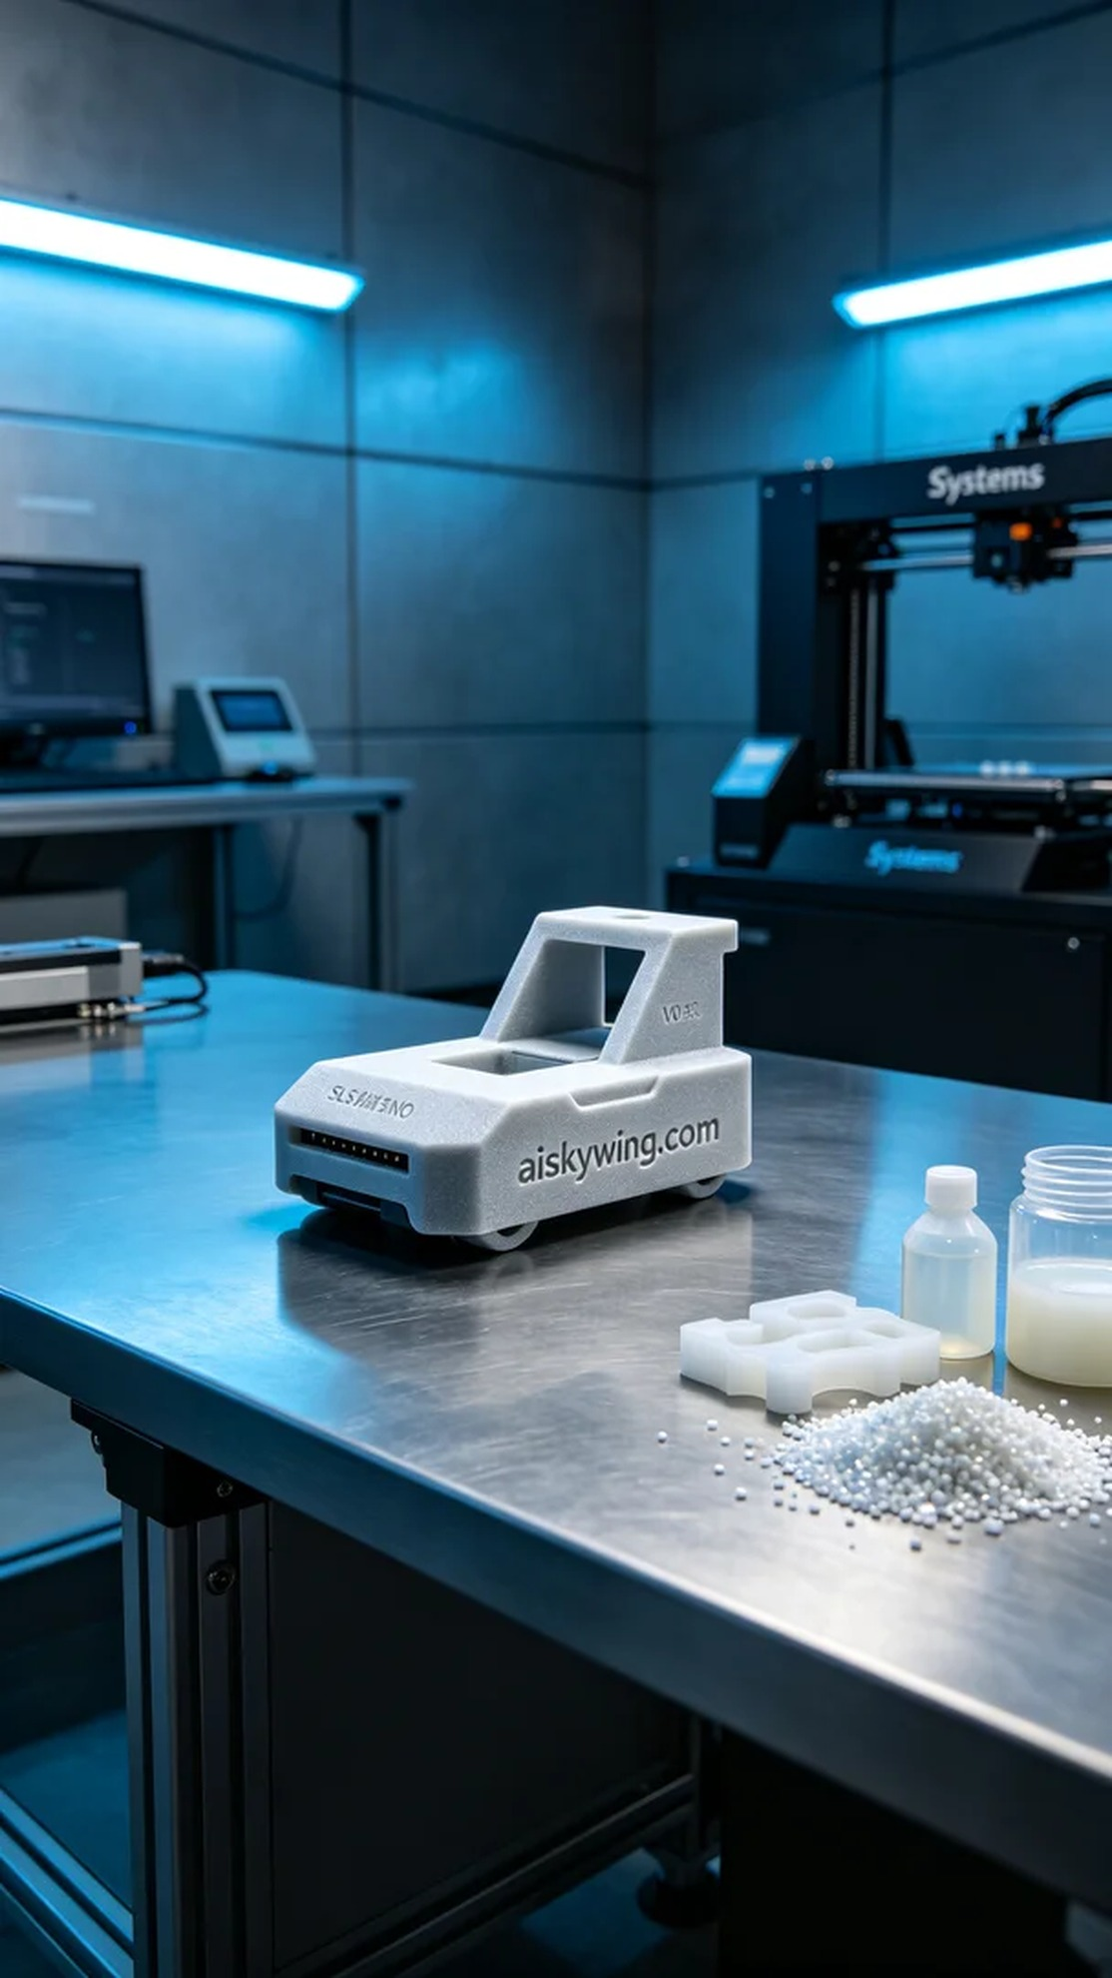
Life can sometimes feel overwhelming, but every bit of perseverance is aimed at realizing our ideals. Just like today, I received a task for printing an AGV small vehicle guiding sensor bracket.
On YouTube, someone published a video regarding the AGV small vehicle guiding sensor bracket, mentioning stability issues during transportation. To enhance product performance, they requested us to make improvements. This task involves using SLS flame-retardant nylon material for printing to ensure the durability and stability of the bracket.
We chose SLS flame-retardant nylon as the raw material. This material has excellent strength and toughness while possessing V0 flame-retardant properties, making it particularly suitable for industrial environments. We used a Systems brand 3D printer, setting a layer thickness of 0.1mm, a printing temperature of 180 degrees Celsius, a power setting of 1000 watts, and controlling the printing speed to 30mm per hour, with an estimated printing time of 8 hours.
As the printing process began, the equipment operated smoothly, and the precision of SLS printing technology allowed every layer to fuse perfectly. Throughout the entire printing process, I monitored the machine's status to ensure that temperature and material supply were within normal ranges, guaranteeing the stability and quality of the print. Each layer added up very smoothly without bubbles or defects, and the quality performance was impressive.
After printing, we carried out detailed post-processing procedures. First, we cleaned the printed piece to remove any uncured powder from the surface, then sanded it down to ensure a smooth surface. Next, we cured the bracket to improve its durability, followed by a thorough inspection to ensure every detail met the standards.
This task was successfully completed, enhancing the stability of the AGV small vehicle guiding sensor bracket and providing confidence to the user. Each production experience accumulates knowledge, and I look forward to tackling more technical challenges in the future.
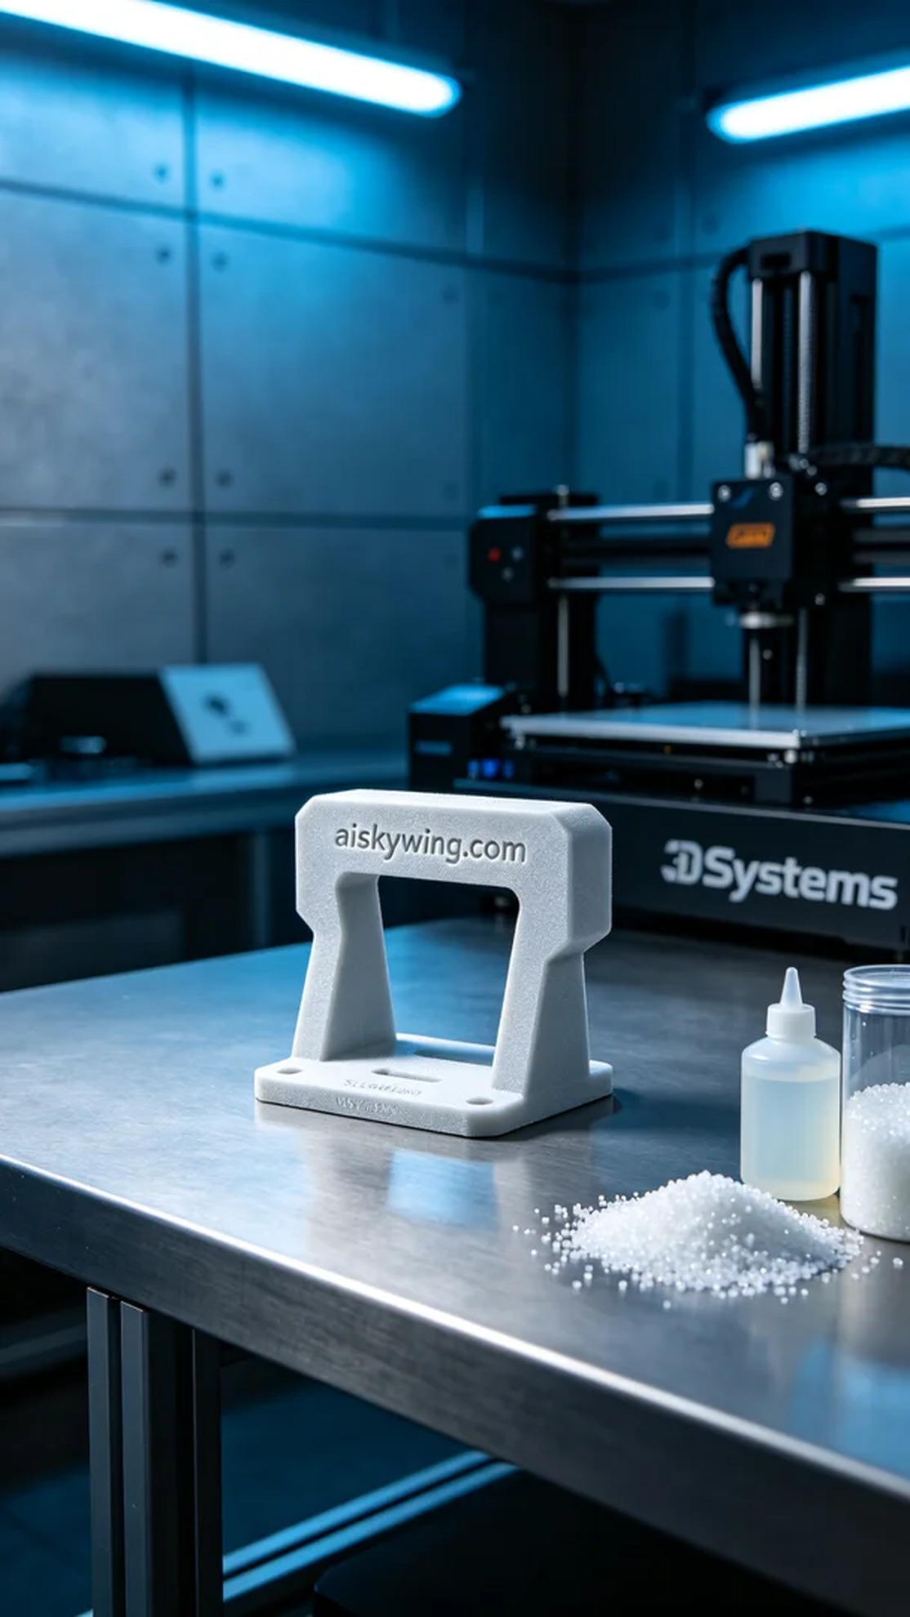
在YouTube上，有人发布了关于AGV小车导引传感器支架的使用视频，视频中提到支架在运输过程中出现了稳定性问题。为了提升产品的性能，要求我们进行改进。这次的任务是根据需求，利用SLS阻燃尼龙材料进行打印，确保支架的耐用性和稳定性。
我们选用SLS阻燃尼龙作为原材料。此材料具备良好的强度与韧性，同时具备V0级阻燃性能，特别适合用于工业环境。我们使用的是Systems品牌的3D打印机，设置层厚为0.1毫米，打印温度为180摄氏度，功率设定在1000瓦，打印速度则控制在每小时30毫米，预估打印时间为8小时。
打印过程开始后，设备顺利运行，SLS打印技术的精度让每一层都能够完美融合。在整个打印过程中，我全程监控着机器的状态，确保温度和材料供给都在正常范围，保证打印的稳定性和质量。每次层的叠加都非常平滑，没有气泡或缺陷，质量表现相当不错。
完成打印后，我们进行了详细的后处理工序。首先对打印件进行清洗，去除表面的未固化粉末，然后使用砂纸进行打磨，确保表面光滑。接着，对支架进行固化处理，以提升其耐用性，最后进行了严格的检验，确保每个细节都符合标准。
这次的任务圆满完成，AGV小车导引传感器支架的稳定性得到了提升，同时也为客户提供了信心。每一次的生产都是经验的积累，期待未来能继续挑战更多的技术难题。
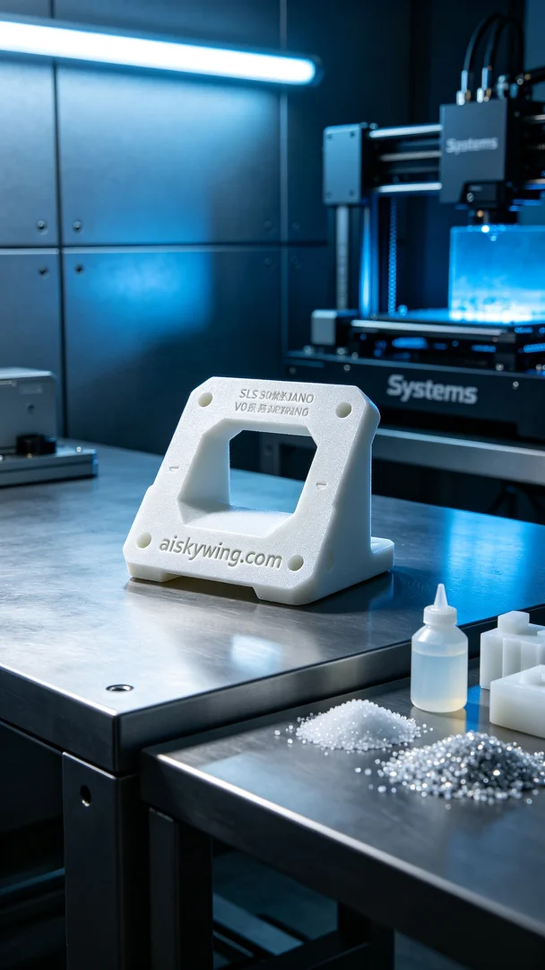
Aiskywing Industrial 3D Printing
AGV Cart Guidance Sensor Bracket


