0581-AGV小车急停按钮支架的打印记录
AGV Cart Emergency Stop Button Bracket
🖨️ SLS尼龙烧结
🖥️ 打印机: Rize
📦 材料: SLS阻燃尼龙
生活再难，也别停下脚步。就像接下这个AGV小车急停按钮支架的单子，有人因为急停按钮支架不够稳固而找到了我们。
No matter how difficult life gets, don't stop moving forward. Just like when we took on the order for the AGV cart emergency stop button bracket; someone reached out to us because the emergency stop button bracket was not stable enough.
________________________________________________________________________________
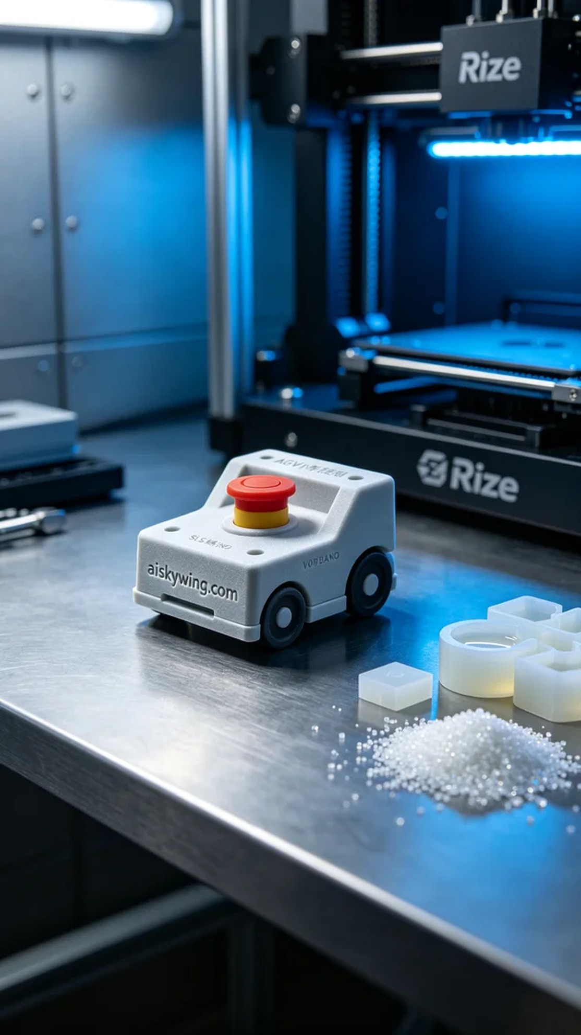
Life can be tough, but we must keep moving forward. Just like when we took on the task of creating an AGV cart emergency stop button bracket, someone reached out due to safety concerns with their existing bracket.
For this project, we chose to work with SLS flame-retardant nylon material. It’s known for its durability and meets the necessary fire-resistance standards, making it the perfect choice for the emergency stop button bracket.
We prepared to use a Rize printer for this task. To ensure optimal print quality, we set the layer thickness to 0.1 mm, maintained a printing temperature of 180 degrees Celsius, used a power of 40 watts, and kept the printing speed at 30 mm per hour. These settings would guarantee effective melting and forming of the material, reducing the chances of issues during printing.
The printing process went smoothly. As the printer started, we closely monitored the operation to ensure that each layer was deposited perfectly. The machine emitted a consistent low-frequency hum, indicating efficient operation. We periodically checked the printing progress to confirm that the bracket’s details and overall structure met the design requirements, maintaining high quality throughout.
After printing, we began the post-processing steps. The bracket was carefully removed and cleaned with a special solution to eliminate excess powder. Next, we sanded the surface to ensure smoothness. During the curing phase, we used UV light to enhance the bracket's strength and fire-retardance properties, followed by a thorough inspection to confirm that all details adhered to the design standards.
In the end, the AGV cart emergency stop button bracket was successfully completed, sturdy and safe, effectively addressing the user's concerns. This outcome brings us great satisfaction, and we look forward to more projects that can bring convenience to people's work and lives.
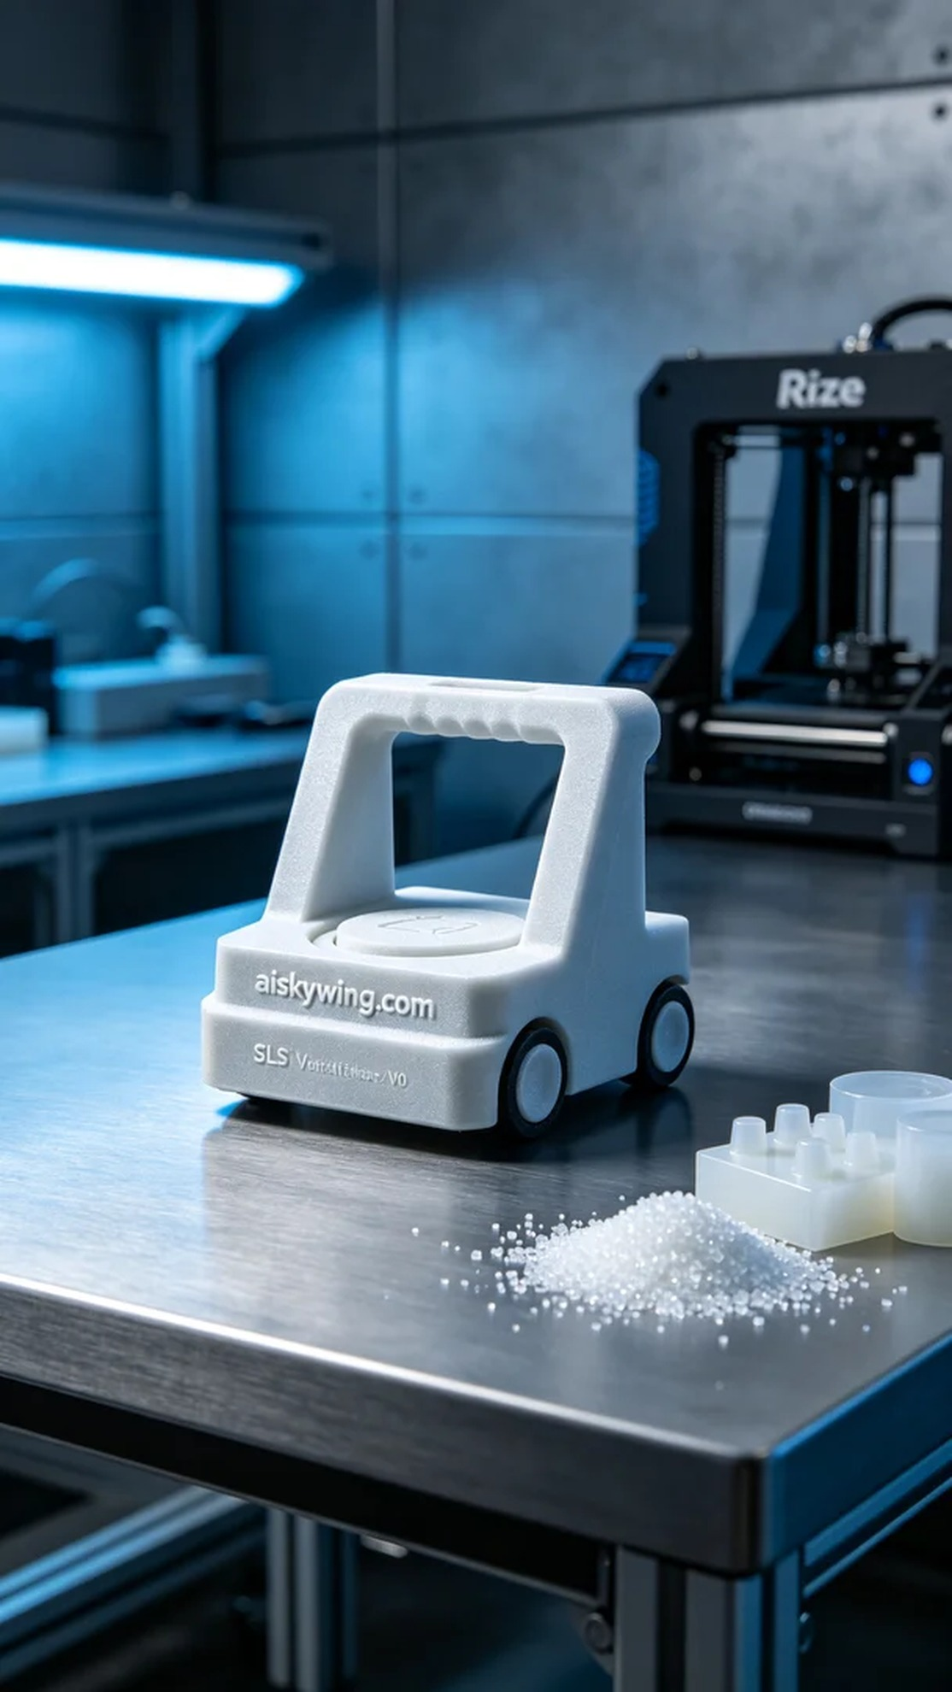
这次我们接到的订单是为AGV小车制作急停按钮支架。有些人在使用过程中发现，现有的支架不够牢固，存在一定安全隐患，因此找上了我们。我们决定采用SLS阻燃尼龙材料来解决这个问题，因为它既耐用又能满足阻燃的需求。
在准备工作方面，我们选用了Rize打印机。为了确保打印效果，我们将层厚设置为0.1毫米，打印温度保持在180摄氏度，功率为40瓦，打印速度控制在每小时30毫米。这样的参数保证了材料的有效熔融与成型，最大限度减少了打印过程中的问题。
打印过程相对顺利。打印机启动后，我们监控了运行状态，确保每一层都能完美沉积。其间，打印过程中发出一致的低频轰鸣声，显示出设备的高效运转。我们定期检查打印进度，确认支架的细节处理和整体结构都符合设计要求，质量十分稳定。
完成打印后，我们开始了后处理工序。首先将支架取出，使用专门的清洗液进行清洗，去除表面多余的粉末。随后进行打磨，确保支架的表面光滑。固化过程中，我们采用UV灯照射，确保支架的强度和阻燃性能达到标准，最后进行一遍检验，确保所有细节都符合设计要求。
最终，经过一系列严谨的流程，这个AGV小车急停按钮支架顺利完成，既坚固又安全，解决了使用者的隐患。这样的成果让我们倍感欣慰，期待更多的项目能够为人们的工作和生活带去便利。
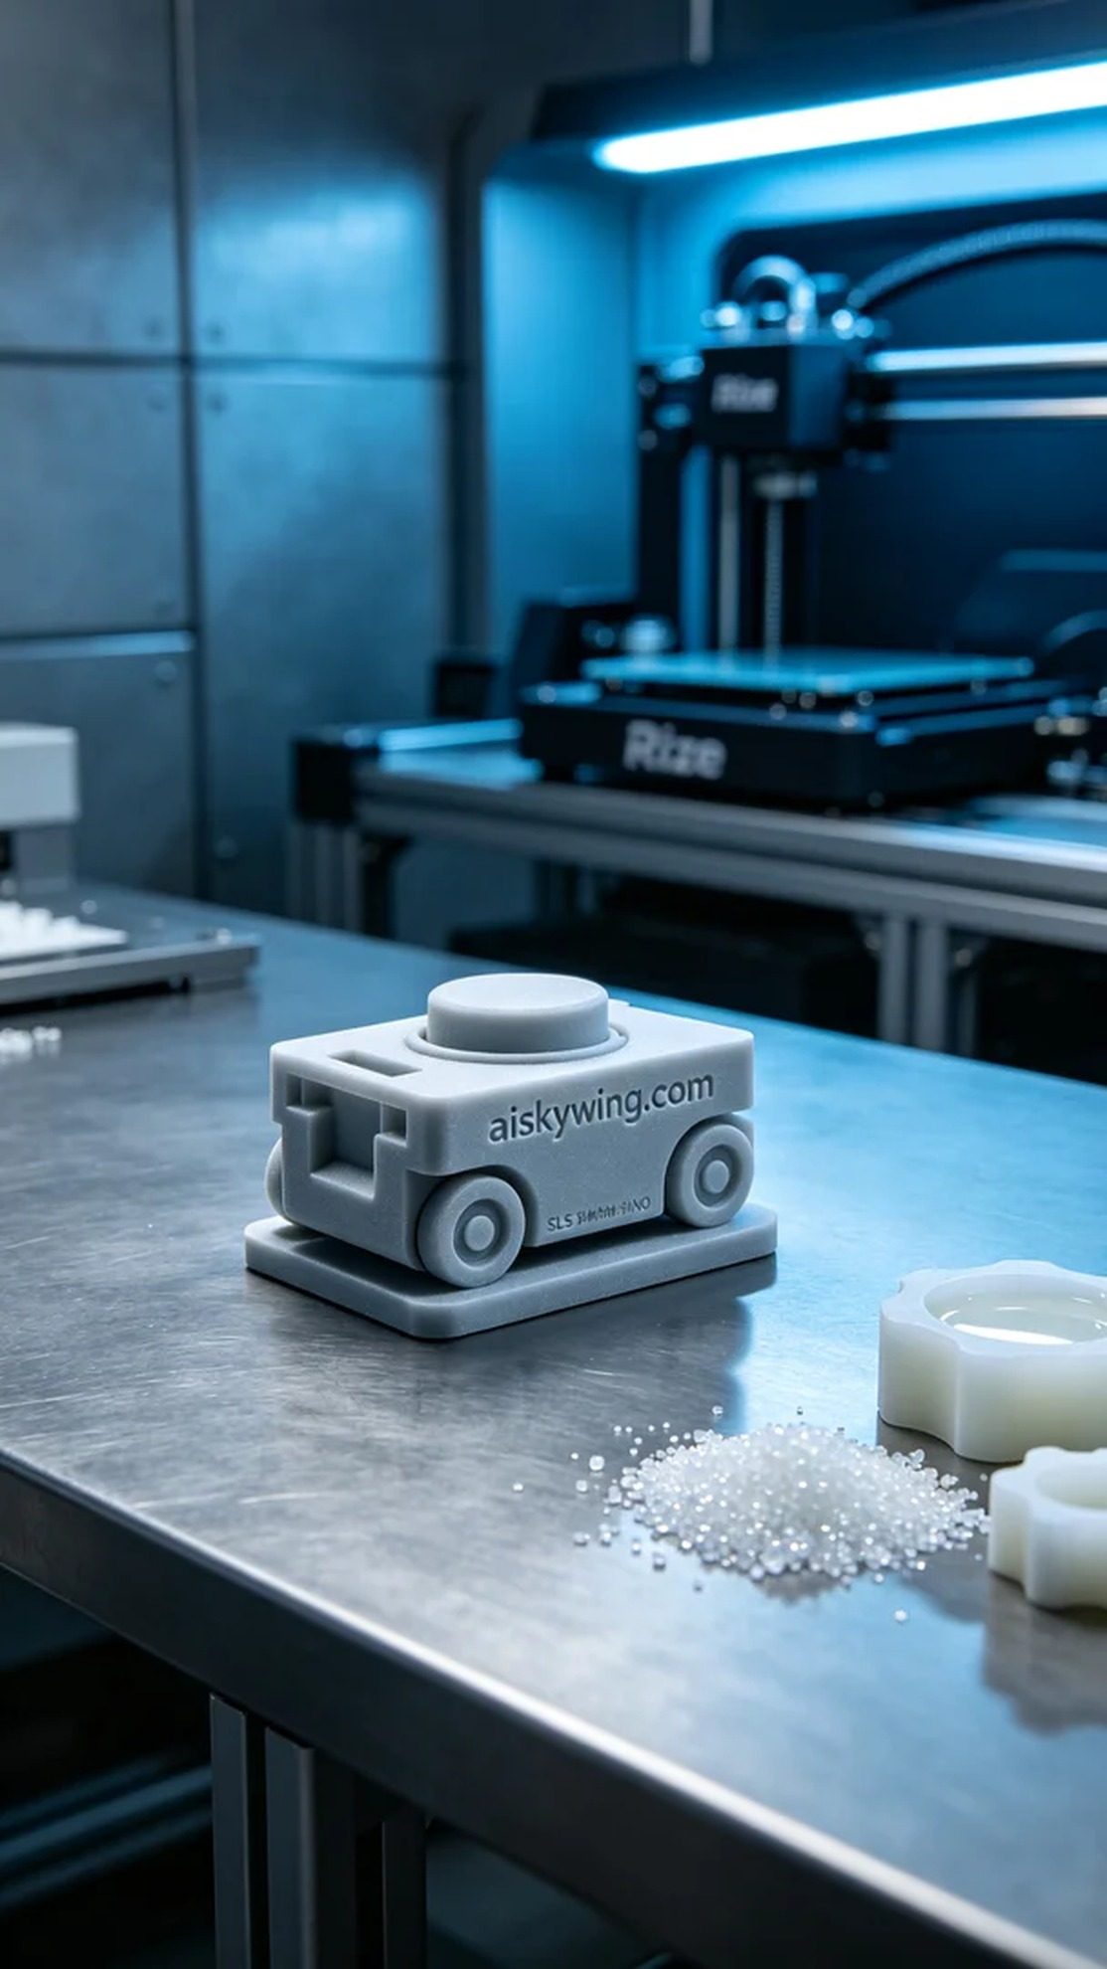
Aiskywing Industrial 3D Printing
AGV Cart Emergency Stop Button Bracket


