0584-SCR外壳3D打印生产记录
SCR shell
🖨️ SLM金属打印
🖥️ 打印机: Carbon
📦 材料: 摆放着未成型的液态光敏
生活再难，也别停下脚步。就像接下这个SCR外壳的单子，有人因为产品的独特需求找上了我们，期待通过3D打印实现完美的设计。
No matter how difficult life gets, don't stop moving forward. Just like when we took on the order for the SCR shell—someone approached us because of the unique requirements of the product, hoping to achieve a perfect design through 3D printing.
________________________________________________________________________________
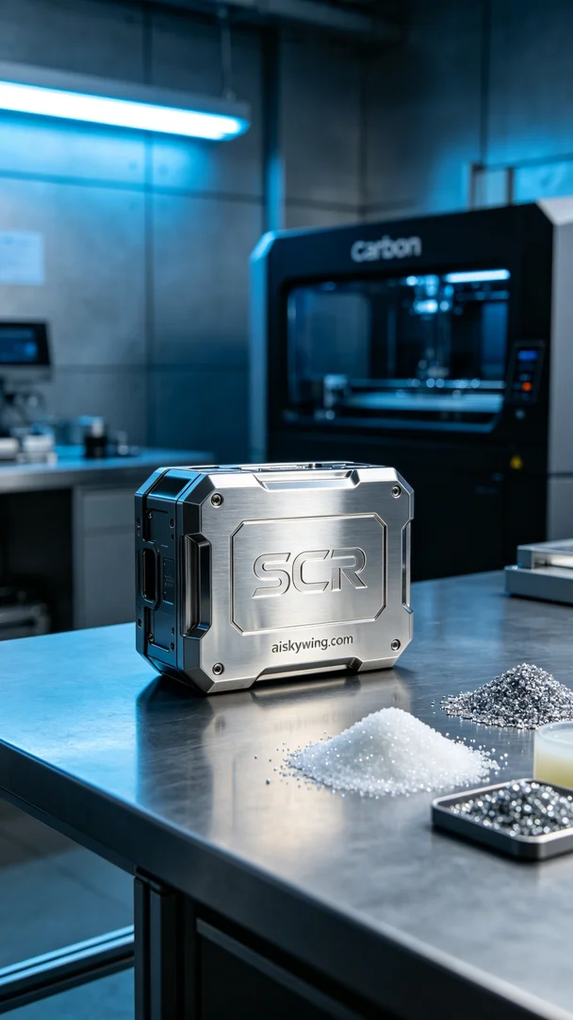
Despite the challenges life throws at us, we must keep pushing forward. Someone reached out to us on Twitter needing a high-precision SCR shell, expecting our 3D printing expertise to bring their design to life.
We opted to use unformed liquid photopolymer resin as our primary material. This material offers excellent flow properties and curing characteristics, making it suitable for intricate structures. For the printing process, we utilized a Carbon 3D printer, setting the printing parameters to a layer thickness of 0.1mm, with a temperature of 25°C, power at 60W, and a printing speed of 100mm/s, estimating the entire process to take around 8 hours.
During the printing phase, the Carbon printer operated steadily, utilizing precise light technology to ensure that each layer's details were clearly represented. We conducted real-time monitoring of the equipment, ensuring that the quality remained consistent throughout the process, from material input to layer adhesion.
Once printing was complete, we moved on to the post-processing stage. First, the printed SCR shell was cleaned to remove any excess resin. Next, we performed sanding to achieve a smoother surface, followed by curing to enhance material strength and durability. After rigorous inspection, we confirmed that the product met our quality standards.
After completing this series of processes, the production of the SCR shell was successfully concluded, resulting in a unique mirror-like metallic finish that embodies the industrial style we strive for.
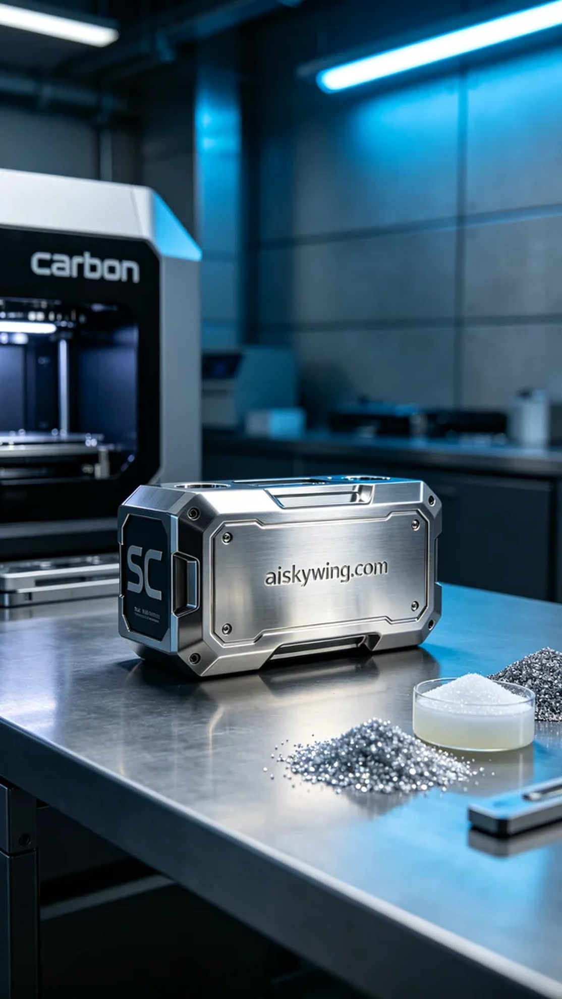
在Twitter上，有人提到他们需要一个高精度的SCR外壳，要求表面处理精细，能够反射出冷峻的工业美感。这个需求正好符合我们擅长的SLM金属打印工艺。
我们选择使用未成型的液态光敏树脂作为主要原材料。该材料具有优良的流动性和固化特性，适合复杂结构的打印。设备方面，我们使用的是Carbon品牌的3D打印机，打印参数设置为层厚0.1mm，打印温度设定为25℃，功率为60W，打印速度控制在100mm/s，整个打印过程预计持续8小时。
在实际打印过程中，Carbon打印机稳定运转，通过精准的光照技术，确保了每一层的细节都能清晰呈现。我们在打印的同时，对设备进行实时监控，确保质量始终如一，无论是材料的输入还是层间的粘合，都保持在最佳状态。
完成打印后，我们进入后处理环节。首先，将打印好的SCR外壳进行清洗，以去除多余的树脂。然后进行打磨处理，使表面更加光滑，最后进行固化，以增强材料的强度和耐久性。经过严格的检验，我们确认产品的质量达到了预期标准。
经过这一系列的工序，SCR外壳的生产顺利完成，最终呈现出独特的镜面金属质感，正是我们所追求的工业风格。
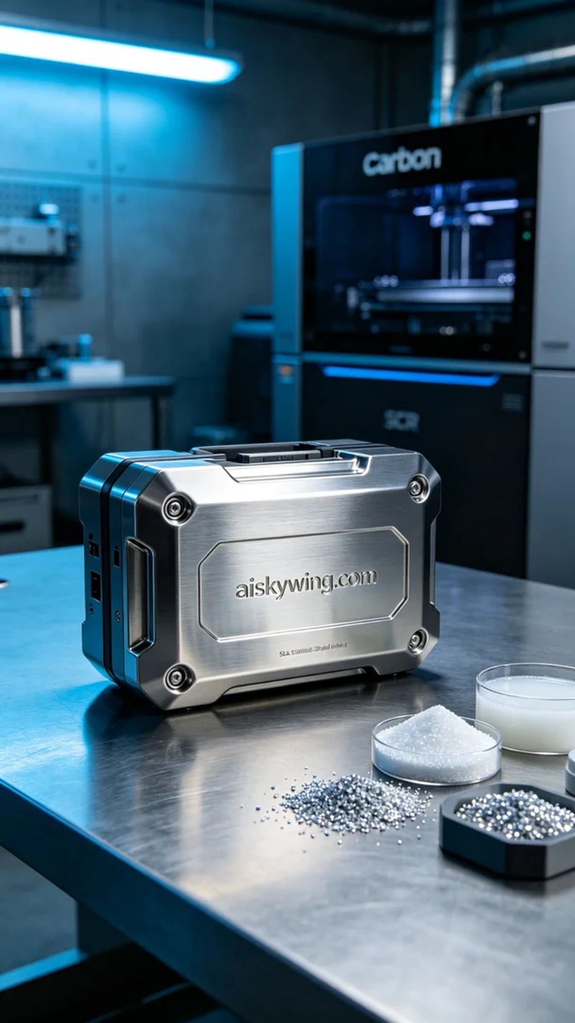
Aiskywing Industrial 3D Printing
SCR shell


