0585-中冷器外壳3D打印生产记录
The translation of "中冷器外壳" is "intercooler housing."
🖨️ SLM金属打印
🖥️ 打印机: Xjet
📦 材料: 摆放着未成型的液态光敏
生活再难，也别停下脚步。就像接下这个中冷器外壳的单子，我们总要面对挑战，努力去克服。
No matter how difficult life gets, don't stop moving forward. Just like taking on this order for the air cooler shell, we always have to face challenges and strive to overcome them.
________________________________________________________________________________
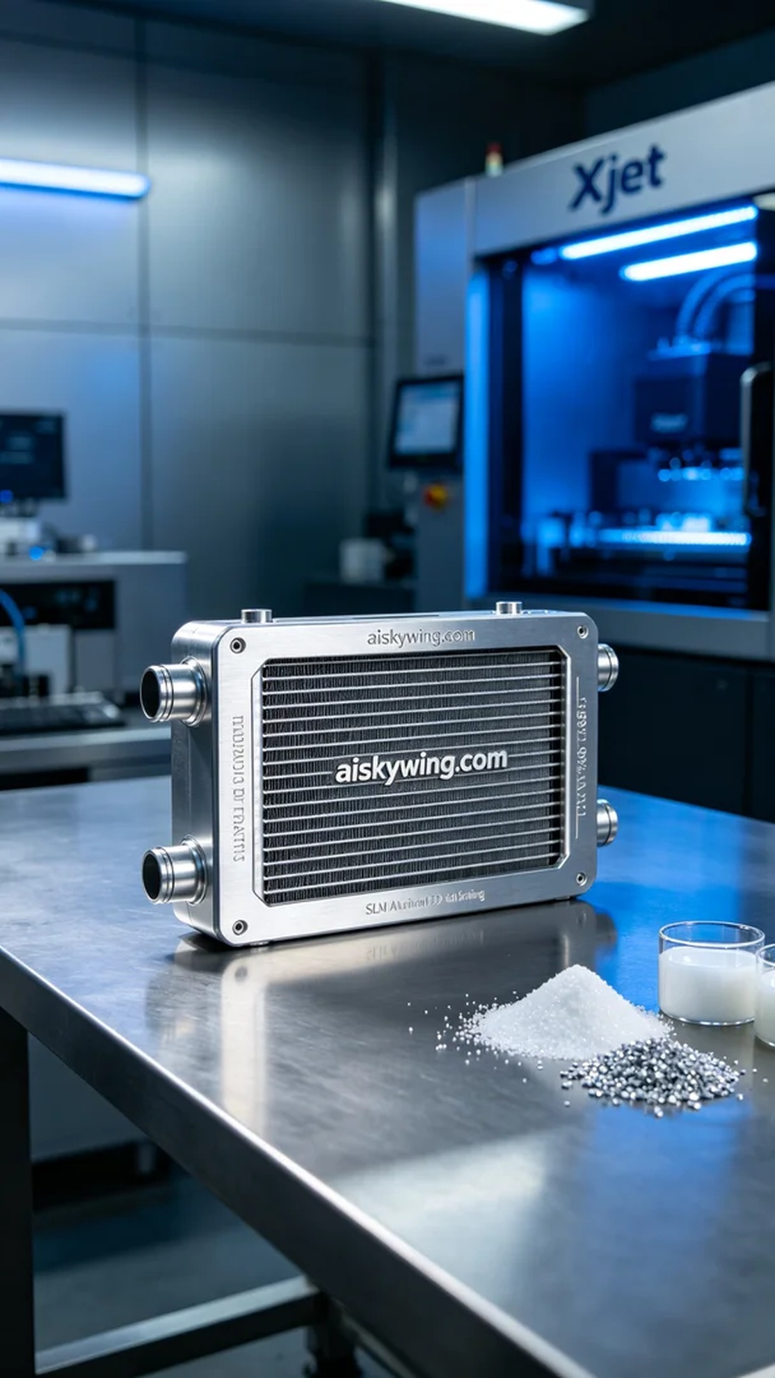
Recently, someone reached out to us through TikTok, looking to customize a cooling shell. Due to its unique design, the material and process requirements were quite high, and they hoped we could produce a durable and aesthetically pleasing product.
We decided to use unformed liquid photopolymer resin as the raw material. This material has excellent fluidity and curing performance, making it ideal for fine 3D printing. Additionally, we prepared to use the Xjet printer for SLM metal printing, setting the parameters to a layer thickness of 0.1mm, a printing temperature of 200°C, a power of 300W, and a speed of 60mm/s. After careful calculations, we estimated the entire printing process would take about 10 hours.
Once the printing began, the machine operated smoothly, and the Xjet printer performed exceptionally well, consistently maintaining stable temperatures and speeds. We monitored the machine's operational status throughout the process to ensure that the quality of each printed layer met our standards. During this process, the metallic luster and delicate surface engraving were beautifully enhanced, with the text "aiskywing.com" clearly visible.
After the printing was completed, we conducted detailed post-processing procedures. First, we thoroughly cleaned the printed cooling shell with a cleaning agent to remove any uncured resin. Next, we meticulously polished the surface to ensure smoothness and enhance its metallic luster. After curing, we ensured the product's durability and stability, followed by a strict quality inspection. Every detail was scrutinized to guarantee the product's perfection.
After completing these meticulous procedures, our cooling shell was finished on time, showcasing the industrial-style technological aesthetics, with results that were truly satisfying. This outcome once again proved the power of persistence and professionalism.
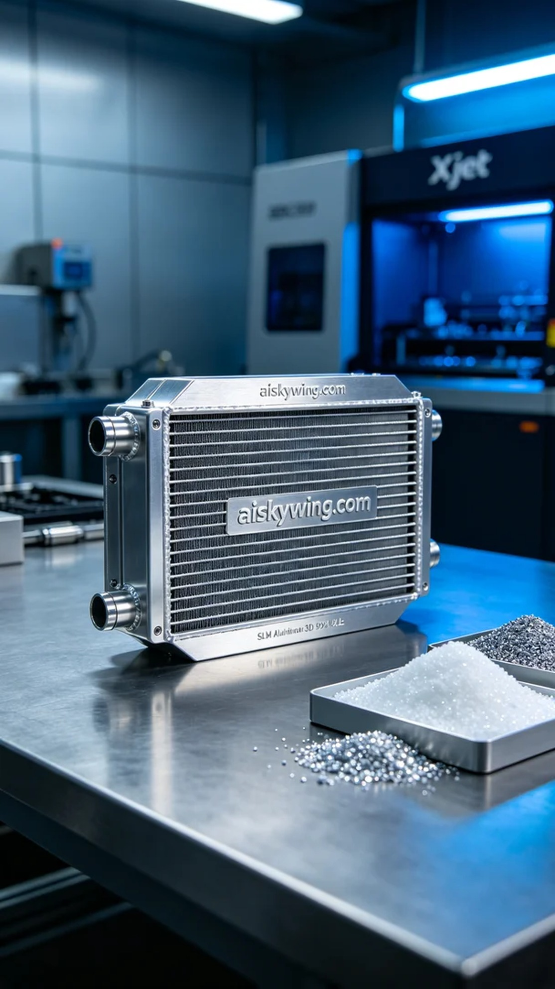
最近，有人通过TikTok联系到我们，想要定制一款中冷器外壳。由于其独特的设计，材料和工艺的要求都相当高，客户希望我们能够生产出耐用又美观的产品。
我们决定使用未成型的液态光敏树脂作为原材料，这种材料具有出色的流动性和固化性能，适合精细的3D打印。此外，我们准备使用Xjet打印机进行SLM金属打印，设定打印参数为层厚0.1毫米，打印温度200°C，功率300W，打印速度60mm/s。经过精确计算，我们预计整个打印过程将持续约10小时。
打印开始后，机器运转顺利，Xjet打印机在工作中表现出色，始终保持稳定的温度和速度。我们全程监控设备运行状态，确保每一层的打印质量都达到标准。在这一过程中，机器的金属光泽和细腻的表面雕刻相得益彰，"aiskywing.com"的字样清晰显现。
完成打印后，我们进行了详细的后处理工序。首先，用清洗剂彻底清洗打印好的中冷器外壳，以去除未固化的树脂。接着，通过细致的打磨工序，使表面光滑，并提升其金属光泽。经过固化处理，确保产品的耐用性和稳定性，最终进行了严格的质量检验。每一个细节都不放过，确保产品的完美。
经过这些精细的工序，我们的中冷器外壳如期完成，展现出了工业风格的科技感，效果令人满意。这样的结果，再次证明了坚持与专业的力量。
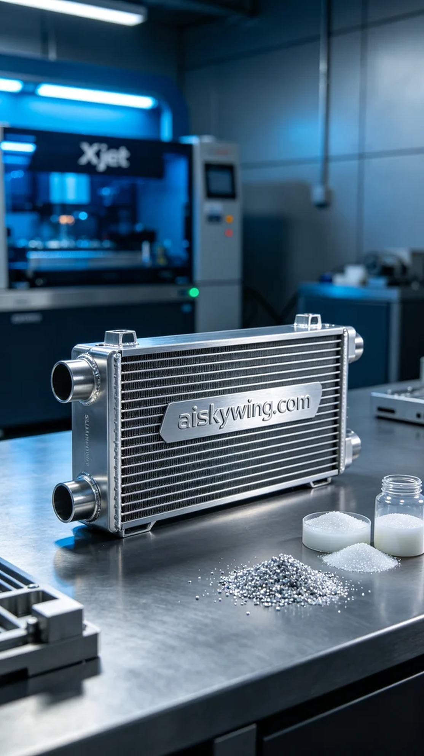
Aiskywing Industrial 3D Printing
The translation of "中冷器外壳" is "intercooler housing."


