0586-传动轴万向节的3D打印记录
Drive shaft universal joint
🖨️ SLM金属打印
🖥️ 打印机: Rize
📦 材料: SLM铝合金
生活就像3D打印，需要耐心与细致。今天我们接到一个传动轴万向节的单子，正好遇到一些挑战。
Life is like 3D printing; it requires patience and attention to detail. Today we received an order for a drive shaft universal joint, and we happened to encounter some challenges.
________________________________________________________________________________
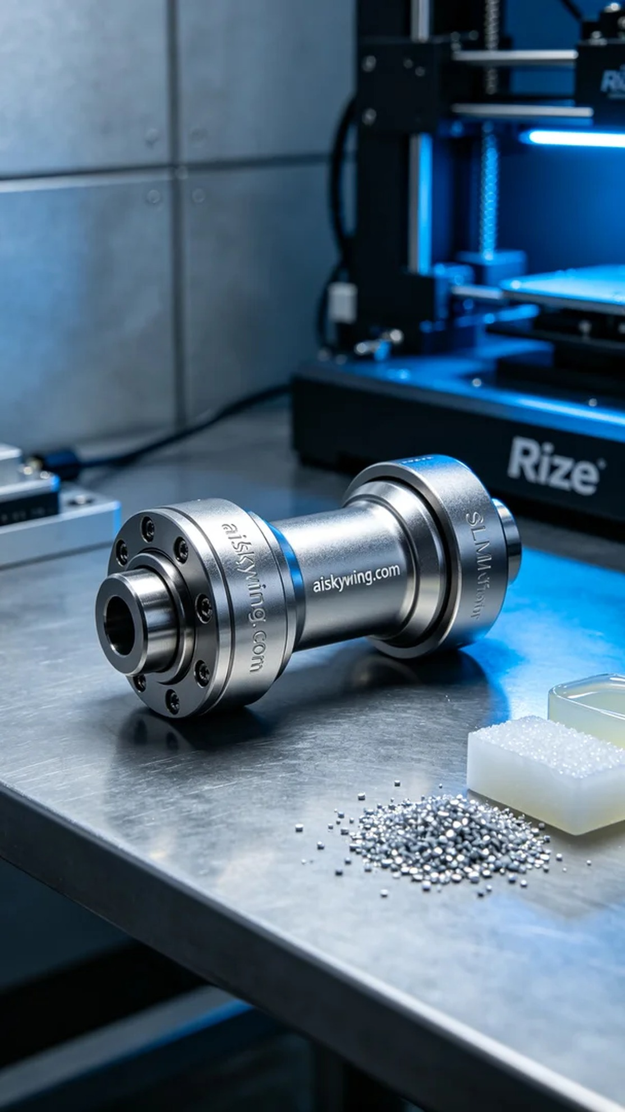
Life is like 3D printing, requiring patience and attention to detail. Today, we've received an order for a drive shaft universal joint, which presents some challenges we need to tackle.
On LinkedIn, someone reached out to us, hoping to quickly produce a high-quality drive shaft universal joint. They were facing the issue that traditional manufacturing methods couldn’t meet their precision and time requirements.
To meet this demand, we chose SLM aluminum alloy as the raw material, known for its lightweight and excellent strength. We used a Rize 3D printer, setting the printing parameters to a layer thickness of 0.1mm, a nozzle temperature of 200°C, a laser power of 90W, and a printing speed of 60mm/s, with an estimated total print time of about 12 hours.
Once the printing started, the device ran smoothly, and we conducted strict quality monitoring throughout the process. By monitoring in real time, we ensured each layer fused evenly, avoiding bubbles or cracks. Each time we saw the model gradually take shape, there was a sense of accomplishment.
After completing the print, we proceeded to post-processing. First, we placed the finished product into an ultrasonic cleaner to remove any residual resin; then we gradually polished it to enhance the surface detail; finally, we cured it to ensure optimal strength, followed by a thorough inspection.
Through this series of processes, we successfully produced a high-quality drive shaft universal joint that met the demands. Every step counts, and this is our commitment to craftsmanship and pursuit of excellence.
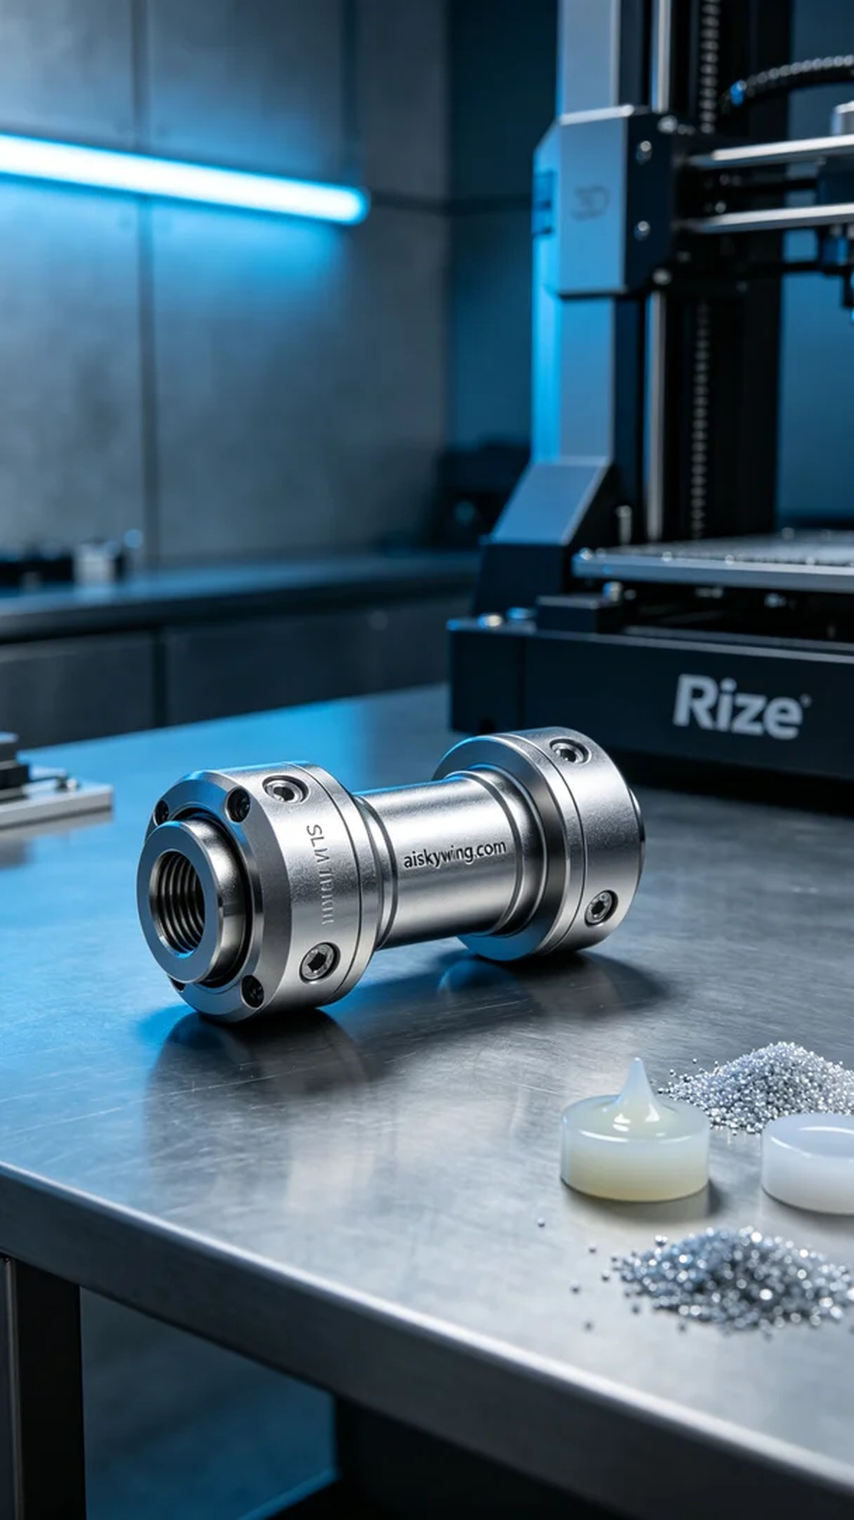
在LinkedIn上，有人找我们，希望能快速生产出一款高品质的传动轴万向节。他们面临的问题是传统生产方式无法满足他们对精度和时间的双重要求。
为了应对这种需求，我们选择了SLM铝合金作为原材料，这种材料不仅轻便，而且具有良好的强度。使用的打印设备是Rize品牌的3D打印机，打印参数设定为层厚0.1mm，喷嘴温度保持在200°C，激光功率设置为90W，打印速度为60mm/s，整件产品的打印时长预计在12小时左右。
打印开始后，设备顺利运行，整个过程我们进行了严格的质量监控。通过实时监测，确保每层都能够均匀融合，避免出现任何气泡或裂纹。每当看到模型逐渐成型，心里总是充满成就感。
完成打印后，我们进行了后处理工序。首先，将成品放入超声波清洗机中，去除残留的树脂；接着，进行逐步打磨，以提升表面的细腻度；最后，我们进行了固化处理，确保其强度达到最佳状态，随后进行了仔细的检验。
通过这一系列的流程，最终我们成功制作出了高质量的传动轴万向节，满足了需求。每个环节都不容小觑，这就是我们对工艺的坚持与追求。
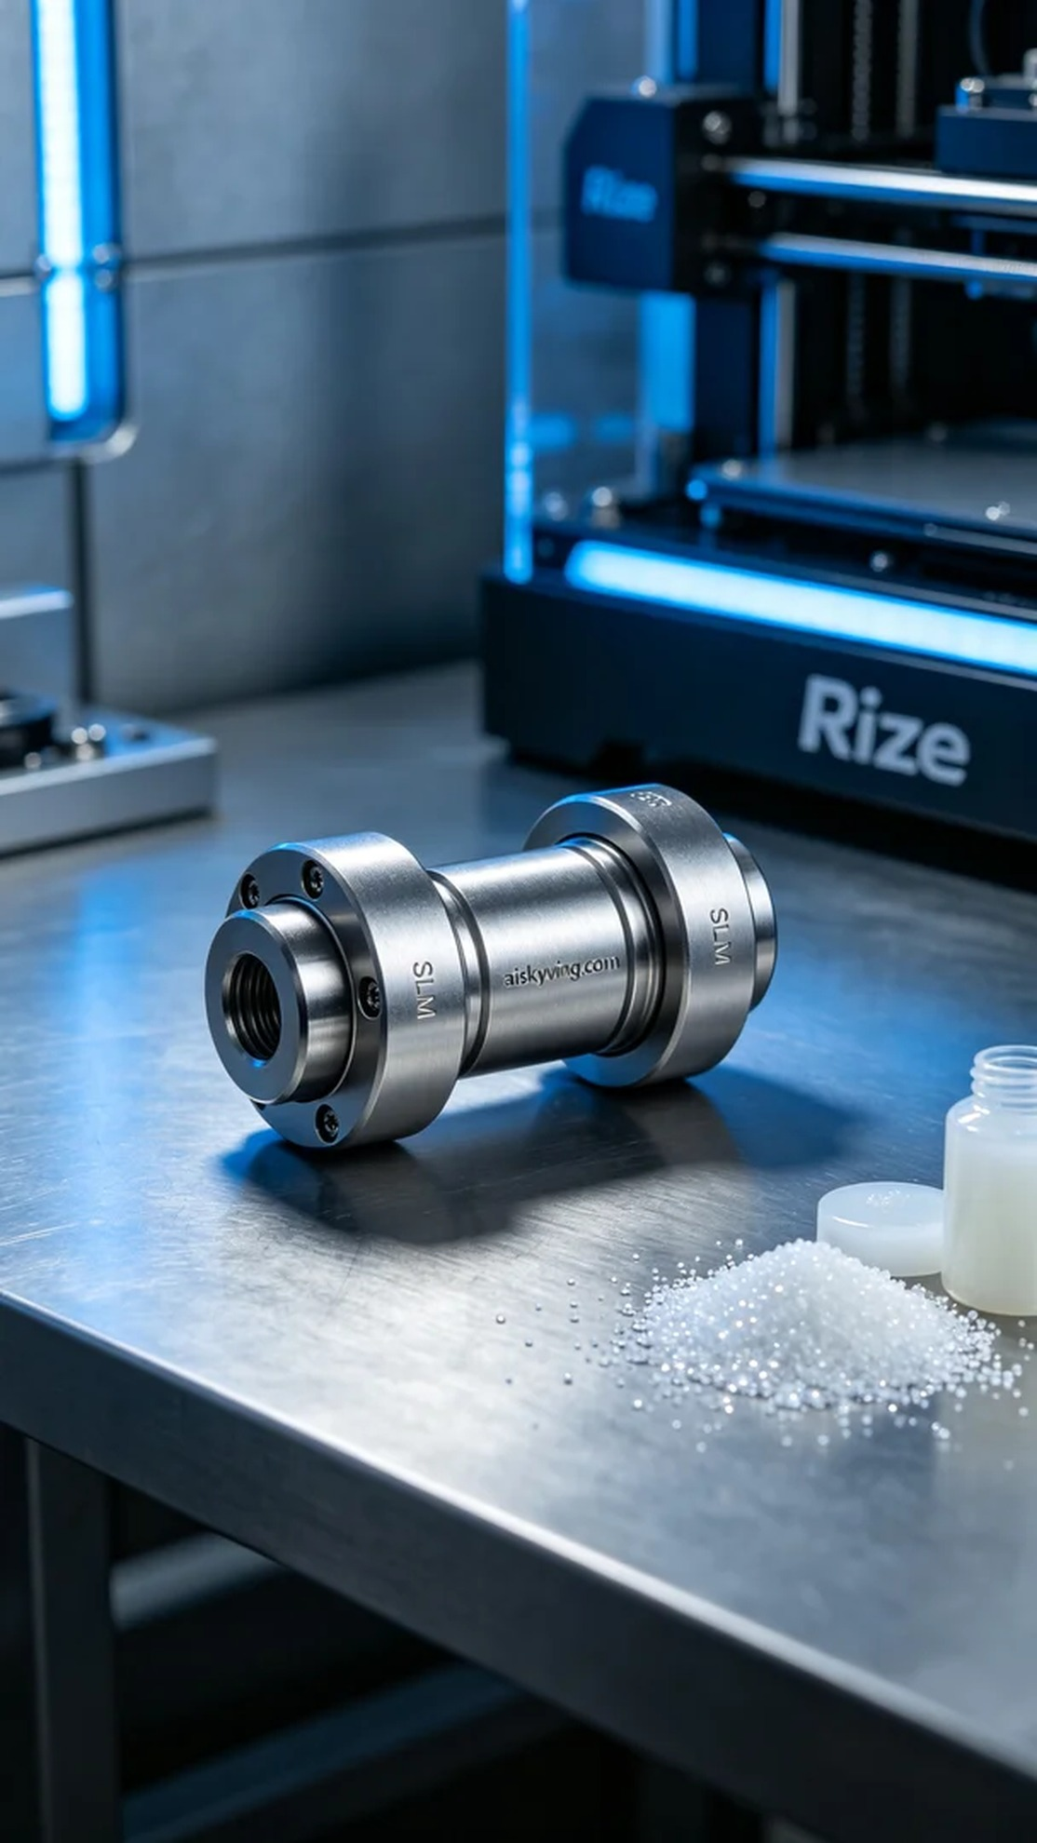
Aiskywing Industrial 3D Printing
Drive shaft universal joint


