0587-传动轴十字节的3D打印生产记录
Drive shaft cross.
🖨️ SLM金属打印
🖥️ 打印机: Stratasys
📦 材料: 摆放着未成型的液态光敏
在TikTok上，有人想要一款高精度的传动轴十字节，我们接下了这个挑战，准备为他们解决问题。
On TikTok, someone wanted a high-precision driveshaft cross, and we took on the challenge, ready to solve the problem for them.
________________________________________________________________________________
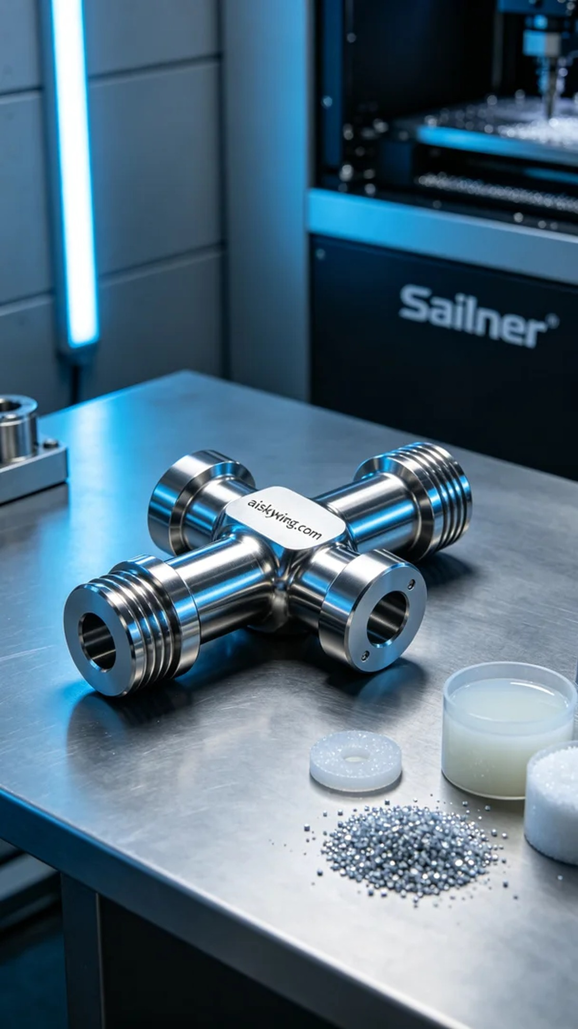
On TikTok, someone sought us out for a high-precision drive shaft cross. We took on the challenge, ready to address their needs with a solution.
We selected unformed liquid photopolymer material, ideal for SLM metal printing, with excellent fluidity and high strength. For equipment, we used a Stratasys printer, setting the layer thickness to 0.1 mm, maintaining a printing temperature of 200 degrees Celsius, with power adjusted to 80%. The printing speed was set at 30 mm/s, with an estimated total printing time of six hours to ensure every detail was accurately presented.
During the printing process, the Stratasys device operated efficiently, with a smooth workflow. We monitored the temperature and printing speed in real-time, ensuring the material cured at its optimal state. Every detail was under our supervision, as quality remained our ultimate goal with no room for flaws.
After printing, we conducted meticulous post-processing. First, we cleaned the finished product to remove any uncured resin on the surface, then proceeded with sanding to ensure a smooth and flawless surface. Next, we placed it in a curing machine for further solidification to achieve optimal strength and durability. A stringent inspection followed to ensure each drive shaft cross met the required standards.
Through this production, we not only delivered a high-quality product but also elevated our technical proficiency in the process, ensuring that every future challenge can be met with ease. Each detail reflects our dedication and determination.
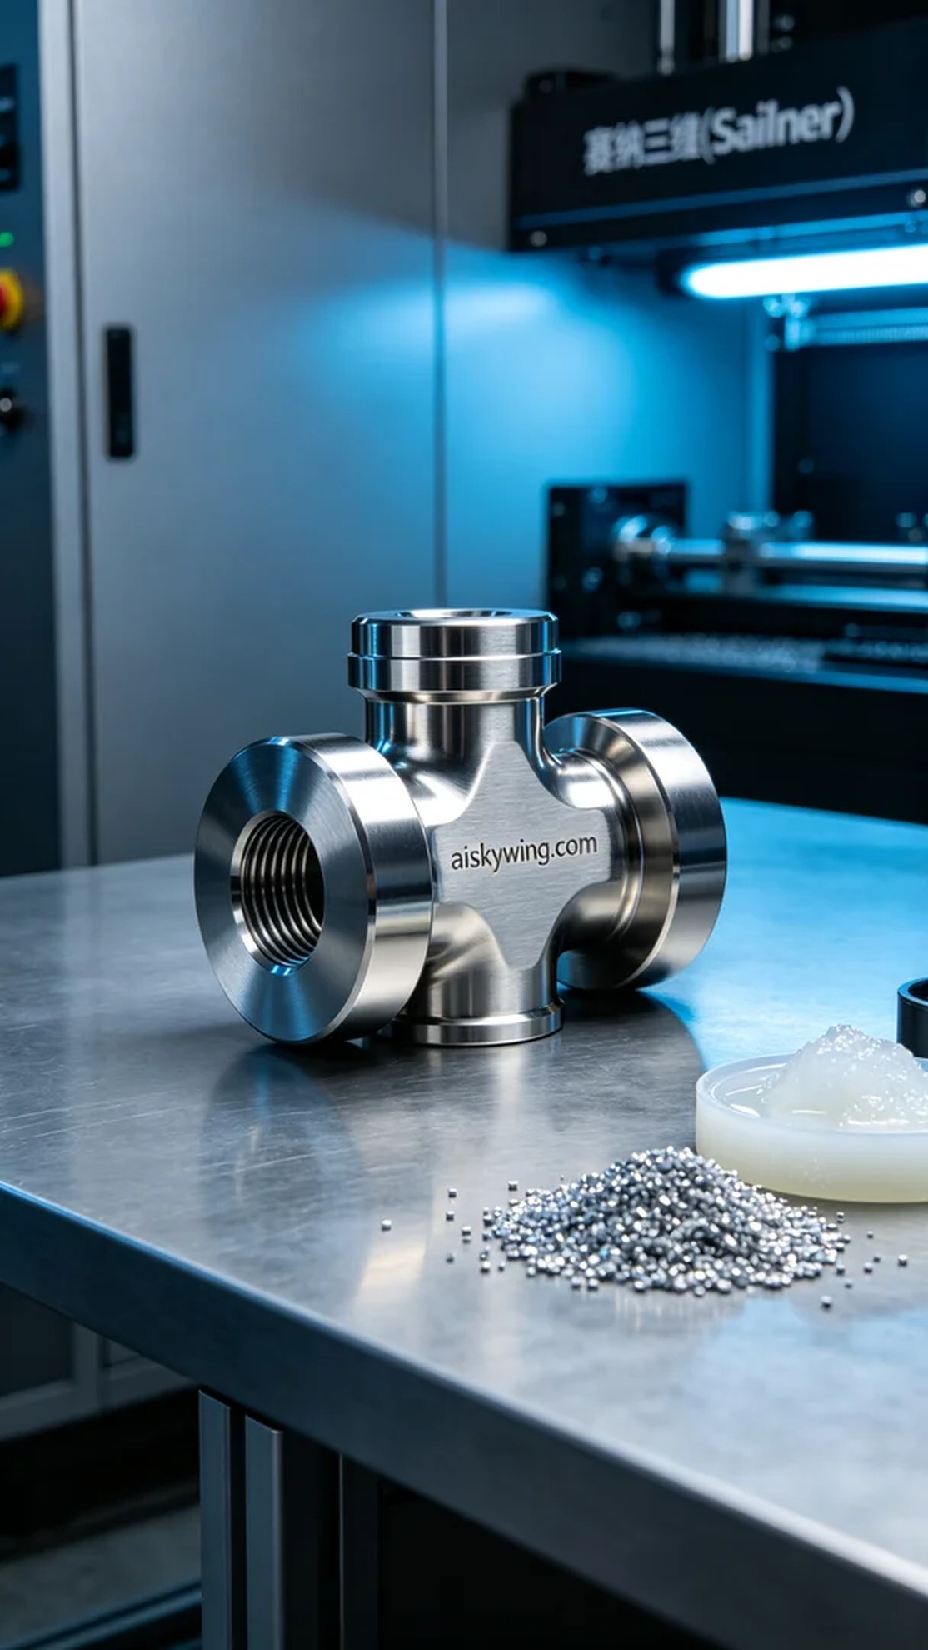
在某个冷色调的工业氛围中，有人找到我们，想要一款精确度极高的传动轴十字节。这个产品不仅是机械传动的重要部件，更是工业设计美学的体现。他们的要求很明确，既要美观又要耐用，正如生活中的每一个挑战，总要找到解决的办法。
我们选用了未成型的液态光敏材料，适合SLM金属打印工艺，具有出色的流动性和高强度。设备方面，我们使用Stratasys打印机，设置了层厚为0.1毫米，打印温度保持在200摄氏度，功率调至80%，打印速度为30mm/s，整个打印过程预计需要六个小时，确保每一个细节都能准确呈现。
打印过程中，Stratasys设备高效运作，整个过程顺畅无阻。我们对温度和打印速度进行了实时监控，确保材料在最佳状态下固化。每一个细节都在我们的监控之下，确保没有任何瑕疵，质量是我们始终追求的目标。
完成打印后，我们进行了精细的后处理。首先，将成品进行清洗，以去除表面的未固化树脂，接着进行了打磨，确保表面光滑无瑕。然后，将其放入固化机中，进行进一步固化，以达到最佳的强度和耐久性。最后，进行了严格的检验，确保每一个传动轴十字节都符合标准。
通过这次生产，我们不仅交付了高质量的产品，也在过程中提升了我们的技术能力，确保以后的每一次挑战都能迎刃而解。每一个细节都承载着我们的努力与执着。
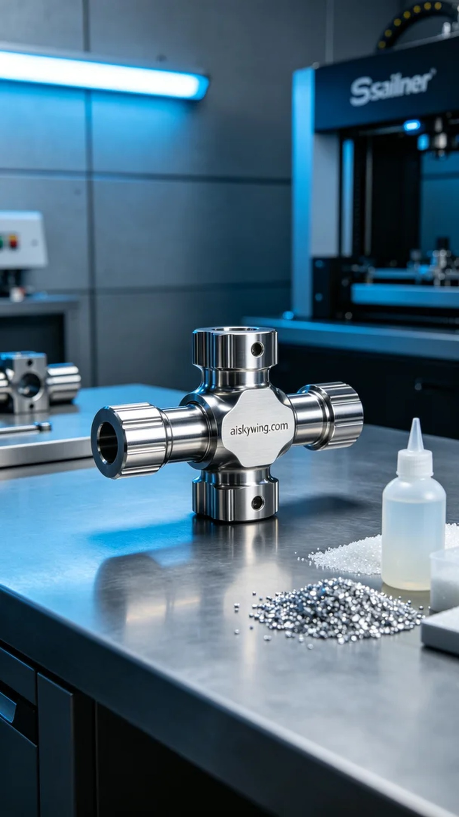
Aiskywing Industrial 3D Printing
Drive shaft cross.


