0588-减震器上座3D打印生产记录
Shock absorber upper mount
🖨️ SLM金属打印
🖥️ 打印机: Stratasys
📦 材料: 摆放着未成型的液态光敏
生活再难，也别停下脚步。就像接下这个减震器上座的单子，很多人都想拥有更稳固的支持和舒适的体验。
No matter how difficult life gets, don't stop moving forward. Just like taking on this order for a shock absorber mount, many people desire more stable support and a comfortable experience.
________________________________________________________________________________
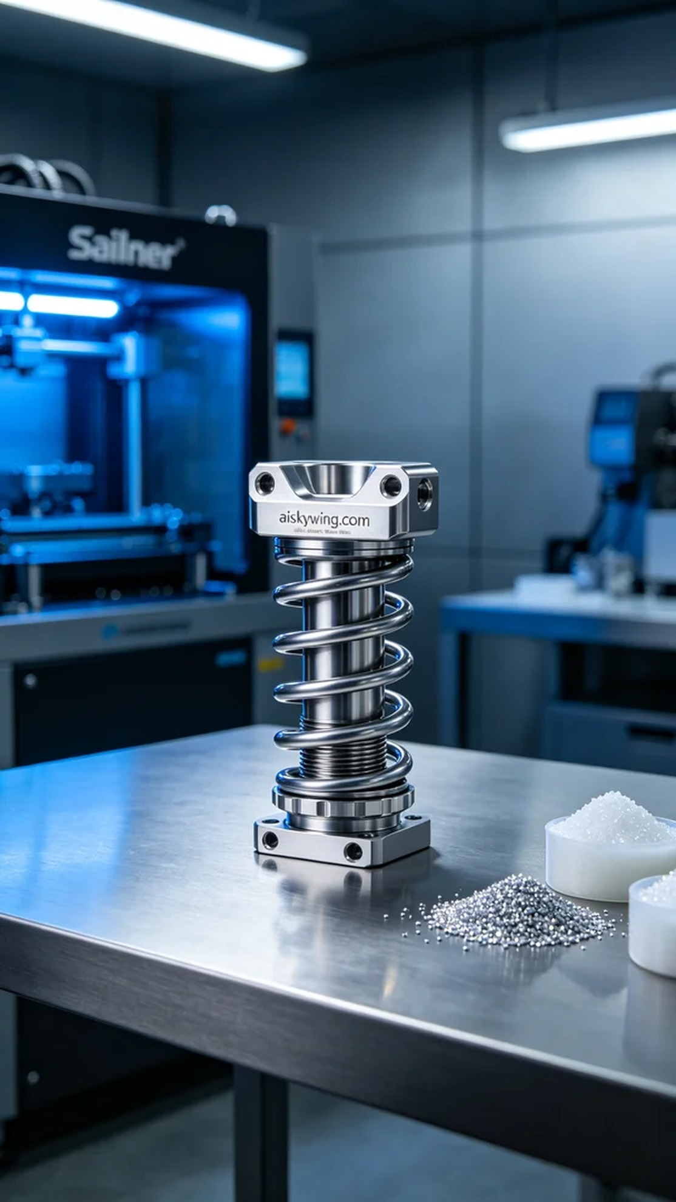
Life can be tough, but we must keep moving forward. Just like taking on the order for the shock absorber mount, many people are looking for more solid support and a comfortable experience.
On Instagram, someone reached out to us seeking to customize a shock absorber mount to improve their vehicle's performance. The main demand for this product was to enhance the damping effect and driving experience, so we took this order very seriously.
We chose unformed liquid photo-curable resin as the raw material, ensuring that the printed shock absorber mount would achieve excellent strength and precision. During the preparation phase, we utilized a Stratasys printer, setting a layer thickness of 0.1mm, a temperature of 60 degrees Celsius, power at 80%, and a printing speed of 40mm/s to ensure every layer formed accurately.
Throughout the printing process, the machine operated steadily while the monitoring system tracked the print status in real-time. We regularly checked the material supply and the nozzle's condition to ensure no impurities affected the quality of the finished product. The details of the shock absorber mount were impressive, exhibiting a smooth surface and metallic feel.
Once printing was complete, we immediately carried out post-processing. First, we cleaned the piece using an ultrasonic cleaner to remove any residual liquid photo-curable resin. Next, we sanded it down to ensure a smooth surface and completed the curing process to optimize its physical properties. Finally, we conducted a thorough quality inspection to ensure the product met design standards without any flaws.
After all these processes, we successfully completed the 3D printing of the shock absorber mount. The final product not only looked exquisite but also delivered on its functional promises, which is incredibly rewarding.
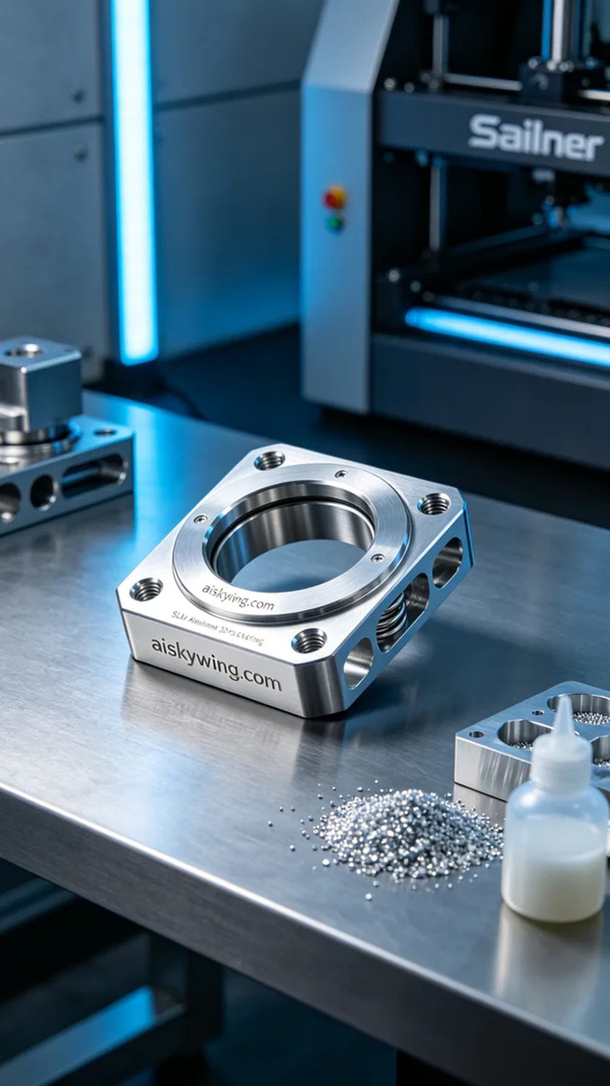
在Instagram上，有人因为要改进他们的车辆性能而找上我们，希望能定制一款减震器上座。这个产品的需求主要是为了提升整车的减震效果和驾驶体验，因此我们非常认真地对待这个订单。
我们选择了未成型的液态光敏树脂作为原材料，确保打印出的减震器上座能够达到优良的强度和精度。在准备阶段，我们使用 Stratasys 打印机，设置了层厚0.1mm，温度为60摄氏度，功率调整至80%，打印速度保持在40mm/s，以确保每一层都能精准成型。
打印过程中，设备运行稳定，监控系统实时跟踪打印状态。我们在打印期间定期检查材料供给和喷嘴的状态，确保没有任何杂质影响成品质量。在整个打印过程里，减震器上座的细节表现非常出色，表面光滑且金属感十足。
打印完成后，我们立即进行了后处理。首先是清洗，使用超声波清洗机去除残留的液态光敏树脂，随后进行打磨，以确保表面光滑，然后完成固化处理，使其物理特性达到最佳。最后，我们进行了全面的质量检验，确保产品符合设计标准，且没有瑕疵。
这一系列工序下来，我们成功地完成了减震器上座的3D打印制作，最终的成品不仅外观精美，功能也得到了落实，真是让人倍感欣慰。
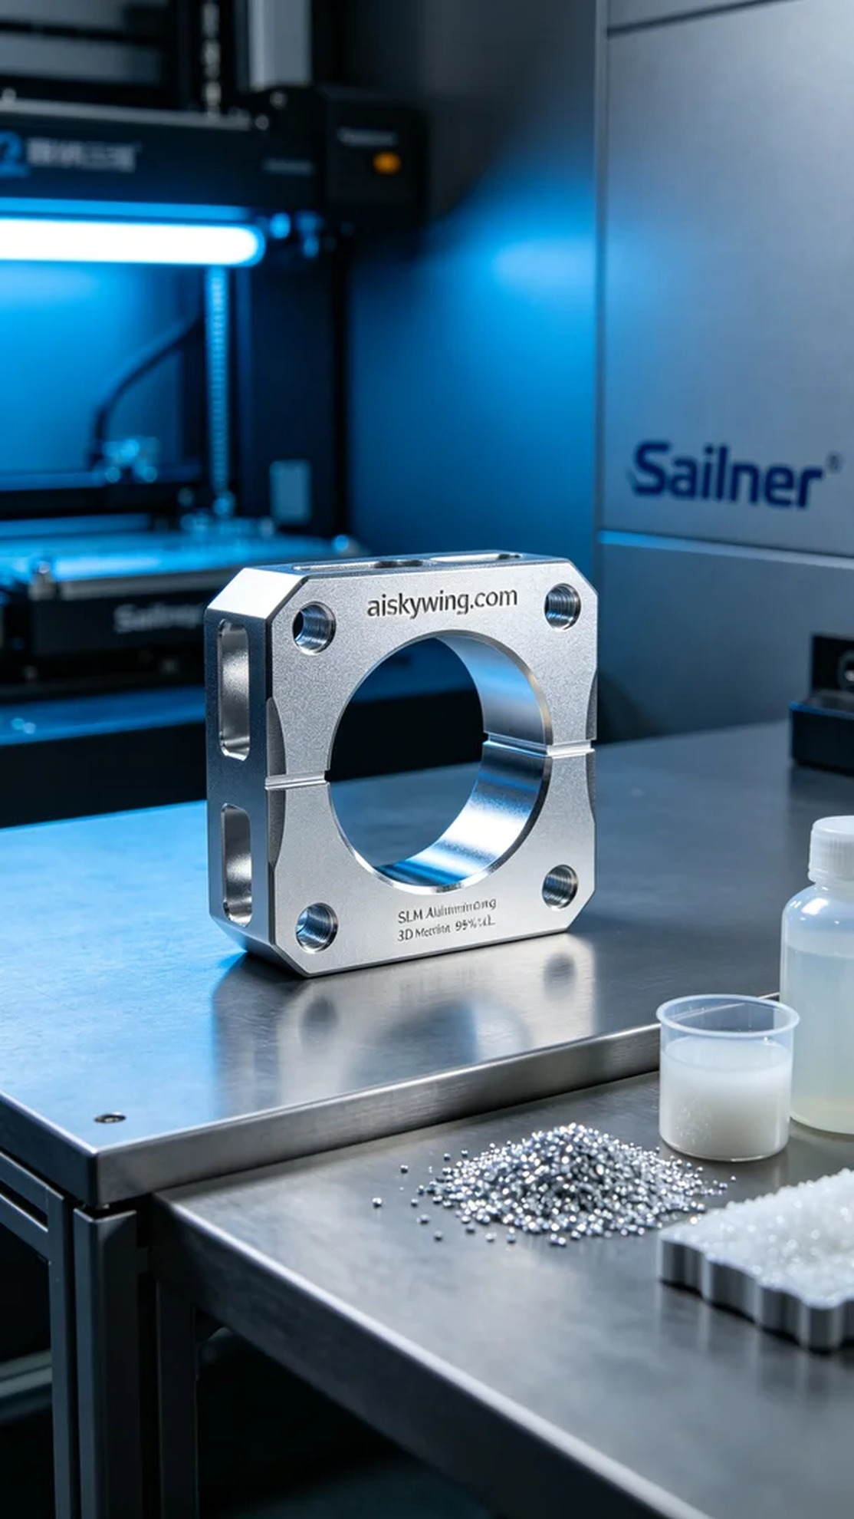
Aiskywing Industrial 3D Printing
Shock absorber upper mount


