0589-减震器下座3D打印生产记录
Shock absorber lower seat
🖨️ SLM金属打印
🖥️ 打印机: Voxeljet
📦 材料: 摆放着未成型的液态光敏
生活的每一步都在考验我们的决心。就像这次有人找到我们，希望我们为他制作一个减震器下座，面对挑战，我们奋勇前行。
Every step in life tests our determination. Just like this time when someone approached us, hoping we could create a shock absorber lower mount for him. Faced with the challenge, we bravely moved forward.
________________________________________________________________________________
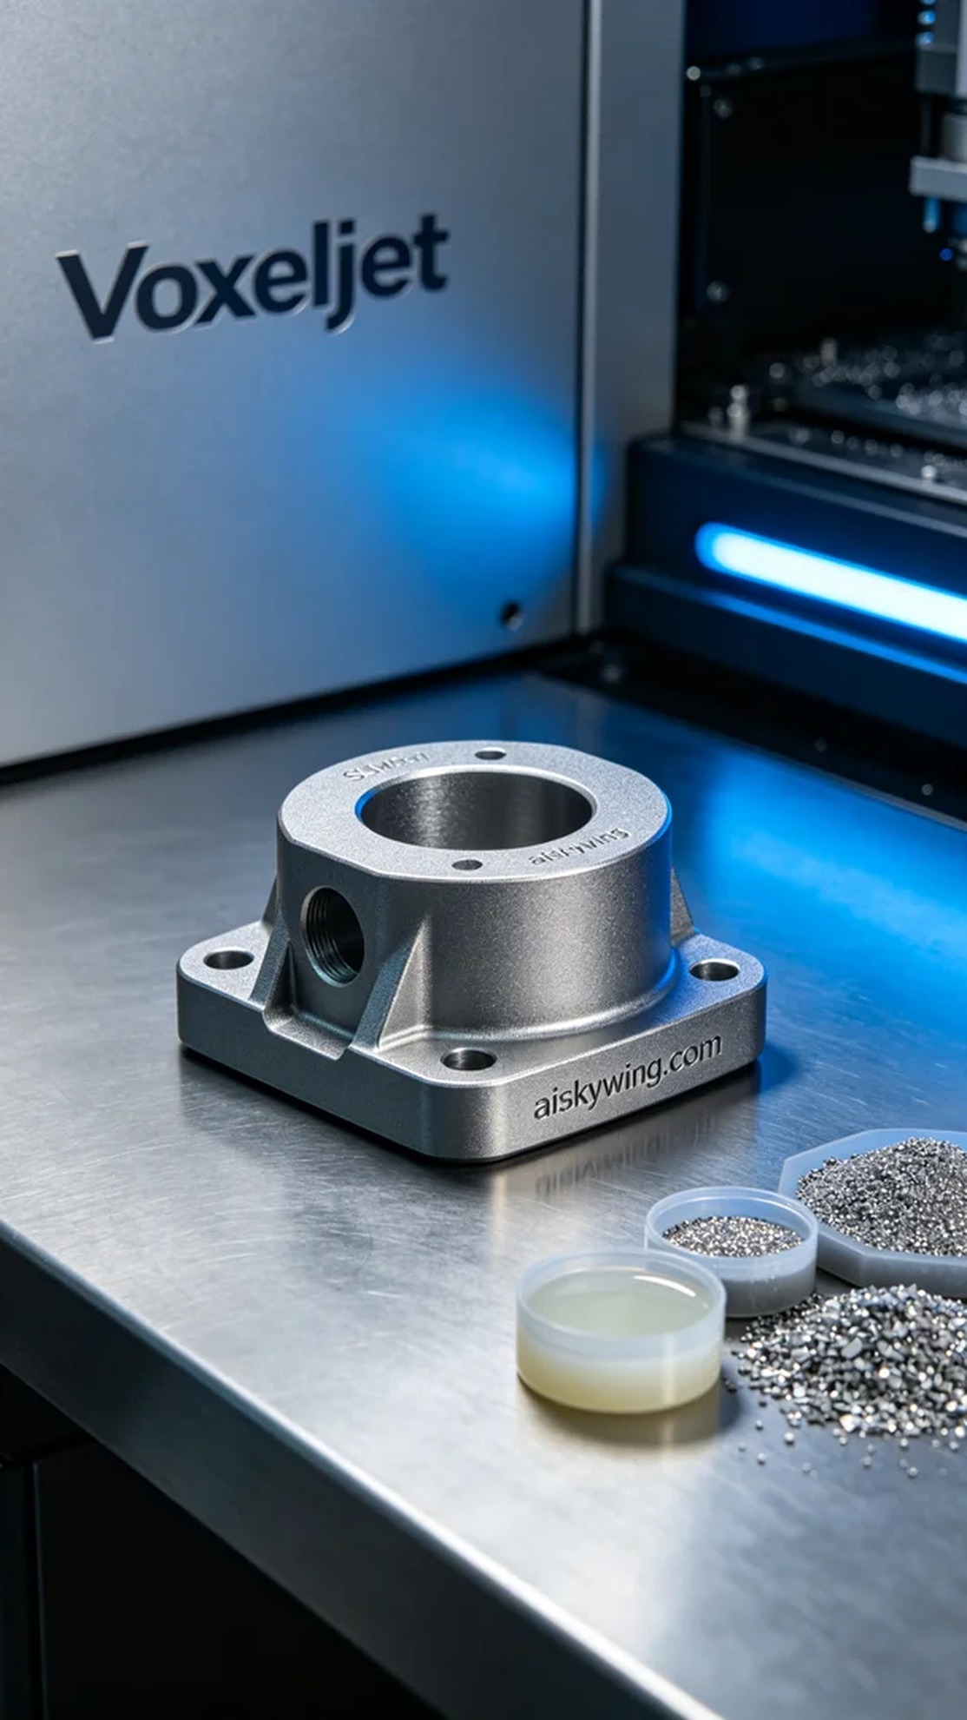
Every step in life tests our determination. Just like this time when someone approached us, hoping we could create a shock absorber base for him. Facing challenges, we move forward bravely.
For this task, we chose unformed liquid photoresin as the primary raw material due to its excellent forming properties and adaptability. Meanwhile, we prepared the Voxeljet printer, meticulously adjusting the printing parameters: layer thickness set to 0.1 mm, temperature controlled at 200 degrees Celsius, power set at 300 watts, and a printing speed of 60 mm per hour. With all preparations in place, we eagerly started the printing process.
Once the printing process began, the Voxeljet printer operated like a skilled craftsman, building the shock absorber base layer by layer. The machine ran smoothly, and we kept a close eye on the printing quality, ensuring that everything was flawless. Each precise layer added was a test of material and technology.
After printing, we moved to the post-processing stage. First, we cleaned the finished product to remove any excess resin residue. Next, we polished it to enhance surface smoothness and improve the overall visual appeal. Finally, the curing process was essential to ensure the strength and durability of the shock absorber base. After completing these procedures, we conducted a final inspection to ensure every detail met our expected standards.
After all these efforts, the production of the shock absorber base came to a perfect conclusion. Each step continuously improved our technical level, and the product was delivered on schedule, leaving us with a satisfying result.
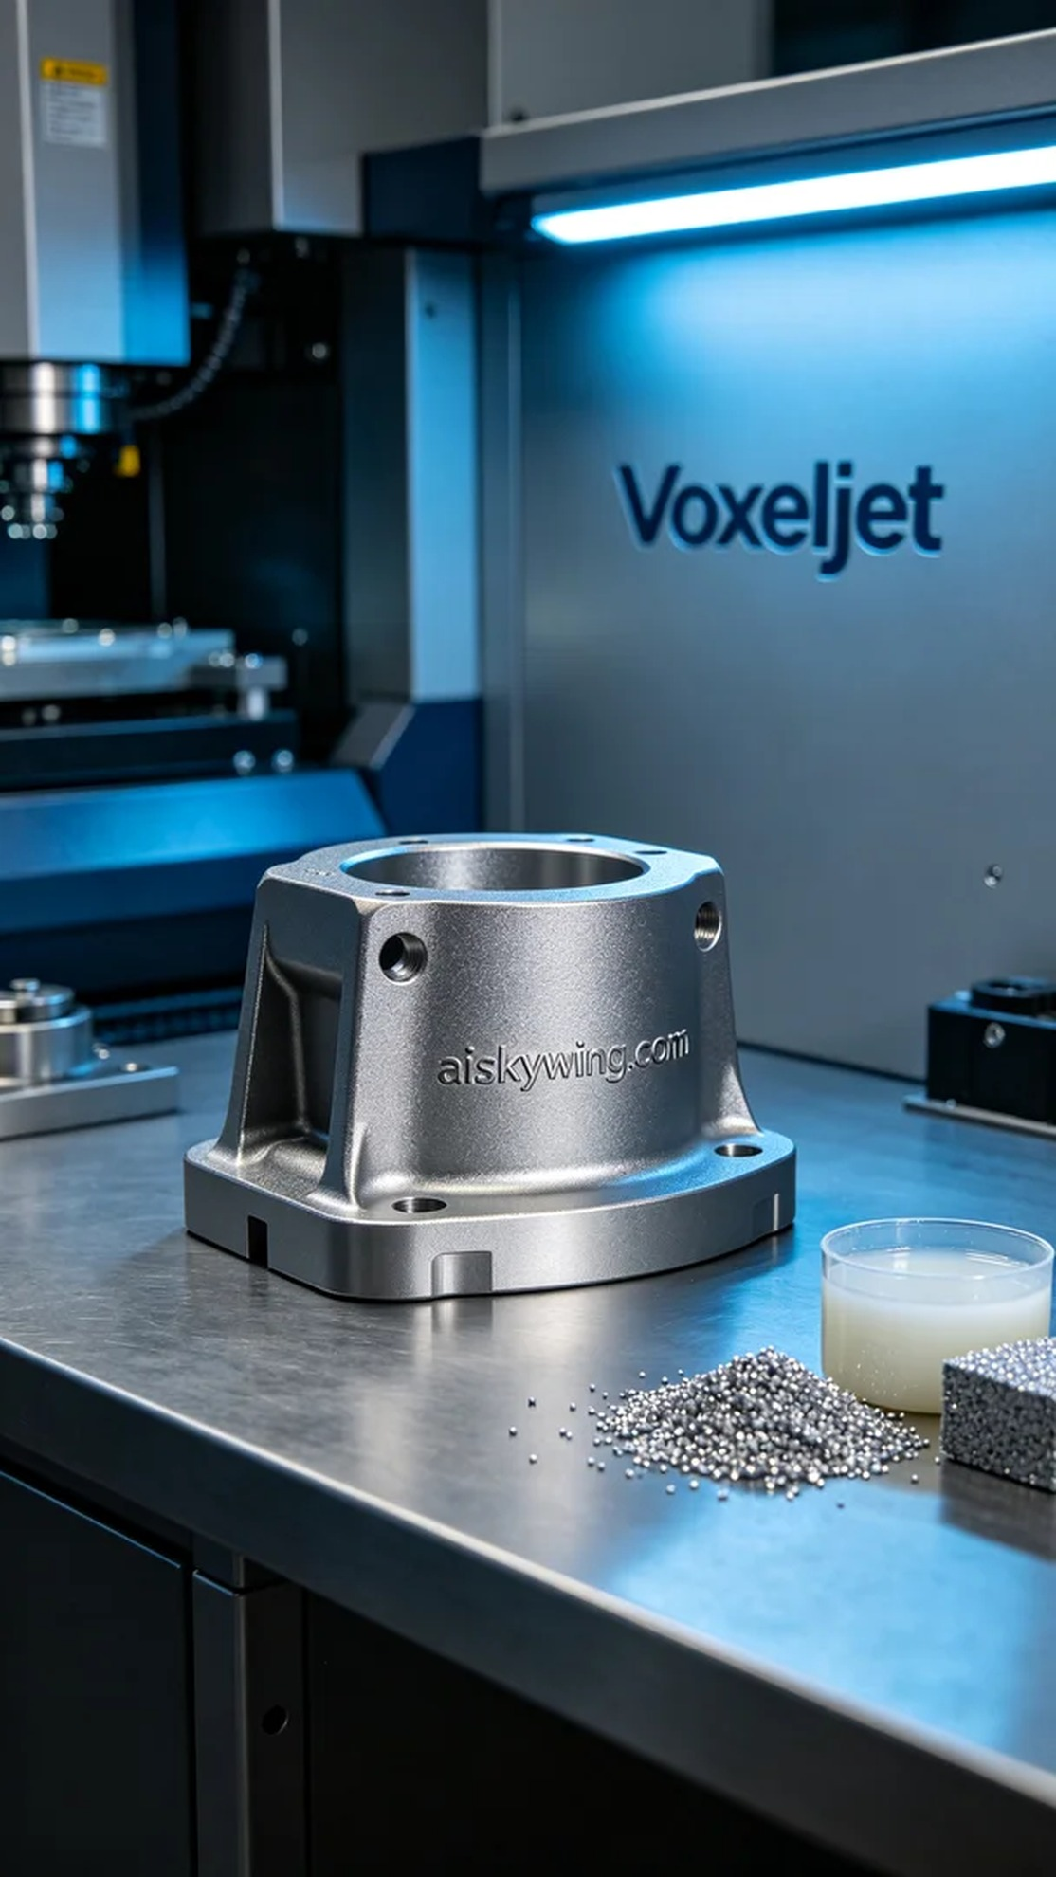
有一个人在Twitter上发声，寻找解决方案，他的减震器下座需要更强的耐用性和轻量化设计。我们的任务就是用SLM金属打印技术，帮助他实现这个要求，为他提供一个完美的3D打印产品。
为此，我们选择了未成型的液态光敏树脂作为主要原材料，因其优良的成型性能和适应性。同时，我们准备好Voxeljet打印机，将打印参数细致调整：层厚设定为0.1毫米，温度控制在200摄氏度，功率设置为300瓦，打印速度则定为每小时60毫米。经过这些准备，我们迫不及待地开始了打印过程。
打印过程一旦启动，Voxeljet打印机便开始如同一位熟练的工匠，逐层构建减震器下座。设备运行稳定，整个过程中我们始终保持关注，随时监控打印质量，确保没有任何问题。每一层的精准堆叠，都是对材料和技术的考验。
打印完成后，我们进入了后处理阶段。首先，我们对成品进行清洗，去除多余的树脂残留。接着，进行打磨，以提升表面的平滑度，并确保产品的整体视觉效果。最后，固化工序必不可少，这样能保证减震器下座的强度和耐用性。完成这些工序后，我们进行了最终检验，确保每一个细节都达到预期标准。
经过这些努力，减震器下座的生产完美落幕。每一个环节都在不断提升着我们的技术水平，产品也如期交付，令人满意的结果让我们倍感欣慰。
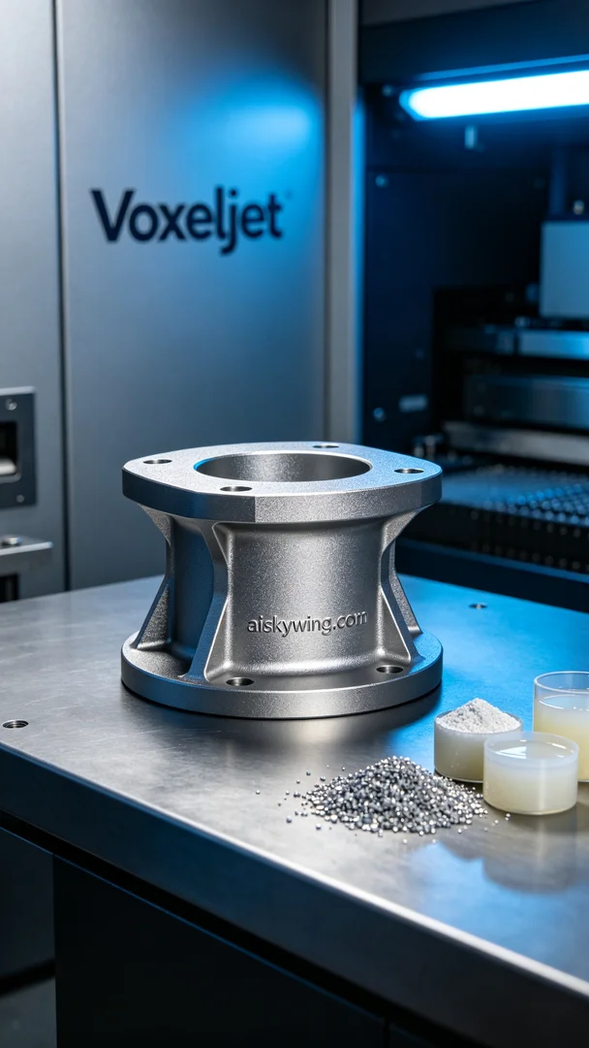
Aiskywing Industrial 3D Printing
Shock absorber lower seat


