0590-3D打印凸轮轴盖的生产记录
Camshaft cover
🖨️ SLM金属打印
🖥️ 打印机: Voxeljet
📦 材料: 摆放着未成型的液态光敏
生活中总会遇到种种困难，正如有人因凸轮轴盖而烦恼，然而挑战往往也是前进的动力。
In life, we will always encounter various difficulties, just as some people are troubled by the camshaft cover. However, challenges often serve as the driving force for progress.
________________________________________________________________________________
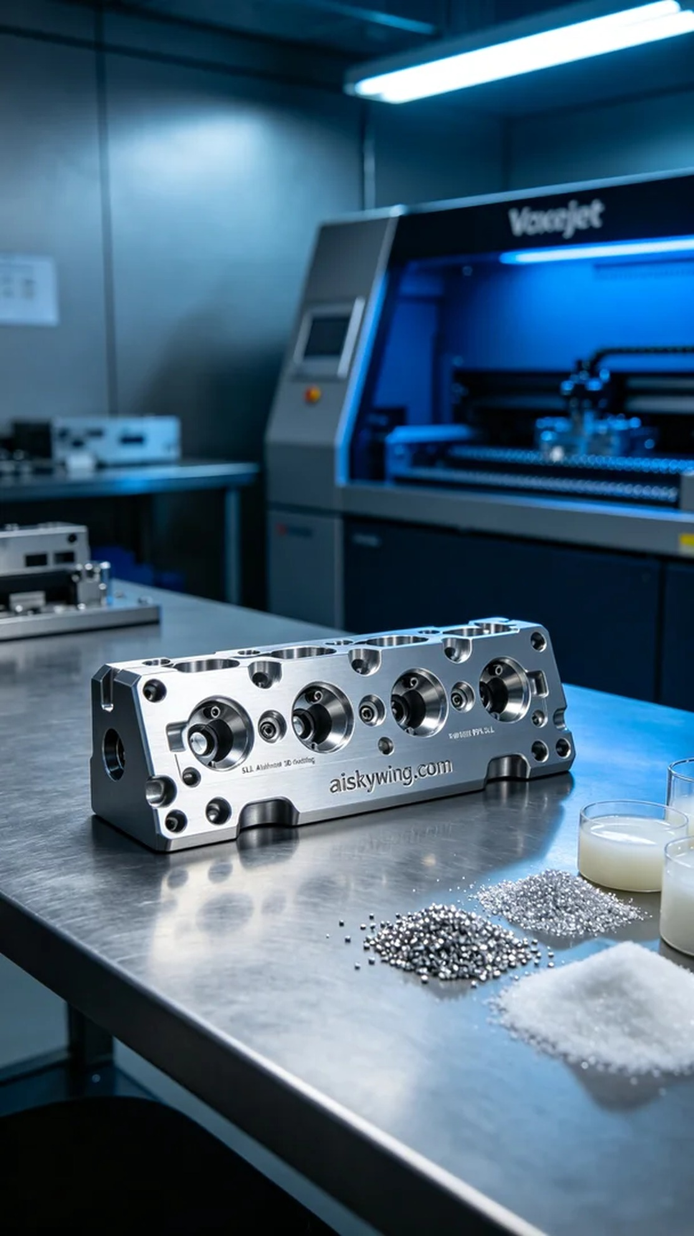
On YouTube, someone reached out to us because they needed a camshaft cover. Their challenge was to achieve high precision and density in metal parts, especially in aluminum alloy. This demand prompted us to embark on a new printing journey.
For this project, we chose unformed liquid photopolymer resin as our raw material, believing it would provide a solid foundation for printing. We utilized a Voxeljet 3D printer, which we configured with a layer thickness of 0.1 mm, a printing temperature of 50°C, a power setting of 200 watts, and a print speed controlled at 80 mm per hour, anticipating the entire printing process to last around 4 hours.
During the printing process, the Voxeljet machine operated like a precision instrument, running smoothly. We closely monitored the quality after each layer was printed to ensure that the output matched the design specifications. The machine's hum was a reassuring sound, echoing our dedication, as we all looked forward to the high-quality end product.
After printing, the post-processing steps were equally crucial. We started with cleaning, using a specialized solution to remove surface residues; followed by sanding to ensure a smooth and delicate finish to the camshaft cover; the curing stage was essential for ensuring material strength and stability. Finally, we conducted rigorous inspections to ensure that every detail met our standards.
In the end, we successfully completed the production of this camshaft cover, proving that our efforts were worthwhile. Each print is an opportunity for growth, and we look forward to every challenge ahead.
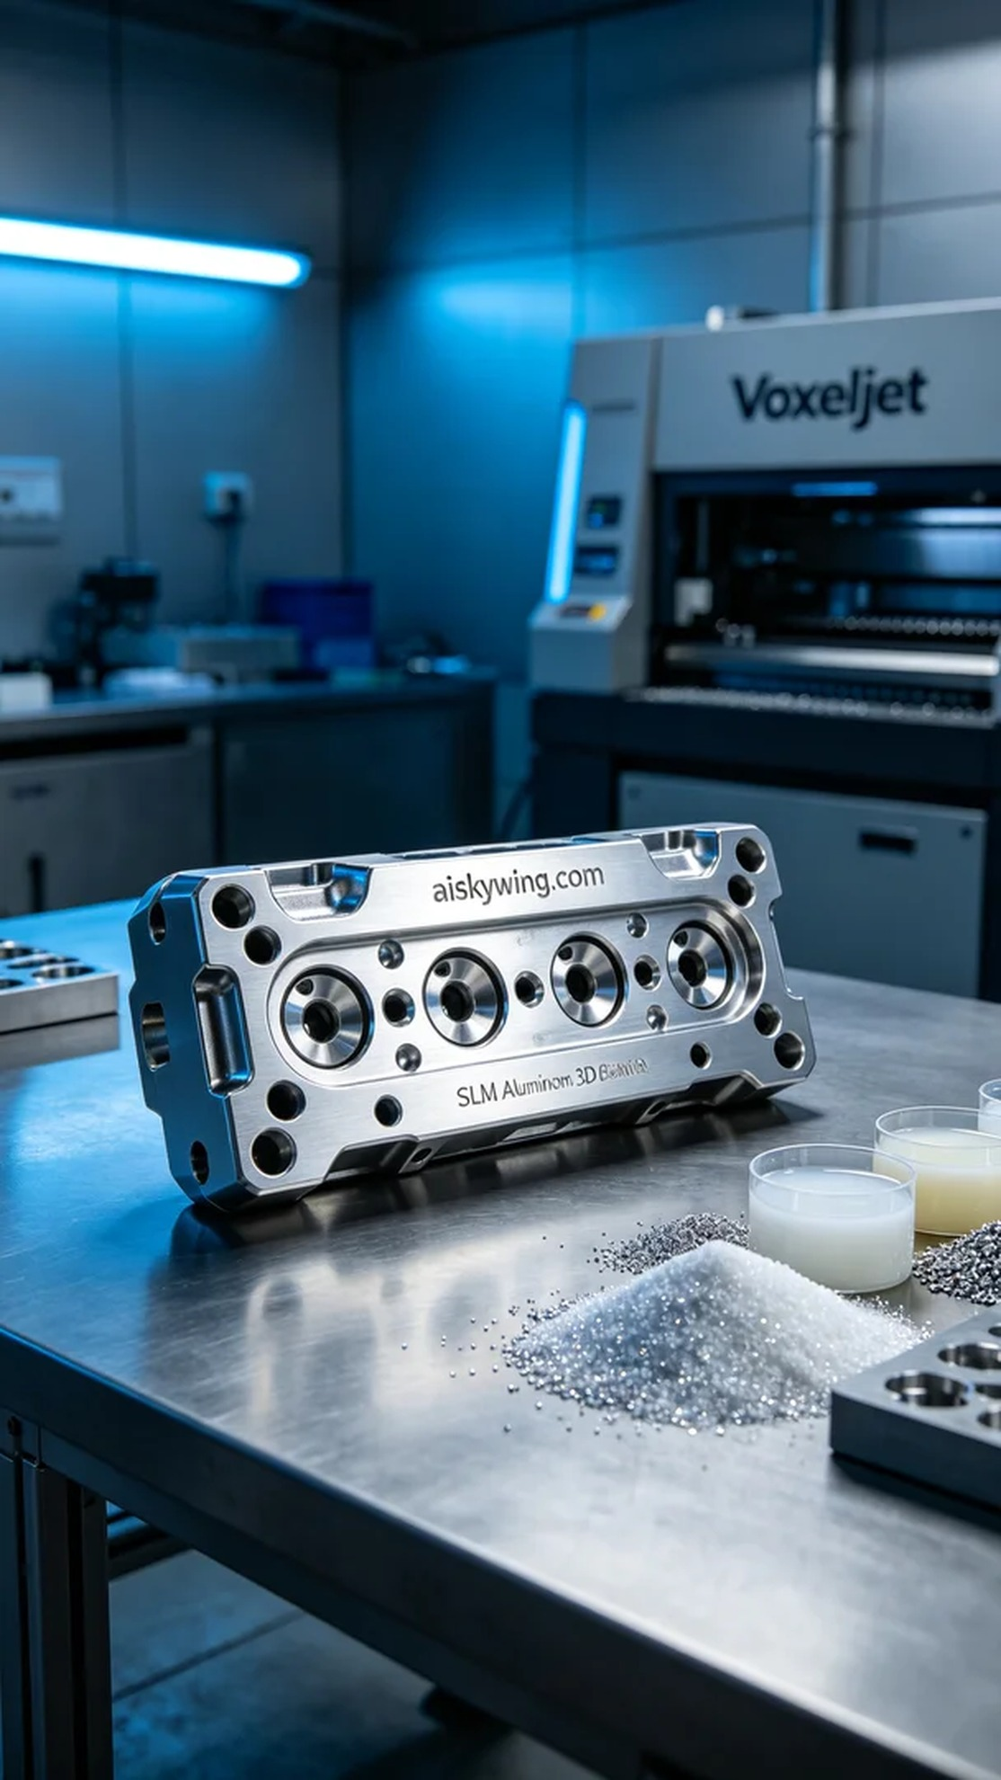
YouTube上，有人因为需要一个凸轮轴盖而找到我们。他们面临的问题是如何实现高精度和高密度的金属零件，特别是在铝合金材料上。这样的需求促使我们开始了一段新的打印旅程。
这次的原材料选择了未成型的液态光敏树脂，我们相信这种材料能够为打印提供良好的基础。设备方面，我们使用了Voxeljet的3D打印机，经过一番调试，设置了层厚为0.1毫米，打印温度保持在50°C，功率设定为200瓦，打印速度则控制在每小时80毫米，预计整个打印过程将持续4小时。
在打印过程中，Voxeljet的机器如同一台精密的乐器，运行得相当顺畅。我们在每层打印完成后都仔细监测质量，确保打印的效果与设计图纸一致。机器运行的声音仿佛是对我们努力的回应，大家都在期待着高质量的成品。
打印完成后，后处理工序同样重要。首先是清洗，使用专业的清洗液去除表面残留物；接着是打磨，确保凸轮轴盖的表面光滑细腻；固化环节则是必不可少的，确保材料的强度和稳定性。最后，我们经过严格的检验，确保每一个细节都符合要求。
最终，我们顺利完成了这个凸轮轴盖的生产，结果证明了我们的努力是值得的。每一次打印都是一次成长的机会，期待未来的每一个挑战。
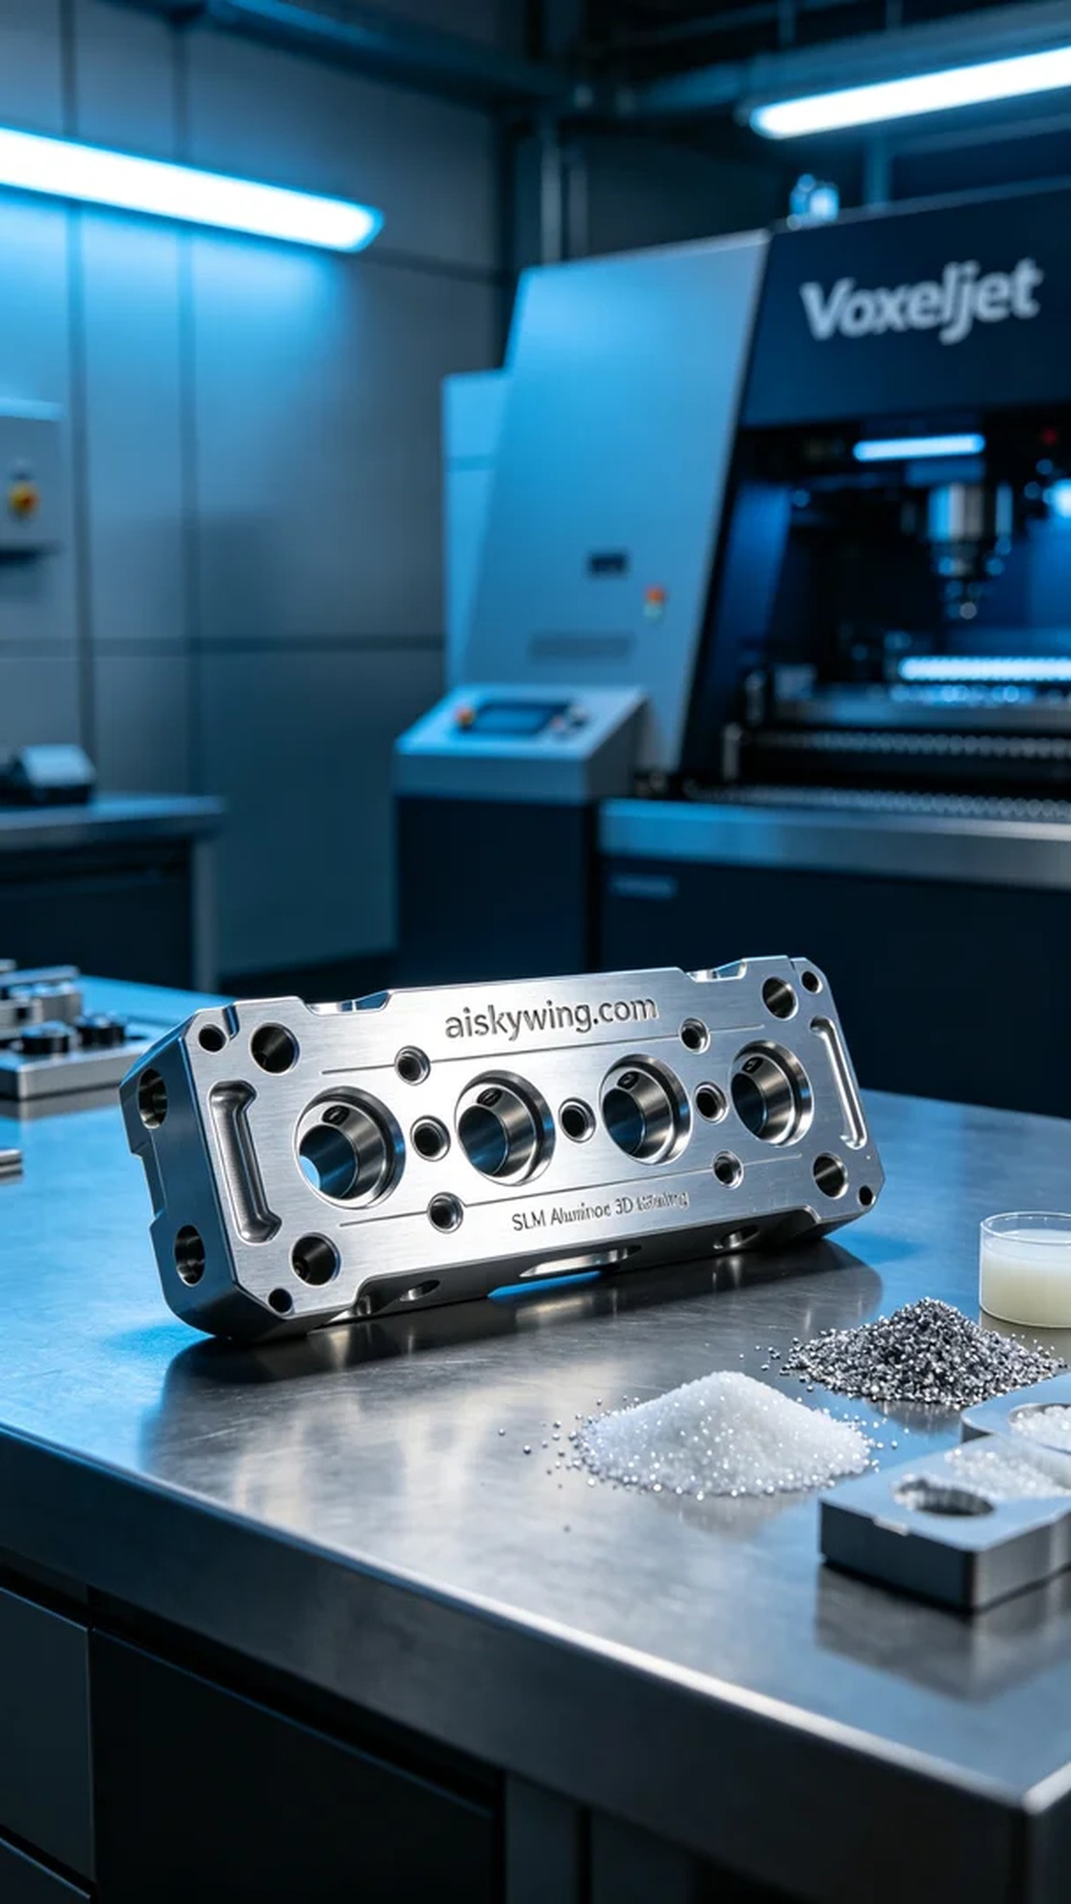
Aiskywing Industrial 3D Printing
Camshaft cover


