0591-分动器外壳的3D打印生产记录
Transfer case housing
🖨️ SLM金属打印
🖥️ 打印机: Rize
📦 材料: 摆放着未成型的液态光敏
在TikTok上，有人因为对分动器外壳的要求而找上我们。这不只是一份工作，更是一种对品质的追求。
On TikTok, someone reached out to us due to their requirements for a splitter shell. This is not just a job; it is a pursuit of quality.
________________________________________________________________________________
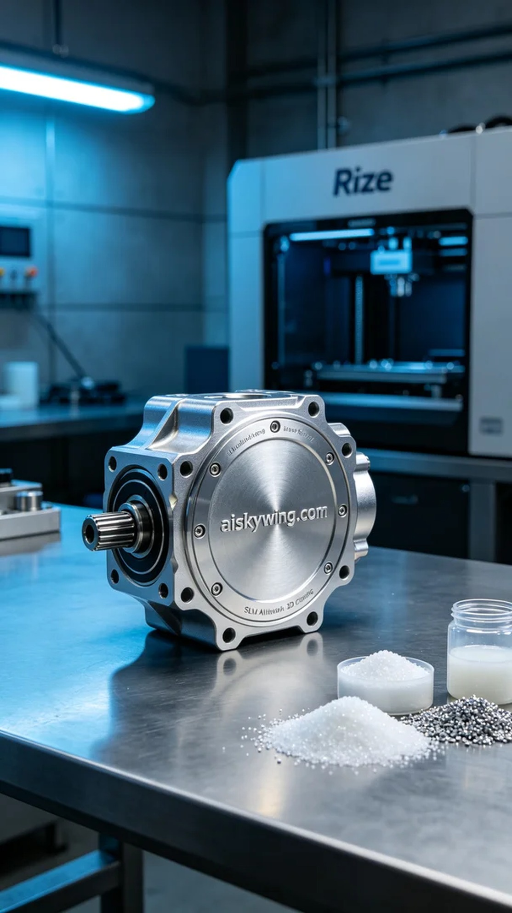
On TikTok, someone reached out to us due to their specific requirements for a transfer case shell. This is not just a job; it's a pursuit of quality.
The production process began with the preparation of unformed liquid photopolymer resin. This liquid resin is ideal for printing the transfer case shell due to its excellent fluidity and forming properties. After careful inspection, we ensured the raw materials were clean and free of impurities. We then adjusted the settings on the Rize 3D printer, selecting a layer thickness of 0.1mm, a temperature set at 25°C, and corresponding power and speed adjustments to guarantee the precision and quality of the final print.
As the printing process commenced, the Rize machine operated steadily, with the print head precisely moving across the platform, building up the shape of the transfer case shell layer by layer. The entire process lasted approximately six hours, during which we closely monitored the print quality to ensure each layer adhered perfectly, avoiding any bubbles or defects. In the cool-toned industrial atmosphere, each movement of the machine felt exceptionally organized.
After printing was complete, we moved to the post-processing stage. First, we removed the formed transfer case shell and cleaned it to remove any uncured resin from the surface. Next, we sanded the shell with fine sandpaper, enhancing its smoothness and metallic sheen. Then, we placed the sanded part into a curing device to ensure it fully cured, achieving the desired strength and durability. Finally, we conducted thorough quality inspections to ensure every detail met our standards.
In the end, through a series of meticulous operations, we successfully delivered a high-quality transfer case shell. This was not only a technical achievement but also a recognition and pride in our craftsmanship. Every detail embodied our dedication.
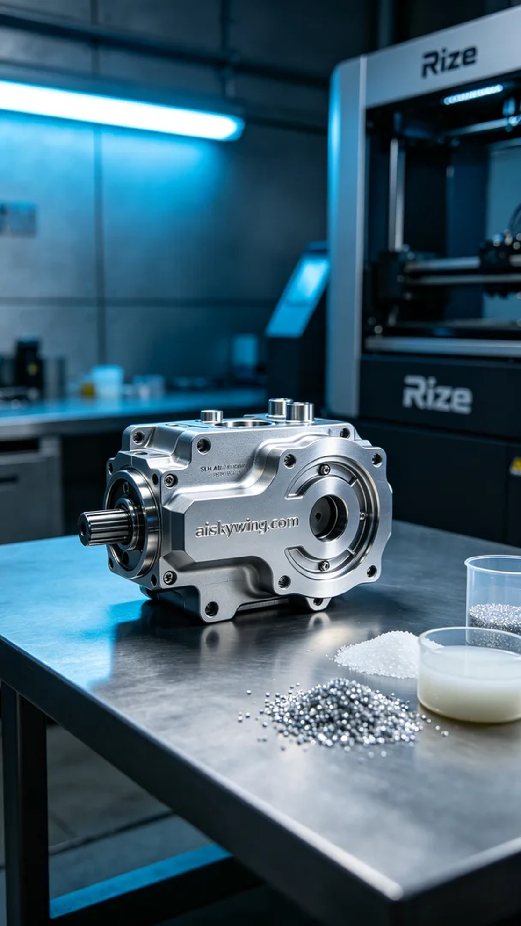
使用摆放着未成型的液态光敏材料，我们的生产过程开始了。液态光敏树脂因其出色的流动性和成型性能，成为打印分动器外壳的理想选择。经过仔细检查后，我们将原材料准备好，确保没有杂质。接着，我们调整了Rize 3D打印机的设置，选择了0.1mm的层厚，温度设定在25°C，功率与速度也进行了相应的调整，以保证最终打印的精度和质量。
打印流程开始时，Rize机器稳稳地运转，打印头在平台上精准移动，逐层构建出分动器外壳的形状。整个过程大约持续了六个小时，期间我们密切监控打印质量，确保每一层都能完美附着，避免出现任何气泡或缺陷。在冷色调的工业氛围中，机器的每一次运作都显得格外有序。
打印完成后，我们进入了后处理阶段。首先，我们将成型的分动器外壳取下，进行清洗，去除表面的未固化树脂。接着，用细砂纸对外壳进行打磨，使其表面更加光滑，金属光泽愈加明显。然后，我们将打磨后的零件放入固化装置中，确保其完全固化，达到理想的强度和耐用性。最后，我们进行了严格的质检，确保每一个细节都符合标准。
最终，经过一系列精细操作，我们成功交付了高质量的分动器外壳。这不仅是一次技术上的成就，更是对我们工艺的认可与自豪。每个细节都凝聚着我们的心血。
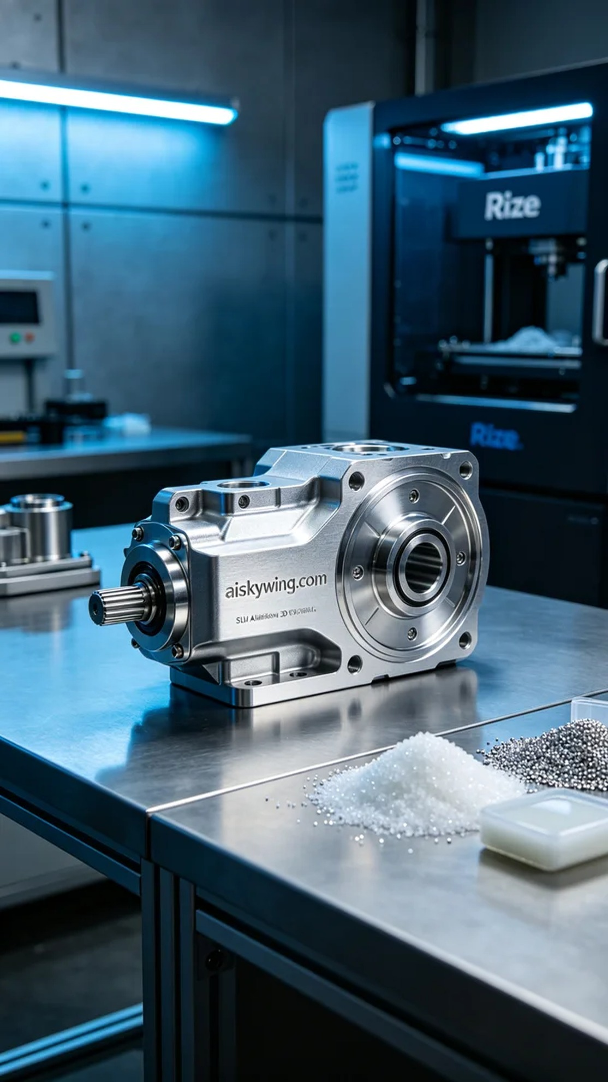
Aiskywing Industrial 3D Printing
Transfer case housing


