0594-传送带导向块的生产记录
Conveyor Belt Guide Block
🖨️ SLS尼龙烧结
🖥️ 打印机: Stratasys
📦 材料: SLS耐高温尼龙
生活就像一场3D打印，有时需要耐心和细致。就像今天，我们接到关于传送带导向块的工作，准备迎接挑战。
Life is like a 3D print; sometimes it requires patience and attention to detail. Just like today, we received a task regarding the conveyor belt guide block, ready to take on the challenge.
________________________________________________________________________________
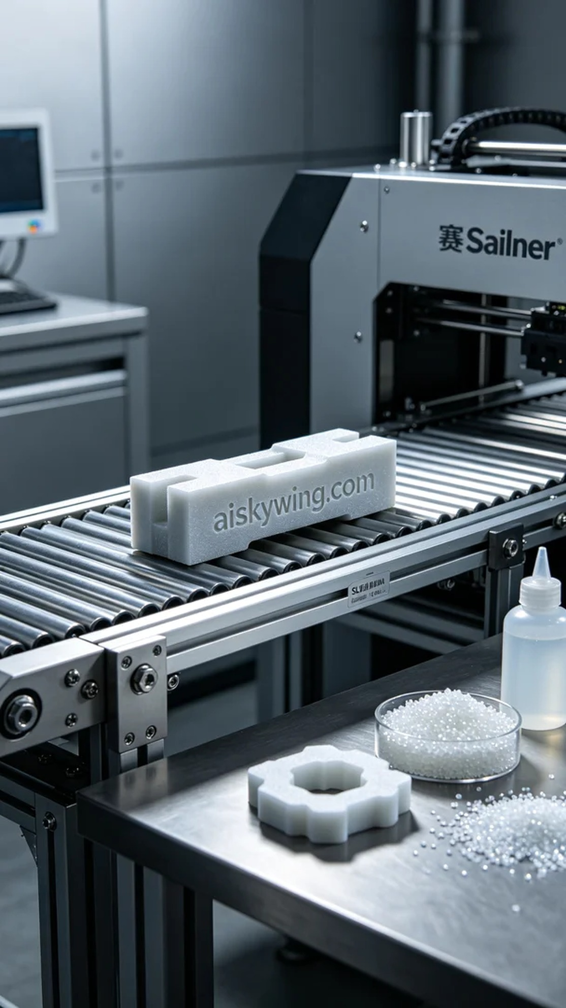
Life is like a 3D print; it often requires patience and attention to detail. Today, we received a request on Instagram for a customized conveyor guide block, and we're ready to embrace the challenge.
In the preparation phase, we selected the Stratasys 3D printer as our main device. Based on the material properties, we set the layer thickness to 0.1mm, printing temperature at 190℃, power at 85%, and speed at 50mm/s, ensuring that every detail is precisely reproduced.
During the printing process, the machine operated smoothly, showcasing the efficiency and precision of the SLS process. By consistently monitoring the print quality, we ensured that throughout every sintering layer, the material maintained consistency in temperature and density, resulting in a sturdy and heat-resistant conveyor guide block.
In the post-processing stage, we thoroughly cleaned the printed parts using specialized cleaning solutions to remove any powder residues, followed by meticulous sanding to achieve a smooth finish. Finally, they were placed in a curing machine to ensure the strength met the expected standards, and after final inspection, we confirmed that every detail was flawless.
Through this production process, we successfully delivered a high-quality conveyor guide block that satisfied the client's needs while showcasing the superior performance of SLS nylon material. Each challenge pushes us further.
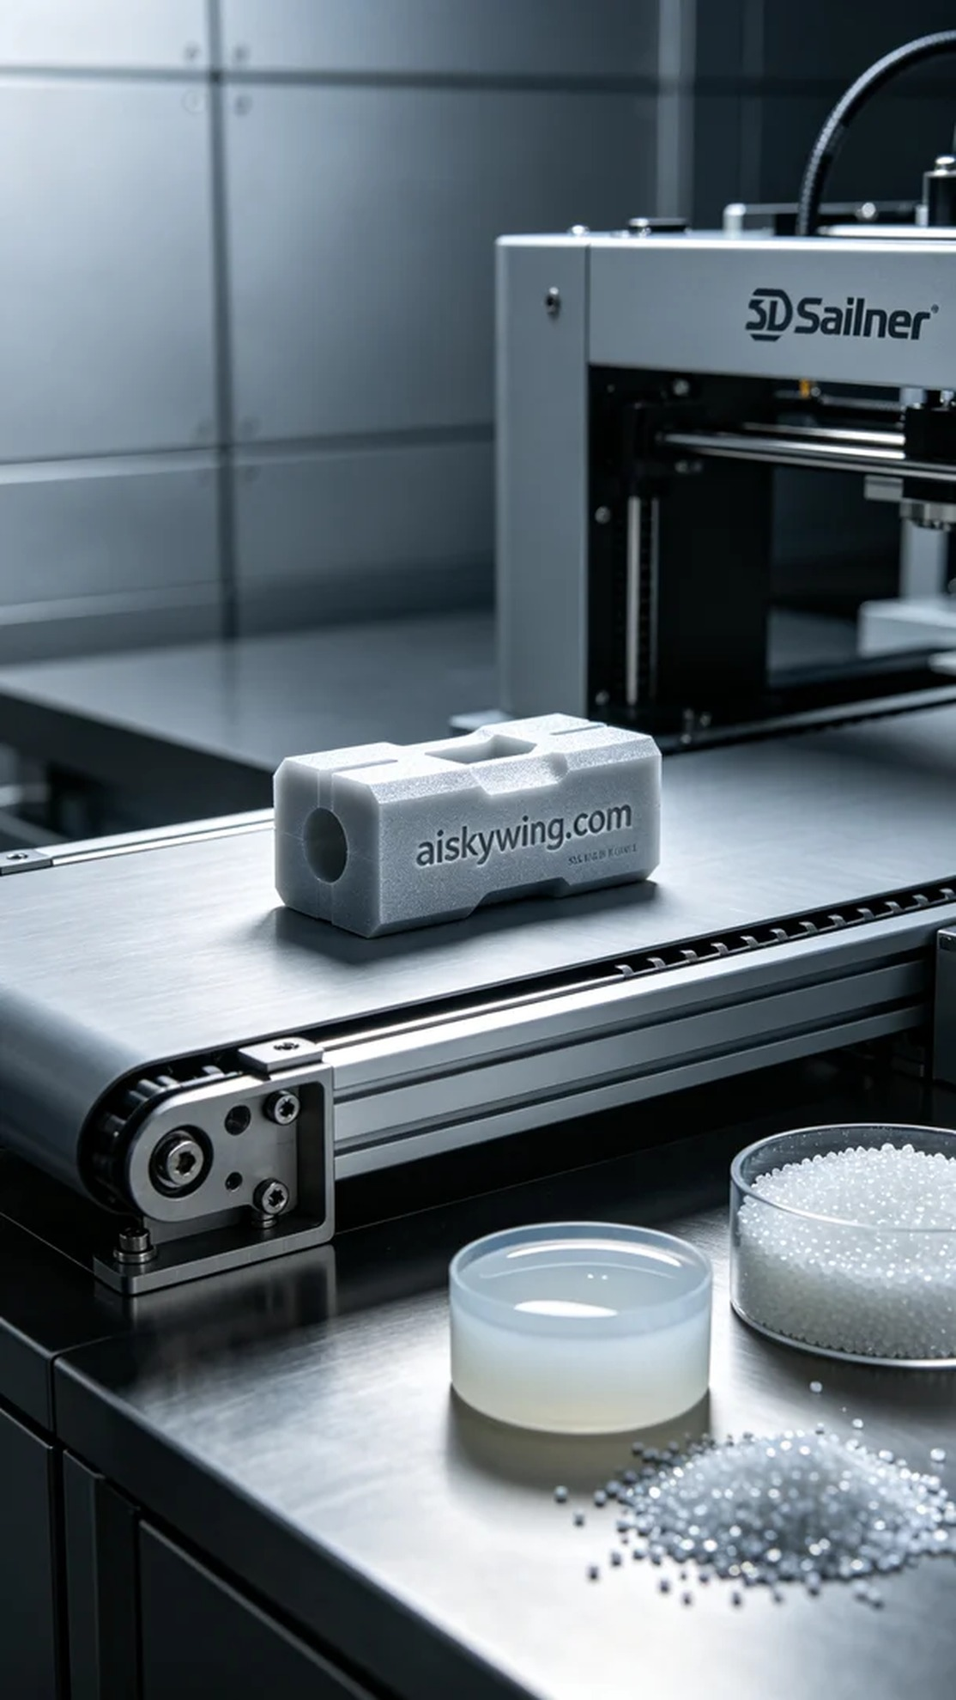
今天，我们在Instagram上接到有人想要定制一款传送带导向块，面临的问题是材料的耐高温性以及精准度。客户对这款产品的要求非常高，希望其能够适应严苛的工业环境，因此我们决定使用SLS耐高温尼龙来进行打印。
在准备阶段，我们首先选定了Stratasys的3D打印机作为主要设备。根据材料的特性，我们将打印层厚设置为0.1毫米，打印温度控制在190℃，功率设置为85%，速度则维持在50mm/s，以确保每个细节都能精确再现。
打印过程中，机器运转平稳，SLS工艺的优势在于它的高效性和高精度。由于我们一直保持对打印质量的监控，确保了在每一层的烧结过程中，材料在温度和密度上的一致性，使得打印的传送带导向块具有极佳的坚固性和耐热性。
后处理中，我们对打印好的部件进行了全面的清洗，使用专用清洗液去除表面残留的粉末后，进行了细致的打磨，使表面光滑如新。最后，将其置于固化设备中，确保其强度达到预期标准，经过最终检验，确认每个细节无误。
通过这次的制作过程，我们成功输出了一款高质量的传送带导向块，既满足了客户的需求，也展示了SLS尼龙材料的优越性能。每一次的挑战都让我们更进一步。
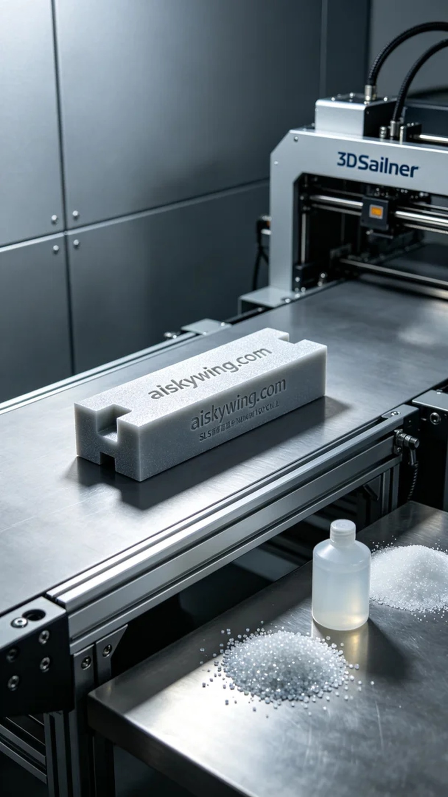
Aiskywing Industrial 3D Printing
Conveyor Belt Guide Block


